Mitosis
Mitosis is the process of somatic cell division that produces two genetically identical daughter cells from a single parent cell, maintaining chromosome number (2n → 2n). It ensures growth, tissue repair, and asexual reproduction; errors can lead to aneuploidy in cancer.

Stages of Mitosis
Mitosis occurs in four sequential stages, followed by cytokinesis:
- Prophase: Chromatin condenses into visible chromosomes (each with two sister chromatids); nucleoli disappear; mitotic spindle forms from centrosomes; nuclear envelope fragments.
- Metaphase: Chromosomes align at the metaphase plate (equator); spindle fibers attach to kinetochores on centromeres.
- Anaphase: Centromeres split; sister chromatids separate and migrate to opposite poles via shortening microtubules (anaphase A) and poleward spindle elongation (anaphase B).
- Telophase: Chromatids reach poles, decondense into chromatin; nuclear envelopes reform; nucleoli reappear.
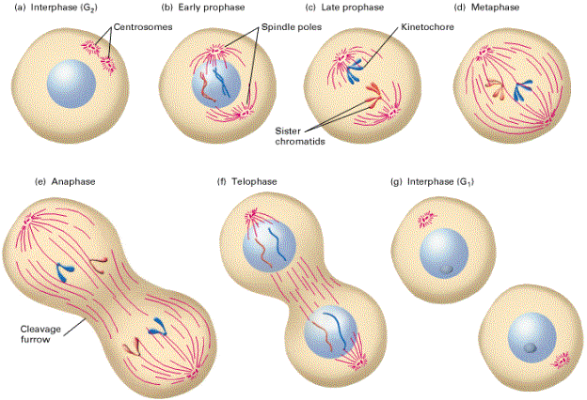
Cytokinesis: Cytoplasm divides via contractile ring (animal cells) or cell plate (plants), yielding two diploid daughter cells.

Key Features
- Duration: ~1 hour in actively dividing cells.
- Regulated by cyclin B-CDK1 complex; checkpoints ensure fidelity.
[TIP]Mnemonic: PMAT (Prophase, Metaphase, Anaphase, Telophase).
[WARNING]Clinical Relevance: Faulty mitosis causes chromosomal instability in tumors; drugs like vincristine disrupt spindles for chemotherapy.
[YOUTUBE] https://youtu.be/iQJ-FlRYb18

