Oogenesis
The formation, development, and maturation of an ovum

Primordial germ cells (PGCs)
PGCs appear in yolk sac endoderm (week 3-4 IUL)
Migrate via hindgut dorsal mesentery to gonadal ridge by week 6 IUL.
In XX embryo, genital ridge → ovary develops by week 8.

Oogonia
Oogonia (from PGC mitoses) peak at ~7 million (week 20)
Enter meiosis I → primary oocytes by birth (~1-2 million, 80% lost via atresia)

Primary oocyte
Primary oocytes enter diplotene arrest mid-gestation; resume briefly pre-ovulation
Arrest at Diplotene by ~week 18 (mid-gestation), sustained via NAT1/NPM2 factors

[TIP]Meiotic arrest - Diplotene stage of prophase I

Follicular Development Stages

Primordial follicle
Primary oocyte + single layer flattened pre-granulosa
Maturation (monthly cohort post-puberty, FSH-driven)
Oocyte enlarges; flattened → cuboidal granulosa;
Zona pellucida forms between oocyte-granulosa)

Secondary follicle
Multilayer granulosa. Theca differentiate into externa and interna

Antral or Graafian
Antrum forms; oocyte eccentric with cumulus oophorus; protrudes at ovarian surface
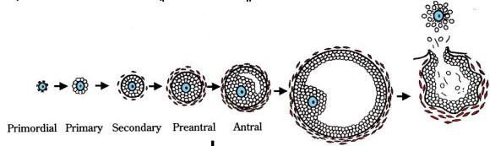

Secondary oocyte
- LH surge: Primary oocyte completes meiosis I
- Forms secondary oocyte (haploid, 23X) + 1st polar body.
- Arrests at metaphase II (Mos kinase stabilization).
- Fertilization: Ca²⁺-dependent calpain degrades Mos → meiosis II finishes
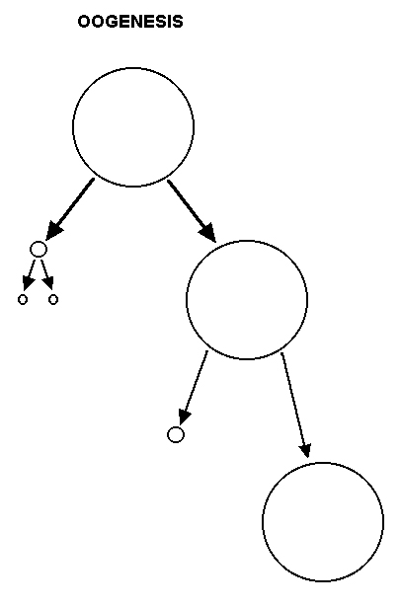

Polar bodies

Ovum
Primary oocyte
Secondary oocyte

Number of primordial follicles
- Highest - Not at birth
- Peaks at 5th month - 7 million
- Most degenerate
- 70000 - 2 million at birth
- 40000 at puberty
[TIP]Primordial follicles = Continuous follicular/oocyte degeneration (apoptosis)

Regulation
Fetal AMH (Sertoli/granulosa homolog) → Müllerian regression in males.
Pubertal: GnRH → FSH (follicle recruitment) + LH (theca/ovulation)
[CLINICAL]Oogenesis: Asymmetric, finite process producing one viable ovum per cycle; begins in utero, completes post-fertilization.

Clinical relevance
Premature Ovarian Insufficiency (POI): Accelerated atresia/depletion of primordial pool (e.g., genetic FMR1 mutations) causes early menopause
Polycystic Ovary Syndrome (PCOS): Disrupted FSH/LH → follicular arrest at antral stage (no dominance); metformin + clomiphene targets recruitment for ovulation induction
Turner Syndrome (45,X): Failed PGC migration → streak gonads (no oocytes); hormone replacement + fertility preservation (oocyte donation) informed by fetal ridge defects
Fertilization Failures: Mos degradation defects (rare mutations) prevent meiosis II completion → polyspermy/aneuploidy; Ca²⁺ ionophores in ICSI mimic sperm-induced release.
Cancer Therapy Protection: Alkylating chemo targets dividing oogonia/follicles; GnRH agonists suppress recruitment during treatment to preserve pool.
[TIP]Learn to draw the diagram
[YOUTUBE] https://youtu.be/yHk8wz4gq4M

___MCQ_START___
Q1. 1. During fetal development, primordial germ cells (PGCs) migrate to the gonadal ridge by which gestational week, initiating oogenesis in a genetically female embryo?
A. Week 3
B. Week 5
C. Week 6[CORRECT]
D. Week 8
___
Q2. What is the approximate number of primary oocytes present in the female ovary at birth, following significant atresia from the peak fetal oogonial pool?
A. 7 million
B. 1-2 million[CORRECT]
C. 300,000-400,000
D. 100,000
___
Q3. Primary oocytes in the fetal ovary enter meiotic arrest at which specific stage of prophase I, remaining paused until puberty?
A. Leptotene
B. Zygotene
C. Pachytene
D. Diplotene[CORRECT]
___
Q4. The secondary oocyte arrests at metaphase II due to stabilization of which protein, which is degraded upon fertilization to allow completion of meiosis?
A. p53
B. Mos kinase[CORRECT]
C. Rb
D. Cyclin B
___
Q5. In Turner syndrome (45,X), which aspect of oogenesis is primarily disrupted, leading to streak gonads and infertility?
A. PGC migration to gonadal ridge[CORRECT]
B. Follicular antrum formation
C. Meiosis II completion post-fertilization
D. Zona pellucida secretion
___
___MCQ_END___

