Placenta
Placenta is the intermediary connecting tissue between mother and fetus. Amongst other functions, the main functions of placenta include exchange of gases and nutrients between maternal and fetal circulations.

The components of placenta
  - Basal plate towards maternal side
  - Chorionic plate towards fetal side
  - Villi
  - Intervillous space in between basal plate and chorionic plate

Basal plate
- Forms the outer wall of the intervillous space.
- The Basal plate is made of the uterine endometrium along with Syncitiotrophoblast and cytotrophoblast.
- In different places the basal plate may contain also contain fibrinoid matrix.

Chorionic plate
Chorionic plate is made up of:
- Amnion
- Extra embryonic mesenchyme
- Trophoblasts.
  - The trophoblastic layer at the embryonic pole advances towards the decidual plate.
  - It comprises inner cytotrophoblastic layer and outer syncytiotrophoblastic layer

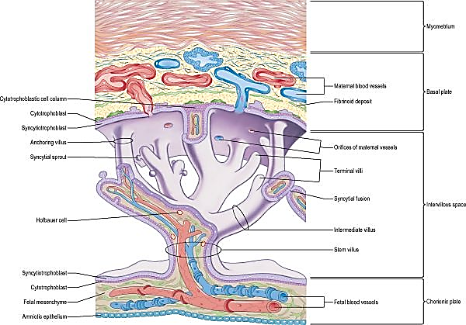

The villi
Villi attach the chorionic plate to the basal plate.
Villi are finger like extensions of the chorionic plate which extend into the basal plate. Since the villi are extensions of the chorion, they are also called as chorionic villi.
There are three types of villi:
- Primary villus: It has a central core of cytotrophoblast and an outer layer of syncytiotrophoblasts. Anchoring villus holds the chorionic plate to the decidual plate.
- Secondary villus: It presents a central core of mesoderm and layers of cytotrophoblasts and syncytiotrophoblasts.
- Tertiary villus: Embryonic vessels run in the central core of mesoderm, which in turn is surrounded by cytotrophoblasts and syncytiotrophoblasts.
The secondary and tertiary villi show branching, hence termed as 'branching villi'.

Intervillous space
- The area between the chorionic plate and the basal plate is occupied by the villi.
- The space in between the adjacent villi is termed as the intervillous space.
- Maternal vessels open into the intervillous space filling it with maternal blood.

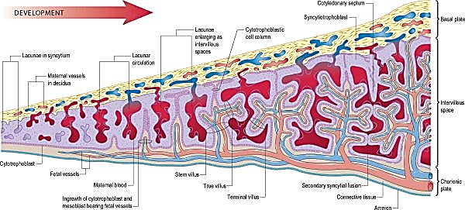

The villi adjacent to the decidua basalis are stouter and longer. These are called chorion frondosum.
As the conceptus continues to expand, the decidua capsularis is progressively compressed and thinned. Abembryonic hemisphere of conceptus is largely denuded. Eventually villi apposed to decidua capsullaris is now smooth and now termed as chorion leave. The chorion frondosum and the decidua basalis constitute the definitive placental site.

As secondary villi form, single mononuclear cells become detached from the distal cytotrophoblast and infiltrate the maternal decidua. These cells are the third line of the original trophoblastic cells. They are found in relation to spiral arteries in the central area of the placenta. At the same time, cytotrophoblast from the spherical shell migrates along the inner walls of maternal spiral arteries. (These cells are called endovascular extravillous trophoblast). The vessels lose their elastic lamina and consequently their responsiveness to circulating vasoactive compounds. The smooth muscle and associated elastic and collagenous matrix is replaced with non-resistive fibrinoid. This arrangement permits an expansion of the vessels and as much as a 20-fold increase in the flow of blood into the intervillous space. In normal pregnancies the transformation of spiral arteries into utero-placental arteries is completed around mid gestation. The main aim of these vascular changes appears to be to optimize the distribution of maternal blood into a low-resistance uterine vascular network.

Common pregnancy pathologies, including intrauterine growth restriction, pre-eclampsia and spontaneous abortion, are all associated with incomplete vascular remodelling, which probably reflects a failure of penetration by extravillous trophoblast

Components of placental barrier
- The maternal blood in the intervillous space is separated from the fetal blood in the fetal vessels running in the central core of tertiary villus.
- A number of structures thus separate maternal blood from the fetal blood. These constitute placental barrier.
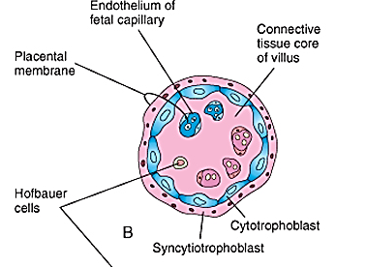

Structures forming placental barrier from the maternal side to fetal side are
- Syncytiotrophoblasts
- Cytotrophoblasts
- Extraembryonic mesoderm
- Endothelium of fetal vessel

Immune considerations
Immunological rejection of the conceptus does not occur because the syncytiotrophoblast expresses neither Class I nor Class II MHC antigens.

Human placenta has five characteristics
- Discoidal as it is disc shaped
- Cotyledenous because it has 15 to 30 individual cotyledons or lodes
- Deciduate – because along with fetal membranes placenta is shed during parturition.
- Hemochorial as the maternal blood (hemo) contacts with villi (chorial)
- Chorio-allantoic as chorion is vascularised by allantoic blood vessels

Morphological features of placenta
The placenta is made up of two parts:
Chorionic plate and villi: Constitute its fetal side.
Decidual plate and the septae: Constitute the maternal side.
Its shape is Oval / Discoid.
Measures about 20 cm in diameter (6-8 inches)
It has a thickness of about 3 inches.
Usually it weighs about 500-600 gm. Weight of placenta will be roughly equal to one sixth the weight of the baby.
Placenta has two surfaces:
- Fetal surface having umbilical cord with vessels with amnion.
- Maternal surface which is convex and has grooves or septae & elevations or cotyledons

Variations of placenta

Abnormal sites of implantation: Placenta previa
Implantation of blastocyst into lower uterine segment is called placenta previa.
Placenta previa varies in its severity.
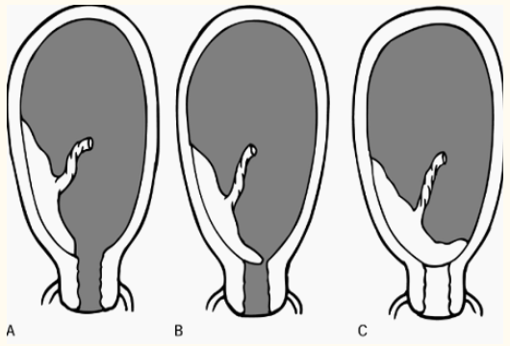

Grading
- If the attachment of placenta is into lower uterine segment and margin of placenta doesn’t extends upto internal os of uterus it is termed as first degree placenta previa.
- If the margin of placenta reaches internal os, but doesn’t completely cover the os, it is termed as second degree placenta previa.
- If the margin of placenta completely covers the cover the internal os, such condition is termed as third degree placenta previa.
- If the placenta completely covers the internal os and occludes the os even after it has dilated, such condition is termed as fourth degree placenta previa.

Nature:
Normally the placenta gets separated from the endometrium in a spontaneous manner as the cytotrophoblastic shell provides a plane of cleavage for the separation. However, the varying depth of invasion of placenta into the uterus causes difficulty in separation and thereby leads to postpartum haemorrhage. Three types of abnormal attachment of placenta into uterine wall are
  - Placenta accreta: Placenta invades the basal layer of endometrium.
  - Placenta increta: Placenta invades upto myometrium.
  - Placenta percreta: It invades the entire thickness of uterus
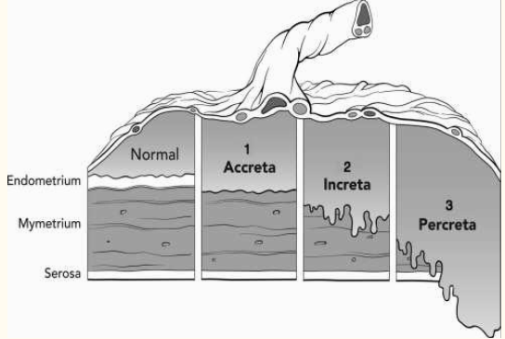

Other anomalies of placenta
Instead of shaped like a disc, the placenta may be
- Bidiscoidal, when it consists of two discs.
- Lobed, when it is divided into lobes
- Diffuse, when chorionic villi persist all around the blastocyst and placenta remains thin.
- Placenta succenturiata, when small part of placenta is separated from the rest of it.
- Placenta fenestrata, when there is a hole in the disc
- Circumvallate, when the peripheral edge of placenta is covered by a circular fold of decidua
- Bipartite or tripartite, when cotyledons get separated

Umbilical cord attachment abnormalities
The umbilical cord is usually attached to the centre of placenta.
But the attachment may be
- Marginal, when it is attached at the margin of placenta ; this type of placenta is celled battledore placenta
- Furcate – when the blood vessels divide before reaching the placenta
- When the blood vessels are attached to amnion and ramify before reaching placenta, such condition is called velamentous insertion.

