Spermatogenesis
It is the process of formation of mature spermatozoa
Pubertal onset in seminiferous tubules; lifelong, FSH/testosterone-driven

Primordial germ cells (PGCs)
Appear in the dorsal wall of yolk sac in the 3rd week of intrauterine life (IUL).
- These migrate and settle in the gonadal ridge (mesenchymal condensation under coelomic epithelium) by the 5th week of IUL
- If the embryo is genetically male, the gonadal ridge would form testis.
- In foetus the testis is made up of sex cords.

Each sex cord is made up of two types of cells:
- Spermatogonia (from PGCs)
- Pre-Sertoli cells (from coelomic epithelium; become supporting Sertoli cells). Mesenchymal cells outside cords differentiate into Leydig cells (testosterone-producing)

Spermatogenesis is divided into three phases
- Spermatocytogenesis
- Meiosis
- Spermiogenesis

[TIP]Mnemonic = S-M-S
[TIP]Spermatocytogenesis-Mitotic, Meiosis-Reduct., Spermiogenesis-Shape

Spermatocytogenesis

Spermatocytogenesis is the process of replenishment of spermatogonial cells. Spermatogonium divides mitotically to form spermatogonia A and B. Spermatogonium A, on division gives rise to spermatogonium B. Only spermatogonium B on division gives rise to primary spermatocyte.

Spermatogonia Type A (stem cells)
Divide mitotically—some self-renew (Ad), others produce Type Ap → Type B.
Type B → primary spermatocyte (enters meiosis).

[TIP]Mnemonic: A (Always) renews, B (Becomes) primary

[WARNING]Type A: Self-renew (A_d) or commit (A_p) → Type B → primary spermatocyte

Meiosis
Primary spermatocyte (largest, diploid 2n=46, XX or 46, XY) undergoes Meiosis I → two secondary spermatocytes (haploid n=23: one X, one Y).
Each secondary spermatocyte forms → two spermatids via Meiosis II (total: two 23X + two 23Y spermatids)

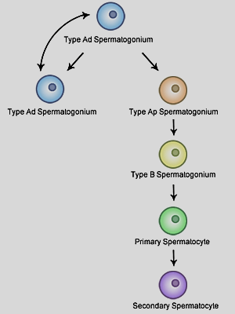

Spermiogenesis
- It is the conversion / metamorphosis of spermatid into sperm/ spermatozoa.
- This process takes place in Sertoli cells. It takes 24 days for spermatids to mature into spermatozoa.
- The cell organelles of spermatid undergo changes that contribute in the final shape of the sperm.
[TIP]Spermatids embed in Sertoli cytoplasm for nourishment/protection

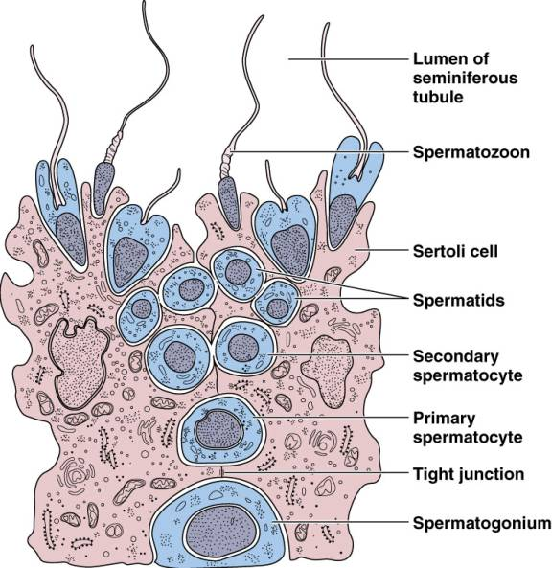

Comprises the following phases:
Metamorphosis of round spermatid → streamlined spermatozoon in Sertoli cells (~24 days). Phases:
- Golgi: Golgi forms acrosomal vesicle over nucleus.
- Cap: Vesicle flattens into acrosomal cap (hyaluronidase/acrosin enzymes).
- Acrosome: Cap spreads; nucleus condenses; flagellum elongates.
- Maturation: Cytoplasm sheds; midpiece mitochondria coil for ATP.

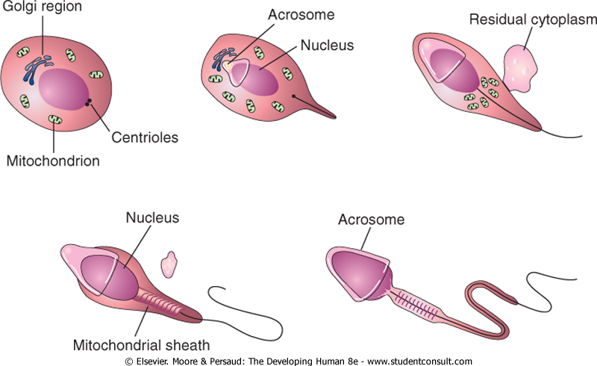

The changes are:
Nucleus: From rounded it becomes oval or elongated.
Golgi apparatus: Settles on one pole of the nucleus to form acrosomal cap.
Centriole: It divides into two. One part of centriole settles at the other pole of the nucleus opposite the acrosomal cap. It gives off axial filament.
Mitochondria: They start arranging below the centriole around proximal part of the axial filament. This arrangement of mitochondrial sheath is limited caudally by the other part of centriole (which is arranged in the form of a ring). Thus the middle piece is formed.
Cytoplasm: It is seen as a thin layer surrounding the head, middle piece and the axial filament. The remaining cytoplasm is extruded.

[YOUTUBE] https://www.youtube.com/watch?v=VCwjWLlrU8U

Duration of spermatogenesis
~72 to 76 days in humans, with waves every ~16 days for continuous output.

Spermatocytogenesis = 16 days
Meiosis = 24 days
Spermiogenesis = 24 days
Epididymal Transit (Maturation/Motility) = 8-12 days

Spermiation
Post-spermiogenesis release from Sertoli cells into tubule lumen

Structure of mature spermatozoa

Thus, from the rounded spermatid mature sperm (spermatozoon) is formed having:

- Head: Nucleus
- Acrosomal cap: Golgi apparatus
- Neck: Proximal centriole
- Middle piece: Mitochondria around the axial filament
- Tail: Axial filament (microtubules in 9+2 arrangement) extends into principal piece (fibrous sheath) and end piece

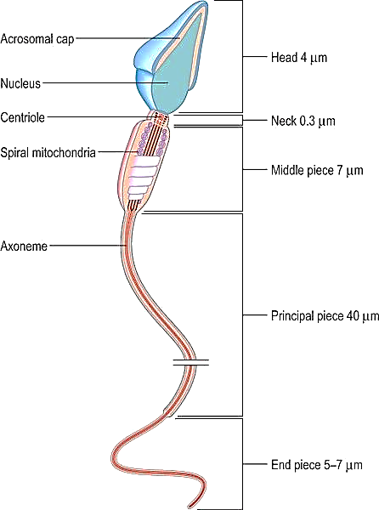

Numbers

~100-400 million spermatozoa/day per testis.
Only ~50% motile/viable.
From 1 spermatogonium → 4 spermatozoa (but some degenerate)

Hormonal Regulation
Regulation: Hypothalamus (GnRH) → Pituitary (FSH: Sertoli proliferation; LH: Leydig testosterone).
Testosterone + inhibin feedback loop maintains balance

Clinical corelations
Chemotherapy or radiotherapy can affect spermatogenesis: Alkylating agents disrupt meiosis/spermiogenesis, causing oligospermia. Cryopreservation pre-treatment preserves spermatogonia; knowledge of 74-day cycle informs recovery timelines.
Genetic Screening for Aneuploidy: Meiotic errors (e.g., nondisjunction in primary/secondary spermatocytes) cause conditions like Klinefelter syndrome (47,XXY) or translocations, leading to azoospermia. Karyotyping detects these, enabling preimplantation genetic testing (PGT) in IVF.
Infertility Subtyping: Defects in spermatocytogenesis (e.g., Sertoli cell-only syndrome) differentiate obstructive vs. non-obstructive azoospermia. Testicular biopsy targets specific phases for TESE (testicular sperm extraction) in ICSI (Intracytoplasmic Sperm Injection).
Endocrine Management:
- Hypogonadism impairs FSH-driven spermatocytogenesis
- hCG/FSH therapy stimulates Leydig/Sertoli function
- Monitoring testosterone levels ties to mesenchymal (Leydig) differentiation, treating hypogonadotropic hypogonadism.
Environmental/Toxin Exposure: Pesticides/heavy metals target mitochondrial arrangement in spermiogenesis, causing asthenozoospermia (low motility). Occupational screening (e.g., for farmers) uses phase-specific biomarkers for early intervention

