Twinning
Harnessing two or more foetuses simultaneously is called twinning.
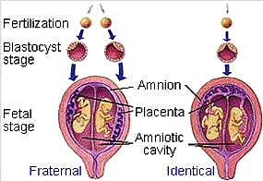

Classified as
Dizygotic (fraternal): two zygotes from separate ova/sperm)
Monozygotic (identical): one zygote splitting

Dizygotic twins
- Double ovulation/fertilization, FSH-driven
- Two blastocysts implant separately (day 7-10)
- Always dichorionic-diamniotic
- Two independent embryonic discs, chorions, amnions
- Fused placentas possible but separate villi

Monozygotic twins
- Early split (days 1-3, morula): dichorionic-diamniotic (70%, separate placentas and amnia).
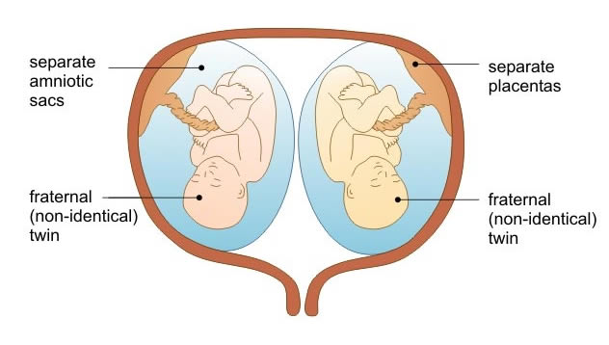
- Mid split (days 4-8, blastocyst): Monochorionic-diamniotic (25%, shared placenta and separate amnia).
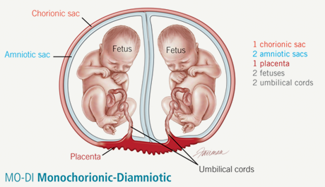
- Late split (days 9-13, post-implantation): Monochorionic-monoamniotic (1-2%, shared everything, high-risk).
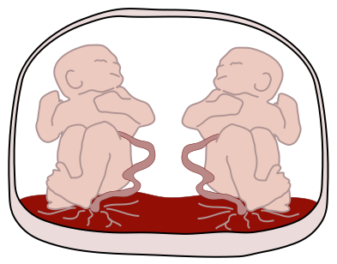
- Very late (post-week 13): Conjoined (1:50,000-200,000 MZ, incomplete split)
