Ureter

Location
Retroperitoneal - placed on posterior abdominal wall

Length
25 cm

Extent
From pelviuretral junction to urinary bladder
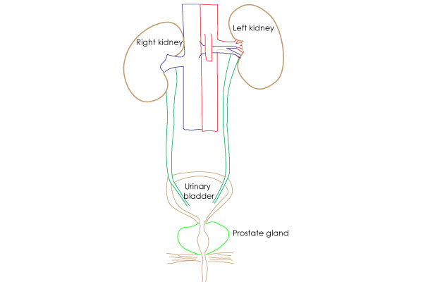

Parts

Abdominal part
Upto the pelvic brim

Pelvic part
Beyond pelvic brim

Intravesical or Intramural part
Inside the bladder wall

Constrictions of ureter

5 Constrictions
- Pelviureteric junction – L2
- Pelvic brim (sacroiliac joint)
- Crossing of vas deferens in males, Tunnel in broad ligament in females
- Intramural part (at ischial spine)
- Ureteric orifice
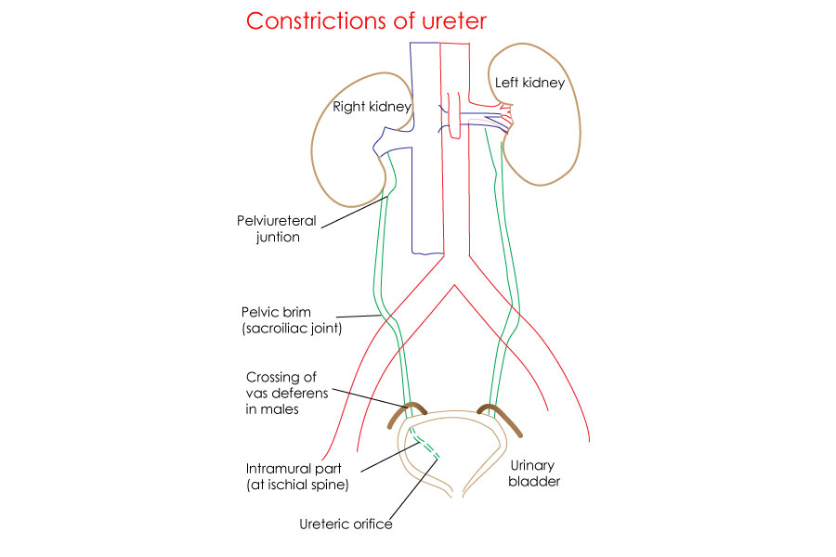

Relations – anterior

On rigth side
- Second part of duodenum
- Right colic vessels
- Ileocolic vessels
- Right gonadal vessels
- Root of mesentery

On left side
- Left colic vessels
- Sigmoidal vessels
- Left gonadal vessels
- Sigmoid mesocolon

Relations – Posterior
Psoas muscle
Genitofemoral nerve
Tips of lumbar transverse processes
At pelvic brim – crosses common iliac vessels

Blood supply
Segmental subadventitial arterial supply from branches of
- Renal artery
- Inferior suprarenal artery
- Gonadal artery
- External iliac artery
- Internal iliac artery
- inferior vesical artery
- uterine artery
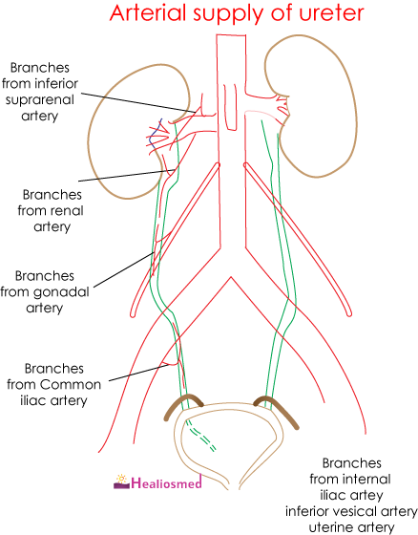

Stricture
Injury to these blood vessels during gynaecological, urological and general surgeries leads to iatrogenic ureteric stricture

Nerve supply

Sympathetic
- Least splanchnic nerve (T12)
- L1 and L2

Parasympathetic
- Pelvic splanchnic nerves (S2, 3, 4)

Surface marking
4 cm lateral to spine of T12 to L2
Join posterior superior iliac spine (dimple)

Applied aspects - Intravenous pyelography (IVP)
X-ray examination of the kidneys, ureters and urinary bladder that uses iodinated contrast material injected into veins
In IVP, the contrast agent is given intravenously, allowed to be cleared by the kidneys and excreted through the urinary tract as part of the urine.
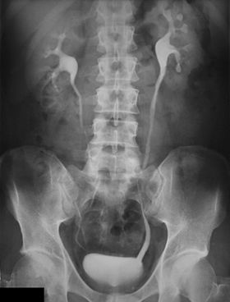

Cystoscopy - is a method of endoscopic visualization of the bladder

Applied aspects - identification of ureter during surgery
Ureter shows peristaltic activity that is much different from nearby pulsatile blood vessels.

