Lymphatic drainage of breast

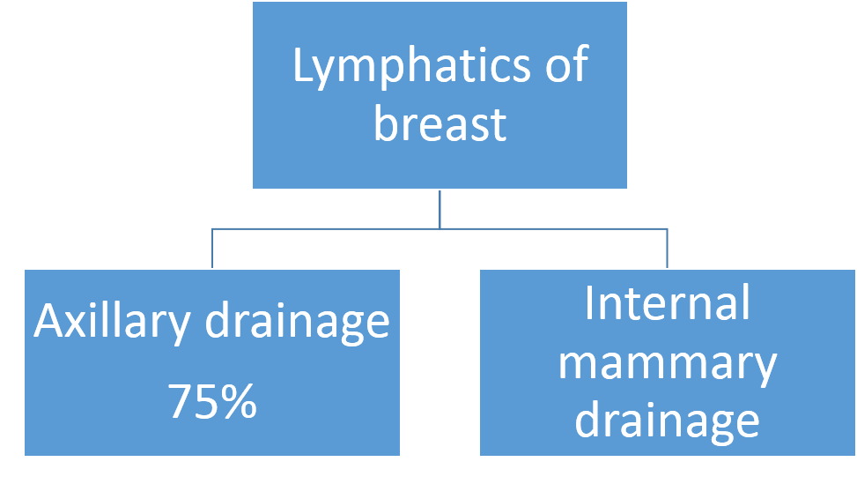
Axillary drainage

Axillary group of lymph nodes

Anterior pectoral group (external mammary group)
    - Along lateral border of pectoralis minor
    - Deep to pectoralis major
    - Along medial side of lateral thoracic artery from 2nd to 6th rib
    - Deep to areola – extensive plexus of lymphatics present
    - Called Subareolar plexus of Sappey
    - Pass around the lateral border of pectoralis major to reach external mammary group.
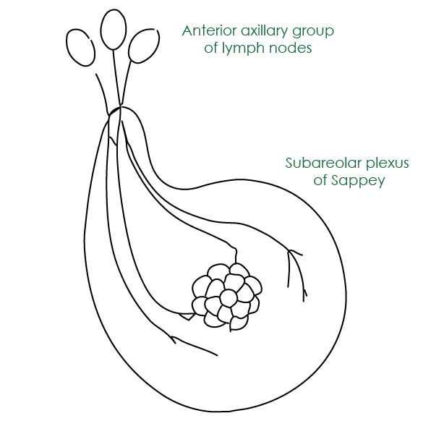

Scapular nodes (posterior group)
    - lie on the subscapular vessels and their thoracodorsal branches
    - Intercommunicate with intercostal lymph nodes

Central nodes
    - largest group of lymph nodes
    - they can be easily palpable in axilla
    - embedded in fat in the centre of the axilla
    - When these nodes enlarge, they can compress the intercostobrachial nerve, the lateral cutaneous branch of the second or third thoracic nerve that results in pain

Interpectoral nodes (Rotter's nodes)
    - lie between the pectoralis major and minor muscles

Axillary vein nodes (lateral group)
    - lie on the caudal and ventral surfaces of the lateral part of the axillary vein

Subclavicular nodes (apical group)
    - lie on the caudal and ventral surfaces of the medial part of the axillary vein
    - Inaccessible unless Pectoralis major is sacrificed

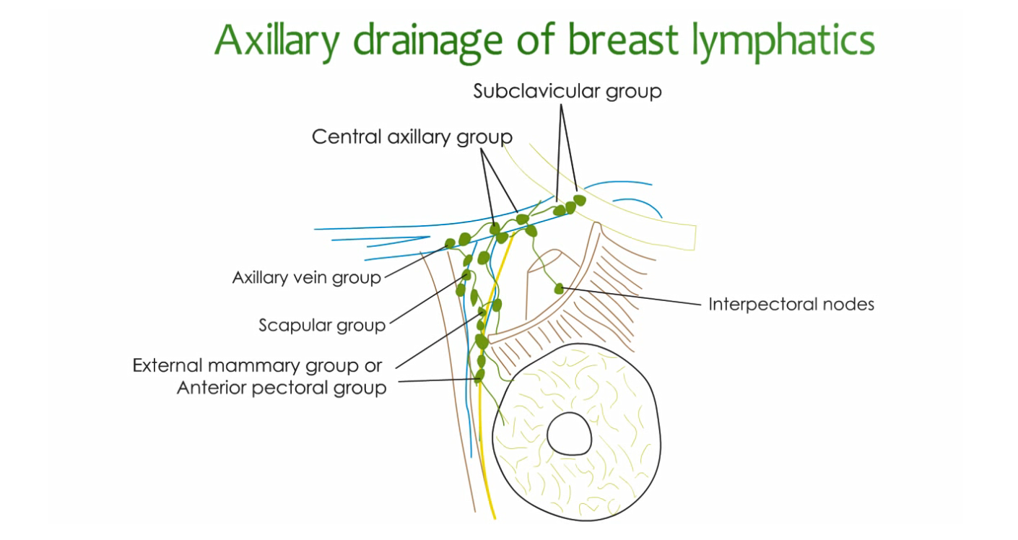
[YOUTUBE] https://youtu.be/86840hDuToQ

Axillary lymph nodes can be divided into surgical levels:
- level 1: lying below pectoralis minor
- level 2: lying behind pectoralis minor
- level 3: lying between the upper border of pectoralis minor and lower border of the clavicle
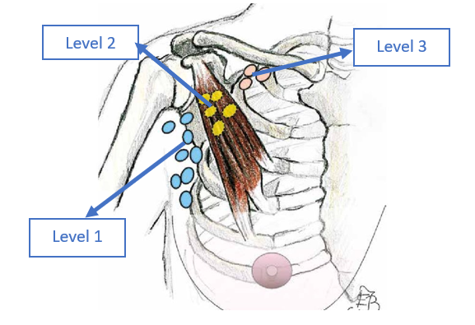

Internal mammary group of lymph nodes
  - Located on medial edge of the breast on the pectoralis fascia
  - accompany the perforating blood vessels
  - also receive lymphatic trunks from the skin of the opposite breast, the liver, the diaphragm, the rectus sheath, and the upper part of the rectus abdominis
  - This route to the venous system is shorter than the axillary route

Drainage route
- In general lymphatic from breast accompany blood vessels
- Spread of tumor will be to lower axilla first, then to middle axilla before reaching upper axilla

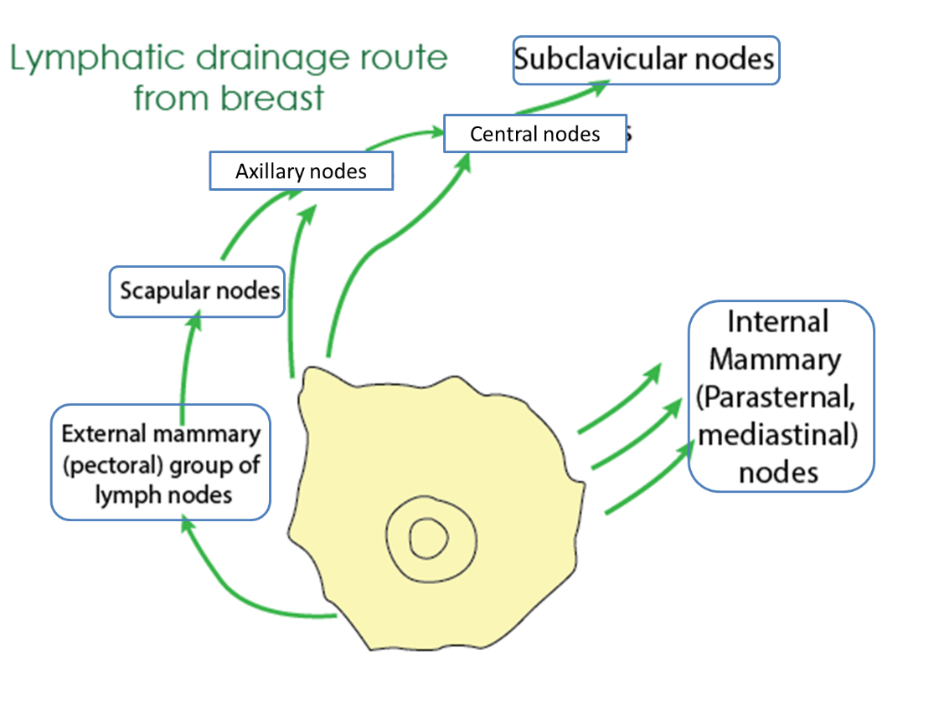
[CLINICAL]Learn to draw the diagram
[YOUTUBE] https://youtu.be/q4jyfOVvci8

Applied aspects

Spread of breast cancer
- Lymphatic metastasis occurs primarily to the axillary and the internal mammary lymph nodes.
- Tumours in the posterior one-third of the breast are more likely to drain to the internal mammary nodes.
- Spread by the bloodstream - initial spread may be via the lymphatic system.
- In order of frequency the lumbar vertebrae, femur, thoracic vertebrae, rib and skull
- Metastases may also commonly occur in the liver, lungs and brain
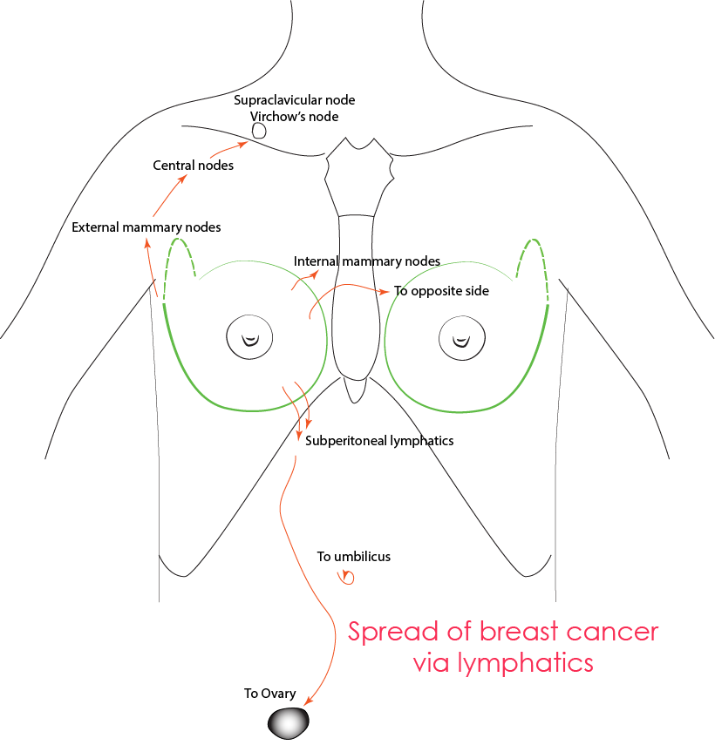

Sentinel node
- First site of metastatic disease
- It is the first node receiving lymph from primary tumor
- Detected using blue- dye and gamma camera
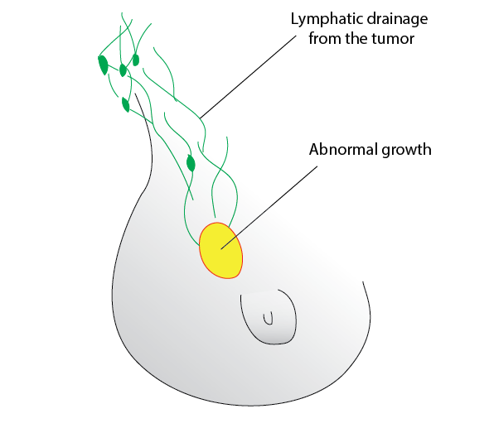

After the excision of an abnormal growth from breast

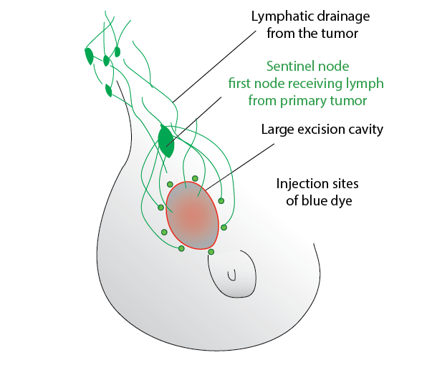

Blue dye is injected to its walls and first node receiving the dye is observed using gamma camera

___MCQ_START___
Q1. What is the primary route of lymphatic drainage of the breast?
A. Internal mammary lymph nodes
B. Supraclavicular lymph nodes
C. Axillary lymph nodes [CORRECT]
D. Posterior intercostal lymph nodes
___
Q2. Which group of axillary lymph nodes receives lymph directly from the breast parenchyma?
A. Apical group
B. Central group
C. Lateral group
D. Anterior (pectoral) group [CORRECT]
___
Q3. Lymph from the medial quadrants of the breast predominantly drains into which lymph nodes?
A. Axillary lymph nodes
B. Supraclavicular lymph nodes
C. Internal mammary (parasternal) lymph nodes [CORRECT]
D. Posterior mediastinal lymph nodes
___
Q4. Which lymph node group acts as the final collecting station before lymph enters the subclavian lymph trunk?
A. Central axillary nodes
B. Lateral axillary nodes
C. Apical axillary nodes [CORRECT]
D. Posterior axillary nodes
___
Q5. Lymphatic spread of carcinoma of the breast to the opposite breast most commonly occurs through which pathway?
A. Axillary lymph nodes
B. Internal mammary lymph nodes [CORRECT]
C. Supraclavicular lymph nodes
D. Posterior intercostal lymph nodes
___
Q6. The sentinel lymph node in breast cancer is most commonly located in which axillary lymph node group?
A. Posterior (subscapular) group
B. Central group
C. Anterior (pectoral) group [CORRECT]
D. Apical group
___MCQ_END___

