Humerus
Etymology: humorous – may be secondary to tingling sensation after ulnar nerve is stimulated

Upper end
- Features: head, neck, greater and lesser tubercle with intertubercular sulcus
- Head is covered with articular cartilage and articulates with glenoid cavity and intervening labrum to form glenohumeral joint
- Constriction just next to head is anatomical head – glenohumeral joint capsule is attached here
- Junction between diaphysis and epiphysis represented by epiphyseal line is morphological head
- Short constriction in upper end below the greater and lesser tubercle is surgical neck
[IMP]Surgical neck of humerus is related to axillary nerve with posterior and anterior circumflex humeral vessels
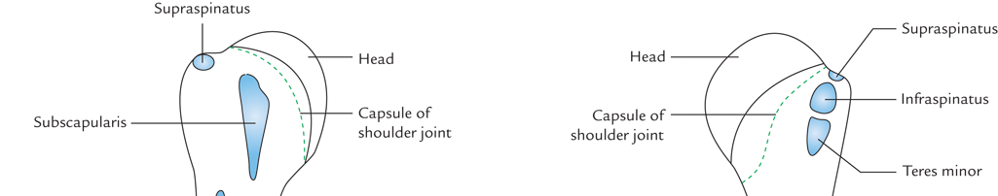
- Attachments

Part | Muscles
Greater tubercle | Supraspinatus  Infraspinatus  Teres minor
Lesser tubercle | Subscapularis

Intertubercular sulcus attachments
Part | Muscles
lateral lip | Pectoralis major
Floor | Latissimus dorsi
medial lip | Teres major

Nerves related to humerus
Axillary nerve – around neck of humerus
Radial nerve – radial groove
Ulnar nerve – behind medial malleolus
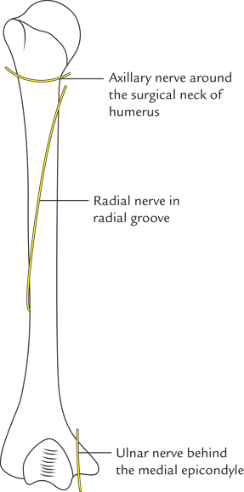

Anatomical predisposition to supracondylar fractures
- Supracondylar region is the junction between diaphysis and metaphysis
- This is the region of transformation of compact bone to cancellous bone
- The shape of humerus changes from circular profile to triangular profile below this level
- Below this region – humerus exhibits medial and lateral supracondylar ridges. This essentially divides the power of bone into two pillars
- During the fall on outstretched hand the line of force passes through this region posteriorly.
Mechanism of injury – fall on outstretched hand with elbow hyperextended, arm abducted/adducted and wrist hyperextension

