Centralized and Decentralized Coordination for LF Hardware
  - Design choices and implementation flow for reactor chisel on ZCU106
Expanded technical design note | 8 October 2026

1 Recommended first implementation
Begin with centralized coordination using the existing project HW-RTI and the ZCU106 reactor-chisel port. The decisive advantage is architectural fit: Codesign already provides a grant-controlled execution boundary and NET/LTC-like progress signals. A centralized baseline allows the team to establish tag representation, completion, transport ordering and participant isolation before introducing another local advancement policy.
This is a recommendation for the current project, not a claim that centralized coordination is always faster or simpler. It is conditional on the project HW-RTI having a usable, verified policy for the chosen initial topology. If that policy is unavailable, build and validate a reference coordinator for that scope first; do not connect unverified grant logic to the FPGA and treat successful execution as proof of safety.
Use two hardware participants, a static acyclic topology with explicit connection delays, bounded channels, and final grants. Keep startup and diagnostics on the Arm processing system. Defer provisional grants, zero-delay cyclic dependencies and mixed coordination modes until their semantics are required and tested. If the intended application fundamentally needs those features, the restricted baseline is a verification scaffold rather than an application-complete solution.
Develop the decentralized case as a second policy branch on the same participant and transport infrastructure. Start with explicit input knowledge or absence information, then add bounded waiting only after deriving the timing assumptions and the violation response. This keeps the comparison focused on coordination rather than on two unrelated hardware implementations.

Scope and evidence
The existing board port is taken as complete. The original Codesign interface findings are based on inspected source files [1–8]. LF and micro-LF documentation provides semantic reference points [9–12]. The architectures, records and flowcharts below are proposed integration artifacts; they do not assert that Codesign already implements federation or that the project HW-RTI has been audited here.
The note preserves the original Codesign findings and expands them with both coordination choices, their motivation, code reuse, implementation gates, example traces and validation criteria. No canonical project document is modified.

2 Why coordination is needed
Independent participants can compute concurrently, yet they must agree on the logical order of events when that order affects reactions and state. A receiver facing an input with no value at a candidate tag must distinguish known absence from a value that is merely delayed. A local timer can otherwise trigger a reaction before causally relevant remote data becomes visible.
Coordination answers when a participant may commit to a tag, which inputs belong to that tag, and what completion means for downstream participants. Transport answers how information moves. Central placement of decisions does not inherently require central routing of all payloads; conversely, peer-to-peer payload exchange does not establish decentralized advancement.

Motivation for centralization
A coordinator provides a single place to evaluate progress against topology and connection delays. It offers a useful reference architecture when sender execution and channel delays vary and the initial research goal is faithful logical-time ordering. Global traces can make incorrect grants, missing reports and unresolved dependencies easier to diagnose. Central hardware can also share policy resources rather than replicating them beside every participant.
Its costs include report traffic, grant arbitration, dependence on the coordinator, and potential serialization. Conservative coordination can wait indefinitely for stalled upstream participants. Causal correctness alone provides no deadline guarantee; schedulability still requires bounds on computation, transport, arbitration and release timing.

Motivation for decentralization
Local decisions can remove the per-tag grant round trip, keep traffic close to the computation, and suit larger or physically distributed deployments. Bounded waiting can make a deliberate availability choice when a peer is slow or unavailable. The cost is replicated knowledge state and a stronger obligation to justify timeouts, preserve ordering, and handle late data.
Distribution does not automatically provide fault tolerance or lower latency. Infinite waits preserve input alignment but can block progress; short waits can create tardy inputs. A shared clock on one FPGA simplifies clock alignment, but does not bound sender lag, queueing or downstream backpressure. These costs must be measured or bounded for the selected workload.
Decision dimension | Centralized initial baseline | Decentralized branch
Authority to advance | Verified grant policy | Local knowledge and waiting policy
Unknown input | Resolve by protocol before final execution | Wait or assume absence under explicit policy
Main integration risk | Progress and grant meanings do not match | Local policy and timing assumptions are incomplete
Failure behavior | Coordinator or missing progress can stall | Peer loss can stall or trigger a configured violation
Expected first use | Reference implementation on current ZCU106 setup | Subsequent experiment in local progress and availability

3 What the original Codesign implementation provides
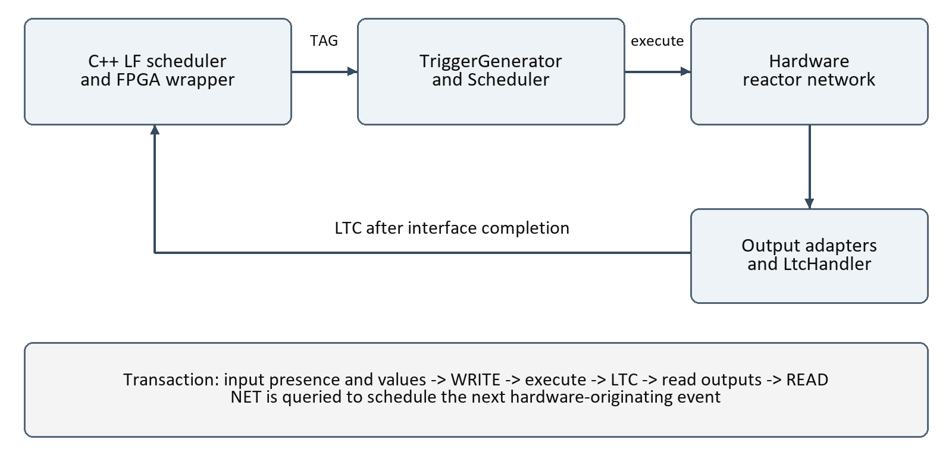
Figure 1. Original hardware and software coordination path. This is a component execution protocol, not an identified multi-federate RTI.
CodesignSwEmitter selects the Cpp software target. CodesignFpgaWrapperTransformation generates a wrapper that uses software elapsed logical time as a hardware grant, issues WRITE, polls logicalTagComplete, forwards outputs and issues READ. It queries nextEventTag to schedule hardware-originating work in the software runtime [6,7].
CoordinationIO exposes NET, TAG, LTC and shutdown fields. TriggerGenerator connects its token-queue NET, clock and coordination-valid signal to Scheduler. The scheduler selects local, external or combined execution, then sends a decoupled execute command [1,2].
Code location | Meaning for integration
Scheduler.scala | Readiness predicates and the execution gate; TAG greater than NET restriction
Reaction.scala | reactionEnable/reactionDone and sIdle/sRunning/sDone token handling
CodesignTopReactor.scala | WRITE-linked validity, top-level ports, DMA and LtcHandler
Wrapper transformation in compiler | Software transaction sequence and next-event scheduling
Tag.scala | Scalar 32-bit tags and sentinel representation

reactionDone defaults to true and must be controlled for multi-cycle bodies. LtcHandler tracks output adapter completion rather than directly reducing every reactionDone. Array outputs wait for both reactor and DMA completion. No-output completion uses input-port readiness; that proxy needs validation for a new federation contract [3–5].

4 Centralized block architecture
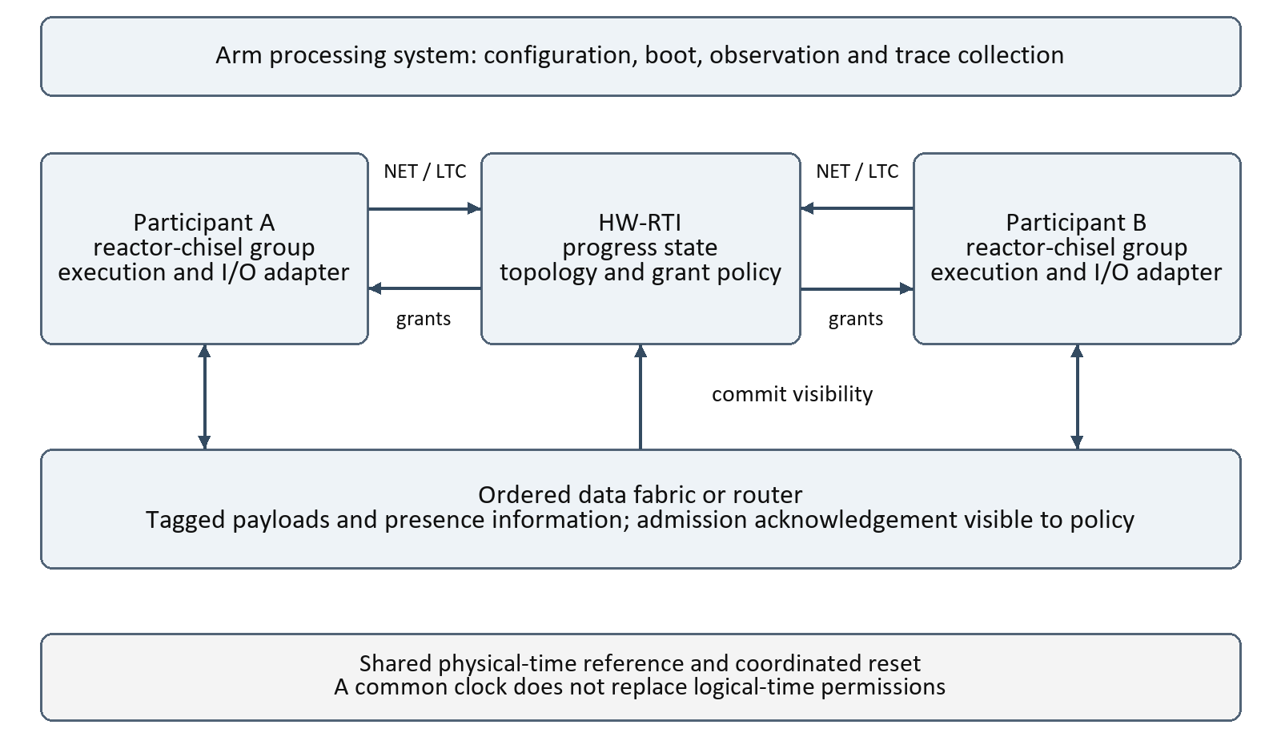
Figure 2. Proposed central coordination. The ordered data plane exposes admission information to the policy; payload routing and grant placement remain separate choices.
Each participant contains a reactor-chisel group and an adapter that owns ingress state, execution transactions, egress buffers and progress reports. HW-RTI receives coherent participant state and issues grants according to the project topology and delay policy. The Arm side configures and observes the experiment rather than granting every tag.
For the first experiment, prefer a route whose delivery ordering is visible to the coordinator, such as a simple ordered router with explicit admission acknowledgement. A control-only coordinator with direct peer data is also possible, but then in-flight data and knowledge closure require a proved protocol. An egress enqueue alone does not establish downstream input visibility.
Central authority permits advancement only when the verified policy excludes causally earlier missing input or otherwise provides the required input closure. A simplistic minimum of NET values is not an RTI algorithm. Progress reports must cover the event sources, connection delays, executing work and outbound information required by that policy.

5 Centralized participant flow
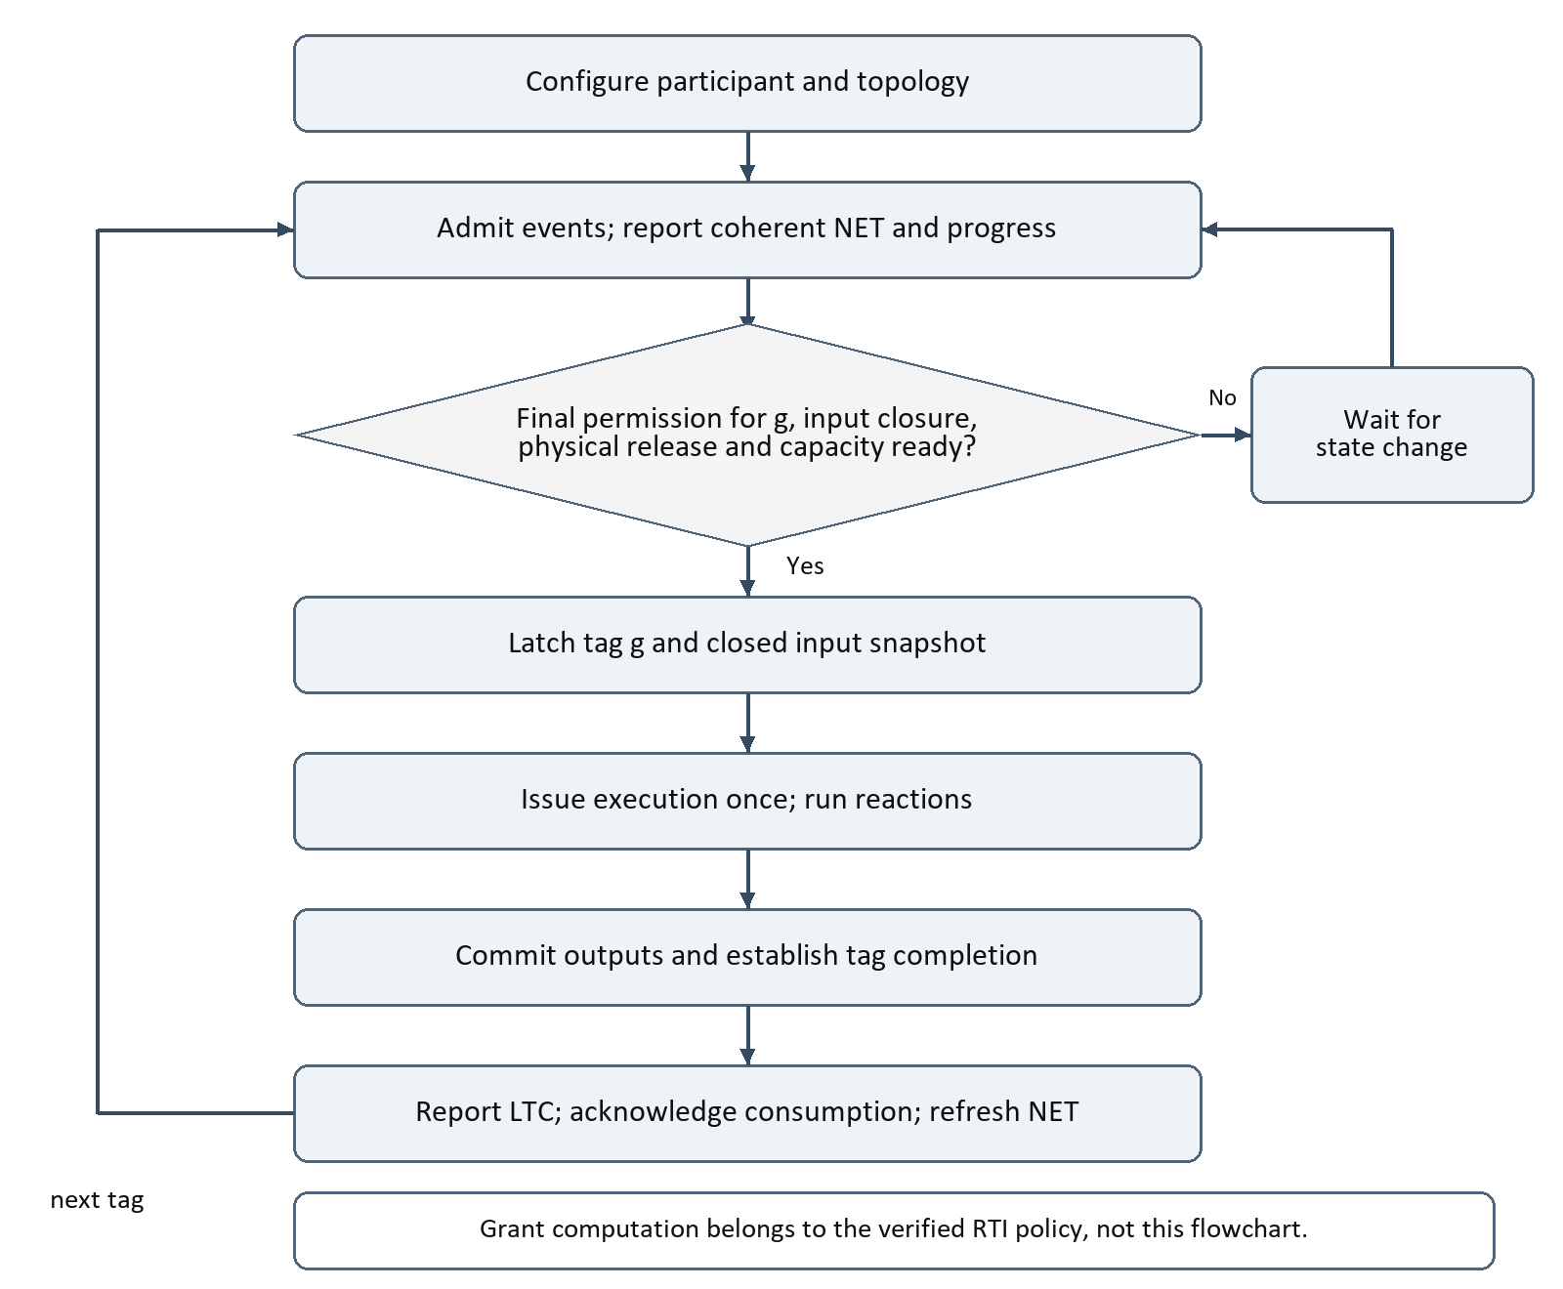
Figure 3. Proposed central participant flow. The guard combines policy permission with local transaction conditions; it is not a replacement for the RTI algorithm.
Maintain a retained grant with explicit validity and request identity. Select a real pending candidate covered by that grant. Latch one input snapshot and issue execution exactly once. A permission to advance is not an instruction to fabricate an event.
Before reporting completion, establish the required output publication point and retain all buffer ownership until downstream acknowledgement or an equivalent release. The next report must not advertise a later candidate while the previous transaction still has unreported causally relevant work.

6 Centralized protocol and implementation obligations

A small transaction sequence
Step | Participant A | Coordinator and ordered fabric | Participant B
1 | Reports candidate g | Evaluates initial progress | Reports its pending state
2 | Executes under permission | Maintains dependency information | Waits for input closure
3 | Produces output for destination tag h | Admits data or tracks ordered delivery | Accepts tagged input h
4 | Reports completion after required commit | Evaluates downstream safety for h | Receives final permission for h
5 | Refreshes candidate | Processes coherent progress | Executes h and reports completion

Here h is derived by the agreed connection-delay and tag transformation. Zero delay is not assumed to preserve a scalar timestamp without microstep implications. This sequence is an explanatory trace for the restricted baseline, not the full coordinator transition function.

Required adapter changes
Separate grant value, grant validity and grant acknowledgement from input publication. The original WRITE mechanism couples them. Define a command handshake that cannot lose repeated commands; SwCommand currently recognizes changes in command value. Preserve a consumption acknowledgement equivalent to READ for output token release.
Resolve the current scheduler assertion rejecting TAG greater than NET except FOREVER. Either narrow the adapter to an explicitly proved execution transaction model, retaining a wider grant separately, or extend the scheduler after checking the RTI contract. Do not silently discard the assertion or truncate grant values.
NET from the local token queue is not automatically the participant NET needed by an RTI. The adapter may need to combine admitted external events, local timers, physical actions and executing-state restrictions. Similarly, publish LTC only when reaction work and outbound commitments satisfy the project invariant.

Safety and progress boundaries
Use final grants first on the verified acyclic scope. A valid zero-delay feedback network can require provisional coordination or finer knowledge exchange; restricting such networks is a scope decision, not proof that all feedback is invalid. Deadlock and safety must be tested separately. Shutdown and reset need coherent epochs so old messages and reports cannot affect a new run.

7 Decentralized block architecture
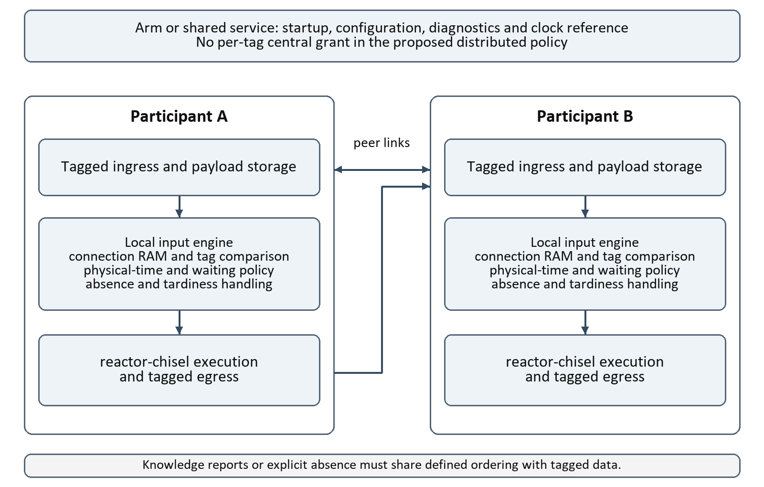
Figure 4. Proposed local coordination engines. Replicated state replaces per-tag central grants; shared startup or clock services can remain.
Place a local policy engine beside each reactor-chisel group. Incoming data and knowledge information update a connection table and tagged ingress queue. The engine chooses a candidate, evaluates input knowledge and physical release, and either waits or admits execution under the selected policy. Egress publications carry enough ordering information for peers to update knowledge safely.
Use the same participant buffers, connection maps and execution interface as the centralized baseline where possible. Only one engine owns advancement at a time. Switching policies requires a quiescent protocol or a verified handover; two simultaneous authorities are unsafe.
The LF documentation distinguishes conventional decentralized targets, which may retain RTI services for lifecycle and clock synchronization, from micro-LF, which uses peer coordination without an RTI [9]. The proposed hardware design can retain an Arm startup service without making that service a per-tag coordinator.

8 Decentralized admission flow
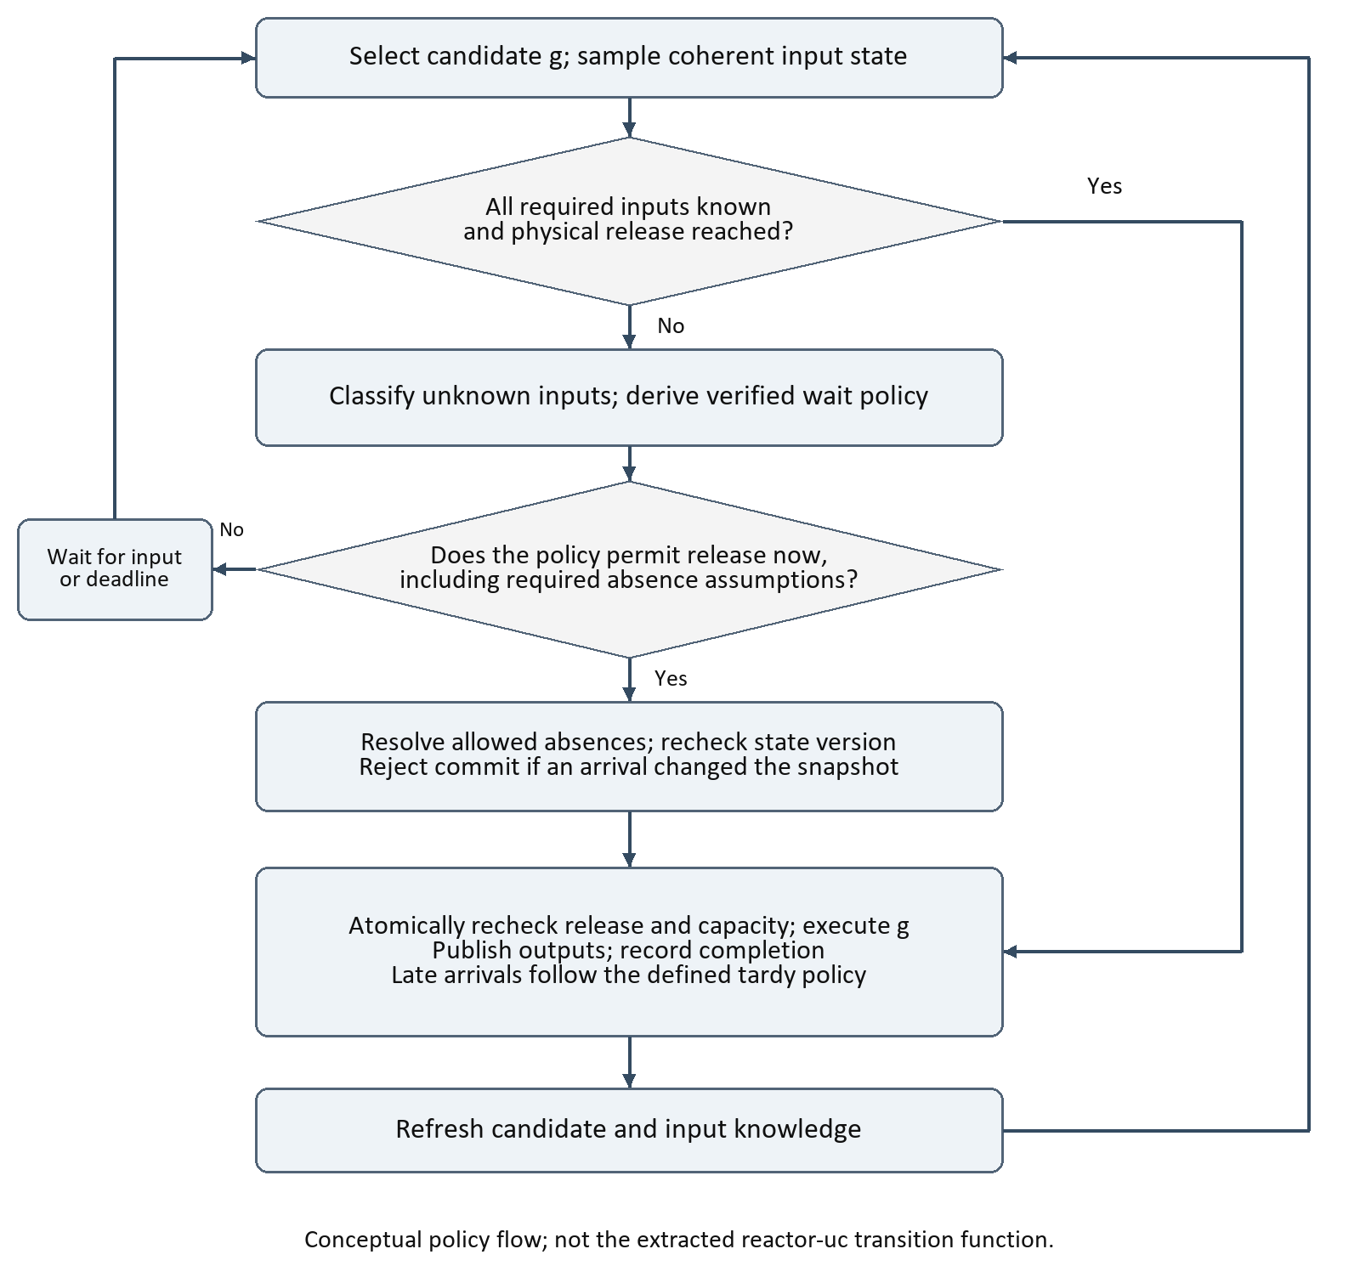
Figure 5. Conceptual decentralized admission flow. Exact deadline derivation, absence rules and update priority must be extracted from the selected reference implementation.
Knowledge may be established by a present event, explicit absence, or a valid ordered progress bound. A larger arriving tag proves earlier knowledge only if the sender and channel contract justifies that inference. Check all required inputs for the candidate; do not replace per-input state with the last packet timestamp.
A receive update racing with timeout must be resolved through an atomic snapshot/commit protocol. If the input state version changes, recompute readiness before execution. Late input classification uses the intended tag and completed execution frontier, with a defined equality and microstep rule.

9 Waiting policy and timing discussion
The decentralized branch should first use known-input progress, including explicit absence or lower-bound information where necessary. This establishes correctness without guessing a finite waiting parameter. It can stall if upstream peers fail to produce the knowledge needed for progress. Cyclic waiting dependencies require a protocol argument, lookahead, or an explicit source of progress.
Only then introduce finite waiting as an application policy. The current LF documentation describes connection-level maxwait and absence-related attributes, while older documentation uses STP offsets [9,10]. These versions are not interchangeable with the examined Chisel runtime or unpinned reactor-uc headers. Extract the full policy from one chosen commit before translating it to hardware.

Timing budget proposal
For a required input at destination time t, establish an upper bound on the physical arrival time as observed by the receiver. The analysis must include source release and execution lag, all queue and transport delay, timestamp conversion and connection delay, receiver admission delay, clock error, and any margin used by the design. Microsteps are logical ordering components, not physical durations.
Define B_i(g) as a derived upper bound on the receiver-clock arrival time for input i relevant to candidate g, and D_i(g) as the policy instant at which absence may be assumed. To claim no tardiness from that assumption, require D_i(g) to be no earlier than B_i(g), under the exact boundary rule. This is a verification condition, not the reactor-uc max_wait equation.
If queueing or backpressure is unbounded, a finite B_i(g) has not been established. Average latency, a typical FPGA clock frequency, or a shared clock do not establish it. A smaller waiting allowance may still be intentional, but it changes the availability/consistency contract and requires explicit late-data handling.

Violation response
Define whether a tardy input triggers a fault, drops a value, invokes a hardware handler, switches to a declared degraded mode, or requests application recovery. Rollback is not supplied by the original Codesign interface and is outside the initial design. Do not let ordinary reaction execution silently consume stale data after a timeout.

10 Worked timing example
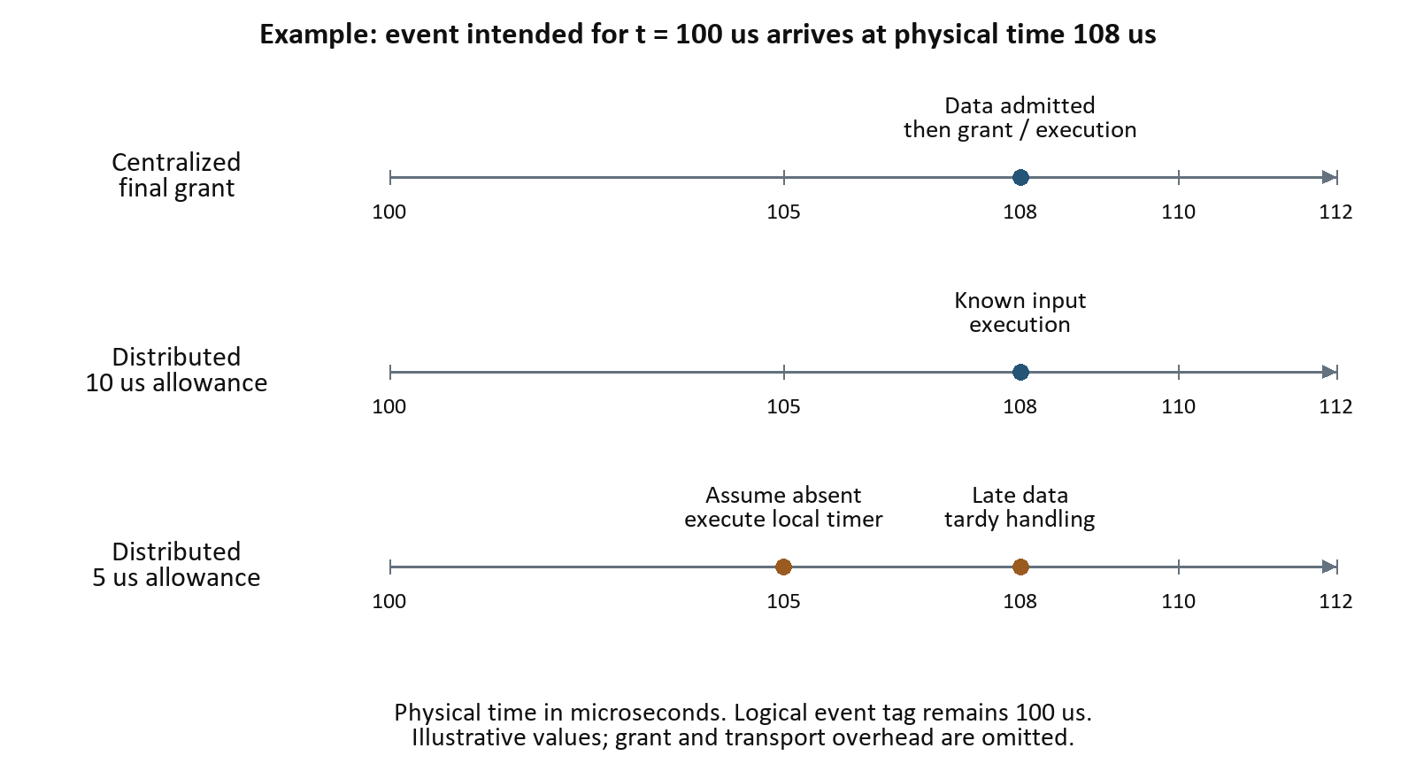
Figure 6. A delayed input distinguishes a conservative wait from a finite absence assumption. This is an illustrative experiment, not a measured performance result.
Consider a receiver with a local timer at logical time 100 us and one remote logical input relevant to that tag. The remote value arrives at physical time 108 us. The example assumes a coherent time reference, a supported tag representation and no microstep complication.
In the centralized case, the final permission is withheld until the required data/knowledge closure is satisfied. The receiver can then process the logical tag 100 us after physical arrival. Physical lateness has not changed the intended logical tag, although an application deadline may already have been missed.
In a decentralized case whose verified policy allows a 10 us waiting allowance, arrival at 108 us can satisfy knowledge before the illustrative deadline at 110 us. The receiver need not wait to the deadline once all required conditions are satisfied.
With a 5 us allowance, the engine may assume absence at physical time 105 us, if that is permitted by the policy. The timer reaction executes without the remote value. Arrival at 108 us is then tardy relative to that committed decision. This case demonstrates a contract change, not a faster equivalent execution.
If the engine has two unknown inputs, it must account for both input policies and their dependencies. A single global offset chosen from this example is insufficient. Include a delayed-input and an absence-input test, because receiving no message is not inherently evidence that an input is absent.

11 Reuse of LF Codesign and micro LF
Source | Centralized route | Decentralized route
reactor-chisel and Codesign | Reuse reactions, token protocols, execution gate and I/O adapters; adapt TAG/NET/LTC | Reuse execution and transport primitives; add a local admission policy
Conventional LF RTI and federated runtime | Reference grant safety, topology, completion, startup and relevant control messages | Reference supported local coordination semantics and late-data behavior
micro-LF/reactor-uc | Use bounded buffers and channel patterns where useful; no central policy to import | Reference per-input state, max_wait handling, input knowledge and scheduler transitions
Existing project HW-RTI | First authority for the verified initial scope | Comparison baseline and possible reusable arithmetic or RAM blocks

Reuse algorithms and contracts separately from reuse of source code. C and C++ runtime structs, mutexes and pointer-based queues are not Chisel modules. Their behavior can serve as a reference model; hardware requires explicit storage, ownership, arbitration and bounded capacity. Existing Chisel modules can be reused more directly, subject to version and semantic compatibility.
The reactor-uc federation header exposes per-input delay, type, last_known_tag, max_wait and payload_pool [11]. These identify candidate state for a local engine. They do not establish its scheduler decision function or prove correspondence between max_wait and newer source-language annotations. Preserve logical versus physical connection behavior and trace every knowledge update.
The event header retains intended_tag alongside scheduled event metadata [12]. This supports the design requirement to preserve intended logical identity for violation detection, even if an arrival is admitted after its intended execution frontier.

Corrections carried into both routes
NetworkChannel backends are transport alternatives rather than TCP emulation. Application payload serialization is distinct from protocol-envelope encoding; protobuf is not universally required for port values. Peer transport is not synonymous with decentralized advancement. A bounded wait is not proof that late input is impossible. These distinctions remain relevant even when all endpoints are hardware.

12 Common interface and implementation artifacts
Artifact | Required fields or decisions | Purpose
Source manifest | Compiler, runtime, submodule, board port and HW-RTI commits; tool versions | Reproducible baseline
Topology manifest | Participant and connection IDs, logical/physical type, delay, payload schema | Same configuration for both policies
Tag contract | Time width, microsteps, epoch, unit, sentinels, order and overflow | Remove incompatible scalar/pair interpretations
Event record proposal | Destination, intended tag, presence, payload handle/length, sequence and epoch | Atomic admission and owned payload lifetime
Progress/grant record proposal | Participant, event frontier, valid flags, grant kind and report version | Coherent authority and progress exchange
Transition model | State, guards, updates, failure paths and same-cycle priority | Reference for RTL and differential testing
Trace schema | Physical sample, participant, event tag, commit, execute, completion and violation | Explain mismatches and measure latency

These are contract outlines, not a frozen wire format or register map. Data structures need separate validity for no event and sentinel tags. Grant permissions and progress frontiers must retain their distinct meanings. The trace should distinguish a candidate query from execution and computation completion from transport commit.

Source incompatibilities to close
The inspected reactor-chisel Tag is a 32-bit UInt, whereas reaction registers and software conversions have different widths. Its NEVER and FOREVER construction and unsigned comparisons need review. No explicit microstep pair appears in that Tag definition. Resolve these differences before using LF tag comparators or accepting project HW-RTI tags [8].
The runtime baseline is d94dd2d272ce46145ac13c3c6a141bc2ba9dfca1. The compiler baseline is f60c83c5fbf0f0c26c780c28e58e50c0fc60a608, whose reactor-chisel submodule is 6c8aecd0211acc4c1e58d1cdd9ae950880a25204. Pin a matched combination from the working ZCU106 port rather than combining these observations as a proven build.

13 Implementation stages and acceptance gates
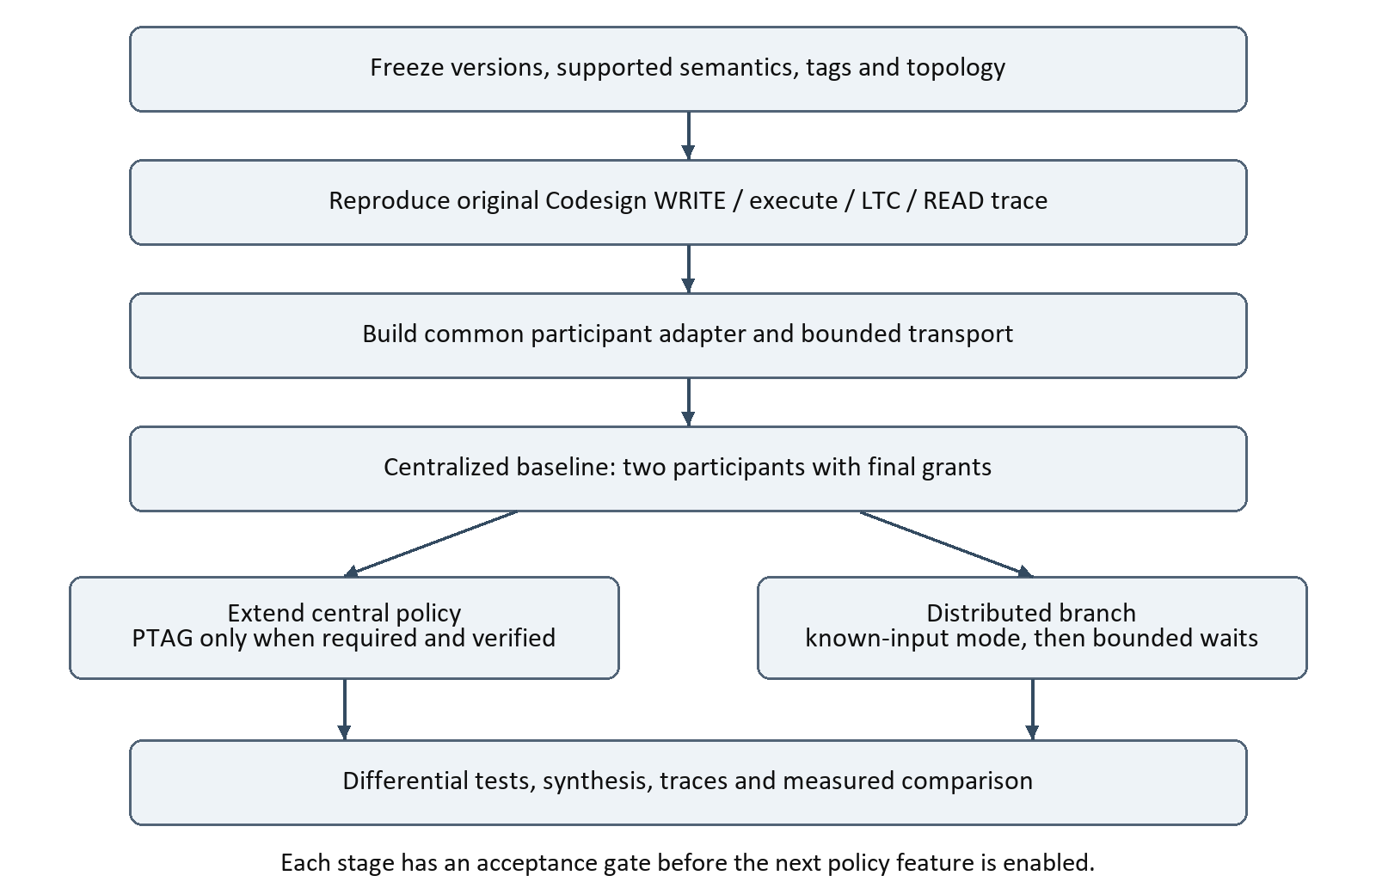
Figure 7. Recommended development sequence. Shared adapters and tests precede divergent policy work.
Stage | Deliverable | Acceptance gate
S0 | Matched source manifest and semantic subset | Working port reproduces the original example
S1 | Instrumented original Codesign trace | WRITE, execute, LTC and READ agree with expectations
S2 | Common participant adapter and bounded channels | Atomic admission, ownership and backpressure tests pass
S3 | Two-participant centralized baseline | Final grants and completion match the reference on the declared scope
S4 | Distributed known-input branch | No premature absence; live progress demonstrated on its scope
S5 | Bounded wait and later advanced grants | Timing assumptions, violations and policy semantics tested

Start with source/sink behavior, then add a join with two upstream inputs and a local timer. Positive-delay feedback can be a later case after its liveness argument is established. Do not activate PTAG or mixed-policy handover merely because the simpler trace passes.

14 Validation and the decision to distribute
Scenario | Centralized check | Distributed check
Delayed input | No premature final execution; data visibility ordered with grant | Known-input wait or deliberate timeout; correct tardy classification
Explicit absence | Absence/closure justifies the grant | Absence or progress information is committed before release
Multiple inputs | Grant does not bypass an unresolved dependency | All required input policies are evaluated
Same time and microsteps | Tag ordering and supported grant transitions | Knowledge and expiry handle the declared microstep rules
Multi-cycle reaction / DMA | LTC does not precede required output commit | Local completion and peer knowledge remain ordered
Full buffers / stalled peer | Correct backpressure; no false progress | No silent loss; configured waiting/violation behavior
Reset and boundary arrival | Epoch protection and defined update priority | Atomic timeout/arrival decision and intended-tag retention

Use a reference transition model and compare logical traces rather than demanding equal clock-cycle timing from different policies. Where finite waiting changes behavior intentionally, compare each trace against its own declared contract and report violations. Never count a timeout-driven omission as an equivalent throughput improvement.
Measure event-to-execution latency, physical lag, coordination traffic, queue occupancy, wait time, tardy count, sustained throughput, logic/RAM usage and timing closure. Record where coordinator arbitration or local policy scanning is the bottleneck. Use identical reaction computation, topology and channel capacity when comparing policies; isolate deliberate timing-policy differences.

Decision gate
Proceed toward distributed coordination when the central baseline is semantically stable and measurements or deployment requirements justify removing per-tag central dependence. Confirm that needed timing bounds are defensible, the local knowledge protocol is complete, and the application has an acceptable response to late or missing data. If these conditions are absent, central coordination remains the more defensible baseline for this project.
For this ZCU106 effort, the first milestone is a verified central federation of two hardware participants. The second milestone is a local known-input policy using the same infrastructure. The third is a measured, explicitly bounded distributed experiment. This order maximizes reuse and provides a clear reference when the two policies differ.

15 Source map and references
[1] TriggerGenerator.scala
CoordinationIO; scheduler wiring at lines 123–131; repeated-tag assertion at lines 135–137.
[2] Scheduler.scala
SchedulerIO, readiness predicates, grant restriction and execution state machine.
[3] CodesignTopReactor.scala
LtcHandler at line 76; top at 126; validity at 175; TopLevelPorts at 220; array output completion at 623.
[4] Reaction.scala
reactionDone and reactionEnable; reactionMain and output-token publication.
[5] Reactor.scala
isIdle implementation and reactorMain.
[6] CodesignFpgaWrapperTransformation.java
Main wrapper generation; TAG and WRITE at 408–410; LTC polling at 412; READ and NET at 421–428.
[7] CodesignSwEmitter.kt
Cpp target selection and generated software project.
[8] Tag.scala
Scalar hardware Tag type, width and sentinels.
[9] LF distributed execution documentation
Nightly reference for centralized/decentralized coordination and micro-LF differences. Documentation semantics require commit alignment.
[10] LF 0 8 distributed execution documentation
Earlier STP-offset description; retained to explain terminology evolution, not as the new hardware policy.
[11] reactor uc federated connection header
Per-input connection state and serializer/deserializer interfaces; generated API is not a pinned implementation.
[12] reactor uc event header
Event metadata, intended_tag and payload pools.
Source inspection and documentation access: 8 October 2026. The existing HW-RTI implementation and the ZCU106 port are project context, not audited source in this note. Proposed architectures and flowcharts must be checked against their exact contracts before RTL implementation.

