(1)PROGRAM : SOLID RECTANGLE PATTERN

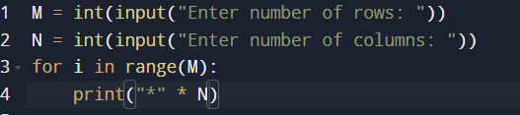

OUTPUT :

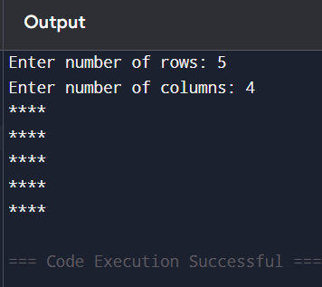

(2)PROGRAM : RIGHT - ANGLED TRIANGLE PATERN

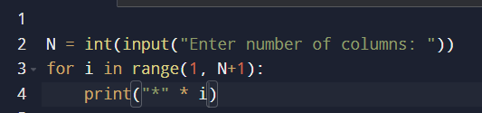

OUTPUT :

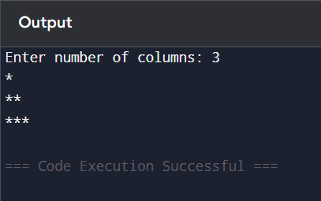

(3)PROGRAM : INVERTED RIGHT-ANGLED TRIANGLE

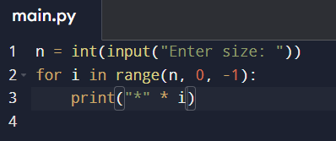

OUTPUT :

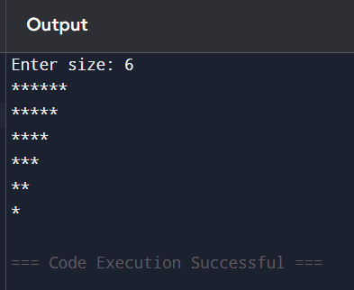

(4)PROGRAM : SQUARE PATTERN

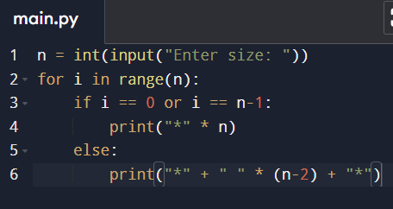

OUTPUT :

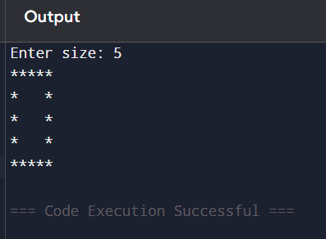

(5)PROGRAM : HEXAGON PATTERN

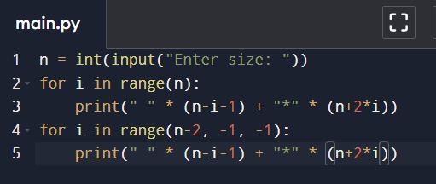

OUTPUT :

