**PREPINSTA TOP 100 CODES – 21/8/25**

(1)PROGRAM : Fibonacciseriesuptonth term

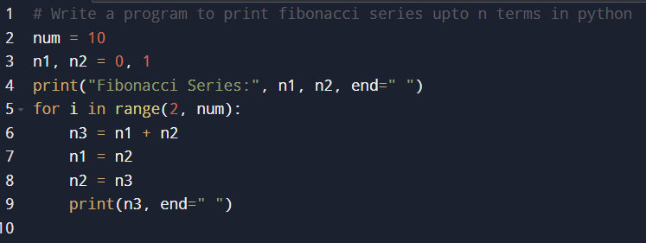

OUTPUT :

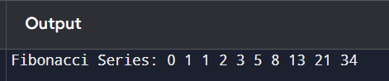

(2)PROGRAM : Find thenth term of theFibonacci series

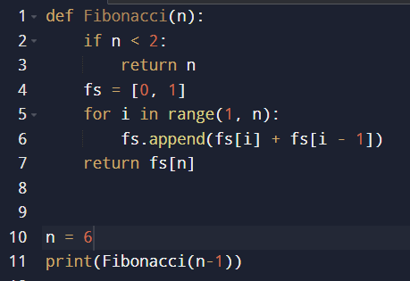

OUTPUT :



(3)PROGRAM : Factorial of a number

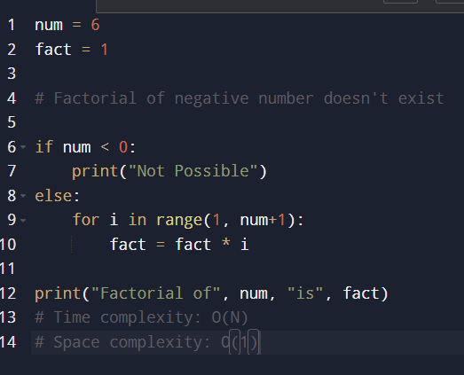

OUTPUT :

