**PREPINSTA TOP 100 CODES – 22-8-25**

(1)PROGRAM : POWER OF A NUMBER

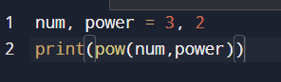

OUTPUT :

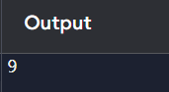

(2)PROGRAM : FACTOR OF A NUMBER

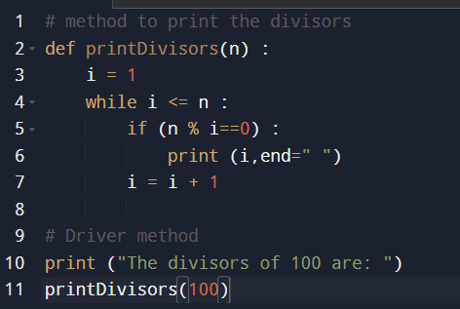

OUTPUT :

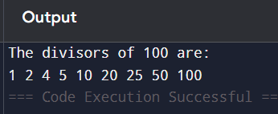

(3)PROGRAM : FINDING PRIME FACTOR OF A NUMBER

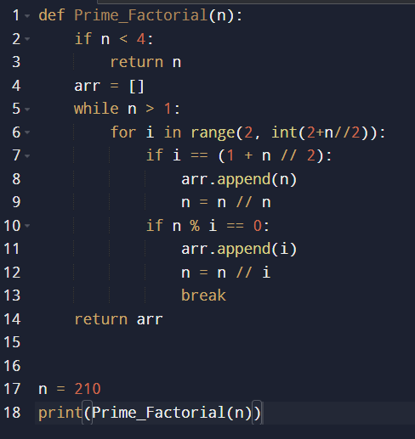

OUTPUT :

