**PREPINSTA TOP 100 CODES – 23-8-25**

(1)PROGRAM – STRONG NUMBER

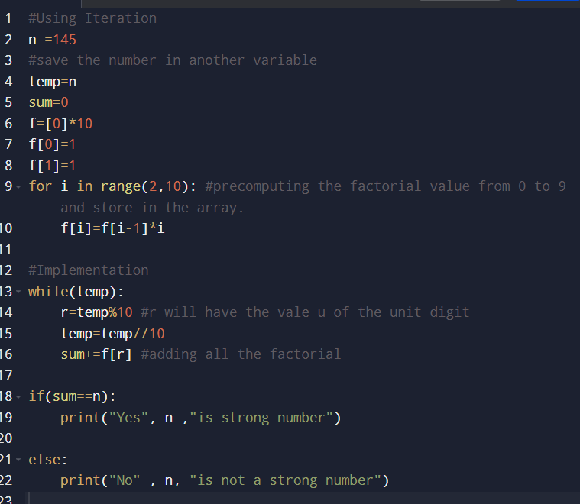

OUTPUT :

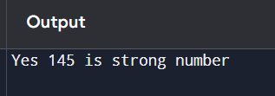

(2)PROGRAM : PERFECT NUMBER

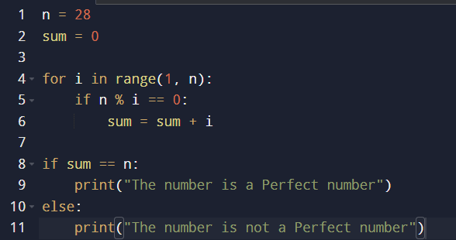

OUTPUT :

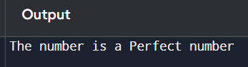

(3)PROGRAM : PERFECT SQUARE

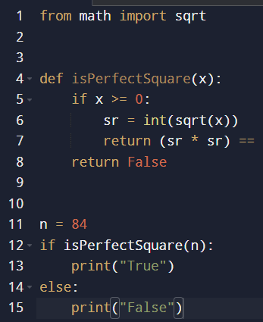

OUTPUT :

