(1)PROGRAM : AUTOMORPHIC NUMBER

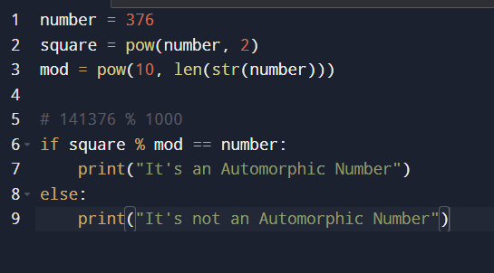

OUTPUT :

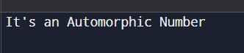

(2)PROGRAM : HARSHAD NUMBER

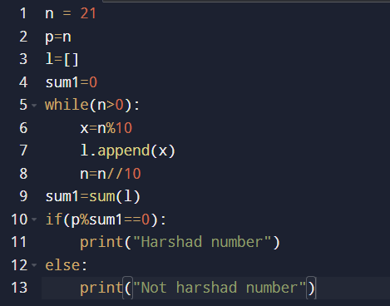

OUTPUT :

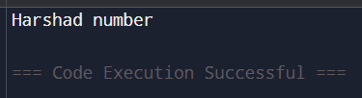

(3)PROGRAM : ABUNDANT NUMBER

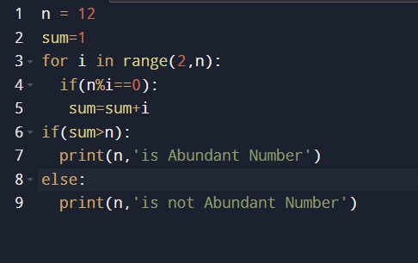

OUTPUT :

