(1)PROGRAM : FRIENDLY PAIR

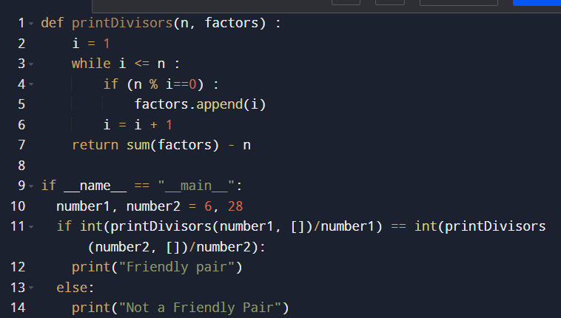

OUTPUT :

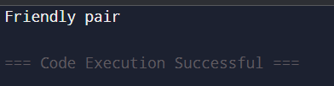

(2)PROGRAM : HIGHEST COMMON FACTOR (HCF)

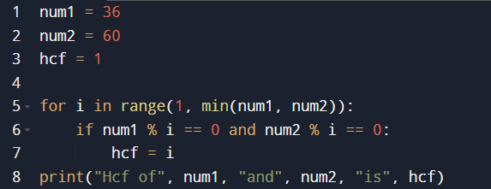

OUTPUT :

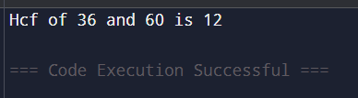

(3)PROGRAM : LOWEST COMMON MULTIPLE

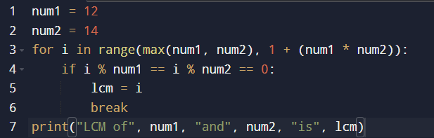

OUTPUT :

