(1)PROGRAM : FACTORIAL

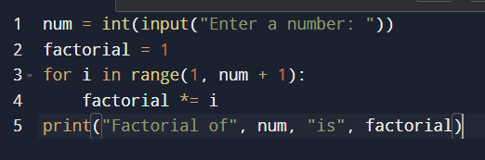

OUTPUT :

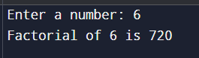

(2)PROGRAM : FACTOR OF A NUMBER

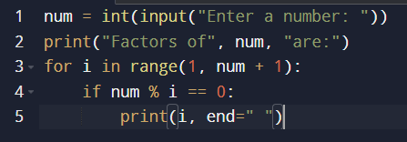

OUTPUT :

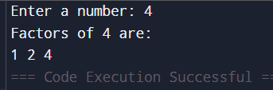

(3)PROGRAM : PERFECT NUMBER

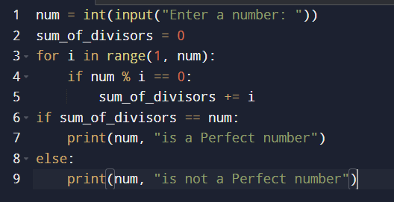

OUTPUT :

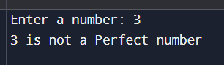

(4)PROGRAM : PERFECT SQUARE

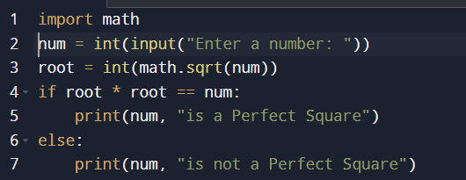

OUTPUT :

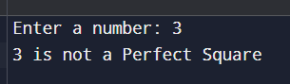

(5)PROGRAM : HARSHAD NUMBER

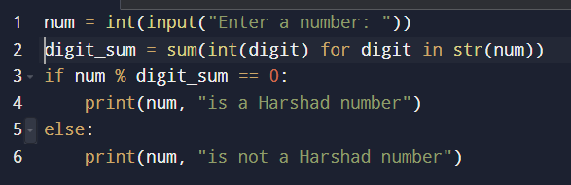

OUTPUT :

