(1)PROGRAM : FRIENDLY PAIR

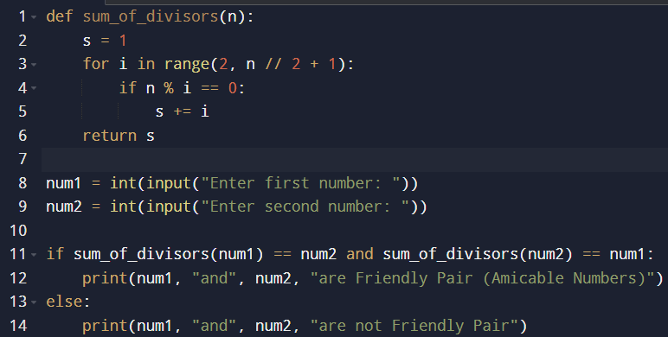

OUTPUT :

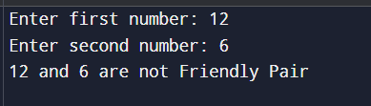

(2)PROGRAM : ABUNDANT NUMBER

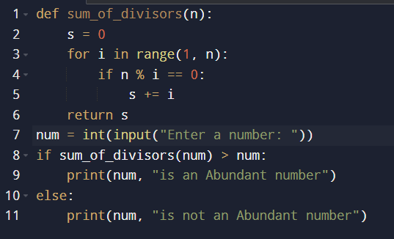

OUTPUT :

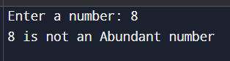

(3)PROGRAM : STRONG NUMBER

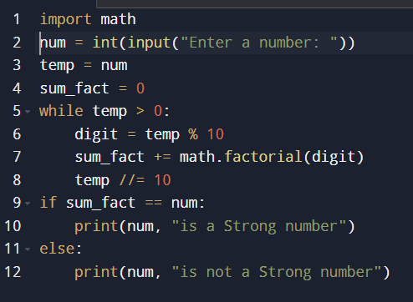

OUTPUT :

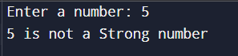

(4)PROGRAM : AUTOMORPHIC NUMBER

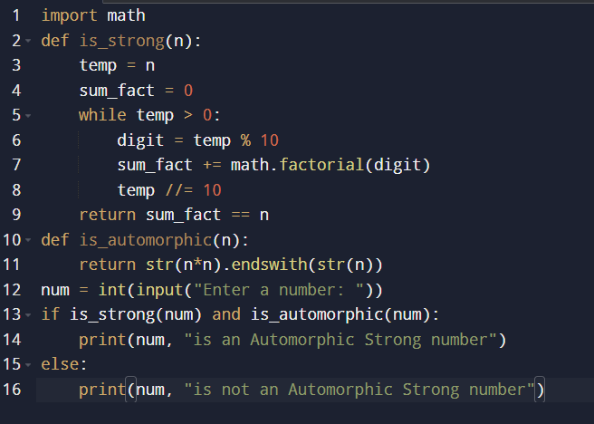

OUTPUT :

