Perla Garcia Cavazos
Module 1.2 Assignment
6/5/2026

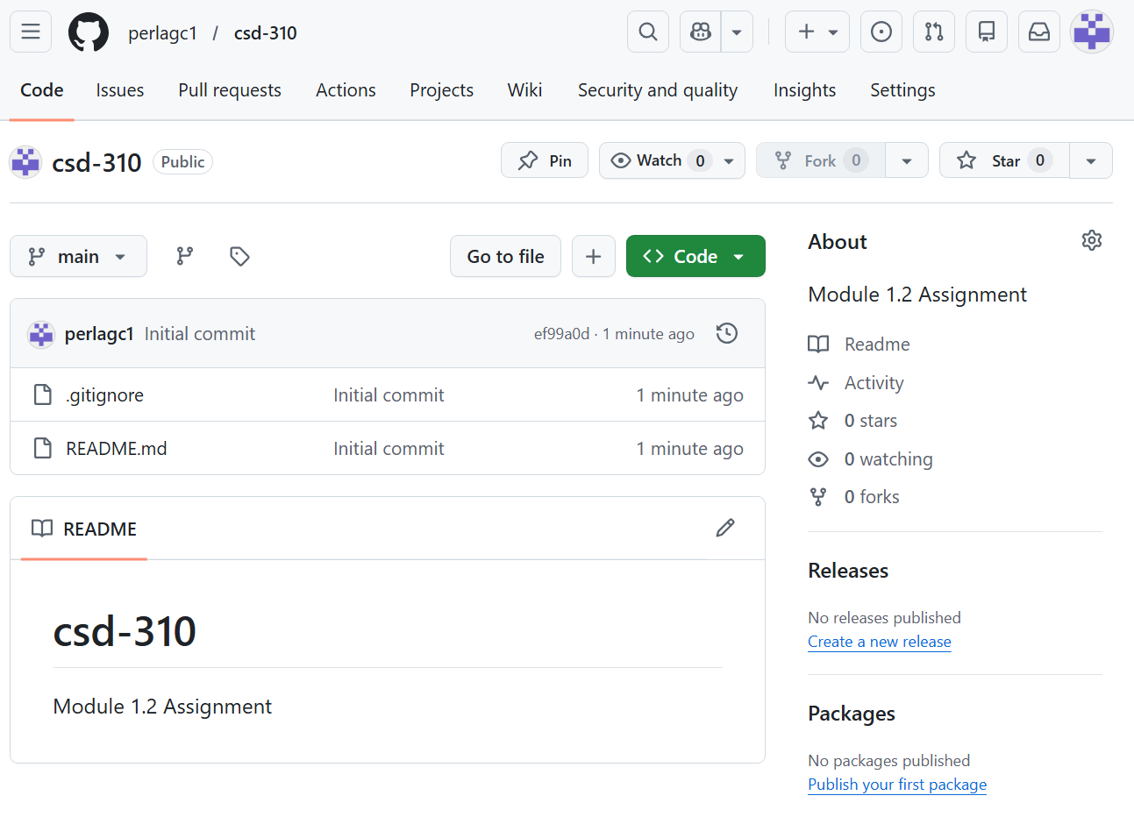

PS C:\csd> git clone https://github.com/perlagc1/csd-310.git
Cloning into 'csd-310'...
remote: Enumerating objects: 4, done.
remote: Counting objects: 100% (4/4), done.
remote: Compressing objects: 100% (3/3), done.
remote: Total 4 (delta 0), reused 0 (delta 0), pack-reused 0 (from 0)
Receiving objects: 100% (4/4), done.
PS C:\csd> dir

Directory: C:\csd

Mode LastWriteTime Length Name
---- ------------- ------ ----
d----- 6/5/2026 8:55 PM csd-310

PS C:\csd>

PS C:\csd> cd csd-310
PS C:\csd\csd-310> mkdir module-1

Directory: C:\csd\csd-310

Mode LastWriteTime Length Name
---- ------------- ------ ----
d----- 6/5/2026 8:57 PM module-1

PS C:\csd\csd-310> dir

Directory: C:\csd\csd-310

Mode LastWriteTime Length Name
---- ------------- ------ ----
d----- 6/5/2026 8:57 PM module-1
-a---- 6/5/2026 8:55 PM 4846 .gitignore
-a---- 6/5/2026 8:55 PM 34 README.md

PS C:\csd\csd-310>
Directory: C:\csd\csd-310

module-1
.gitignore
README.md
perlagc1/csd-310: Module 1.2 Assignment

