Group Name: Alpha
Group Members:
Perla Garcia Cavazos
Dallas Baldwin
Jose Rodriguez
Orlando Camacho
Kristian Wareing

Case Study Selected: Bacchus Winery
7/19/2026
Module 9.1
Assignment: Milestone #2

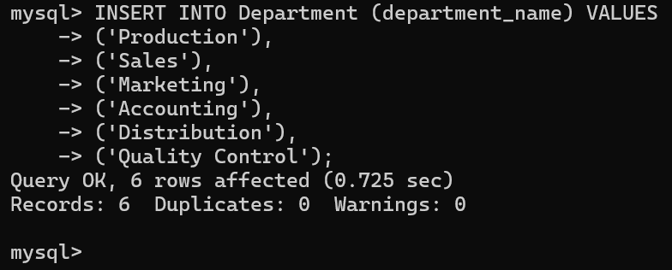
Screenshot 1: Successful Department table insert — 6 rows added.
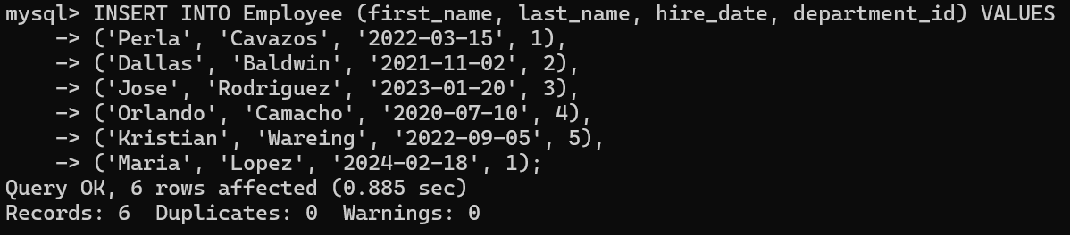
Screenshot: Employee table successfully populated with 6 records using valid department IDs.
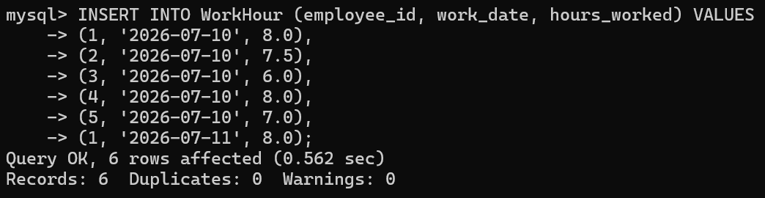
Screenshot: Work Hour table successfully populated with 6 records linked to existing employees.

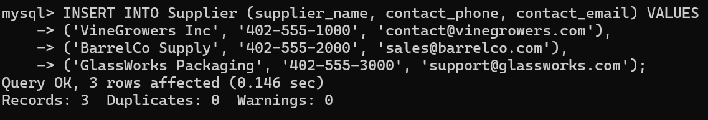
Screenshot: Supplier table successfully populated with 3 records as required by the case study.

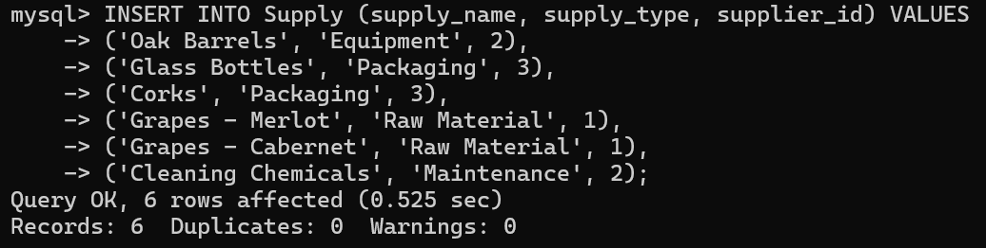
Screenshot: Supply table successfully populated with 6 records linked to valid suppliers.

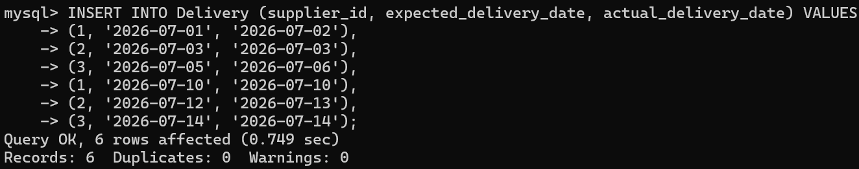
Screenshot: Delivery table successfully populated with 6 delivery records showing expected and actual dates.

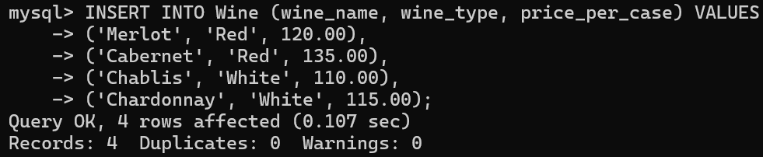
Screenshot: Wine table successfully populated with 4 wine records as specified in the case study.

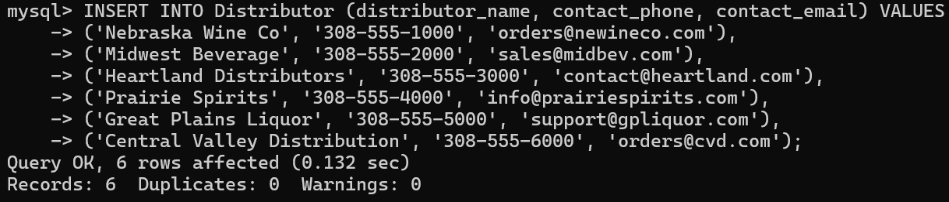
Screenshot: Distributor table successfully populated with 6 distributor records.

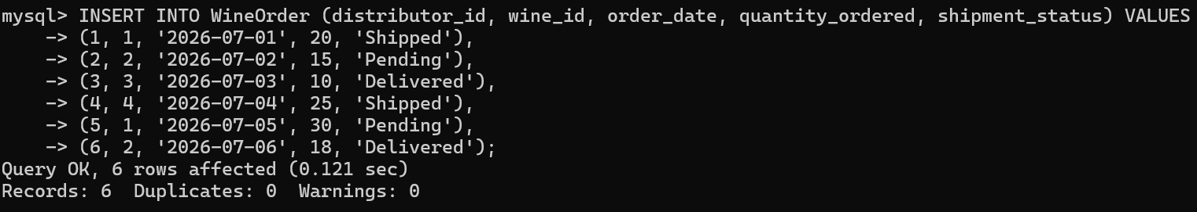
Screenshot: Wine Order table successfully populated with 6 records linking distributors and wines.

