Perla Garcia Cavazos
CSD-325 – Module 3
Brownfield + Flowchart(s)
Date: June 17, 2026

This assignment demonstrates the flow of execution for the chohan.py program and the modifications made to meet the new requirements. The flowchart models the logic of dice rolls, bonus conditions, and house percentage calculations.

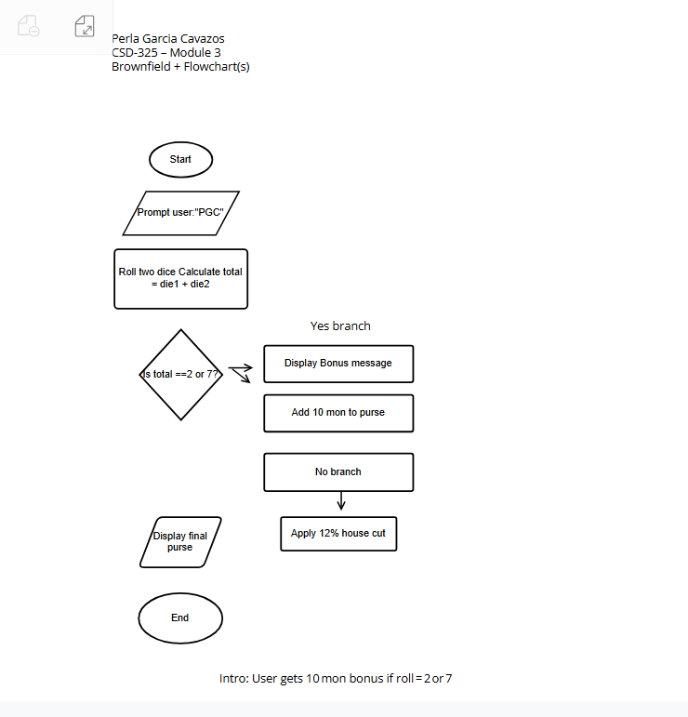
Figure 1: Flowchart for chohan_pgc.py

- Changed input prompt to “PGC:”
- Updated house percentage to 12 %
- Added bonus rule for dice total = 2 or 7
- Added message and bonus addition to purse
- Documented all changes in comments
This exercise helped reinforce understanding of program flow and conditional logic. Creating the flowchart clarified how each decision affects the final output.

