Perla Garcia Cavazos
Module 2 Debugging Assignment
6/14/2026

result = add_numbers(x, y)
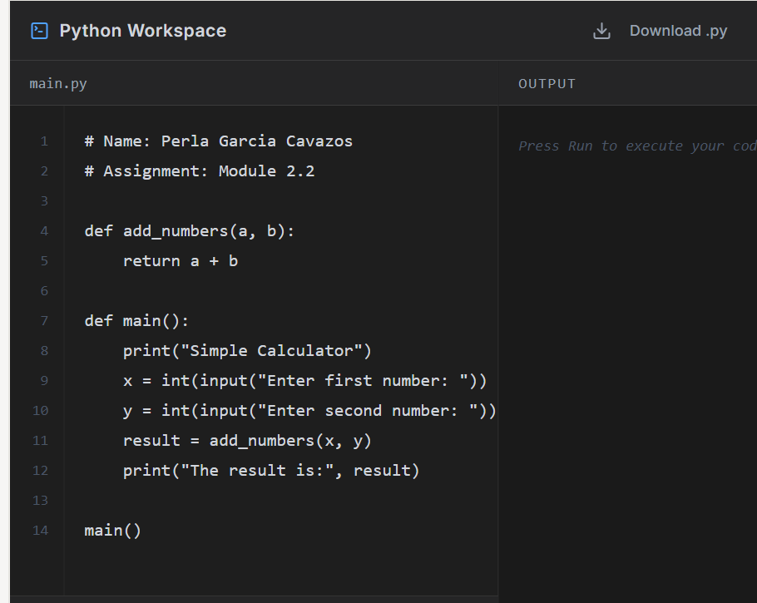

def add_numbers(a, b):
return a + b

def main():
print("Simple Calculator")
x = int(input("Enter first number: "))
y = int(input("Enter second number: "))
result = add_numbers(x, y)
print("The result is:", result)

main()
Module2-Flowchart
- 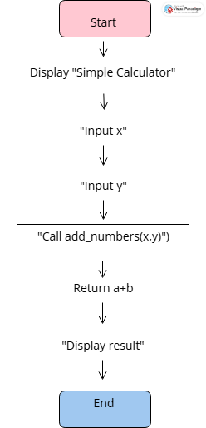“Flowchart illustrating the logic of a simple calculator program using a function.”

