Perla Garcia Cavazos
Module 1.3 Assignment
Assignment: Building a Web Page Exercise, Part 1
8/16/2026

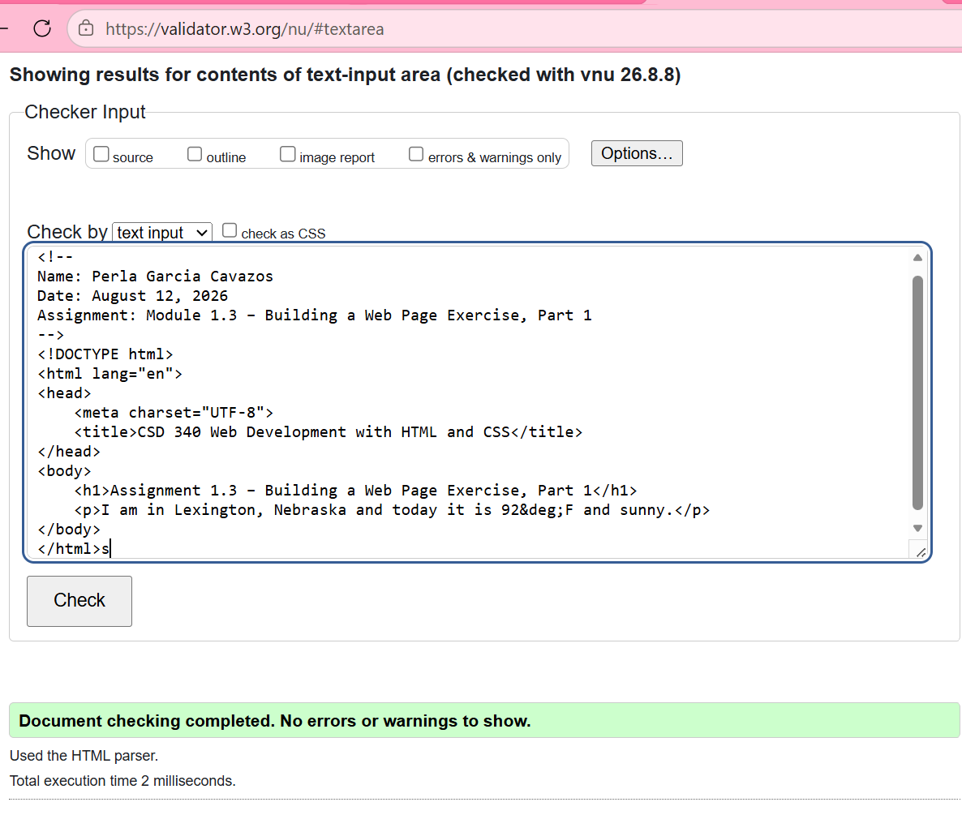
“Created and switched to the main branch.”

“Committed Module 1.3 assignment files.”
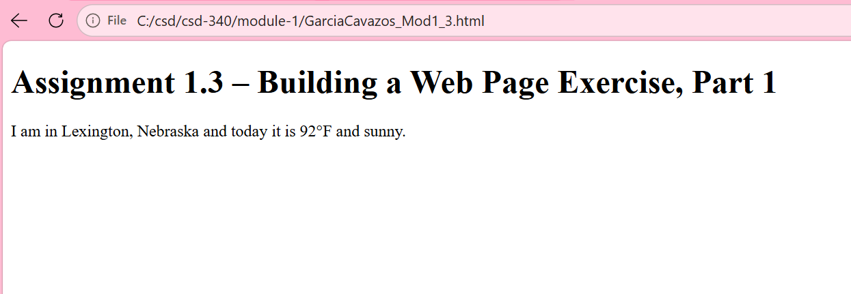
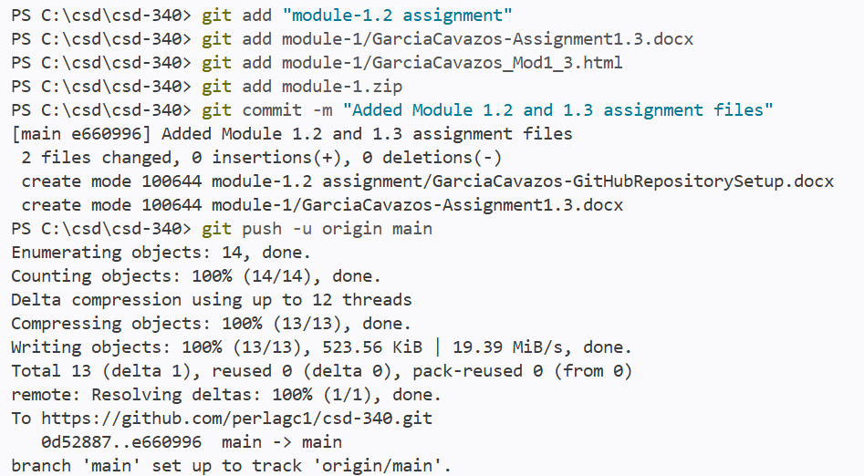
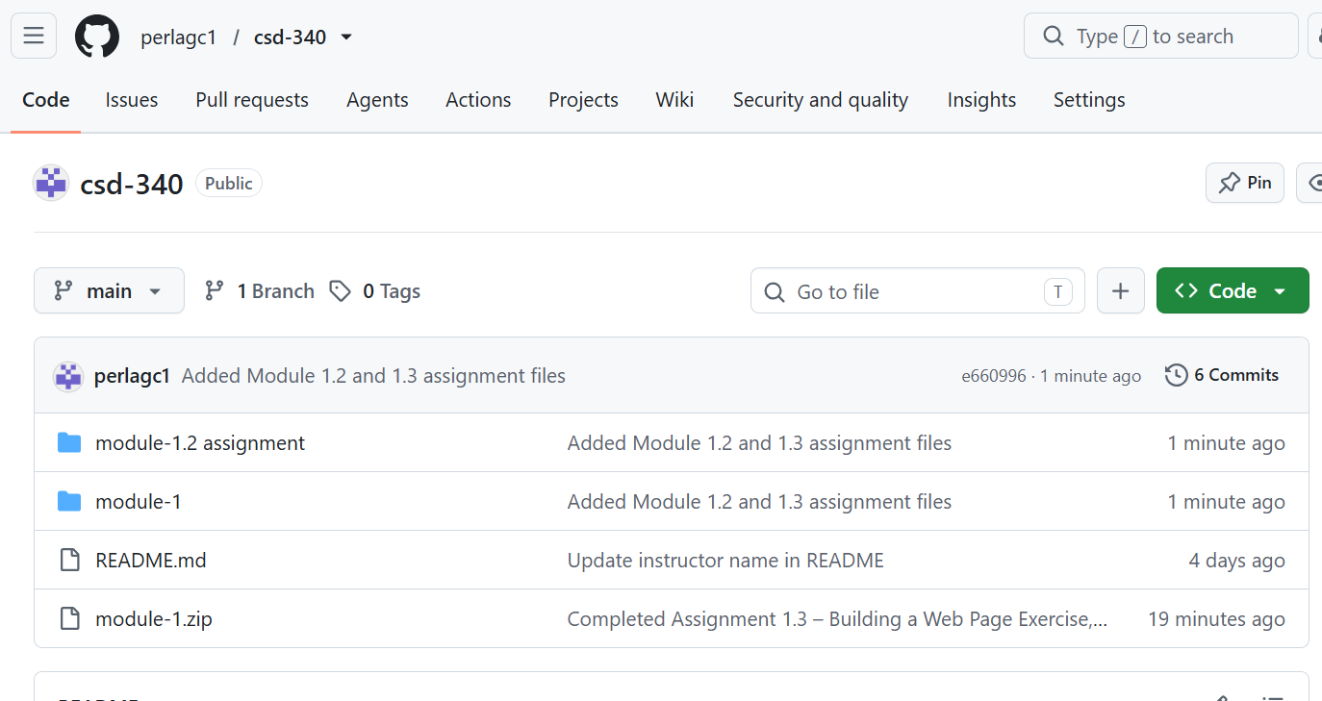
“Successfully pushed to GitHub repository.”

