Perla Garcia Cavazos
Module 3.3 Assignment
Assignment: Build a Webpage Exercise, Part 3
8/19/2026

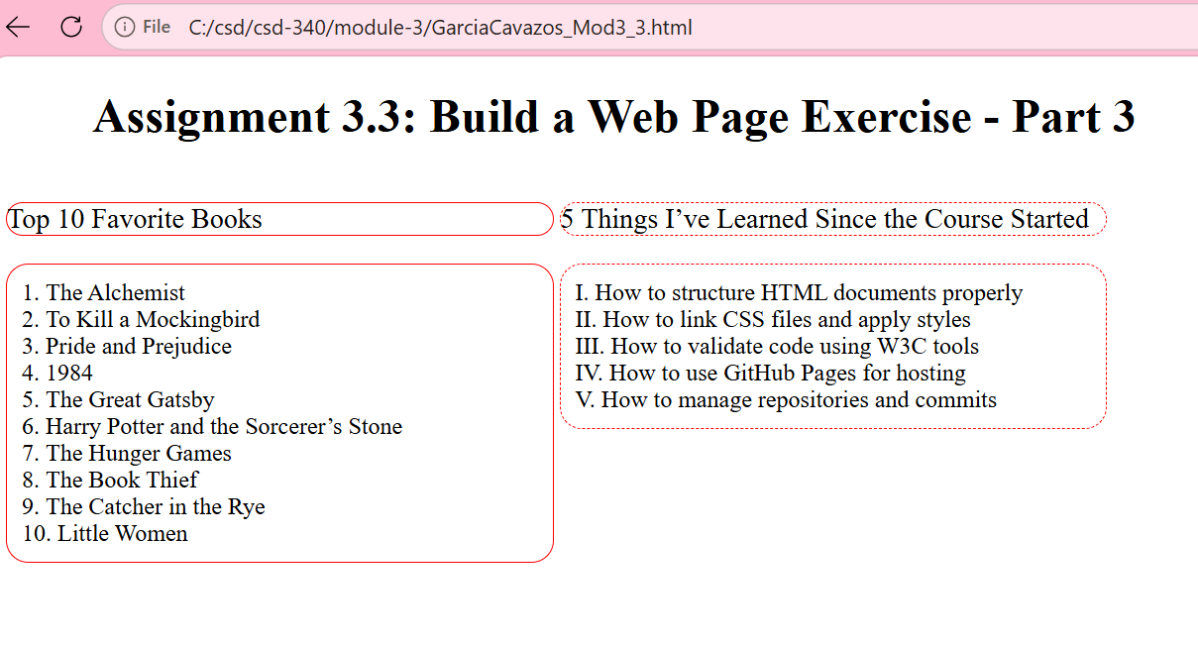This screenshot shows my HTML code being checked using the W3C Nu HTML Validator. It confirms that my webpage structure follows proper syntax and accessibility standards. Running this validation helped me identify and fix heading hierarchy issues before finalizing the page.

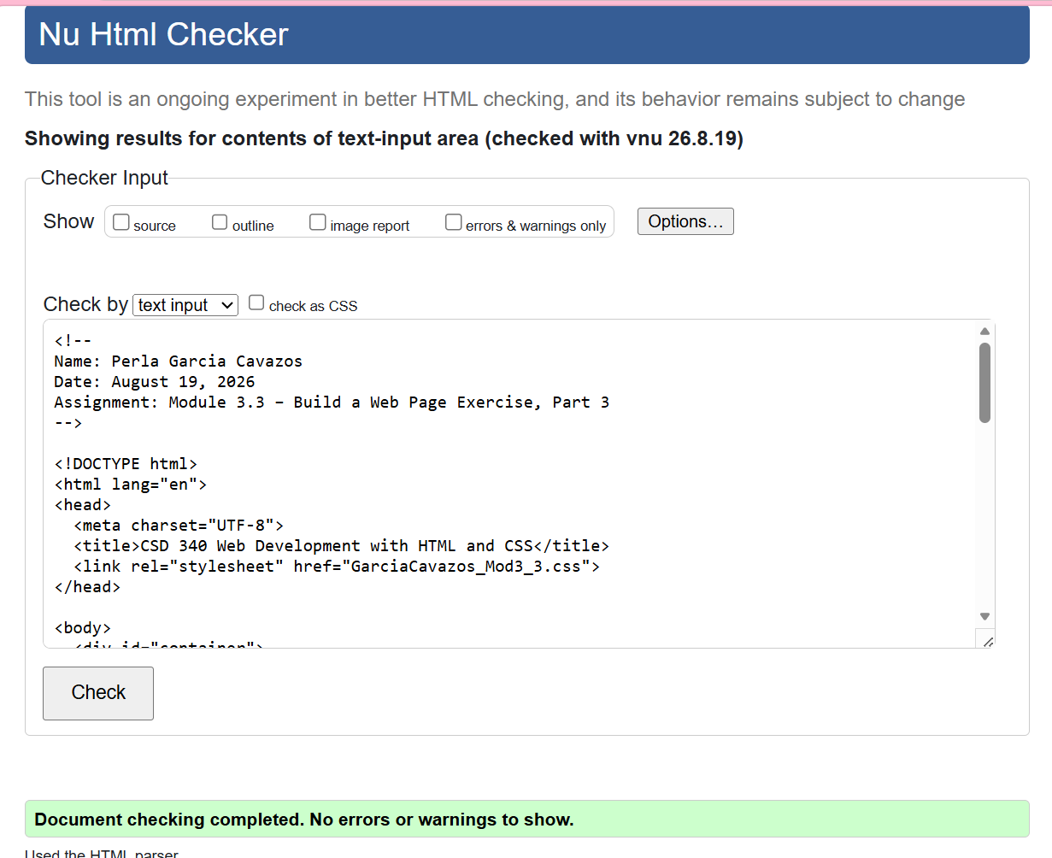This screenshot shows the final validation of my HTML code using the W3C Nu HTML Checker. The results confirm that my webpage is free of errors and warnings, meaning the structure and syntax follow proper web standards. This step ensures my HTML is clean, accessible, and ready for publishing.

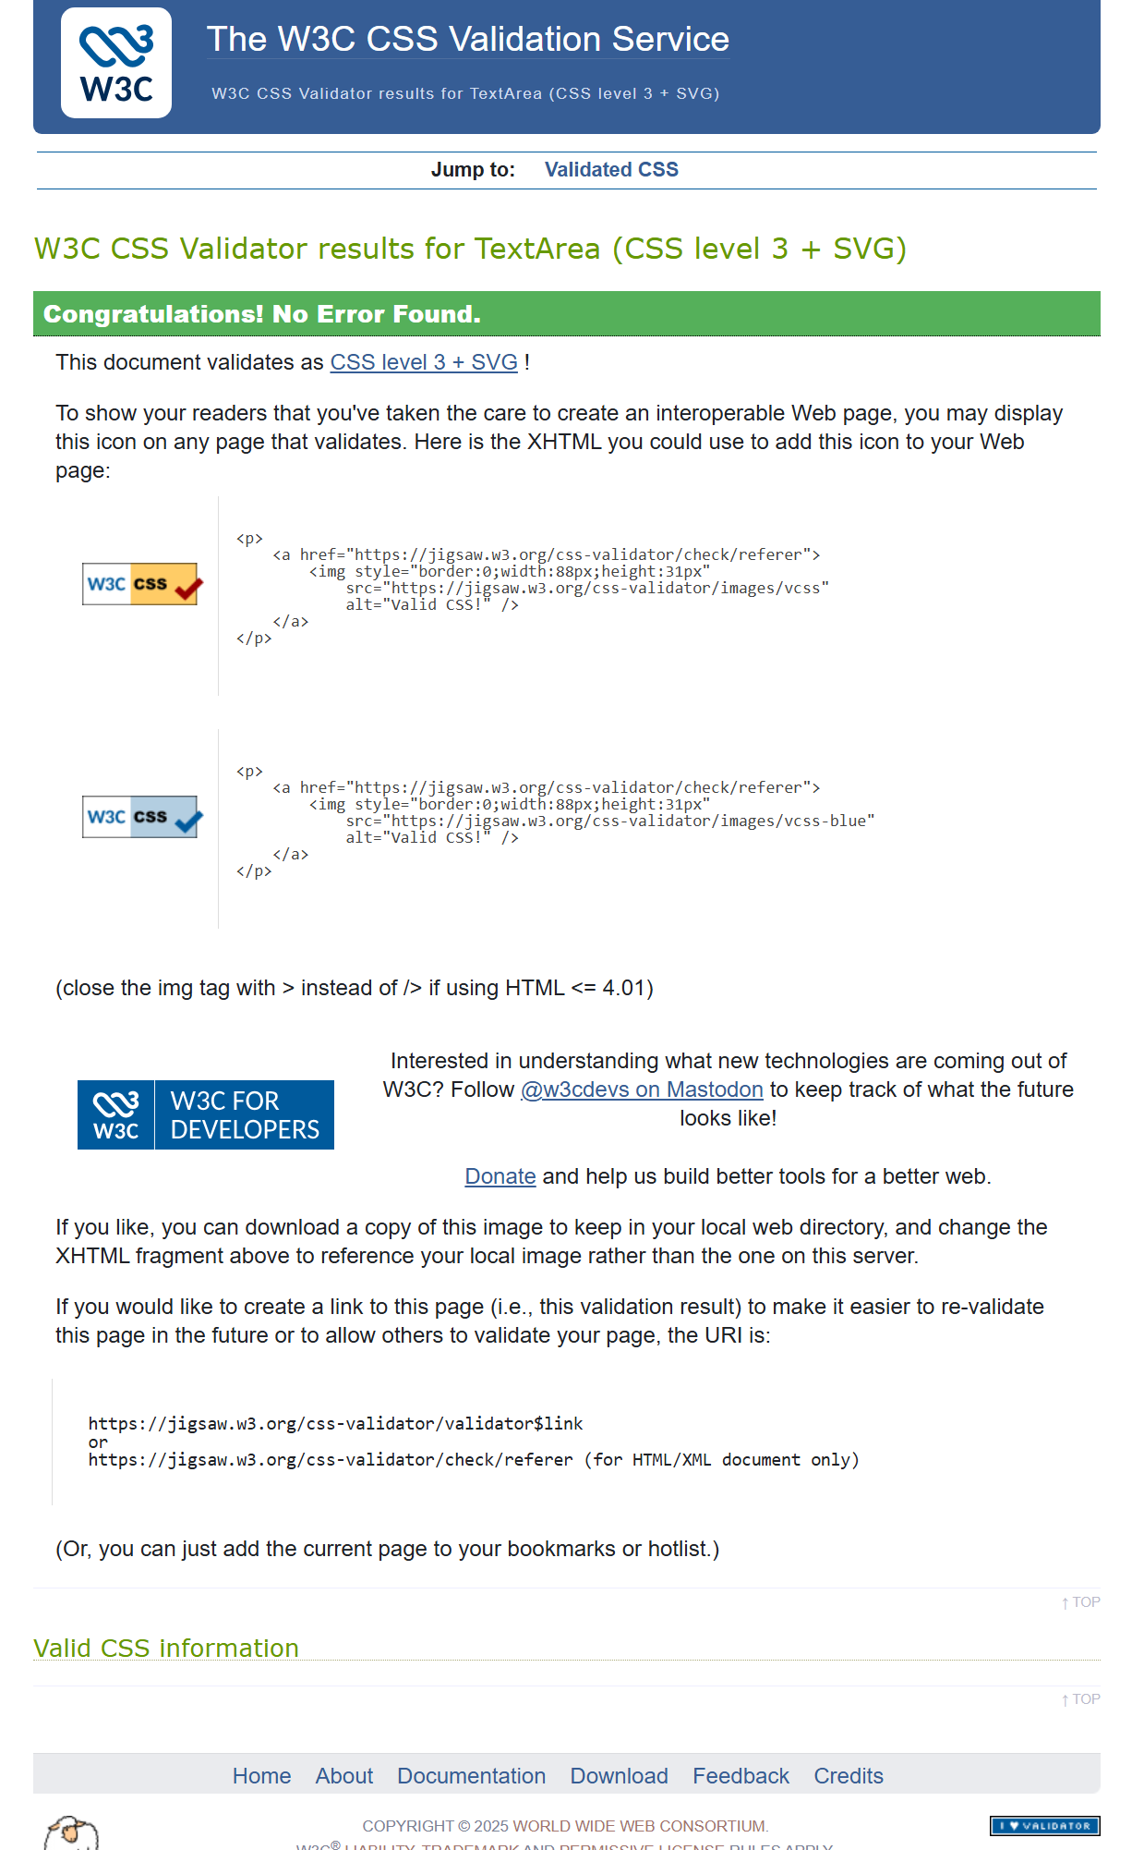This screenshot displays the results from the W3C CSS Validator, confirming that my stylesheet passed with no errors. It is validated as CSS Level 3 + SVG, meaning all my styles follow modern web standards. This step ensures my webpage’s design is consistent, accessible, and compatible across browsers.
Completing this assignment helped me understand how HTML and CSS work together to build structured, visually appealing webpages. Validating my code taught me the importance of clean syntax and accessibility standards. This project strengthened my confidence in creating professional web pages that meet modern web development practices.
