Sensor Monitoring System
Complete Technical Architecture Document
Version 2.0 | July 2026 — Updated with API Gateway & Circuit Breaker

1. System Overview
The Sensor Monitoring System is a production-grade, event-driven IoT platform built with Spring Boot microservices. It demonstrates industry-standard patterns including centralized API Gateway routing, JWT-based security, client-side and gateway-level resilience via circuit breakers, asynchronous messaging via Apache Kafka, synchronous service-to-service communication via OpenFeign, and shared cross-cutting concerns through a common library.
The platform is fully containerised via Docker Compose, making it deployable without any locally installed JDK or Maven.
UPDATED: An api-gateway (Spring Cloud Gateway) has been introduced as the single entry point for all client traffic on port 8080, and Resilience4j Circuit Breakers now protect every Gateway route as well as the sensor-service → device-service Feign call.

2. High-Level Architecture

2.1 Service Topology
The system is composed of five deployable units and three infrastructure components:
Service / Component | Port | Primary Responsibility | Key Dependencies
api-gateway | 8080 | Single entry point for all clients. Routes requests by path to auth-service, device-service, and sensor-service. Pre-validates JWTs and wraps every route in a Resilience4j Circuit Breaker with a fallback response. | Spring Cloud Gateway, common-lib (JwtUtil, Resilience4j config), auth-service, device-service, sensor-service
auth-service | 8081 | Authenticates demo credentials (admin/admin123) and issues signed HS256 JWT tokens valid for 1 hour. | common-lib (JwtUtil)
device-service | 8082 | Full CRUD for physical IoT device registry. Devices have a code, name, location, and lifecycle status. | PostgreSQL, common-lib
sensor-service | 8083 | Scheduler polls device-service every 10s (via a circuit-breaker-wrapped Feign call); generates temperature readings; publishes to Kafka; consumes events and persists them; raises CRITICAL alerts. | PostgreSQL, Kafka, device-service (Feign + Resilience4j CB), common-lib
common-lib | (library) | Shared JWT filter, rate-limiting filter, Resilience4j circuit-breaker configuration, SensorEvent DTO, AlertLevel enum, and custom exceptions. | (none — zero external runtime deps)
PostgreSQL 16 | 5432 | Relational persistence for devices and sensor_readings tables. Schema managed by Hibernate DDL auto. | (infrastructure)
Apache Kafka 7.5 (KRaft) | 9092 / 29092 | Durable async message bus. Two topics: sensor-readings and sensor-alerts. KRaft mode — no ZooKeeper. | (infrastructure)
Kafka UI | 8089 | Web dashboard to browse topics, partitions, messages, and consumer group lag in real time. | Kafka

2.2 Communication Patterns
Pattern | Type | Mechanism | Purpose
Client entry | Synchronous | HTTPS → api-gateway (Spring Cloud Gateway) route, wrapped in a Resilience4j Circuit Breaker | Single entry point for all clients; centralizes routing, JWT pre-validation, and resilience.
Device list fetch | Synchronous | OpenFeign client (HTTP GET), wrapped in the deviceClientCB Circuit Breaker | sensor-service retrieves active devices from device-service before generating readings, with a fallback if device-service is unavailable.
Reading pipeline | Asynchronous | Kafka producer → topic: sensor-readings → Kafka consumer | Decouples reading generation from persistence; enables replay and fan-out.
Alert pipeline | Asynchronous | Kafka producer → topic: sensor-alerts → Kafka consumer | Publishes only CRITICAL-level events for separate alert handling.
Security enforcement | Filter chain | Gateway JWT pre-check + JwtAuthenticationFilter + RateLimitingFilter (common-lib) | Every inbound HTTP request is validated once at the Gateway and again at the downstream service (defense in depth), rate-limited (20 req/s/IP) and JWT-validated before reaching a controller.

2.3 Updated Architecture Diagram
The diagram below reflects the current topology, including the API Gateway as the single entry point and the Resilience4j Circuit Breakers guarding Gateway routes and the sensor-service → device-service call.
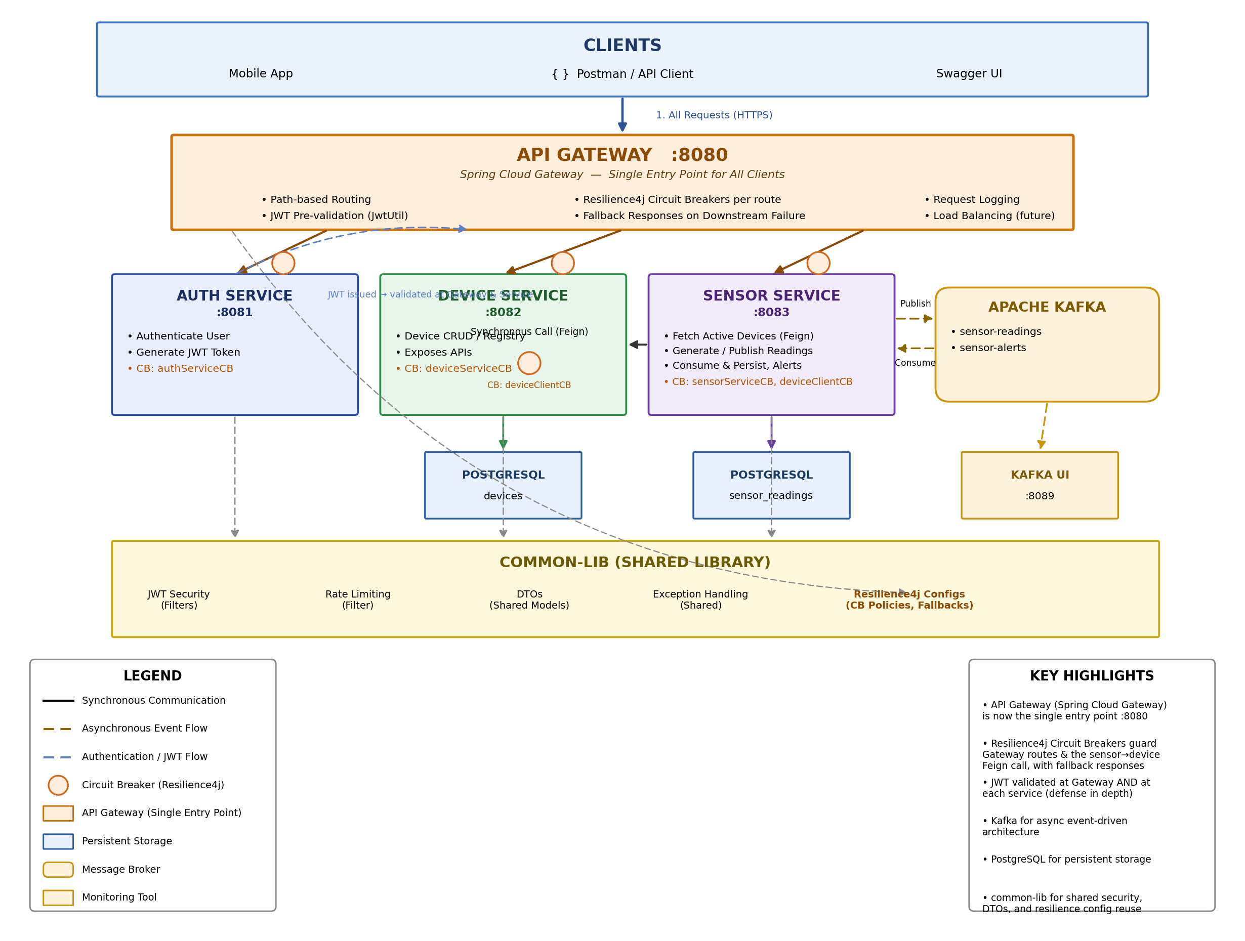

3. Component Deep-Dive

3.1 api-gateway (Port 8080) — NEW
The api-gateway is built on Spring Cloud Gateway and is now the single entry point for every client (mobile app, Postman/API clients, Swagger UI). It replaces direct client calls to 8081/8082/8083 for external traffic; those ports remain open for internal service-to-service calls and local debugging.
Responsibilities:
- Path-based routing — forwards /api/v1/auth/** to auth-service, /api/v1/devices/** to device-service, and /api/v1/sensors/** to sensor-service.
- JWT pre-validation — reuses JwtUtil from common-lib to reject malformed/expired tokens early, before a request reaches a downstream service.
- Circuit breaking — every route is wrapped in a Resilience4j Circuit Breaker (authServiceCB, deviceServiceCB, sensorServiceCB); when a downstream service is failing or slow, the breaker opens and the Gateway returns a fallback response instead of hanging or cascading the failure back to the client.
- Centralized request logging for all inbound traffic.
PLANNED: Load balancing and rate limiting at the Gateway layer are natural next steps (Spring Cloud Gateway supports both), but are not yet enabled in this iteration — rate limiting still runs per-service via common-lib's RateLimitingFilter.

3.2 auth-service (Port 8081)
The auth-service acts as a lightweight identity provider. It does not persist users — credentials are hardcoded for the POC phase (admin / admin123). The service delegates all cryptographic operations to JwtUtil from common-lib, producing HMAC-SHA256 signed tokens.
Key class: AuthService — validates credentials and calls JwtUtil.generateToken(), embedding the username as the subject claim. Tokens expire after 3,600,000 ms (1 hour).
Endpoint: POST /api/v1/auth/login — accepts JSON body { username, password }; returns { token }. Reached via the Gateway at api-gateway:8080/api/v1/auth/login, proxied to auth-service:8081.

3.3 device-service (Port 8082)
The device-service owns the canonical registry of IoT sensor devices. It exposes a full REST API and persists data to the devices table in PostgreSQL via Spring Data JPA.
Device model fields: id (UUID, auto-generated), deviceCode (unique, business key), name, location, status (ACTIVE | INACTIVE | MAINTENANCE), createdAt, updatedAt.
Security posture: All mutating operations (POST, PUT, DELETE) require a valid Bearer JWT. GET endpoints are permitted without authentication to allow the sensor-service Feign client to list active devices without re-authenticating.
UPDATED: Calls into device-service — whether from the Gateway (deviceServiceCB) or from sensor-service's Feign client (deviceClientCB) — are now circuit-breaker protected. See Section 7 for configuration details.

3.4 sensor-service (Port 8083)
The sensor-service is the system's data processing hub. It has four responsibilities:
- Simulation — SensorDataScheduler fires every SENSOR_INTERVAL_MS (default 10,000 ms). It calls DeviceClient.getActiveDevices() via a circuit-breaker-wrapped Feign client (deviceClientCB), then passes each device to SensorReadingService.triggerManualReading(). If the breaker is OPEN, a fallback (empty device list, logged as degraded mode) is returned instead of blocking the scheduler.
- Production — SensorEventProducer.publishReading() sends a SensorEvent JSON payload keyed by deviceCode to the sensor-readings topic.
- Consumption — SensorEventConsumer listens to sensor-readings (group sensor-monitoring-group). Each received event is mapped to a SensorReading entity and saved via JPA.
- Alerting — If AlertLevel is CRITICAL (temperature outside a safe threshold), a second event is published to sensor-alerts and consumed by a separate listener group.

3.5 common-lib (Shared Module)
common-lib is a Maven dependency (not a deployable service). It provides:
- JwtUtil — token generation and validation using the shared JWT_SECRET environment variable, reused by the Gateway and all three services.
- JwtAuthenticationFilter — Spring Security filter that extracts the Bearer token, validates it, and populates the SecurityContext.
- RateLimitingFilter — in-memory per-IP rate limiter (Bucket4j). Returns HTTP 429 if a single IP exceeds 20 requests per second.
- Resilience4j Circuit Breaker configuration — shared CircuitBreakerConfig beans and fallback conventions used by the Gateway routes and the sensor-service Feign client.
- SensorEvent — DTO carrying deviceCode, temperature (Double), alertLevel, and timestamp.
- AlertLevel — enum: NORMAL, WARNING, CRITICAL.
- ResourceNotFoundException and DuplicateResourceException — used by all services for consistent REST error responses.

4. Data Model

4.1 PostgreSQL Database: sensordb
Table | Column | Type | Notes
devices | id | UUID | Primary key, auto-generated
 | device_code | VARCHAR | Unique business key (e.g. SN-001)
 | name | VARCHAR | Human-readable label
 | location | VARCHAR | Physical location string
 | status | VARCHAR | ACTIVE | INACTIVE | MAINTENANCE
 | created_at | TIMESTAMP | Set on insert
 | updated_at | TIMESTAMP | Set on update
sensor_readings | id | UUID | Primary key, auto-generated
 | device_code | VARCHAR | FK reference (logical) to devices.device_code
 | temperature | DOUBLE | Celsius value from simulator
 | alert_level | VARCHAR | NORMAL | WARNING | CRITICAL
 | recorded_at | TIMESTAMP | Event timestamp from SensorEvent
Schema is managed by Hibernate ddl-auto: update, so tables are auto-created on first start.

5. Kafka Configuration

5.1 Broker Setup
Kafka runs in KRaft mode (no ZooKeeper) using Confluent Platform 7.5.0. The broker exposes two listeners:
- PLAINTEXT://kafka:9092 — for inter-container communication (sensor-service → broker → sensor-service consumer).
- PLAINTEXT_HOST://localhost:29092 — for host-machine tools such as kafka-console-consumer or Kafka UI direct testing.

5.2 Topics
Topic | Consumer Group | Purpose
sensor-readings | sensor-monitoring-group | Receives every generated sensor event. Consumer persists the reading to PostgreSQL via SensorEventConsumer.consumeReading().
sensor-alerts | sensor-alerts-group | Receives only CRITICAL events. Consumer logs an ERROR-level alert. Can be extended to trigger notifications.
Topics are auto-created by the broker (KAFKA_AUTO_CREATE_TOPICS_ENABLE=true) when the first message is produced. Replication factor is 1 (single-node cluster appropriate for development).

6. Security Architecture

6.1 JWT Token Flow
Client POSTs credentials to POST /api/v1/auth/login via the api-gateway (:8080), which routes to auth-service.
- AuthService validates username and password against hardcoded values.
- JwtUtil.generateToken() creates a HS256-signed JWT with subject=username, issued-at, and expiry (1 h).
- Client receives { token: "eyJ..." } and stores it.
- All subsequent requests are sent to the api-gateway with an Authorization: Bearer <token> header.
- The Gateway pre-validates the token (reusing JwtUtil) before routing the request onward.
- JwtAuthenticationFilter (provided by common-lib) intercepts every request again inside the downstream service, validates the token against the shared JWT_SECRET, and populates the Spring SecurityContext.
UPDATED: JWT validation now happens twice — once at the Gateway and once per downstream service — providing defense in depth. Both layers share the same JWT_SECRET and JwtUtil implementation from common-lib.

6.2 Rate Limiting
RateLimitingFilter is a servlet filter applied before Spring Security inside each downstream service. It maintains an in-memory Bucket4j bucket per client IP address, allowing 20 tokens per second with a refill rate of 20 tokens per second. Requests exceeding the limit receive HTTP 429 Too Many Requests immediately, before any authentication or business logic executes. Rate limiting is not yet duplicated at the Gateway layer (see Section 3.1).

6.3 JWT Secret Management
All services — including the api-gateway — share the same JWT_SECRET environment variable. In Docker Compose this is set to a demo value. In production this must be externalized to a secrets manager (AWS Secrets Manager, HashiCorp Vault, Kubernetes Secrets) and rotated periodically.

7. Resilience & Circuit Breaker Architecture — NEW
Resilience4j has been introduced to prevent cascading failures across the platform. Circuit breakers are applied in two places: (1) around every route at the api-gateway, and (2) around the sensor-service → device-service Feign client. Configuration is centralized in common-lib so all breakers follow the same conventions.

7.1 Circuit Breaker Inventory
Breaker Name | Applied To | Protects Against
authServiceCB | api-gateway route: /api/v1/auth/** | auth-service unavailable or slow to respond
deviceServiceCB | api-gateway route: /api/v1/devices/** | device-service unavailable or slow to respond
sensorServiceCB | api-gateway route: /api/v1/sensors/** | sensor-service unavailable or slow to respond
deviceClientCB | sensor-service → device-service Feign client (DeviceClient.getActiveDevices()) | The scheduler polling device-service failing repeatedly and blocking reading generation

7.2 State Machine
Each breaker follows the standard Resilience4j three-state model:
- CLOSED — Requests flow through normally. Failures are counted over a sliding window.
- OPEN — Once the failure-rate threshold is breached within the sliding window, the breaker opens. All calls short-circuit immediately to the configured fallback — the downstream dependency is not called at all — until the wait duration elapses.
- HALF_OPEN — After the wait duration, a limited number of trial calls are allowed through. If they succeed, the breaker returns to CLOSED; if they fail, it reopens.

7.3 Representative Configuration
VERIFY: The values below reflect a typical Resilience4j starting configuration for this kind of setup. Confirm them against your actual resilience4j.yml / application.yml before treating them as authoritative, and update this table if your thresholds differ.
Property | Representative Value | Meaning
slidingWindowType | COUNT_BASED | Failure rate is evaluated over the last N calls rather than a time window.
slidingWindowSize | 10 | Number of calls considered when calculating the failure rate.
minimumNumberOfCalls | 5 | Minimum calls needed before the breaker will evaluate the failure rate.
failureRateThreshold | 50% | Percentage of failed calls (of the sliding window) that trips the breaker to OPEN.
waitDurationInOpenState | 10s (Gateway) / 5s (Feign client) | How long the breaker stays OPEN before moving to HALF_OPEN.
permittedNumberOfCallsInHalfOpenState | 3 | Trial calls allowed through in HALF_OPEN before deciding to close or reopen.

7.4 Fallback Behavior
- Gateway routes: return HTTP 503 Service Unavailable with a JSON body identifying the breaker and the affected route, instead of propagating a timeout or connection error to the client.
- deviceClientCB (Feign): returns an empty device list to the scheduler, which logs a degraded-mode warning and skips that simulation cycle rather than throwing and potentially killing the scheduler thread.

7.5 Observability
Circuit breaker state can be inspected via Spring Boot Actuator endpoints (assuming actuator + resilience4j-spring-boot3 starters are enabled):
GET http://localhost:8080/actuator/circuitbreakers
GET http://localhost:8080/actuator/health (shows aggregated CB health)
Each entry reports the current state (CLOSED / OPEN / HALF_OPEN), failure rate, and the number of buffered calls for that breaker.

8. Container Architecture

8.1 Network
All containers share a single Docker bridge network: sensor-net. Services communicate using their container_name as the DNS hostname (e.g., api-gateway, device-service, kafka, postgres). Only the ports in the ports mapping are reachable from the host machine.

8.2 Service Startup Dependencies
Service | Depends On | Health Check Condition
postgres | (none) | pg_isready -U sensoruser -d sensordb (every 5s, up to 5 retries)
kafka | (none) | nc -z localhost 9092 (every 10s, up to 5 retries)
kafka-ui | kafka (healthy) | Starts after Kafka passes health check
auth-service | (none) | No health check (stateless)
device-service | postgres (healthy) | Starts after Postgres health check passes
sensor-service | postgres (healthy), kafka (healthy), device-service (started) | Starts after all three prerequisites are ready
api-gateway | auth-service, device-service, sensor-service (started) | Starts last, once all routable downstream services are up

8.3 Volumes
A single named volume postgres_data is mounted at /var/lib/postgresql/data inside the postgres container. This ensures device registrations and sensor readings survive docker compose restart. Running docker compose down -v removes this volume and resets all persistent state.

9. API Reference
UPDATED: All endpoints below are reached through the api-gateway at http://localhost:8080. The gateway forwards each path to the corresponding downstream service unchanged.

9.1 auth-service (via Gateway)
Method | Path | Auth Required | Description
POST | /api/v1/auth/login | No | Returns JWT token for valid credentials (admin / admin123). Protected by authServiceCB.

9.2 device-service (via Gateway)
Method | Path | Auth Required | Description
POST | /api/v1/devices | Yes | Register a new device. Body: { deviceCode, name, location, status }. Protected by deviceServiceCB.
GET | /api/v1/devices | No (internal) | List all devices. Used by sensor-service Feign client (deviceClientCB).
GET | /api/v1/devices/{code} | Yes | Get device by code.
PUT | /api/v1/devices/{code} | Yes | Update device metadata or status.
DELETE | /api/v1/devices/{code} | Yes | Remove device from registry.

9.3 sensor-service (via Gateway)
Method | Path | Auth Required | Description
POST | /api/v1/sensors/simulate/{deviceCode} | Yes | Manually trigger one sensor reading for a given device code. Protected by sensorServiceCB.
GET | /api/v1/sensors/readings | Yes | Paginated list of all sensor readings stored in PostgreSQL.
GET | /api/v1/sensors/readings/{deviceCode} | Yes | Filter readings for a specific device.
GET | /api/v1/sensors/alerts | Yes | Return only CRITICAL-level readings.

9.4 api-gateway (New)
Method | Path | Auth Required | Description
GET | /actuator/health | No | Gateway and downstream health, including circuit breaker health indicators.
GET | /actuator/circuitbreakers | No | Current state (CLOSED/OPEN/HALF_OPEN) of every registered circuit breaker.

10. Environment Variables
Variable | Default (Docker Compose) | Description
JWT_SECRET | (demo string) | Shared HMAC key for JWT signing. Used by api-gateway and all three services. Must be changed in production.
GATEWAY_PORT | 8080 | Port the api-gateway listens on.
AUTH_SERVICE_URL | http://auth-service:8081 | Upstream URI the Gateway routes /api/v1/auth/** to.
DEVICE_SERVICE_URL_GATEWAY | http://device-service:8082 | Upstream URI the Gateway routes /api/v1/devices/** to.
SENSOR_SERVICE_URL | http://sensor-service:8083 | Upstream URI the Gateway routes /api/v1/sensors/** to.
DB_HOST | postgres | PostgreSQL hostname on Docker network.
DB_PORT | 5432 | PostgreSQL port.
DB_NAME | sensordb | Database name.
DB_USERNAME | sensoruser | PostgreSQL user.
DB_PASSWORD | sensorpass | PostgreSQL password.
KAFKA_BOOTSTRAP_SERVERS | kafka:9092 | Kafka broker address for producer and consumer.
SENSOR_INTERVAL_MS | 10000 | Milliseconds between automated simulation cycles.
DEVICE_SERVICE_URL | http://device-service:8082 | Base URL for the sensor-service Feign client connecting to device-service (independent of the Gateway route).

11. Technology Stack
Category | Technology / Version | Usage
Language / Runtime | Java 21 | All microservices
Framework | Spring Boot 3.x | Web, JPA, Security, Kafka, OpenFeign
API Gateway | Spring Cloud Gateway | Single entry point, routing, JWT pre-validation, circuit-breaker filters
Resilience | Resilience4j | Circuit breakers for Gateway routes and the sensor→device Feign call
Build | Apache Maven | Multi-module project with parent POM
Messaging | Apache Kafka 7.5 (KRaft) | Event bus for sensor readings and alerts
Database | PostgreSQL 16 | Device registry and sensor readings persistence
Containerisation | Docker Compose | Full-stack local deployment
Security | Spring Security + JWT (JJWT) | Authentication and authorisation, enforced at Gateway and service layers
Rate Limiting | Bucket4j | Per-IP token bucket rate limiter
Inter-service HTTP | OpenFeign (Spring Cloud) | Declarative REST client from sensor-service to device-service
API Docs | SpringDoc OpenAPI 3 / Swagger UI | Live API explorer on device-service and sensor-service
Monitoring UI | Kafka UI (Provectus) | Real-time Kafka topic and consumer group viewer

12. Production Considerations
The current implementation is production-shaped but contains several POC-phase shortcuts that must be addressed before a production deployment:
- JWT credentials are hardcoded. Replace with a user database or an external identity provider (Keycloak, Auth0, AWS Cognito).
- JWT_SECRET is passed via environment variable in plain text. Use a secrets manager and never commit the value to source control.
- Kafka runs as a single broker. Production deployments require a minimum of 3 brokers with replication factor 3 for durability.
- Rate limiting is in-memory and per-node. In a horizontally scaled deployment, use a distributed store (Redis) to share bucket state across instances — including if rate limiting is later added at the Gateway.
- No dead-letter queue (DLQ) is configured for Kafka consumers. Failed message processing silently fails. Add a DLQ topic and error handling.
- Hibernate ddl-auto is set to update. Production schemas should be managed by a migration tool such as Flyway or Liquibase.
- NEW — api-gateway is a single instance and a single point of failure. Run at least two replicas behind a load balancer before production.
- NEW — Circuit breaker thresholds are starting defaults. Tune failureRateThreshold, waitDurationInOpenState, and sliding window sizes against real latency/error data before production, and add alerting on breaker state transitions.
- NEW — Fallback responses are minimal. Consider richer fallbacks (e.g. cached last-known device list) instead of empty responses where user experience matters.

