# Visualizations:

### 1.Gender Distribution

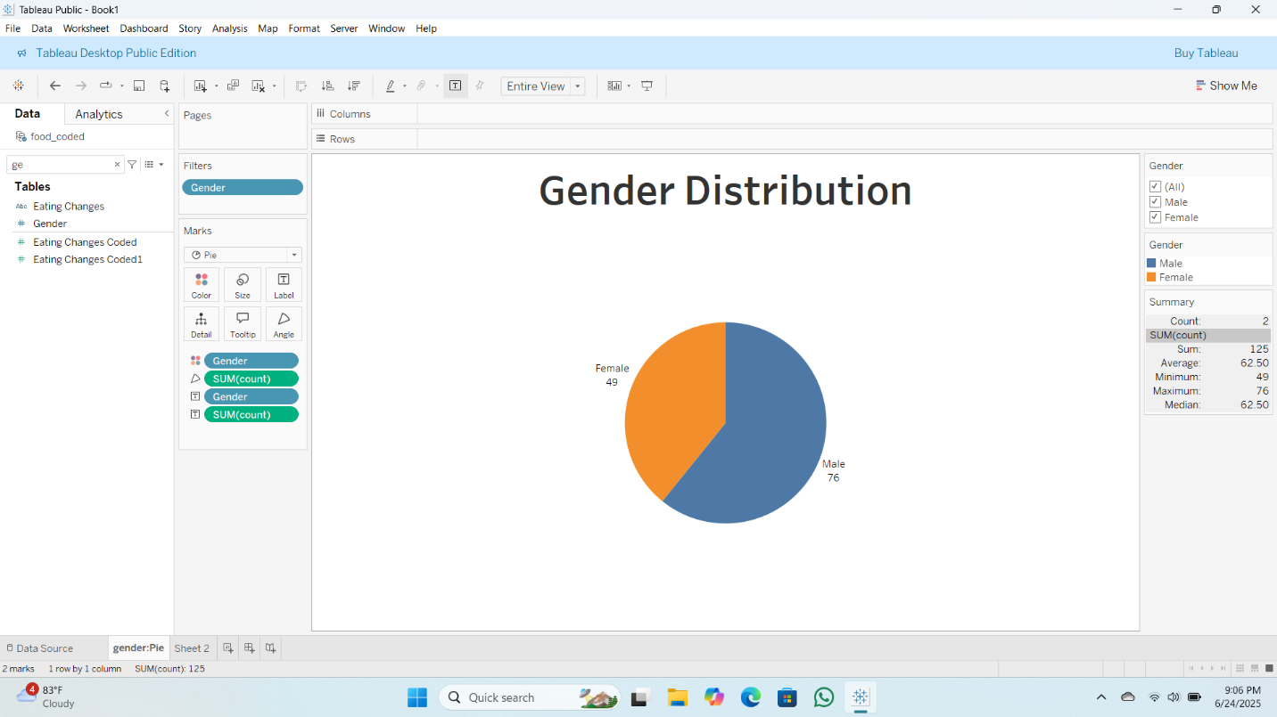

### 2.GPA Distribution

### 3. Breakfast Consumption

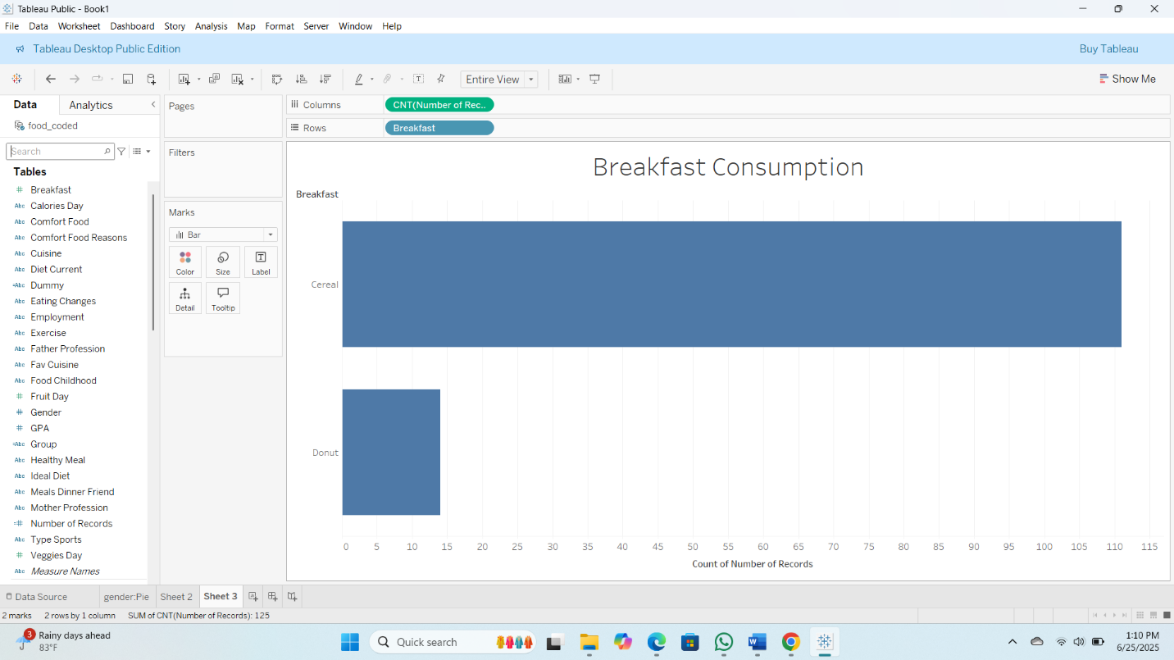

### 4.Calorie Consumption per day

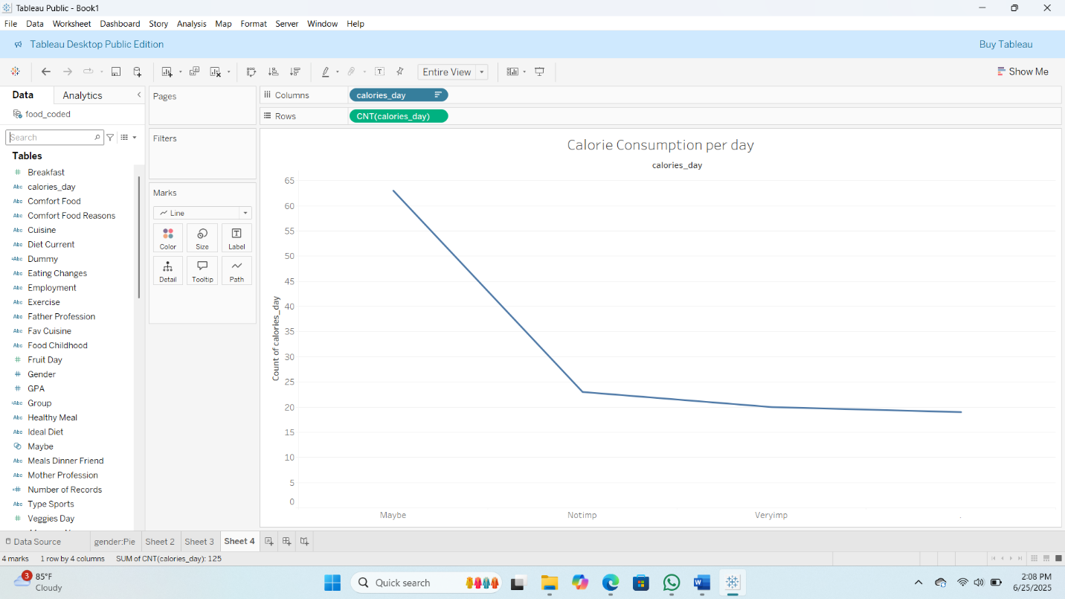

### 5.Favourite_Comfort_foods

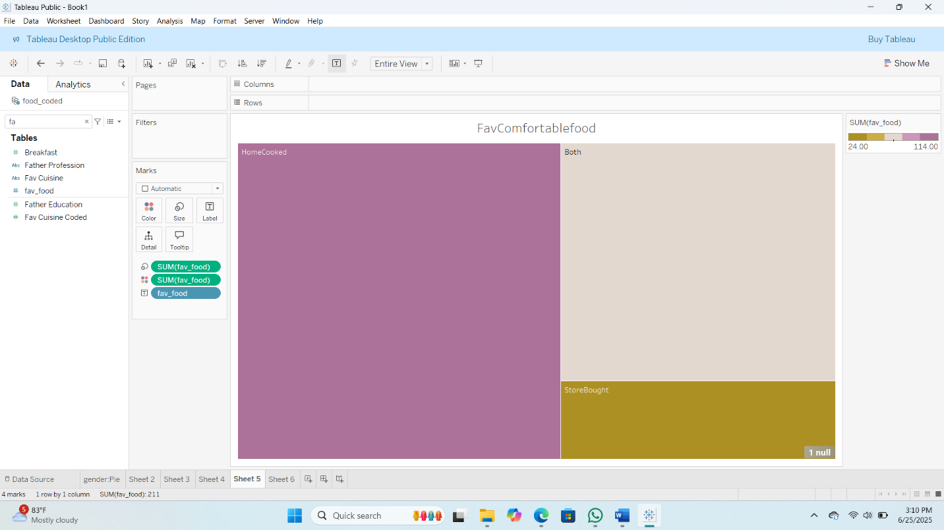

### 6.Comfort_food_reasons

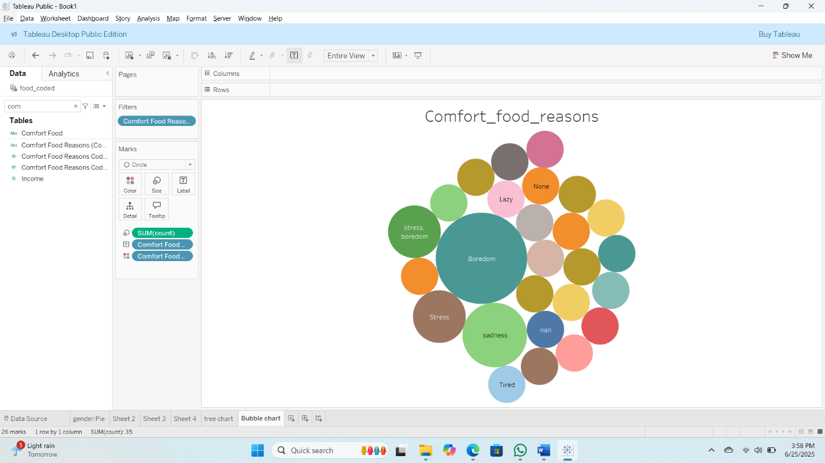

### 7.Cooking frequency per week

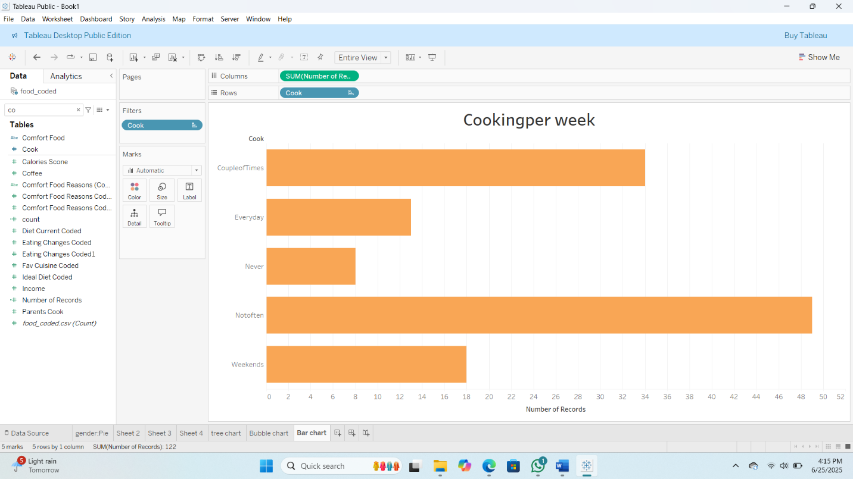

### 8. Cuisine preferences

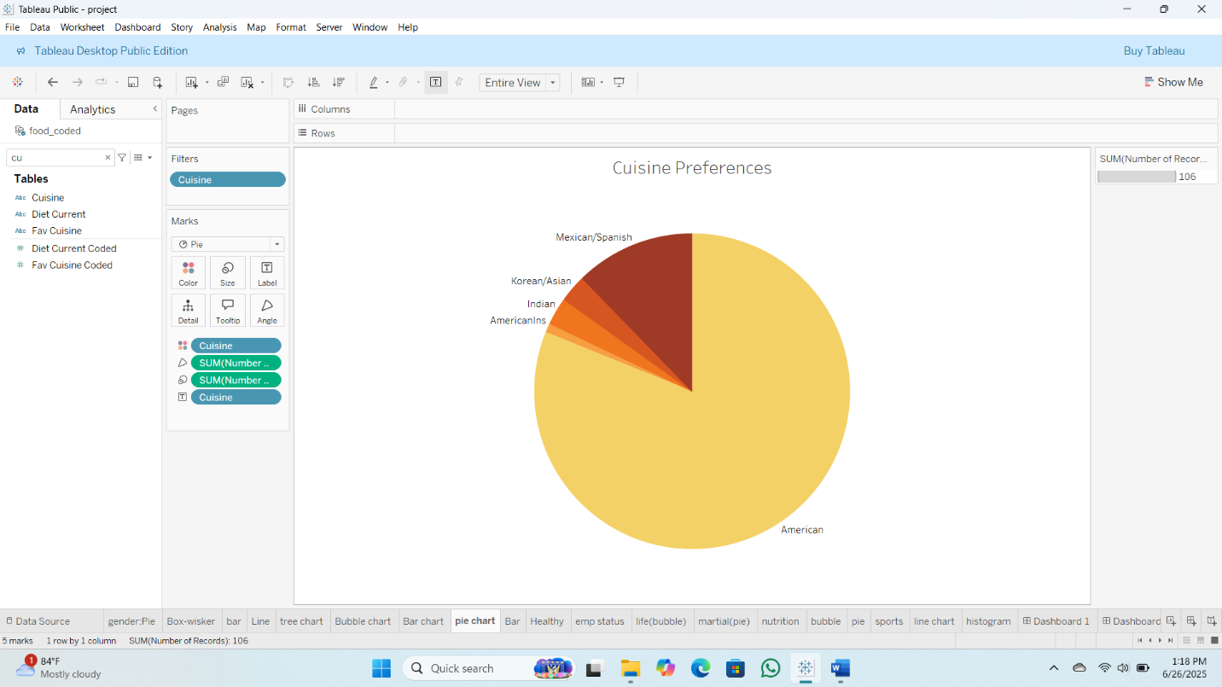

### 9. Diet Status

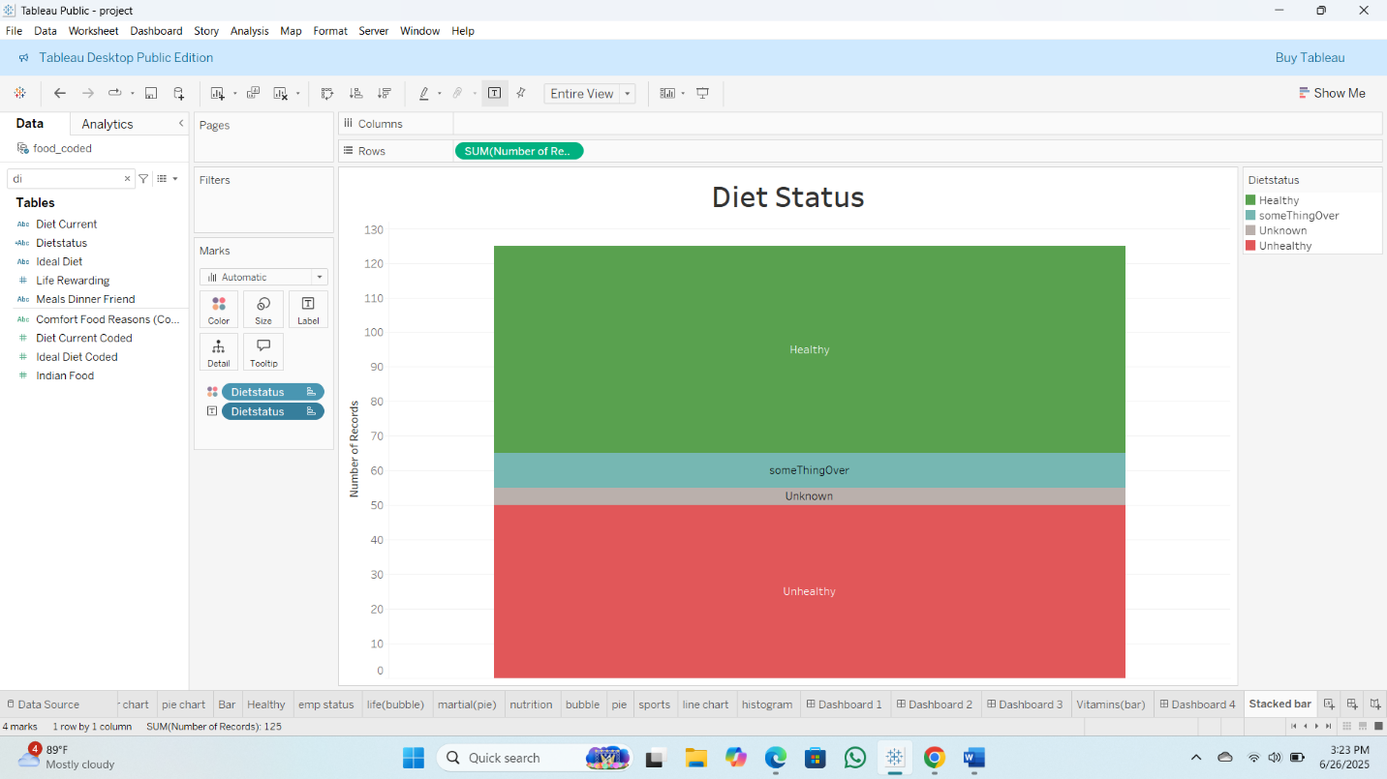

### 10. Exercise Frequency

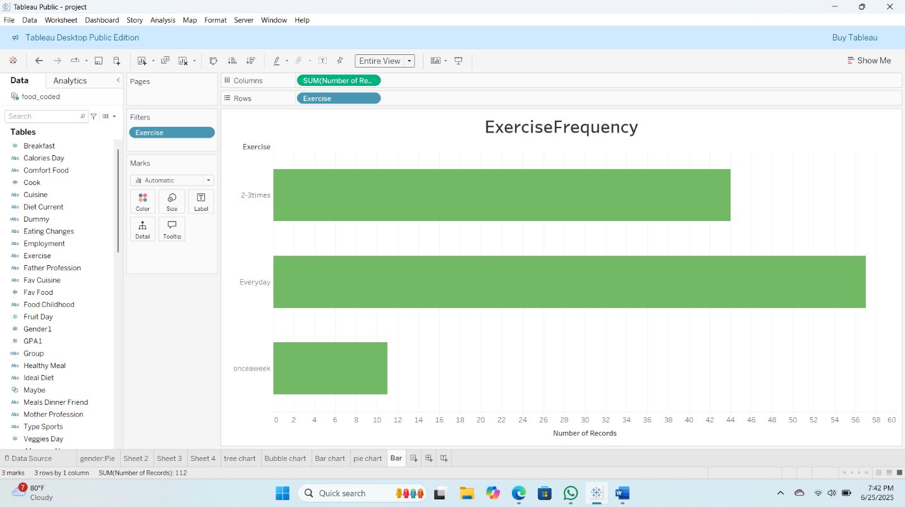

### 11. Employee status

### 12. Healthy Feeling

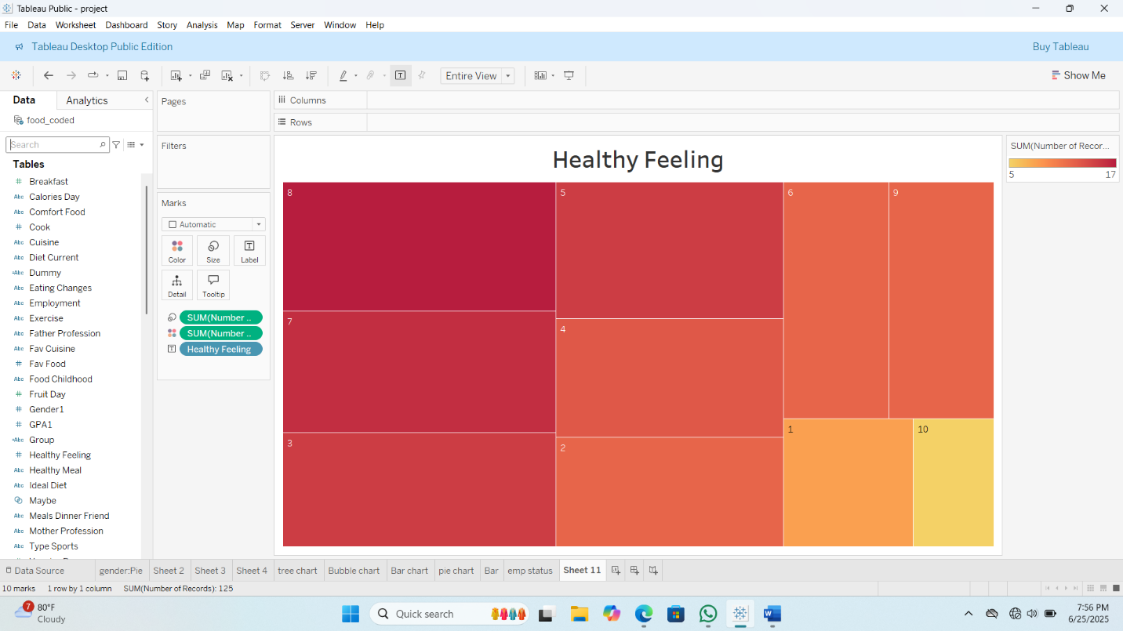

### 13. Life Rewarding rating

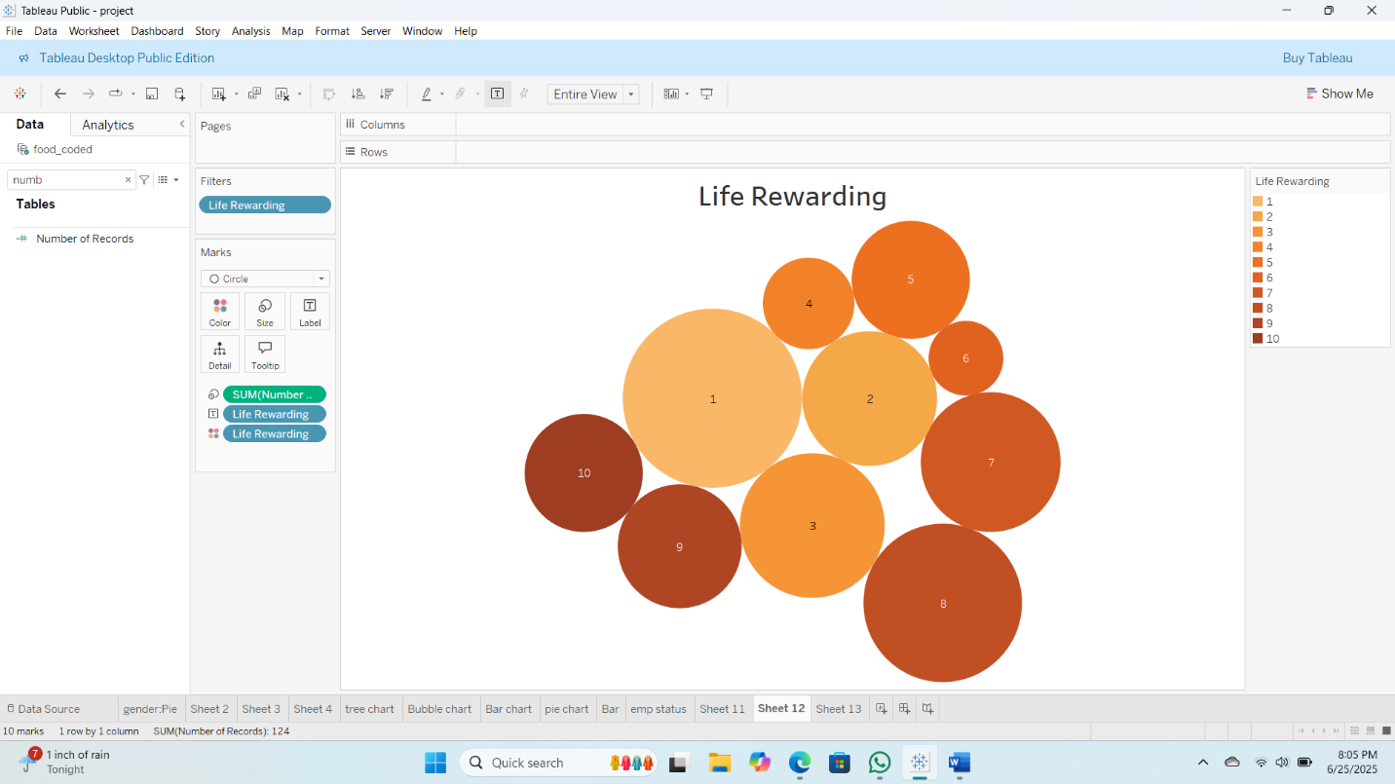

### 14. Martial Status

### 15. Nutritional Check

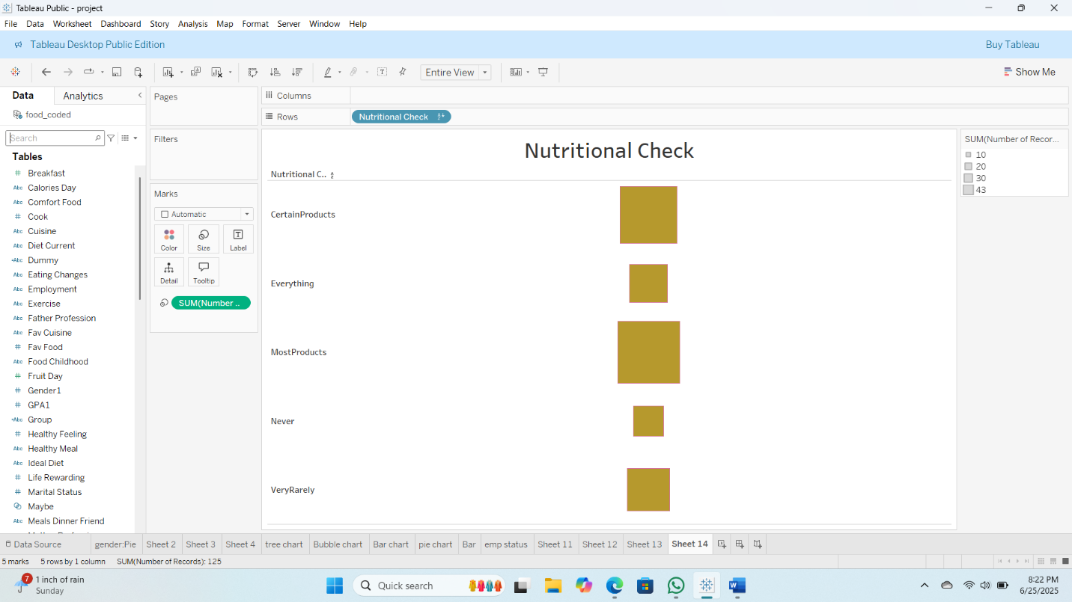

### 16. Parental Cooking Habits

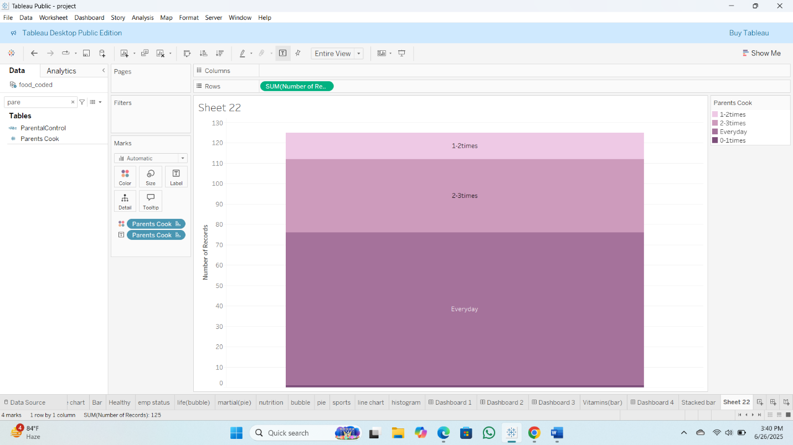

### 17. Meal Payment Habits

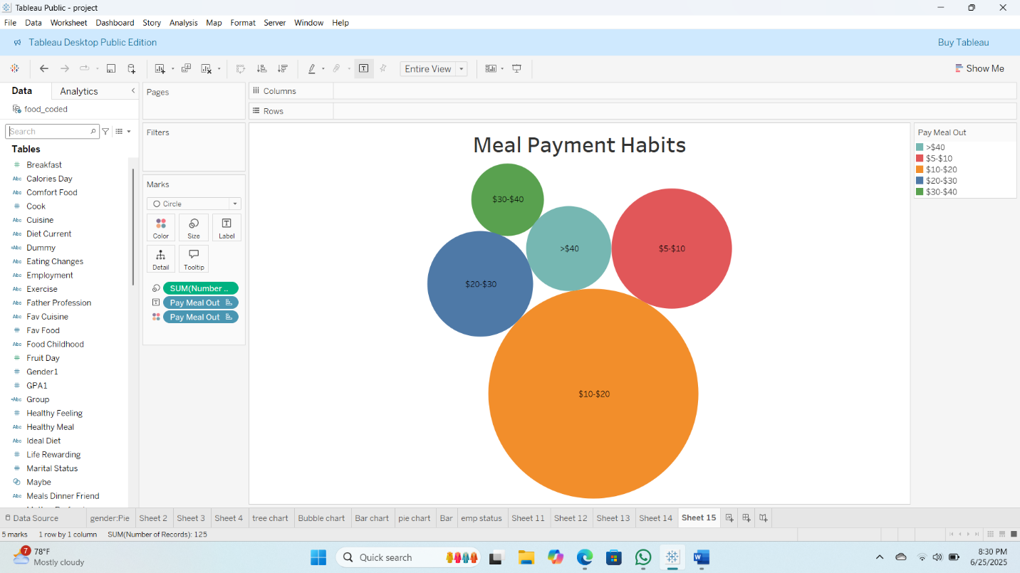

### 18. Weight Self Perception

### 19. sports Participation

### 20. Veggie and Fruit Consumption

### 21. Vitamin Intake

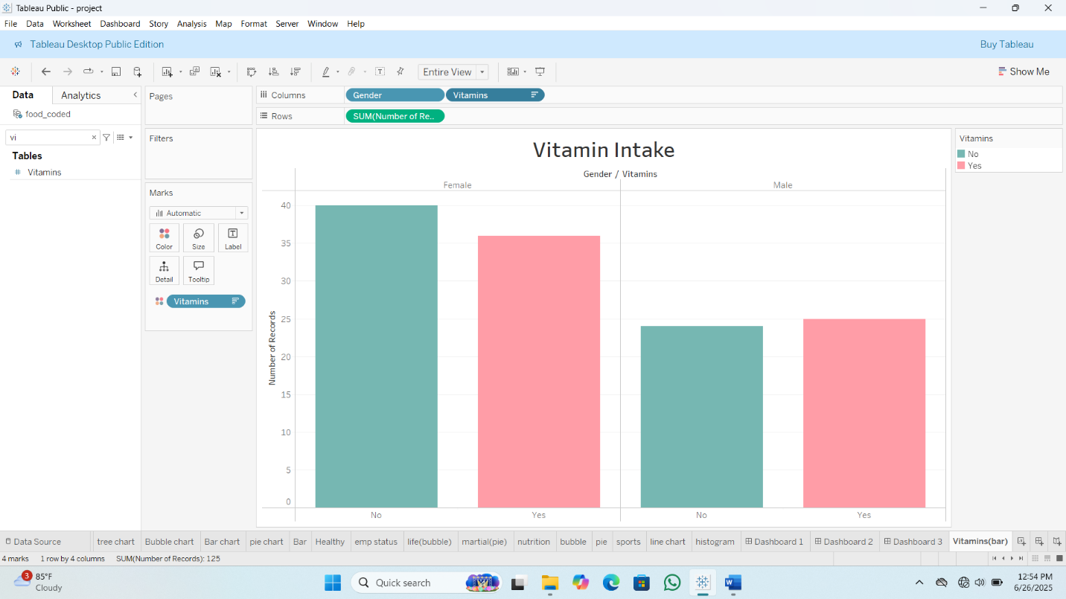

### 22. Weight

