Name **Per Lövdinger**

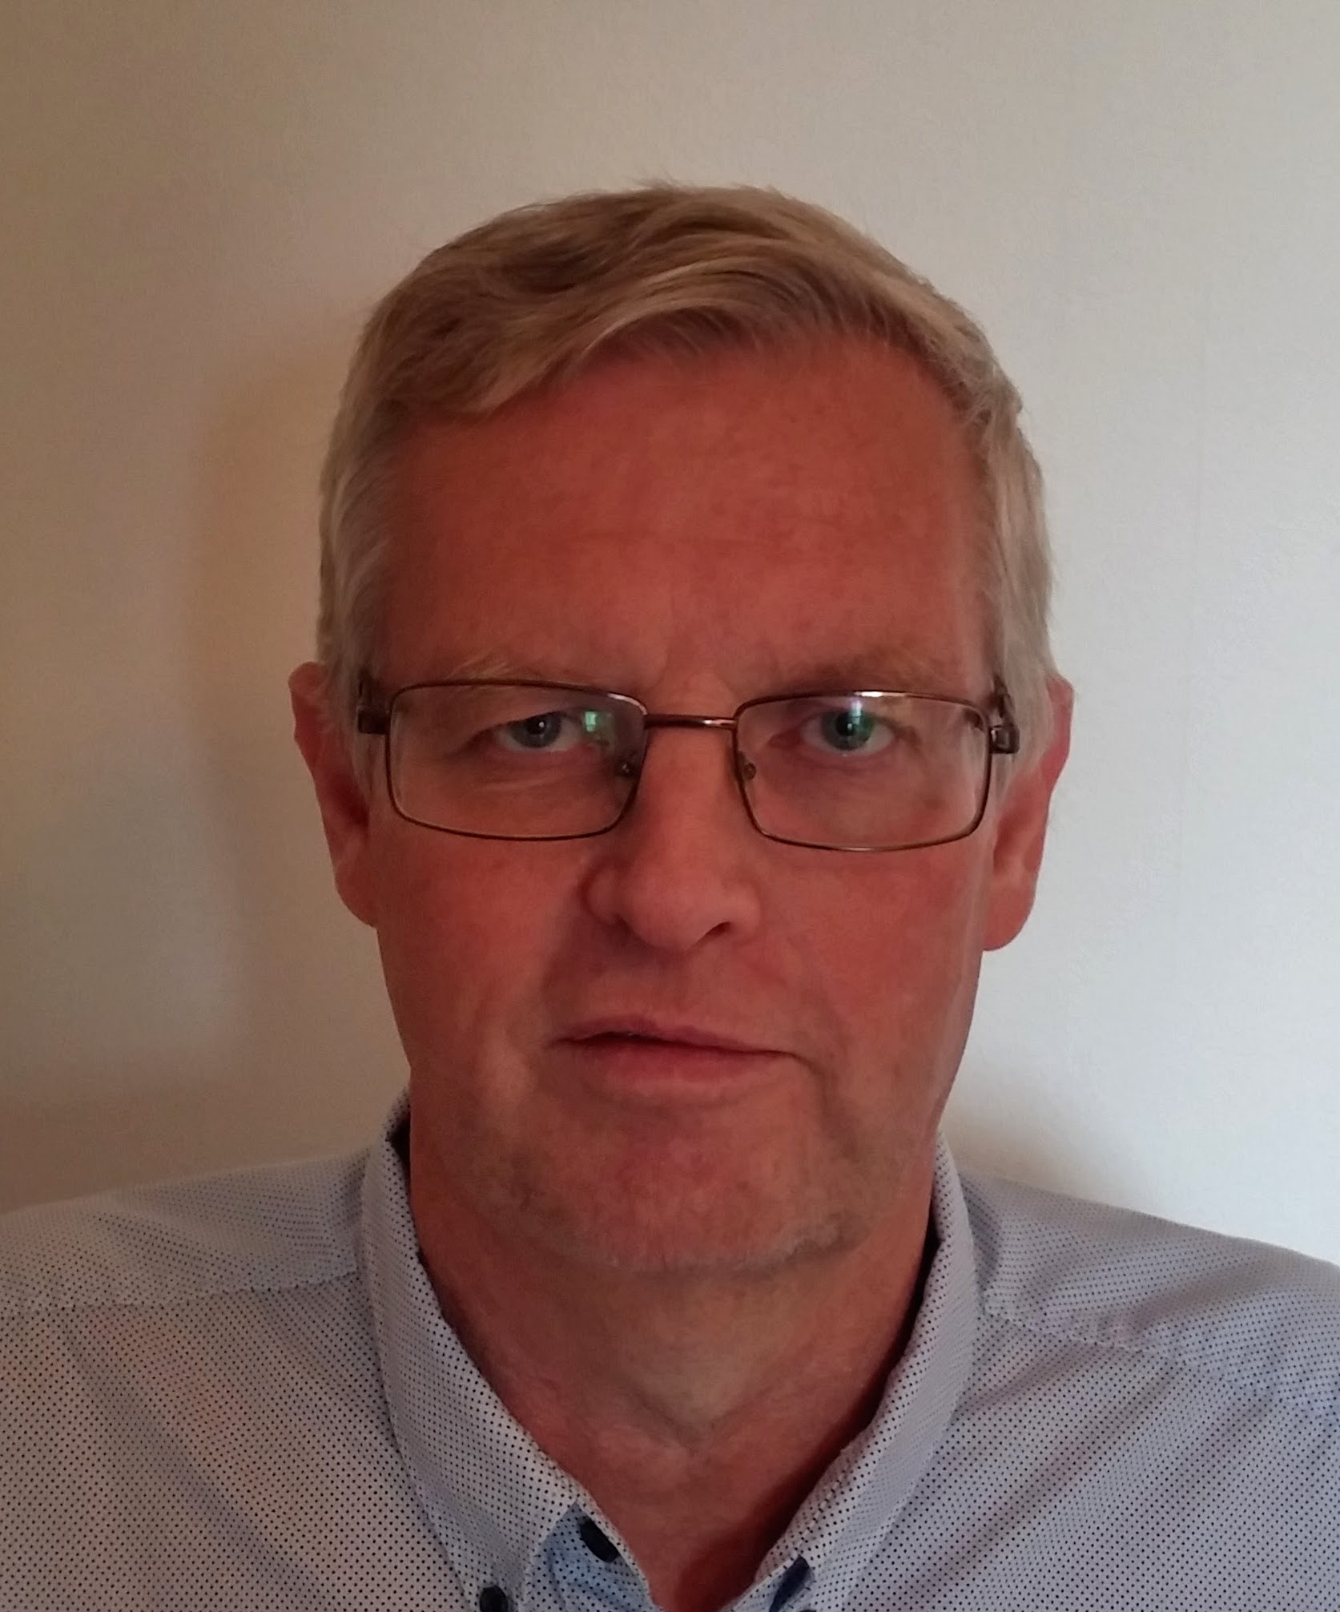

Phone 0739023436

Email per.lovdinger@gmail.com

Linkedin [Link](https://www.linkedin.com/in/per-l%C3%B6vdinger-4868012/)

Address Kalibervägen 1,43350 Öjersjö

Pers.no 600702-0255

# Work Overview

Professional and dedicated Java Solution Architect with the ability to meet and fulfill client’s business goals. Experience in the requirements of commercial IT-development, and capable of participating in many team roles. He has extensive experience in Java Enterprise technologies and object-oriented methods and has worked 3 years as self employed Java-Consultant in Dublin, Ireland. Easy co-worker and positive attitude.

Recently assignment experiences:

* Lead Architect TCP-Test Management - Volvo Group Trucks Technology
* Lead Architect Gloria - Volvo Group Trucks Technology
* Software Architect / Team Lead SCM – Volvo Parts
* Software Architect – Volvo 3P
* Senior Java Developer SID – Volvo Parts
* Solution Architect CDB – Volvo Cars
* Application Architect W2VCC – Volvo Cars
* Designer/Developer J2EE applications – Volvo Parts
* Designer - proof-of-concept architecture, NG Next Generation, Volvo Cars
* Java-Mentor – Volvo Cars IT, Torslanda
* Senior Software Engineer – Omnipay, Dublin
* Team-leader – Marrakech, Dublin

## Business Experience:

Automotive, Logistics, Bank industry, Credit card industry, Ecommerce

## Roles:

Lead Architect, IT Architect, Team Lead, Designer, Developer, Mentor

## Languages:

Swedish, English

German, French

## Education:

Gothenburg University, Information Technology 1984-1986

## Employment History

|  |  |  |
| --- | --- | --- |
| **Company** | **Title** | **Period** |
| Volvo IT, Gothenburg | IT Architect | 2002 - |
| Self employed, Ireland | Java Consultant | 1999-2002 |
| Volvo IT, Gothenburg | Method specialist | 1994-1999 |
| Volvo Logistics | Analyst, Developer, Project leader | 1986-1994 |

## Assignment History

|  |  |
| --- | --- |
|  | |
|  |  |
| **Customer**:  Assignment/Project: | **Volvo Group Trucks Technology**  **TCP Test Management** |
| Role  Method/Techniques | Lead Architect  Rich Web Client, Java script framework (Angular,TypeScript),  RESTful Services, Java EE 6 (JPA,JMS) ,Spring,  XML-schema, JAXB, Volvo Frameworks (JVS) ,  Database PostgreSQL, JBOSS, Eclipse, Maven,GIT |
| Description of Assignment: | Lead Architect for new global application that supports the Test management process of complete vehicle |
| Duration: | October 2016-present |
| **Customer**:  Assignment/Project | **Volvo Group Trucks Technology**  **DVP prestudies** |
| Role  Method/Techniques | Lead Architect  not applicable |
| Description of Assignments: | PLM Services Roadmap  Strategy for development tools for Embedded Software Engineering |
| Duration: | August 2016 – October 2016 |
| **Customer**:  Assignment/Project: | **Volvo Group Trucks Technology**  **Gloria** |
| Role  Method/Techniques | Lead Architect  Rich Web Client, RESTful Services,Java EE 5 (Servlet,EJB,JPA,JMS) , XML-schema, JAXB  Volvo Frameworks (JVS3) , Databases (PostgreSQL,Derby)  Eclipse, Subversion,Websphere Application Server,tomcat |
| Description of Assignment: | Lead Architect for new global application that supports Procurement, Order,Delivery Control and Storage of parts in Prototype warehouses. Application supports GTT global process “Build Physical Object”. |
| Duration: | April 2012 – June 2016 |
| **Customer:**  Assignment/Project | **Volvo Group Trucks Technology**  **Protus TOM** |
| Role  Method/Techniques | Senior Developer  Java EE 5 (Servlet,EJB,JPA,JMS) , XML-schema, JAXB  Volvo Frameworks (JVS3, Java Swing) , Databases (DB2,Derby)  Eclipse 3.6 Galileo, subversion |
| Description of Assignment: | Develop a domain oriented solution for PROTUS Test Object Management. |
| Duration: | October 2011 – April 2012 |

|  |  |
| --- | --- |
| **Customer**  Assignment/Project  Role  Method/Techniques | **Volvo Parts**  **SCM DM R3**  Architect/Team lead  Java EE 5 (Servlet,EJB,JPA,JMS) , XML-schema, JAXB  Volvo Frameworks (JVS3, VPLF) , Databases (DB2,Derby)  Eclipse 3.6 Galileo, subversion |
| Description of Assignment: | Architect/Team lead for development of new global DFS (Dealer facing system) which will be used by Volvo, Renault and Mack. Leading a team of 11 developers. |
| Duration | January 2010 – October 2011 |
| **Customer:**  Assignment/Project | **Volvo 3P**  **KOLA Integration roadmap** |
| Role | Architect |
| Method/Techniques: | not applicable |
| Description of Assignment: | Developing and documenting new Kola integration strategy.  Coordinate pilot-test of KOLA Integration with 3P platform. |
| Duration: | October 2009 – December 2009 |
|  |  |
|  |  |
| **Customer:**  Assignment/Project | **Volvo Parts**  **SID** – Service Information Database |
| Role | Senior Java developer |
| Method: | Rational Application Developer 7.0, WebSphere-6.1,  J2EE 1.4, J2SE5.0, Web Services, EJB, DB2, MQ, JMS, XSD, Scrum,Clearcase |
| Description of Assignment: | SID – SGML2XML project.  Designed and implemented various tasks in the project. |
| Duration: | January 2009 – October 2009 |
|  |  |
| **Customer:**  Assignment/Project | **Volvo Cars**  **CDB** – Customer DataBase |
| Role | Solution Architect |
| Method: | Rational Application Developer 7.0, WebSphere-6.1,  J2EE 1.4, J2SE5.0, Web Services , EJB, JSP, Struts, Oracle, MQ, JMS, XSD ,JAXB, OAGIS, test-driven development, ant, cruise-control, UML, Subversion |
| Description of Assignment: | CDB is an application that serves as the consumer master at  VCC and is integrated with many different systems, e.g.  ordering, warranty, prospect and sales lead, soft product,  customer complaint. My role as solution architect consisted of being responsible for the application architecture, the design, the integrations and the infrastructure. |
| Duration: | October 2007– December 2008 |
|  |  |
| **Customer:**  Assignment/Project | **Volvo Cars**  **W2VCC** project |
| Role | Application architect – team lead |
| Method:  Description of Assignment  Duration: | TP2007:J2EE 1.4, J2SE5.0, Rational Application Developer 7.0, WebSphere,6.1 test-driven development, ant, cruise-control, Oracle,DB2,MQSeries,Ehub and CVS  Integration project to enable communication between KDP and WERS.  Establishing IT-architecture and design of a new J2EE-application called Translator that serves as an integration-application. Team lead and responsible for the development of the application.  November 2006 – October 2007 |
|  |  |
| **Customer:**  Assignment/Project | **Volvo Parts**  **IMPACT** 3.0 |
| Role | Developer/Designer J2EE |
| Method:  Description of Assignment: | J2EE 1.4, Rational Application Developer, WebSphere, test-driven development, ANT, cruise-control, Oracle |
|  | J2EE/Web Application that provides that quick access to latest parts, service information and vehicle specification. |
|  | Designing and developing Impact 3.0. |
| Duration: | September 2005 – November 2006 |
|  |  |
|  |  |
| **Customer:**  Assignment/Project | **Volvo Parts**  **SID** 4.2 - Service Information Database |
| Role | Developer/Designer J2EE |
| Method: | J2EE 1.3, WSAD, WebSphere, test-driven development, ANT Jeeves, WebServices, Castor, DB2 |
| Description of Assignment: | Designing and developing SID 4.2. |
| Duration: | March 2005 - September 2005 |
|  |  |

|  |  |
| --- | --- |
| **Customer:**  Assignment/Project | **Volvo Cars**  **NG** – Next Generation - Architecture proof-of-concept |
| Role | Designer/Developer/Architect |
| Method: | J2EE, USDM, WSAD, WebSphere, test-driven development, ant, maven, Oracle |
| Description: | NG will support a VCC global solution for products in process(PPS) and material planning systems. |
|  | Designing proof-of-concept architecture – establishing guidelines for design. |
| Duration: | October-2004 - March 2005 |
|  |  |

|  |  |
| --- | --- |
| **Customer:**  Assignment/Project | **Volvo Cars Torslanda – IT department**  Various project for example OEE |
| Role | Java Mentor |
| Method: | Websphere,J2EE,EJB (incl. Message Driven Beans),  Servlet, JSP, Struts, JMS, ant, Tenvironment, VMS, Mimer |
| Description of Assignment: | Method/Technique support for Java-projects within the VCT-IT organisation. |
| Duration: | October 2002 – October 2004 |
|  |  |

|  |  |
| --- | --- |
|  |  |
| **Customer:**  Assignment/Project | **Omnipay, Dublin** [www.omnipaygroup.com](http://www.omnipaygroup.com)  RAM – project. Omnipay provides and develops a service for creditcard-transactions over the internet. |
| Role | Software Architect, designer |
| Method: | J2EE , EJB, JSP, Oracle, WebLogic |
| Description of Assignment: | Created the architecture, designed and implemented a proof-of-concept solution for Omnipay Ram-Web-application.  We used Weblogic as the application-server , Java Server Pages as client technology and EJB as the back-end technology.  The contract has also involved administration of Weblogic servers.  I have also designed and implemented a file-transmission system involving XML-technology (DOM/SAX). |
| Duration: | December 2000-October 2002 |

|  |  |
| --- | --- |
| **Customer:**  Assignment/Project | **Marrakech, Dublin** [www.marrakech.com](http://www.marrakech.com)  **Laser – Marrakech** |
| Role | Team-leader, Developer |
| Method: | Netdynamics, Java, Web, EJB |
| Description of Assignment: | During this period I worked on an E-commerce project developing a web-application for procurement. We used Netdynamics as application-server and technologies such as Java 1.2, Enterprise Java Beans, Web and HTML.  During the last 6 months I worked as the Lead Engineer/Team Lead developing a new release of the eProcurement application.  I was responsible for Technical Design and managed a team of 10 engineers implementing the software. |
| Duration: | October 1999- December 2000 |
|  |  |
| **Customer:**  Assignment/Project | **Bank of Ireland, Dublin** [www.bankofireland.com](http://www.bankofireland.com)  CEB-project – Bank of Ireland |
| Role | Developer |
| Method: | Cool:Gen |
| Description of Assignment: | Worked on contract basis for the CEB-project (Commercial Electronic Banking) at Bank of Ireland, developing back-end applications using a case-tool called Cool:Gen. |
| Duration: | July 1999 - October 1999 |
|  |  |
| **Customer:**  Assignment/Project | **Volvo**  Various java-projects |
| Role | Java Mentor |
| Method: | Websphere, Java, Web, Servlet, EJB, Applet |
| Description of Assignment: | I worked as a member of a Java-team where we gave support to Java-projects within Volvo.  From the beginning of 1999, I was promoted to a position as a Java Method leader.  The position meant that I was responsible for:  The communication of information regarding Java  Coordinating of Java-activities within Volvo  Exchanging experiences between Java-projects at Volvo  Suggesting strategies/architecture for Java-projects |
| Duration: | July 1998 - July 1999 |
|  |  |

## Training

|  |  |  |  |
| --- | --- | --- | --- |
| **Date** | **Training** | **Comment** | **Institute/Supplier** |
| 2017 | Enterprise Architecture Repository |  |  |
| 2013 | JVS - In depth training |  |  |
| 2013 | Introduction to Websphere MQ |  |  |
| 2013 | BlackBelt-Volvo Group Software  Architecture Course |  |  |
| 2012 | Teamleader |  |  |
| 2012 | PMTP D2 - Soft Skills Fundamentals |  |  |
| 2012 | ITA Training – Integration |  |  |
| 2011 | JVS |  |  |
| 2011 | ITA training module I&O |  |  |
| 2008 | Black belt 2008 |  |  |
| 2006 | Advanced Object Orientation with UML |  | Informator |
| 2004 | IT Architect – Certification program |  | Dataföreningen |
| 1999 | Enterprise Java Beans |  |  |
| 1998 | Rational Rose – RUP |  |  |
| 1997 | Corba – basics |  | Rational |
| 1997 | Java Basics |  |  |