Compliance Evidence Report
Automotive_Cluster Requirements Compliance Evidence Report
Formal technical verification report based on requirement-to-evidence traceability
Field | Value
Project | Automotive_Cluster
Workspace | C:\Users\JunsangS\workspaceS32DS.Power.2.1\Automotive_Cluster
Source requirement document | MPC5748G_Embedded_Training_Requirements_EN.docx
Prepared date | 2026-06-04
Verification basis | Inspection, static artifacts, host unit tests, and available logs

Document Purpose
This report states the compliance evidence for the Automotive_Cluster workspace by linking each requirement ID to its implementation location, verification method, evidence files/logs, and final status. Items without sufficient evidence are not marked compliant.

Project Overview
The source requirement document defines a six-ECU MPC5748G training project. This workspace is ECU6 Gateway + OTA + Security focused. CANoe simulator and DBC assets exist for ECU1 through ECU5, but independent MPC5748G ECU implementation evidence for those roles was not found.

Verification Scope
- All 96 source requirements are included in the traceability matrix.
- The ECU6 active scope contains 35 requirements: 15 Common, 16 ECU6, and 4 ECU6-related Integration requirements.
- ECU1 through ECU5 board-specific requirements and several integration scenarios remain Needs Confirmation based on the current workspace evidence.

Evidence Sources Reviewed
Category | Path | Reviewed Evidence
Requirements | MPC5748G_Embedded_Training_Requirements_EN.docx | Extracted 96 requirements
Status document | Documentation/ecu6_gateway/requirements_status.md | Status basis for the 35 ECU6 active-scope requirements
Design/test docs | Documentation/ecu6_gateway/design.md; test_report.md | CAN, GatewayStatus, OTA/security design and test assets
Source code | Sources/**/*.c; Generated_Code/**/*.c | Initialization, CAN, gateway, scheduler, and logging implementation
CANoe/CMM | CANOE/*; cmm/* | DBC, CAPL, panel, Trace32 scripts, and binary report artifacts
Build/test | Debug_FLASH/Automotive_Cluster.elf; host_unit_tests_2026-06-04.txt | Build artifacts and 9/9 passing host unit tests

Compliance Summary
Status | Count | Meaning
Compliant | 31 | Code, documentation, test, or executable evidence is sufficient to close the requirement.
Partially Compliant | 4 | Implementation or test assets exist, but runtime or external-tool evidence is incomplete.
Non-compliant | 0 | No meaningful implementation evidence was found.
Needs Confirmation | 61 | The current workspace does not contain enough evidence to make a final determination.

Requirements Traceability Matrix
Requirement ID | Requirement Description | Compliance Status | Implementation Location | Verification Method | Evidence File/Log | Notes
REQ-COM-001 | Each ECU MUST initialize system clock, GPIO, UART, CAN controller, timer/scheduler, and required interrupts. | Partially Compliant | Sources/main.c; Sources/services/system_init.c; Sources/drivers/gpio.c; Sources/drivers/can.c | Source inspection; Debug_FLASH artifact inspection; pending S32DS runtime/flash evidence | Debug_FLASH/Automotive_Cluster.elf; Debug_FLASH/Automotive_Cluster.map; cmm/interrupt_evidence.cmm | Runtime stability, UART boot log, heartbeat LED, and Trace32 screenshot evidence are still required.
REQ-COM-002 | Each ECU MUST provide UART logging with a consistent format: [time][ECUx][module][level] message. | Compliant | Sources/services/logger.c; Sources/automotive.h; Sources/services/com_gateway.c | Source inspection of LOG_Print() format and gateway/OTA logging call sites | Sources/services/logger.c; Sources/services/com_gateway.c | Saved UART terminal evidence was not found, but code implements the required format.
REQ-COM-003 | Each ECU MUST transmit at least one periodic CAN message and receive at least one CAN message from another ECU or CANoe. | Partially Compliant | Sources/drivers/can.c; Sources/services/com_gateway.c; CANOE/*.dbc; CANOE/*.can | Source/DBC/CAPL inspection; readable CANoe verdict export still pending | CANOE/6_ECUs_dbc_0206.dbc; CANOE/ECU6_Gateway_Test.can; CANOE/*.vtestreport | Binary CANoe reports exist, but text-readable PASS/FAIL verdicts were not available.
REQ-COM-004 | Each ECU MUST implement a 10 ms, 100 ms, and 1000 ms task or an equivalent scheduler. | Partially Compliant | Sources/services/ms_scheduler.c; Sources/main.c; cmm/scheduler_evidence.cmm | Source inspection; Trace32 scheduler counter capture pending | Sources/services/ms_scheduler.c; cmm/scheduler_evidence.cmm; Debug_FLASH/Automotive_Cluster.map | Scheduler counters are present in source; a rebuild and Trace32 evidence are required for final runtime closure.
REQ-COM-005 | Each ECU MUST implement timeout monitoring for critical received CAN messages or external sensor inputs. | Compliant | Sources/services/com_gateway.c: COM_GatewayCheckTimeouts(), COM_GatewayHandleRxMessage() | Source inspection and host unit test coverage | Tests/host/test_ecu6_gateway_logic.py; Documentation/ecu6_gateway/evidence/host_unit_tests_2026-06-04.txt | Host tests passed; hardware/CANoe runtime evidence remains recommended.
REQ-COM-006 | Each ECU primary status message MUST include a 4-bit alive counter. | Compliant | Sources/services/com_gateway.c: COM_GatewayBuildStatusMessage(); CANOE/6_ECUs_dbc_0206.dbc | Source and DBC inspection | Sources/services/com_gateway.c; CANOE/6_ECUs_dbc_0206.dbc | GatewayStatus byte 6 carries the 4-bit alive counter.
REQ-COM-007 | Each ECU primary status message MUST include a simple checksum. | Compliant | Sources/services/com_gateway.c: COM_CalculateChecksum(), COM_VerifyChecksum() | Source inspection and host unit test coverage | Tests/host/test_ecu6_gateway_logic.py; host_unit_tests_2026-06-04.txt | Host tests passed for checksum calculation and validation.
REQ-COM-008 | Each ECU SHOULD separate driver, service, and application layers. | Compliant | Sources/main.c; Sources/drivers/*.c; Sources/services/*.c; Generated_Code/*.c | Source tree review | Sources/drivers; Sources/services; Generated_Code | Driver/service/generated layers are separated.
REQ-COM-009 | Each ECU SHOULD implement a state machine when application behavior has multiple modes. | Compliant | Sources/services/com_gateway.c: gateway, OTA, and security state handling | Source inspection and host unit test coverage | Documentation/ecu6_gateway/design.md; Tests/host/test_ecu6_gateway_logic.py | Gateway, OTA, and security modes are explicitly represented.
REQ-COM-010 | Each mentee MUST create init_debug.cmm and test_debug.cmm for Trace32. | Compliant | cmm/init_debug.cmm; cmm/test_debug.cmm; cmm/*.cmm | File inspection | cmm/init_debug.cmm; cmm/test_debug.cmm; cmm/interrupt_evidence.cmm | Trace32 screenshots are still required for runtime evidence.
REQ-COM-011 | Each mentee MUST create at least three CAPL test cases for the assigned ECU. | Compliant | CANOE/ECU6_Gateway_Test.can; CANOE/ECU6_OTA_State_Test.can | CAPL file inspection; binary report artifacts observed | CANOE/ECU6_Gateway_Test.can; CANOE/ECU6_OTA_State_Test.can; CANOE/*.vtestreport | Readable CANoe PASS/FAIL export is pending.
REQ-COM-012 | Each mentee MUST provide design and test documentation. | Compliant | Documentation/ecu6_gateway/design.md; Documentation/ecu6_gateway/test_report.md | Document inspection | Documentation/ecu6_gateway/design.md; Documentation/ecu6_gateway/test_report.md | Design and test documentation exists.
REQ-COM-013 | Each ECU SHOULD support fault recovery when inputs or messages return to valid condition. | Compliant | Sources/services/com_gateway.c: timeout/alive/checksum recovery paths | Source inspection and host unit test coverage | Tests/host/test_ecu6_gateway_logic.py; Documentation/ecu6_gateway/design.md | Host tests include alive and timeout recovery.
REQ-COM-014 | Each ECU SHOULD use traceable names and comments linking important logic to requirement IDs. | Compliant | Sources/services/com_gateway.c comments; cmm/gateway_debug.cmm; Documentation/ecu6_gateway/*.md | Traceability review | Sources/services/com_gateway.c; cmm/gateway_debug.cmm; Documentation/ecu6_gateway/requirements_status.md | Requirement IDs appear in code, scripts, and status documents.
REQ-COM-015 | Each ECU MAY include host-side unit tests for pure logic such as checksum, filters, warning rules, and state transitions. | Compliant | Tests/host/test_ecu6_gateway_logic.py | Executed Python unittest discovery | Documentation/ecu6_gateway/evidence/host_unit_tests_2026-06-04.txt | 9/9 host-side unit tests passed.
REQ-ECU1-001 | ECU1 MUST read or receive four door states and validate each value. | Needs Confirmation | No ECU1 MPC5748G board source implementation found in this workspace; supporting CAPL simulator: CANOE\ECU1.can | Workspace inspection only; board implementation and execution evidence required | MPC5748G_Embedded_Training_Requirements_EN.docx; CANOE support files where present | Insufficient evidence / needs confirmation. Insufficient evidence for the assigned ECU board implementation.
REQ-ECU1-002 | ECU1 MUST read or receive seatbelt status and include it in BodyStatus. | Needs Confirmation | No ECU1 MPC5748G board source implementation found in this workspace; supporting CAPL simulator: CANOE\ECU1.can | Workspace inspection only; board implementation and execution evidence required | MPC5748G_Embedded_Training_Requirements_EN.docx; CANOE support files where present | Insufficient evidence / needs confirmation. Insufficient evidence for the assigned ECU board implementation.
REQ-ECU1-003 | ECU1 MUST support turn signal modes: off, left, right, and hazard. | Needs Confirmation | No ECU1 MPC5748G board source implementation found in this workspace; supporting CAPL simulator: CANOE\ECU1.can | Workspace inspection only; board implementation and execution evidence required | MPC5748G_Embedded_Training_Requirements_EN.docx; CANOE support files where present | Insufficient evidence / needs confirmation. Insufficient evidence for the assigned ECU board implementation.
REQ-ECU1-004 | ECU1 MUST send BodyStatus on CAN ID 0x101 every 100 ms. | Needs Confirmation | No ECU1 MPC5748G board source implementation found in this workspace; supporting CAPL simulator: CANOE\ECU1.can | Workspace inspection only; board implementation and execution evidence required | MPC5748G_Embedded_Training_Requirements_EN.docx; CANOE support files where present | Insufficient evidence / needs confirmation. Insufficient evidence for the assigned ECU board implementation.
REQ-ECU1-005 | ECU1 MUST set BodyWarning if vehicle speed is greater than 5 km/h and any door is open. | Needs Confirmation | No ECU1 MPC5748G board source implementation found in this workspace; supporting CAPL simulator: CANOE\ECU1.can | Workspace inspection only; board implementation and execution evidence required | MPC5748G_Embedded_Training_Requirements_EN.docx; CANOE support files where present | Insufficient evidence / needs confirmation. Insufficient evidence for the assigned ECU board implementation.
REQ-ECU1-006 | ECU1 MUST set BodyWarning if speed is greater than 10 km/h and seatbelt is not fastened. | Needs Confirmation | No ECU1 MPC5748G board source implementation found in this workspace; supporting CAPL simulator: CANOE\ECU1.can | Workspace inspection only; board implementation and execution evidence required | MPC5748G_Embedded_Training_Requirements_EN.docx; CANOE support files where present | Insufficient evidence / needs confirmation. Insufficient evidence for the assigned ECU board implementation.
REQ-ECU1-007 | ECU1 SHOULD debounce physical/simulated switch inputs. | Needs Confirmation | No ECU1 MPC5748G board source implementation found in this workspace; supporting CAPL simulator: CANOE\ECU1.can | Workspace inspection only; board implementation and execution evidence required | MPC5748G_Embedded_Training_Requirements_EN.docx; CANOE support files where present | Insufficient evidence / needs confirmation. Insufficient evidence for the assigned ECU board implementation.
REQ-ECU1-008 | ECU1 MUST detect input timeout if the selected input source is not updated for more than 500 ms. | Needs Confirmation | No ECU1 MPC5748G board source implementation found in this workspace; supporting CAPL simulator: CANOE\ECU1.can | Workspace inspection only; board implementation and execution evidence required | MPC5748G_Embedded_Training_Requirements_EN.docx; CANOE support files where present | Insufficient evidence / needs confirmation. Insufficient evidence for the assigned ECU board implementation.
REQ-ECU1-009 | ECU1 SHOULD recover from input timeout when valid input resumes. | Needs Confirmation | No ECU1 MPC5748G board source implementation found in this workspace; supporting CAPL simulator: CANOE\ECU1.can | Workspace inspection only; board implementation and execution evidence required | MPC5748G_Embedded_Training_Requirements_EN.docx; CANOE support files where present | Insufficient evidence / needs confirmation. Insufficient evidence for the assigned ECU board implementation.
REQ-ECU1-010 | ECU1 SHOULD provide a Body Control CANoe panel. | Needs Confirmation | No ECU1 MPC5748G board source implementation found in this workspace; supporting CAPL simulator: CANOE\ECU1.can | Workspace inspection only; board implementation and execution evidence required | MPC5748G_Embedded_Training_Requirements_EN.docx; CANOE support files where present | Insufficient evidence / needs confirmation. Insufficient evidence for the assigned ECU board implementation.
REQ-ECU2-001 | ECU2 MUST receive or read EngineRPM, ThrottlePercent, and EngineTemp. | Needs Confirmation | No ECU2 MPC5748G board source implementation found in this workspace; supporting CAPL simulator: CANOE\ECU2.can | Workspace inspection only; board implementation and execution evidence required | MPC5748G_Embedded_Training_Requirements_EN.docx; CANOE support files where present | Insufficient evidence / needs confirmation. Insufficient evidence for the assigned ECU board implementation.
REQ-ECU2-002 | ECU2 MUST validate sensor ranges before using values. | Needs Confirmation | No ECU2 MPC5748G board source implementation found in this workspace; supporting CAPL simulator: CANOE\ECU2.can | Workspace inspection only; board implementation and execution evidence required | MPC5748G_Embedded_Training_Requirements_EN.docx; CANOE support files where present | Insufficient evidence / needs confirmation. Insufficient evidence for the assigned ECU board implementation.
REQ-ECU2-003 | ECU2 MUST calculate VehicleSpeed from RPM or accepted input using a documented formula. | Needs Confirmation | No ECU2 MPC5748G board source implementation found in this workspace; supporting CAPL simulator: CANOE\ECU2.can | Workspace inspection only; board implementation and execution evidence required | MPC5748G_Embedded_Training_Requirements_EN.docx; CANOE support files where present | Insufficient evidence / needs confirmation. Insufficient evidence for the assigned ECU board implementation.
REQ-ECU2-004 | ECU2 SHOULD smooth speed changes instead of jumping instantly to target speed. | Needs Confirmation | No ECU2 MPC5748G board source implementation found in this workspace; supporting CAPL simulator: CANOE\ECU2.can | Workspace inspection only; board implementation and execution evidence required | MPC5748G_Embedded_Training_Requirements_EN.docx; CANOE support files where present | Insufficient evidence / needs confirmation. Insufficient evidence for the assigned ECU board implementation.
REQ-ECU2-005 | ECU2 MUST send PowertrainStatus on CAN ID 0x201 every 50 ms. | Needs Confirmation | No ECU2 MPC5748G board source implementation found in this workspace; supporting CAPL simulator: CANOE\ECU2.can | Workspace inspection only; board implementation and execution evidence required | MPC5748G_Embedded_Training_Requirements_EN.docx; CANOE support files where present | Insufficient evidence / needs confirmation. Insufficient evidence for the assigned ECU board implementation.
REQ-ECU2-006 | ECU2 MUST set EngineWarning when EngineTemp > 105 degC. | Needs Confirmation | No ECU2 MPC5748G board source implementation found in this workspace; supporting CAPL simulator: CANOE\ECU2.can | Workspace inspection only; board implementation and execution evidence required | MPC5748G_Embedded_Training_Requirements_EN.docx; CANOE support files where present | Insufficient evidence / needs confirmation. Insufficient evidence for the assigned ECU board implementation.
REQ-ECU2-007 | ECU2 MUST set EngineCriticalFault when EngineTemp > 120 degC. | Needs Confirmation | No ECU2 MPC5748G board source implementation found in this workspace; supporting CAPL simulator: CANOE\ECU2.can | Workspace inspection only; board implementation and execution evidence required | MPC5748G_Embedded_Training_Requirements_EN.docx; CANOE support files where present | Insufficient evidence / needs confirmation. Insufficient evidence for the assigned ECU board implementation.
REQ-ECU2-008 | ECU2 MUST enter limp mode when EngineCriticalFault is active. | Needs Confirmation | No ECU2 MPC5748G board source implementation found in this workspace; supporting CAPL simulator: CANOE\ECU2.can | Workspace inspection only; board implementation and execution evidence required | MPC5748G_Embedded_Training_Requirements_EN.docx; CANOE support files where present | Insufficient evidence / needs confirmation. Insufficient evidence for the assigned ECU board implementation.
REQ-ECU2-009 | ECU2 MUST detect sensor timeout after 500 ms without valid input update. | Needs Confirmation | No ECU2 MPC5748G board source implementation found in this workspace; supporting CAPL simulator: CANOE\ECU2.can | Workspace inspection only; board implementation and execution evidence required | MPC5748G_Embedded_Training_Requirements_EN.docx; CANOE support files where present | Insufficient evidence / needs confirmation. Insufficient evidence for the assigned ECU board implementation.
REQ-ECU2-010 | ECU2 SHOULD provide a recovery rule for overheat and sensor timeout. | Needs Confirmation | No ECU2 MPC5748G board source implementation found in this workspace; supporting CAPL simulator: CANOE\ECU2.can | Workspace inspection only; board implementation and execution evidence required | MPC5748G_Embedded_Training_Requirements_EN.docx; CANOE support files where present | Insufficient evidence / needs confirmation. Insufficient evidence for the assigned ECU board implementation.
REQ-ECU3-001 | ECU3 MUST receive or read ambient temperature, light level, battery voltage, and steering angle. | Needs Confirmation | No ECU3 MPC5748G board source implementation found in this workspace; supporting CAPL simulator: CANOE\ECU3.can | Workspace inspection only; board implementation and execution evidence required | MPC5748G_Embedded_Training_Requirements_EN.docx; CANOE support files where present | Insufficient evidence / needs confirmation. Insufficient evidence for the assigned ECU board implementation.
REQ-ECU3-002 | ECU3 MUST validate range for all sensor inputs. | Needs Confirmation | No ECU3 MPC5748G board source implementation found in this workspace; supporting CAPL simulator: CANOE\ECU3.can | Workspace inspection only; board implementation and execution evidence required | MPC5748G_Embedded_Training_Requirements_EN.docx; CANOE support files where present | Insufficient evidence / needs confirmation. Insufficient evidence for the assigned ECU board implementation.
REQ-ECU3-003 | ECU3 MUST apply a moving average filter to at least one sensor. | Needs Confirmation | No ECU3 MPC5748G board source implementation found in this workspace; supporting CAPL simulator: CANOE\ECU3.can | Workspace inspection only; board implementation and execution evidence required | MPC5748G_Embedded_Training_Requirements_EN.docx; CANOE support files where present | Insufficient evidence / needs confirmation. Insufficient evidence for the assigned ECU board implementation.
REQ-ECU3-004 | ECU3 MUST send SensorStatus on CAN ID 0x301 every 100 ms. | Needs Confirmation | No ECU3 MPC5748G board source implementation found in this workspace; supporting CAPL simulator: CANOE\ECU3.can | Workspace inspection only; board implementation and execution evidence required | MPC5748G_Embedded_Training_Requirements_EN.docx; CANOE support files where present | Insufficient evidence / needs confirmation. Insufficient evidence for the assigned ECU board implementation.
REQ-ECU3-005 | ECU3 MUST set NightModeRequest when LightLevel < 20 %. | Needs Confirmation | No ECU3 MPC5748G board source implementation found in this workspace; supporting CAPL simulator: CANOE\ECU3.can | Workspace inspection only; board implementation and execution evidence required | MPC5748G_Embedded_Training_Requirements_EN.docx; CANOE support files where present | Insufficient evidence / needs confirmation. Insufficient evidence for the assigned ECU board implementation.
REQ-ECU3-006 | ECU3 MUST set BatteryLow when BatteryVoltage < 11 V. | Needs Confirmation | No ECU3 MPC5748G board source implementation found in this workspace; supporting CAPL simulator: CANOE\ECU3.can | Workspace inspection only; board implementation and execution evidence required | MPC5748G_Embedded_Training_Requirements_EN.docx; CANOE support files where present | Insufficient evidence / needs confirmation. Insufficient evidence for the assigned ECU board implementation.
REQ-ECU3-007 | ECU3 MUST set BatteryOverVoltage when BatteryVoltage > 15 V. | Needs Confirmation | No ECU3 MPC5748G board source implementation found in this workspace; supporting CAPL simulator: CANOE\ECU3.can | Workspace inspection only; board implementation and execution evidence required | MPC5748G_Embedded_Training_Requirements_EN.docx; CANOE support files where present | Insufficient evidence / needs confirmation. Insufficient evidence for the assigned ECU board implementation.
REQ-ECU3-008 | ECU3 MUST detect sensor timeout when no update is received for more than 500 ms. | Needs Confirmation | No ECU3 MPC5748G board source implementation found in this workspace; supporting CAPL simulator: CANOE\ECU3.can | Workspace inspection only; board implementation and execution evidence required | MPC5748G_Embedded_Training_Requirements_EN.docx; CANOE support files where present | Insufficient evidence / needs confirmation. Insufficient evidence for the assigned ECU board implementation.
REQ-ECU3-009 | ECU3 SHOULD detect a stuck sensor when a value remains unchanged for a configured number of samples while source is active. | Needs Confirmation | No ECU3 MPC5748G board source implementation found in this workspace; supporting CAPL simulator: CANOE\ECU3.can | Workspace inspection only; board implementation and execution evidence required | MPC5748G_Embedded_Training_Requirements_EN.docx; CANOE support files where present | Insufficient evidence / needs confirmation. Insufficient evidence for the assigned ECU board implementation.
REQ-ECU3-010 | ECU3 SHOULD document I2C/SPI frame format used with Arduino. | Needs Confirmation | No ECU3 MPC5748G board source implementation found in this workspace; supporting CAPL simulator: CANOE\ECU3.can | Workspace inspection only; board implementation and execution evidence required | MPC5748G_Embedded_Training_Requirements_EN.docx; CANOE support files where present | Insufficient evidence / needs confirmation. Insufficient evidence for the assigned ECU board implementation.
REQ-ECU4-001 | ECU4 MUST receive BodyStatus, PowertrainStatus, SensorStatus, DiagnosticStatus, and GatewayStatus. | Needs Confirmation | No ECU4 MPC5748G board source implementation found in this workspace; supporting CAPL simulator: CANOE\ECU4.can | Workspace inspection only; board implementation and execution evidence required | MPC5748G_Embedded_Training_Requirements_EN.docx; CANOE support files where present | Insufficient evidence / needs confirmation. Insufficient evidence for the assigned ECU board implementation.
REQ-ECU4-002 | ECU4 MUST implement a cluster state machine with INIT, NORMAL, WARNING, DIAG_MODE, OTA_MODE, and FAIL_SAFE states. | Needs Confirmation | No ECU4 MPC5748G board source implementation found in this workspace; supporting CAPL simulator: CANOE\ECU4.can | Workspace inspection only; board implementation and execution evidence required | MPC5748G_Embedded_Training_Requirements_EN.docx; CANOE support files where present | Insufficient evidence / needs confirmation. Insufficient evidence for the assigned ECU board implementation.
REQ-ECU4-003 | ECU4 MUST send ClusterStatus on CAN ID 0x401 every 100 ms. | Needs Confirmation | No ECU4 MPC5748G board source implementation found in this workspace; supporting CAPL simulator: CANOE\ECU4.can | Workspace inspection only; board implementation and execution evidence required | MPC5748G_Embedded_Training_Requirements_EN.docx; CANOE support files where present | Insufficient evidence / needs confirmation. Insufficient evidence for the assigned ECU board implementation.
REQ-ECU4-004 | ECU4 MUST display VehicleSpeed and EngineRPM from ECU2. | Needs Confirmation | No ECU4 MPC5748G board source implementation found in this workspace; supporting CAPL simulator: CANOE\ECU4.can | Workspace inspection only; board implementation and execution evidence required | MPC5748G_Embedded_Training_Requirements_EN.docx; CANOE support files where present | Insufficient evidence / needs confirmation. Insufficient evidence for the assigned ECU board implementation.
REQ-ECU4-005 | ECU4 MUST turn on DoorWarningLamp when body warning indicates door open while driving. | Needs Confirmation | No ECU4 MPC5748G board source implementation found in this workspace; supporting CAPL simulator: CANOE\ECU4.can | Workspace inspection only; board implementation and execution evidence required | MPC5748G_Embedded_Training_Requirements_EN.docx; CANOE support files where present | Insufficient evidence / needs confirmation. Insufficient evidence for the assigned ECU board implementation.
REQ-ECU4-006 | ECU4 MUST turn on EngineWarningLamp for ECU2 EngineWarning or CriticalFault. | Needs Confirmation | No ECU4 MPC5748G board source implementation found in this workspace; supporting CAPL simulator: CANOE\ECU4.can | Workspace inspection only; board implementation and execution evidence required | MPC5748G_Embedded_Training_Requirements_EN.docx; CANOE support files where present | Insufficient evidence / needs confirmation. Insufficient evidence for the assigned ECU board implementation.
REQ-ECU4-007 | ECU4 MUST turn on BatteryWarningLamp for low battery or over-voltage from ECU3. | Needs Confirmation | No ECU4 MPC5748G board source implementation found in this workspace; supporting CAPL simulator: CANOE\ECU4.can | Workspace inspection only; board implementation and execution evidence required | MPC5748G_Embedded_Training_Requirements_EN.docx; CANOE support files where present | Insufficient evidence / needs confirmation. Insufficient evidence for the assigned ECU board implementation.
REQ-ECU4-008 | ECU4 MUST enter FAIL_SAFE if PowertrainStatus timeout exceeds 200 ms. | Needs Confirmation | No ECU4 MPC5748G board source implementation found in this workspace; supporting CAPL simulator: CANOE\ECU4.can | Workspace inspection only; board implementation and execution evidence required | MPC5748G_Embedded_Training_Requirements_EN.docx; CANOE support files where present | Insufficient evidence / needs confirmation. Insufficient evidence for the assigned ECU board implementation.
REQ-ECU4-009 | ECU4 MUST enter DIAG_MODE when DiagnosticStatus indicates active diagnostic operation. | Needs Confirmation | No ECU4 MPC5748G board source implementation found in this workspace; supporting CAPL simulator: CANOE\ECU4.can | Workspace inspection only; board implementation and execution evidence required | MPC5748G_Embedded_Training_Requirements_EN.docx; CANOE support files where present | Insufficient evidence / needs confirmation. Insufficient evidence for the assigned ECU board implementation.
REQ-ECU4-010 | ECU4 MUST enter OTA_MODE when GatewayStatus indicates active OTA operation. | Needs Confirmation | No ECU4 MPC5748G board source implementation found in this workspace; supporting CAPL simulator: CANOE\ECU4.can | Workspace inspection only; board implementation and execution evidence required | MPC5748G_Embedded_Training_Requirements_EN.docx; CANOE support files where present | Insufficient evidence / needs confirmation. Insufficient evidence for the assigned ECU board implementation.
REQ-ECU4-011 | ECU4 SHOULD prioritize displays when multiple warnings are active. | Needs Confirmation | No ECU4 MPC5748G board source implementation found in this workspace; supporting CAPL simulator: CANOE\ECU4.can | Workspace inspection only; board implementation and execution evidence required | MPC5748G_Embedded_Training_Requirements_EN.docx; CANOE support files where present | Insufficient evidence / needs confirmation. Insufficient evidence for the assigned ECU board implementation.
REQ-ECU4-012 | ECU4 SHOULD implement readable UART display updated every 500 ms or 1 s. | Needs Confirmation | No ECU4 MPC5748G board source implementation found in this workspace; supporting CAPL simulator: CANOE\ECU4.can | Workspace inspection only; board implementation and execution evidence required | MPC5748G_Embedded_Training_Requirements_EN.docx; CANOE support files where present | Insufficient evidence / needs confirmation. Insufficient evidence for the assigned ECU board implementation.
REQ-ECU5-001 | ECU5 MUST receive UDS physical requests on CAN ID 0x7E0 and respond on 0x7E8. | Needs Confirmation | No ECU5 MPC5748G board source implementation found in this workspace; supporting CAPL simulator: CANOE\ECU5.can | Workspace inspection only; board implementation and execution evidence required | MPC5748G_Embedded_Training_Requirements_EN.docx; CANOE support files where present | Insufficient evidence / needs confirmation. Insufficient evidence for the assigned ECU board implementation.
REQ-ECU5-002 | ECU5 MUST support Diagnostic Session Control service 0x10 for Default Session 0x01 and Extended Session 0x03. | Needs Confirmation | No ECU5 MPC5748G board source implementation found in this workspace; supporting CAPL simulator: CANOE\ECU5.can | Workspace inspection only; board implementation and execution evidence required | MPC5748G_Embedded_Training_Requirements_EN.docx; CANOE support files where present | Insufficient evidence / needs confirmation. Insufficient evidence for the assigned ECU board implementation.
REQ-ECU5-003 | ECU5 MUST support ECU Reset service 0x11 with hard reset sub-function 0x01 or a documented reset simulation. | Needs Confirmation | No ECU5 MPC5748G board source implementation found in this workspace; supporting CAPL simulator: CANOE\ECU5.can | Workspace inspection only; board implementation and execution evidence required | MPC5748G_Embedded_Training_Requirements_EN.docx; CANOE support files where present | Insufficient evidence / needs confirmation. Insufficient evidence for the assigned ECU board implementation.
REQ-ECU5-004 | ECU5 MUST support Read Data By Identifier service 0x22. | Needs Confirmation | No ECU5 MPC5748G board source implementation found in this workspace; supporting CAPL simulator: CANOE\ECU5.can | Workspace inspection only; board implementation and execution evidence required | MPC5748G_Embedded_Training_Requirements_EN.docx; CANOE support files where present | Insufficient evidence / needs confirmation. Insufficient evidence for the assigned ECU board implementation.
REQ-ECU5-005 | ECU5 MUST provide DID 0xF187 Software Version and DID 0xF188 Hardware Version. | Needs Confirmation | No ECU5 MPC5748G board source implementation found in this workspace; supporting CAPL simulator: CANOE\ECU5.can | Workspace inspection only; board implementation and execution evidence required | MPC5748G_Embedded_Training_Requirements_EN.docx; CANOE support files where present | Insufficient evidence / needs confirmation. Insufficient evidence for the assigned ECU board implementation.
REQ-ECU5-006 | ECU5 SHOULD provide DID 0xF190 VIN. | Needs Confirmation | No ECU5 MPC5748G board source implementation found in this workspace; supporting CAPL simulator: CANOE\ECU5.can | Workspace inspection only; board implementation and execution evidence required | MPC5748G_Embedded_Training_Requirements_EN.docx; CANOE support files where present | Insufficient evidence / needs confirmation. Insufficient evidence for the assigned ECU board implementation.
REQ-ECU5-007 | ECU5 MUST support Write Data By Identifier service 0x2E for at least one demo configuration DID. | Needs Confirmation | No ECU5 MPC5748G board source implementation found in this workspace; supporting CAPL simulator: CANOE\ECU5.can | Workspace inspection only; board implementation and execution evidence required | MPC5748G_Embedded_Training_Requirements_EN.docx; CANOE support files where present | Insufficient evidence / needs confirmation. Insufficient evidence for the assigned ECU board implementation.
REQ-ECU5-008 | ECU5 MUST support Read DTC Information service 0x19 0x02. | Needs Confirmation | No ECU5 MPC5748G board source implementation found in this workspace; supporting CAPL simulator: CANOE\ECU5.can | Workspace inspection only; board implementation and execution evidence required | MPC5748G_Embedded_Training_Requirements_EN.docx; CANOE support files where present | Insufficient evidence / needs confirmation. Insufficient evidence for the assigned ECU board implementation.
REQ-ECU5-009 | ECU5 MUST support Clear Diagnostic Information service 0x14 for all DTCs. | Needs Confirmation | No ECU5 MPC5748G board source implementation found in this workspace; supporting CAPL simulator: CANOE\ECU5.can | Workspace inspection only; board implementation and execution evidence required | MPC5748G_Embedded_Training_Requirements_EN.docx; CANOE support files where present | Insufficient evidence / needs confirmation. Insufficient evidence for the assigned ECU board implementation.
REQ-ECU5-010 | ECU5 MUST implement negative responses for unsupported service, unsupported sub-function, request out of range, and conditions not correct. | Needs Confirmation | No ECU5 MPC5748G board source implementation found in this workspace; supporting CAPL simulator: CANOE\ECU5.can | Workspace inspection only; board implementation and execution evidence required | MPC5748G_Embedded_Training_Requirements_EN.docx; CANOE support files where present | Insufficient evidence / needs confirmation. Insufficient evidence for the assigned ECU board implementation.
REQ-ECU5-011 | ECU5 SHOULD implement Security Access service 0x27 using a simple seed/key algorithm. | Needs Confirmation | No ECU5 MPC5748G board source implementation found in this workspace; supporting CAPL simulator: CANOE\ECU5.can | Workspace inspection only; board implementation and execution evidence required | MPC5748G_Embedded_Training_Requirements_EN.docx; CANOE support files where present | Insufficient evidence / needs confirmation. Insufficient evidence for the assigned ECU board implementation.
REQ-ECU5-012 | ECU5 MUST send DiagnosticStatus on CAN ID 0x501 every 100 ms. | Needs Confirmation | No ECU5 MPC5748G board source implementation found in this workspace; supporting CAPL simulator: CANOE\ECU5.can | Workspace inspection only; board implementation and execution evidence required | MPC5748G_Embedded_Training_Requirements_EN.docx; CANOE support files where present | Insufficient evidence / needs confirmation. Insufficient evidence for the assigned ECU board implementation.
REQ-ECU5-013 | ECU5 SHOULD store DTCs based on fault status from ECU2, ECU3, or ECU6. | Needs Confirmation | No ECU5 MPC5748G board source implementation found in this workspace; supporting CAPL simulator: CANOE\ECU5.can | Workspace inspection only; board implementation and execution evidence required | MPC5748G_Embedded_Training_Requirements_EN.docx; CANOE support files where present | Insufficient evidence / needs confirmation. Insufficient evidence for the assigned ECU board implementation.
REQ-ECU5-014 | ECU5 SHOULD include uds_debug.cmm for Trace32. | Needs Confirmation | No ECU5 MPC5748G board source implementation found in this workspace; supporting CAPL simulator: CANOE\ECU5.can | Workspace inspection only; board implementation and execution evidence required | MPC5748G_Embedded_Training_Requirements_EN.docx; CANOE support files where present | Insufficient evidence / needs confirmation. Insufficient evidence for the assigned ECU board implementation.
REQ-ECU6-001 | ECU6 MUST monitor or route allowed CAN IDs 0x101, 0x201, 0x301, 0x401, and 0x501. | Compliant | Sources/drivers/can.c; Sources/services/com_gateway.c | Source/DBC/CAPL inspection | CANOE/6_ECUs_dbc_0206.dbc; CANOE/ECU6_Gateway_Test.can | Allowed IDs 0x101, 0x201, 0x301, 0x401, and 0x501 are monitored.
REQ-ECU6-002 | ECU6 MUST block or count unknown CAN IDs. | Compliant | Sources/drivers/can.c; Sources/services/com_gateway.c: COM_GatewayHandleRxMessage() | Source inspection and host unit test | Tests/host/test_ecu6_gateway_logic.py | Unknown ID increments blocked counter.
REQ-ECU6-003 | ECU6 MUST validate checksum for monitored primary messages. | Compliant | Sources/services/com_gateway.c: COM_VerifyChecksum() | Source inspection and host unit test | Tests/host/test_ecu6_gateway_logic.py | Checksum mismatch sets error/counting behavior.
REQ-ECU6-004 | ECU6 MUST monitor alive counters for selected ECUs. | Compliant | Sources/services/com_gateway.c: COM_UpdateAliveMonitor() | Source inspection and host unit test | Tests/host/test_ecu6_gateway_logic.py | Alive freeze detection and recovery tested on host.
REQ-ECU6-005 | ECU6 MUST implement OTA states: IDLE, START, RECEIVING, VERIFYING, READY_TO_ACTIVATE, SUCCESS, FAILED. | Compliant | Sources/services/com_gateway.c: OTA_ApplyCommandState(); CANOE/6_ECUs_dbc_0206.dbc | Source/DBC/CAPL inspection | CANOE/ECU6_OTA_State_Test.can | OTA states are implemented and exposed in GatewayStatus.
REQ-ECU6-006 | ECU6 MUST support OTA_REQUEST CAN ID 0x650 and OTA_RESPONSE CAN ID 0x651. | Compliant | Sources/drivers/can.c; Sources/services/com_gateway.c: OTA_HandleRequestMessage() | Source/DBC/CAPL inspection | CANOE/6_ECUs_dbc_0206.dbc; CANOE/ECU6_OTA_State_Test.can | 0x650 request and 0x651 response are implemented.
REQ-ECU6-007 | ECU6 MUST support OTA commands START, DATA, END, ACTIVATE, and ABORT. | Compliant | Sources/services/com_gateway.c: OTA_ApplyCommandState() | Source/CAPL inspection | CANOE/ECU6_OTA_State_Test.can | START/DATA/END/ACTIVATE/ABORT paths and invalid sequence NACK are implemented.
REQ-ECU6-008 | ECU6 MUST store OTA data in a bounded buffer of at least 256 bytes. | Compliant | Sources/services/com_gateway.c: OTA_StoreDataPayload() | Source/CAPL inspection | CANOE/ECU6_OTA_State_Test.can | Bounded 256-byte buffer and overflow rejection are implemented.
REQ-ECU6-009 | ECU6 MUST verify OTA data using CRC/checksum before activation. | Compliant | Sources/services/com_gateway.c: OTA_VerifyDataChecksum() | Source inspection and host unit test | Tests/host/test_ecu6_gateway_logic.py | Payload XOR checksum success/failure is tested.
REQ-ECU6-010 | ECU6 MUST require security unlock before accepting OTA_START. | Compliant | Sources/services/com_gateway.c: OTA_ApplyCommandState() | Source inspection and host unit test | Tests/host/test_ecu6_gateway_logic.py | START is rejected before security unlock.
REQ-ECU6-011 | ECU6 MUST implement seed/key security access for OTA. | Compliant | Sources/services/com_gateway.c: Security_GenerateSeed(), Security_CalculateKey() | Source inspection and host unit test | Tests/host/test_ecu6_gateway_logic.py | Seed/key unlock and wrong-key handling are tested.
REQ-ECU6-012 | ECU6 SHOULD implement OTA_DATA authentication byte. | Compliant | Sources/services/com_gateway.c: OTA_VerifyDataAuth() | Source/CAPL inspection | CANOE/ECU6_OTA_State_Test.can; cmm/ota_debug.cmm | OTA_DATA AuthByte rejection is implemented.
REQ-ECU6-013 | ECU6 SHOULD lock OTA after three failed security attempts. | Compliant | Sources/services/com_gateway.c: Security_RecordFailure(), Security_IsLockoutActive() | Source inspection and host unit test | Tests/host/test_ecu6_gateway_logic.py | Three failed attempts trigger lockout and recovery timeout.
REQ-ECU6-014 | ECU6 MUST send GatewayStatus on CAN ID 0x601 every 100 ms. | Compliant | Sources/services/com_gateway.c: COM_GatewayBuildStatusMessage(); Sources/drivers/can.c: vCANTask() | Source/DBC inspection | Debug_FLASH/Automotive_Cluster.map; CANOE/6_ECUs_dbc_0206.dbc | GatewayStatus 0x601 is built and scheduled every 100 ms.
REQ-ECU6-015 | ECU6 SHOULD update ActiveSWVersion after successful OTA activation. | Compliant | Sources/services/com_gateway.c: OTA_AdvanceActiveSwVersion() | Source inspection and host unit test | Tests/host/test_ecu6_gateway_logic.py | Version increments only after verified activation.
REQ-ECU6-016 | ECU6 SHOULD provide gateway_debug.cmm, ota_debug.cmm, and security_debug.cmm. | Compliant | cmm/gateway_debug.cmm; cmm/ota_debug.cmm; cmm/security_debug.cmm | File inspection | cmm/*.cmm | Trace32 scripts watch gateway, OTA, and security variables.
REQ-INT-001 | All six boards MUST run together on the same CAN network without CAN ID conflict. | Partially Compliant | CANOE/ECU1.can..ECU5.can; Sources/drivers/can.c; Sources/services/com_gateway.c; Configuration1.cfg | Static integration setup inspection; full CANoe run pending | Configuration1.cfg; CANOE/6_ECUs_dbc_0206.dbc; CANOE/*.can | Full six-board CANoe/bench trace is still required.
REQ-INT-002 | The system MUST support a Normal Driving scenario. | Needs Confirmation | No complete full-system implementation evidence found in this workspace | Workspace inspection only; full CANoe/bench execution evidence required | Configuration1.cfg; CANOE/*.dbc; CANOE/*.can | Insufficient evidence / needs confirmation. Full integration execution or exported CANoe report is required.
REQ-INT-003 | The system MUST support Door Open While Driving scenario. | Needs Confirmation | No complete full-system implementation evidence found in this workspace | Workspace inspection only; full CANoe/bench execution evidence required | Configuration1.cfg; CANOE/*.dbc; CANOE/*.can | Insufficient evidence / needs confirmation. Full integration execution or exported CANoe report is required.
REQ-INT-004 | The system MUST support Engine Overheat scenario. | Needs Confirmation | No complete full-system implementation evidence found in this workspace | Workspace inspection only; full CANoe/bench execution evidence required | Configuration1.cfg; CANOE/*.dbc; CANOE/*.can | Insufficient evidence / needs confirmation. Full integration execution or exported CANoe report is required.
REQ-INT-005 | The system MUST support Sensor Fault scenario. | Needs Confirmation | No complete full-system implementation evidence found in this workspace | Workspace inspection only; full CANoe/bench execution evidence required | Configuration1.cfg; CANOE/*.dbc; CANOE/*.can | Insufficient evidence / needs confirmation. Full integration execution or exported CANoe report is required.
REQ-INT-006 | The system MUST support Diagnostic scenario. | Needs Confirmation | No complete full-system implementation evidence found in this workspace | Workspace inspection only; full CANoe/bench execution evidence required | Configuration1.cfg; CANOE/*.dbc; CANOE/*.can | Insufficient evidence / needs confirmation. Full integration execution or exported CANoe report is required.
REQ-INT-007 | The system MUST support OTA Success scenario. | Compliant | Sources/services/com_gateway.c; CANOE/ECU6_OTA_State_Test.can | Source/CAPL inspection and host unit test | Tests/host/test_ecu6_gateway_logic.py | OTA success logic, activation, and version update are covered by host tests.
REQ-INT-008 | The system MUST support OTA Fail scenario. | Compliant | Sources/services/com_gateway.c; CANOE/ECU6_OTA_State_Test.can | Source/CAPL inspection and host unit test | Tests/host/test_ecu6_gateway_logic.py | Wrong checksum failure keeps version unchanged.
REQ-INT-009 | The system MUST support Gateway Security scenario. | Compliant | Sources/services/com_gateway.c; CANOE/ECU6_Gateway_Test.can | Source/CAPL inspection and host unit test | Tests/host/test_ecu6_gateway_logic.py | Invalid ID and checksum error behavior is implemented and host-tested.

Detailed Evidence by Function
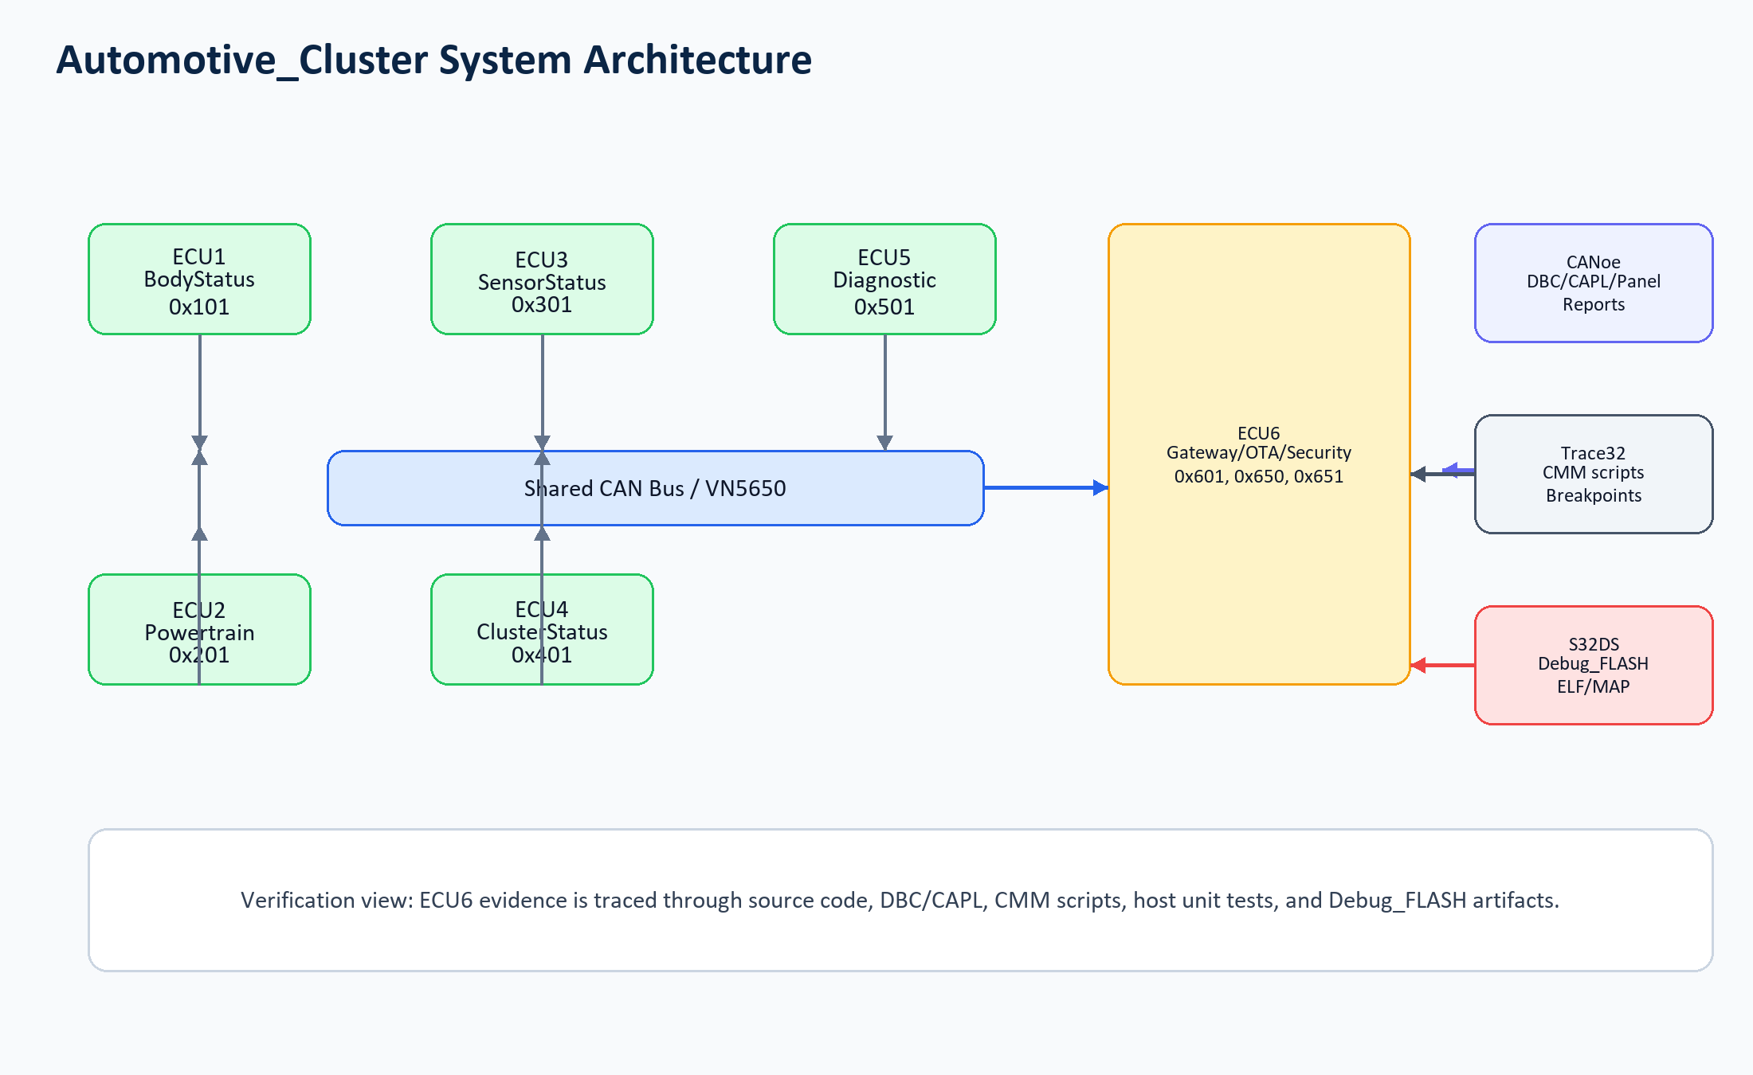
Figure 1. System architecture: evidence linkage across ECU6, CANoe, Trace32, and S32DS artifacts
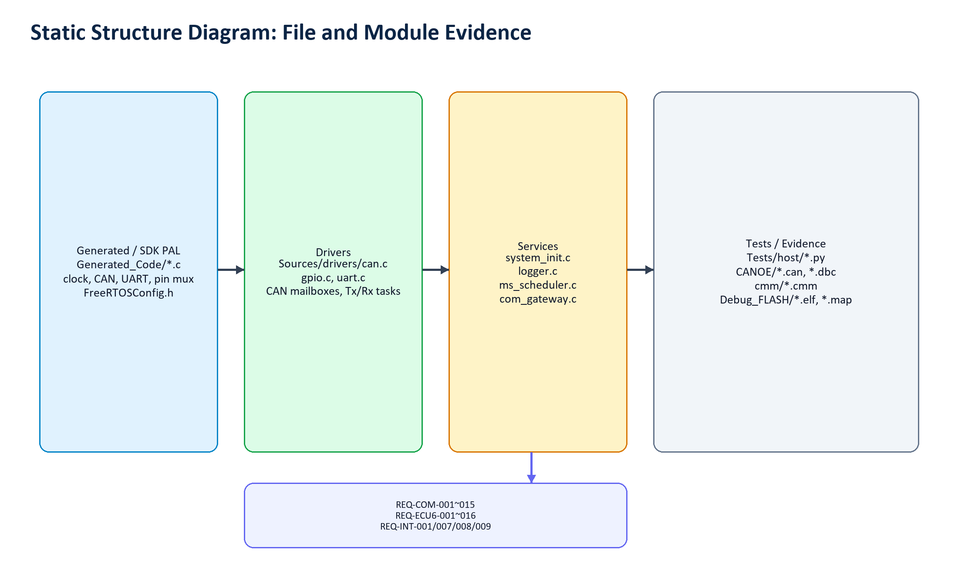
Figure 2. Static structure: Generated/SDK, Driver, Service, and Test/Evidence layers
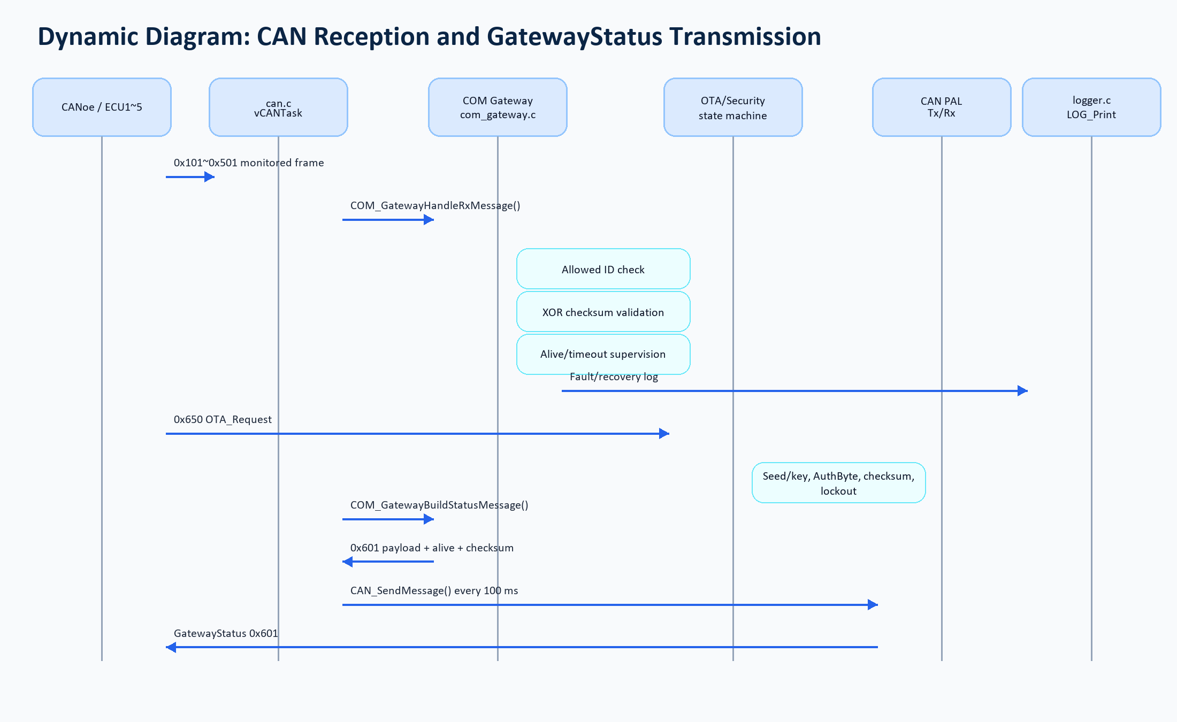
Figure 3. Dynamic flow: CAN reception, gateway validation, OTA/security, and 0x601 transmission
Function Area | Implementation Location | Key Evidence
Initialization/RTOS | Sources/main.c; Sources/services/system_init.c; Generated_Code/FreeRTOSConfig.h | Clock/pin/UART/CAN initialization, FreeRTOS task creation, 32 KB heap setting
CAN gateway | Sources/drivers/can.c; Sources/services/com_gateway.c | 0x101~0x501 reception, 0x601 transmission, unknown-ID catch-all, timeout/checksum/alive supervision
OTA/security | Sources/services/com_gateway.c; CANOE/ECU6_OTA_State_Test.can | 0x650/0x651, START/DATA/END/ACTIVATE/ABORT, seed/key, AuthByte, lockout, ActiveSWVersion
Trace32 | cmm/init_debug.cmm; cmm/test_debug.cmm; cmm/gateway_debug.cmm; cmm/ota_debug.cmm; cmm/security_debug.cmm | Debug entry, breakpoints, watched variables, interrupt/scheduler evidence capture scripts
CANoe | CANOE/6_ECUs_dbc_0206.dbc; CANOE/*.can; Configuration1.cfg | Six-ECU DBC, ECU simulator CAPL, Gateway/OTA CAPL tests, panel bridge, and binary report artifacts

Build and Execution Verification Results
- Debug_FLASH/Automotive_Cluster.elf (2,342,192 bytes) and Debug_FLASH/Automotive_Cluster.map (594,806 bytes) were observed.
- The map file contains vCANTask, OTA_HandleRequestMessage, COM_GatewayBuildStatusMessage, and vComSchedulerTask symbols.
- powerpc-eabivle-gcc and make were not found in the current shell PATH, so Codex did not perform an S32DS rebuild.
- S32DS flash/run stability for 10 minutes, UART boot logs, Trace32 screenshots, and readable CANoe verdict exports still require confirmation.

Test Verification Results
Test | Command/Tool | Result | Related Requirements
Host unit tests | python -m unittest discover -s Tests/host -p "test_*.py" -v | 9/9 pass | REQ-COM-005/007/015, REQ-ECU6-002/003/004/009/010/011/013/015, REQ-INT-007/008
Gateway CAPL tests | CANOE/ECU6_Gateway_Test.can | Test assets and binary report exist; readable verdict export required | REQ-COM-003/011, REQ-ECU6-001/002/003/006/014, REQ-INT-009
OTA/security CAPL tests | CANOE/ECU6_OTA_State_Test.can | Test assets and binary report exist; readable verdict export required | REQ-ECU6-005~013/015, REQ-INT-007/008

Unconfirmed or Insufficient Evidence Items
- REQ-COM-001, REQ-COM-003, REQ-COM-004, and REQ-INT-001 are Partially Compliant because implementation/test assets exist but final runtime evidence is incomplete.
- The 56 ECU1 through ECU5 board-specific requirements and REQ-INT-002 through REQ-INT-006 cannot be marked compliant from the ECU6-focused workspace evidence.
- CANoe .vtestreport files exist, but PASS/FAIL verdicts were not readable by text search and were therefore not used as final verdict evidence.

Conclusion
The Automotive_Cluster workspace satisfies most of the ECU6 Gateway + OTA + Security active scope at code, documentation, and host-unit-test level. It does not yet provide enough evidence to prove full compliance for all 96 requirements because ECU1 through ECU5 board implementations and several full-system runtime artifacts are missing. This report therefore records 31 Compliant, 4 Partially Compliant, and 61 Needs Confirmation requirements.

Appendix: File Paths, Log Summary, Test Commands, Key Configuration Values
Item | Value
Source requirement document | MPC5748G_Embedded_Training_Requirements_EN.docx
Host test log | Documentation\ecu6_gateway\evidence\host_unit_tests_2026-06-04.txt
Host test command | C:\Users\JunsangS\.cache\codex-runtimes\codex-primary-runtime\dependencies\python\python.exe -m unittest discover -s Tests/host -p \"test_*.py\" -v
CAN ID set | 0x101, 0x201, 0x301, 0x401, 0x501, 0x601, 0x650, 0x651
Key settings | CAN_NODE_COUNT=6, CAN_TX_PERIOD_MS=100, LOG_BUFFER_SIZE=256, configTOTAL_HEAP_SIZE=32768

