ECU6 CAN Gateway Requirements Implementation Design
Summary for REQ-COM-005/006/007 and REQ-ECU6-001~004/014
Source files: Sources/drivers/can.c, Sources/services/com_gateway.c, Sources/automotive.h
Generated: 2026-05-22

1. Overview
The implementation separates CAN driver responsibilities from ECU6 Gateway service logic.
- can.c handles CAN PAL wrapping, mailbox setup, receive polling, and the 100 ms transmit trigger.
- com_gateway.c handles allowed CAN ID monitoring, timeout, alive counter, checksum, and GatewayStatus payload creation.
- 0x601 GatewayStatus is the ECU6 primary status message transmitted to All/CANoe.

2. Requirement Mapping
Requirement | Priority | Purpose | Implementation
REQ-COM-005 | P0 | Critical CAN/external input timeout monitoring | Monitors 0x101~0x501 reception with a 300 ms timeout and reports faults through AliveError, GatewayState, and logs
REQ-COM-006 | P0 | 4-bit alive counter in primary status message | Places aliveCounter in the lower nibble of 0x601 Byte6 and wraps 0~15
REQ-COM-007 | P0 | Simple checksum in primary status message | Generates checksum for 0x601 and validates received checksums for 0x101~0x501
REQ-ECU6-001 | P0 | Monitor or route allowed CAN IDs | Accepts only 0x101, 0x201, 0x301, 0x401, and 0x501 as monitored IDs
REQ-ECU6-002 | P0 | Block or count unknown CAN IDs | Increments BlockedMsgCnt and logs when an unknown ID is received
REQ-ECU6-003 | P0 | Validate checksum for monitored primary messages | Sets ChecksumError, increments BlockedMsgCnt, and logs on checksum mismatch
REQ-ECU6-004 | P0 | Monitor alive counters for selected ECUs | Sets AliveError when the same alive counter is repeated 3 times
REQ-ECU6-014 | P0 | Send GatewayStatus on CAN ID 0x601 every 100 ms | vCANTask calls COM_GatewayBuildStatusMessage() and CAN_SendMessage() every 100 ms

3. Software Architecture
Supervision is in com_gateway.c; CAN hardware access remains in can.c.
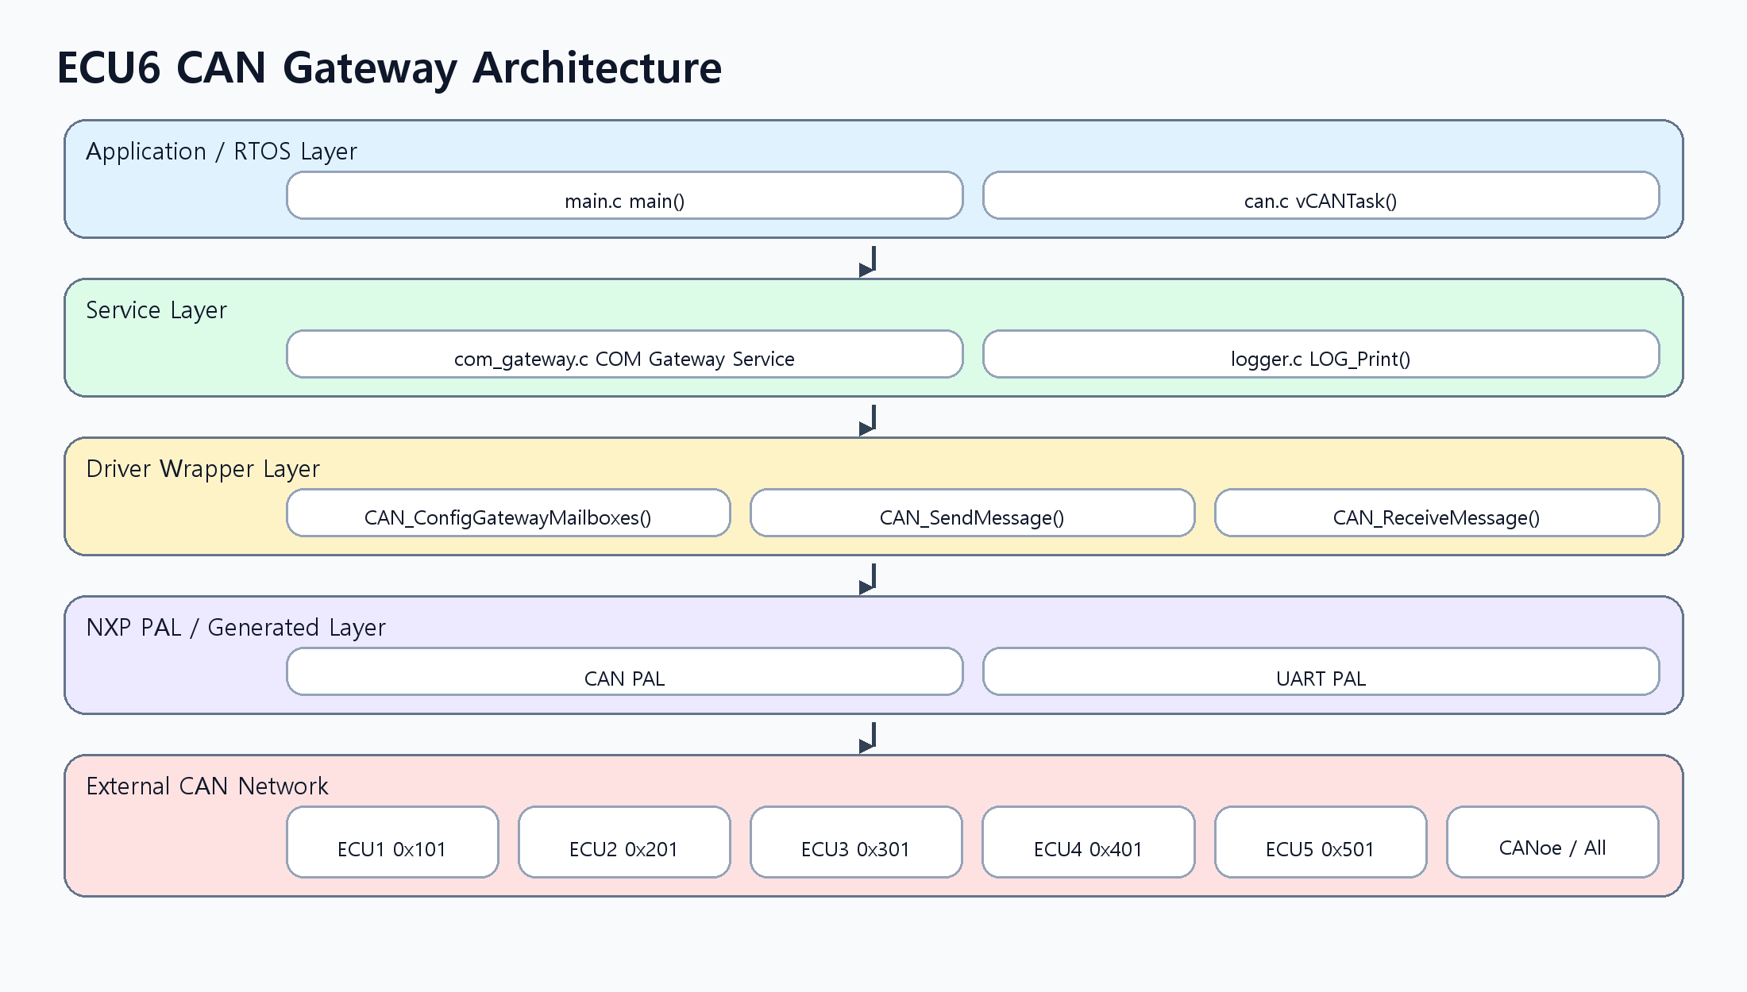

4. Function Sequence
The sequence below shows how a received frame is validated and how 0x601 is periodically transmitted.
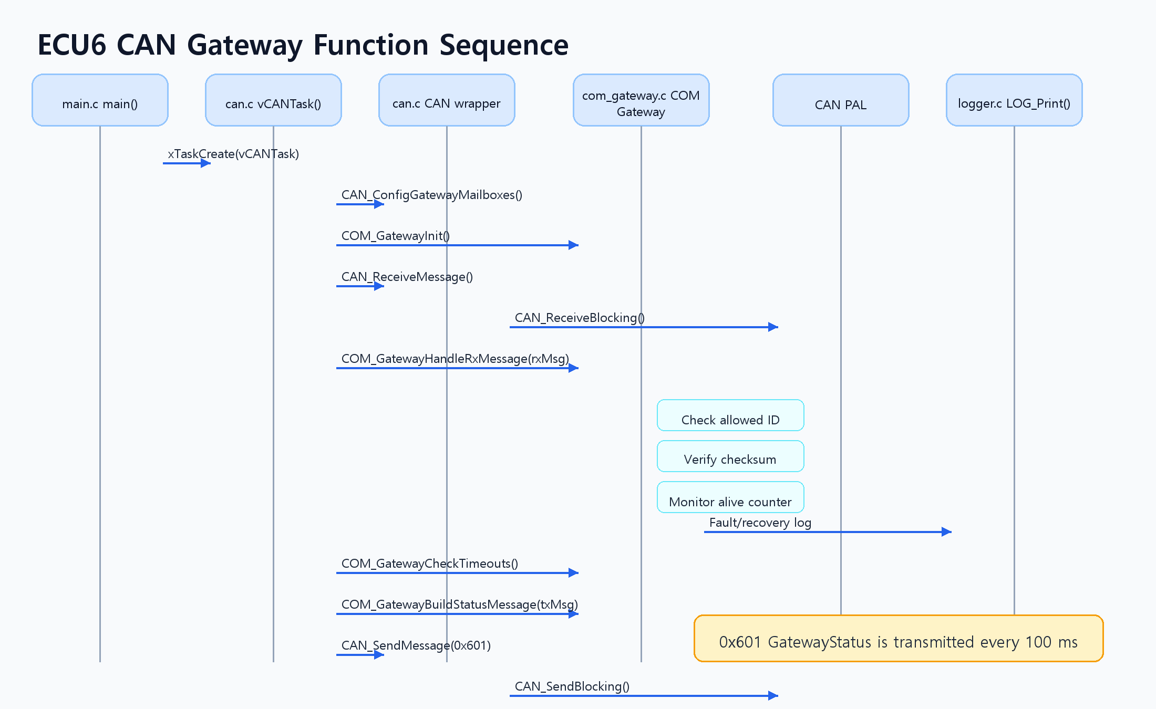

5. Function Responsibility Table
File | Function | Responsibility
can.c | CAN_ConfigGatewayMailboxes() | Configures RX/TX mailboxes used by ECU6 gateway communication.
can.c | CAN_ReceiveMessage() | Wraps CAN PAL CAN_ReceiveBlocking() for gateway reception.
can.c | CAN_SendMessage() | Transmits a prepared CAN frame through the ECU6 TX mailbox.
can.c | vCANTask() | Runs receive polling, timeout supervision, and 100 ms GatewayStatus transmission.
com_gateway.c | COM_GatewayInit() | Initializes the monitor table, GatewayStatus state, alive/checksum/error flags.
com_gateway.c | COM_GatewayHandleRxMessage() | Processes received frame ID filtering, checksum, alive counter, and timeout recovery.
com_gateway.c | COM_GatewayCheckTimeouts() | Checks 300 ms timeout using each monitored ID's lastRxTick.
com_gateway.c | COM_GatewayBuildStatusMessage() | Builds 0x601 GatewayStatus payload, alive counter, and checksum.
com_gateway.c | COM_CalculateChecksum() | Calculates checksum by XORing CAN_ID_LSB with data[0]~data[6].
com_gateway.c | COM_VerifyChecksum() | Compares received data[7] against the calculated checksum.
com_gateway.c | COM_UpdateAliveMonitor() | Supervises whether the Byte6 lower-nibble alive counter stops changing.
automotive.h | function prototypes | Publishes CAN wrapper and COM Gateway service signatures.

6. GatewayStatus 0x601 Payload
The current DLC 8 layout packs error flags into Byte1 and keeps Byte6/Byte7 for alive/checksum.
Byte | Signal | Meaning
Byte0 | GatewayState | 0=INIT, 1=NORMAL, 2=DEGRADED
Byte1 | OTA/security/error flags | bit0~2 OTAState, bit3 SecurityUnlocked, bit4 SecurityLocked, bit5 AliveError, bit6 ChecksumError
Byte2 | BlockedMsgCnt | Saturating count for unknown ID or checksum error
Byte3 | SecurityErrorCounter | Reserved security error counter, currently initialized
Byte4 | ActiveSWVersion | Currently active software version
Byte5 | GatewayRxMask | Bit mask showing received monitored ECU1~ECU5 messages
Byte6 | AliveCounter | Lower 4 bits, wraps 0~15
Byte7 | Checksum | CAN_ID_LSB ^ Byte0 ^ ... ^ Byte6

7. Checksum and Alive Counter Rules
Checksum is calculated with the requested simple XOR rule. The same function is used for GatewayStatus generation and monitored primary-message validation.
checksum = CAN_ID_LSB ^ data[0] ^ data[1] ^ data[2]
^ data[3] ^ data[4] ^ data[5] ^ data[6];
- AliveCounter uses the lower 4 bits of Byte6.
- ECU6 transmit aliveCounter increments from 0 to 15 and wraps to 0.
- A received alive counter repeated for 3 consecutive checks is treated as an alive freeze fault.
- Checksum mismatch sets GatewayChecksumError and increments BlockedMsgCnt.

8. Verification Points
Test | Fault Injection | Expected Result
Timeout | Stop a monitored message such as 0x301 in CANoe | After 300 ms: 0x601 AliveError=1, GatewayState=DEGRADED, UART timeout log
Unknown ID | Inject an unknown CAN ID | BlockedMsgCnt increments and blocked log is emitted
Checksum | Corrupt Byte0~Byte6 or Byte7 | ChecksumError=1, BlockedMsgCnt increments, checksum error log
Alive | Freeze a selected ECU alive counter | After 3 repeats: AliveError=1 and alive frozen log
0x601 Period | Observe 0x601 in CANoe trace | 100 ms periodic transmission and alive counter wraps 0~15

