REQ-COM-001 to REQ-COM-003
Design, Test, and Traceability Report
MPC5748G Automotive Cluster & Gateway Training

Item | Value
Project | Automotive_Cluster
Target | MPC5748G / S32DS Power / FreeRTOS
Scope | REQ-COM-001, REQ-COM-002, REQ-COM-003
Source Code Baseline | Sources/main.c, Sources/services/*.c, Sources/drivers/*.c
Prepared For | Training review / mentor schedule evidence

Implementation Status: REQ-COM-001 and REQ-COM-002 are implemented in source code. REQ-COM-003 transmit and receive handling are implemented in source code; final pass evidence requires CANoe trace or live bus demonstration.

1. Requirement Analysis
Req ID | Requirement Summary | Verification Method | Acceptance Criteria | Evidence
REQ-COM-001 | Initialize system clock, GPIO, UART, CAN controller, timer/scheduler, and required interrupts. | Inspection + Testing + Live Demo | Board boots, prints boot log, toggles heartbeat LED, and runs for at least 10 minutes without abnormal reset. | Initialization code, UART log, live demo.
REQ-COM-002 | Provide UART logging with consistent format: [time][ECUx][module][level] message. | Inspection + Testing | Boot/init/CAN/application events visible; logging does not flood the system. | logger.c, UART terminal screenshot/log file.
REQ-COM-003 | Transmit at least one periodic CAN message and receive at least one CAN message from another ECU or CANoe. | Inspection + Integration Testing + CANoe Test | CANoe trace shows periodic Tx and received messages are processed/observable. | can.c, CANoe trace screenshot/log, DBC decode evidence.

2. Implementation Summary
Component | Source Evidence | Implemented Behavior | Covered Req
Boot / scheduler | Sources/main.c | Calls system_init(), can_init(), creates InitLog, LED, and CAN tasks, then starts FreeRTOS scheduler. | REQ-COM-001
Clock/GPIO/UART init | Sources/services/system_init.c | Initializes clock manager, pin mux, and UART PAL. | REQ-COM-001
CAN init | Sources/services/system_init.c, Generated_Code/can_pal1.c | Initializes CAN PAL over FlexCAN0 in normal mode with 8-byte payload. | REQ-COM-001, REQ-COM-003
UART logger | Sources/services/logger.c | Formats [time][ECU6][module][level] message and transmits through UART. | REQ-COM-002
Heartbeat LED | Sources/drivers/gpio.c | Toggles DS4 on PA10 from a FreeRTOS task. | REQ-COM-001
CAN gateway task | Sources/drivers/can.c | Receives allowed ECU IDs 0x101..0x501, tracks gateway state, and transmits ECU6 status ID 0x601 every 100 ms. | REQ-COM-003

3. Debug Issues and Corrective Actions
Issue | Root Cause | Corrective Action | Prevention / Evidence
UART printed only the first character | UART PAL was configured for interrupt-based transmit. The first byte is written directly, but remaining bytes require TX interrupt and FreeRTOS OSIF semaphore completion. LOG_Print was called before vTaskStartScheduler(). | Move boot logging into vInitLogTask so LOG_Print runs after scheduler start. | Inspect main.c and logger.c; verify complete UART boot strings.
DevAssert during logging | InitLog task stack was too small for 256-byte log buffer, snprintf(), UART driver, and OSIF calls. | Increase task stack to configMINIMAL_STACK_SIZE * 2. | Enable stack overflow hook in future; observe no DevAssert during boot log.
Scheduler failed after CAN added | CAN driver creates many semaphore/RTOS objects. FreeRTOS heap of 8192 bytes was too small, so idle/timer task allocation failed. | Increase configTOTAL_HEAP_SIZE to 32768. | Debug stopped at errCOULD_NOT_ALLOCATE_REQUIRED_MEMORY before fix; scheduler starts after fix.
Queue registry warning | configQUEUE_REGISTRY_SIZE was 0 while queue registry API was enabled in FreeRTOS component. | Set configQUEUE_REGISTRY_SIZE > 0 if queue registry is needed. | Recommended value: 8 for debug object visibility.
DS4 LED did not toggle after changing LED macro only | DS4 is PA10, but PA10 also needs pin mux GPIO output with OBE enabled. | Configure PA10 in PinSettings as GPIO output and enable OBE. | pin_mux.c shows PA10 output buffer enabled after regeneration.

4. Software Architecture Design
Architecture separates generated peripheral configuration, initialization services, drivers/tasks, and application-level communication behavior.
Layer | Modules | Responsibility
Generated / SDK PAL | Generated_Code/*.c, can_pal1, uart_pal1, pin_mux, clockMan1 | Hardware abstraction and generated configuration.
Service layer | system_init.c, logger.c | Boot-time initialization and common UART logging service.
Driver/task layer | gpio.c, can.c, uart.c | FreeRTOS task behavior for heartbeat, CAN gateway, and UART callback support.
Scheduler integration | main.c | Task creation and scheduler start ordering.

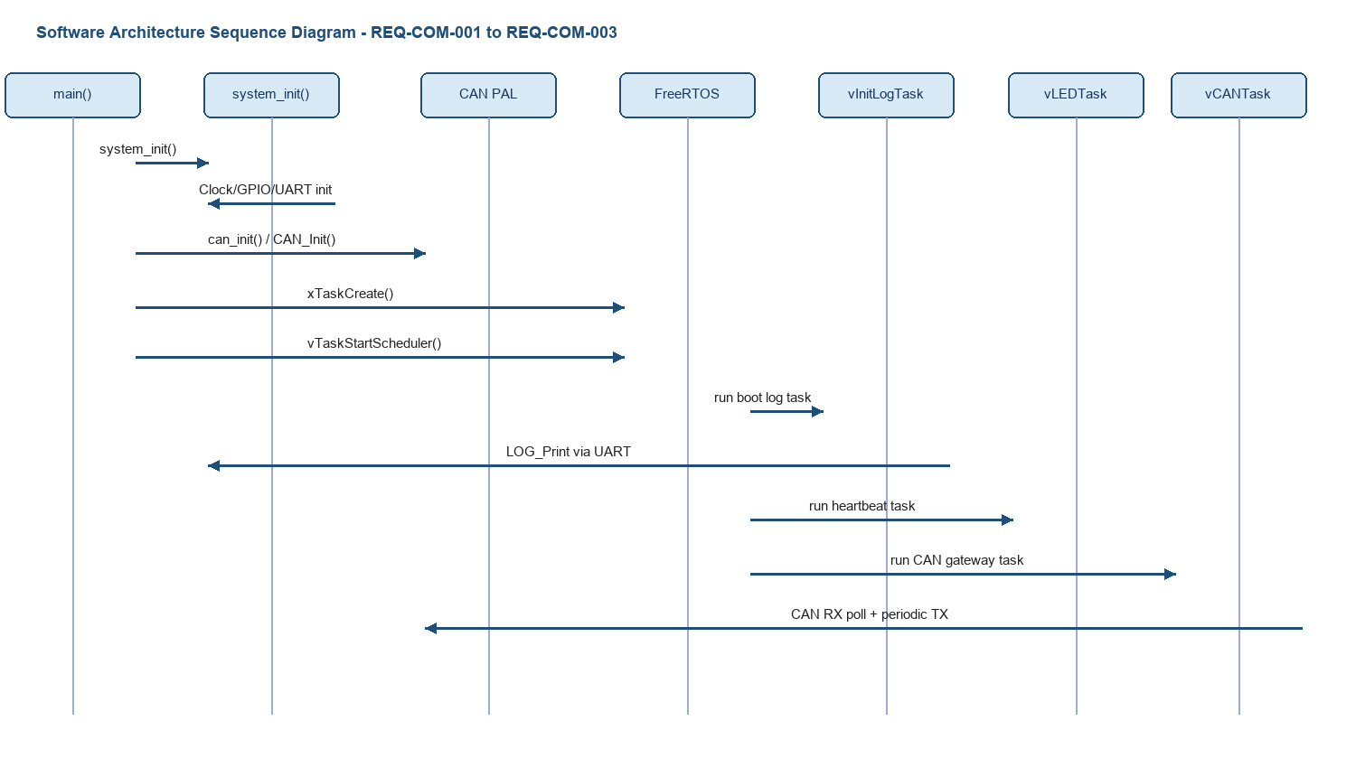

5. Software Unit Design
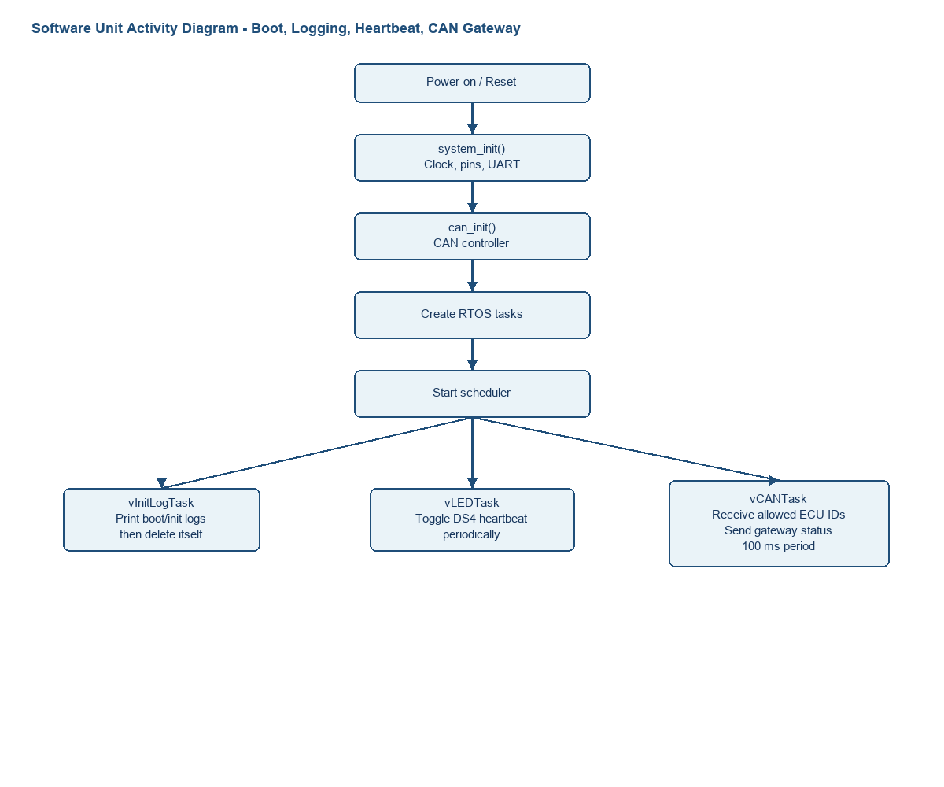
Unit | Inputs | Processing | Outputs
system_init() | None | PEX_RTOS_INIT, clock configuration, pin mux initialization, UART_Init. | Initialized clock/GPIO/UART.
can_init() | None | CAN_Init using can_pal1_Config0. | Initialized CAN controller.
LOG_Print() | module, level, message | Timestamp with xTaskGetTickCount, format log buffer, UART_SendDataBlocking. | UART log line.
vInitLogTask() | FreeRTOS task start | Prints boot/init logs after scheduler starts, then deletes itself. | Boot evidence over UART.
vLEDTask() | LED ID parameter | Delay, clear LED pin, delay, set LED pin. | Heartbeat LED blink.
vCANTask() | CAN frames from bus | Configures RX/TX buffers, accepts IDs 0x101..0x501, updates gateway state, sends 0x601 status every 100 ms. | CAN gateway status frame and CAN RX log.

6. Software Unit Test
Test ID | Unit | Method | Expected Result | Req
UT-COM-001 | system_init() | Inspection + debug stepping | Clock, pins, and UART init complete without assert. | REQ-COM-001
UT-COM-002 | can_init() | Inspection + debug stepping | CAN_Init returns STATUS_SUCCESS or no assert. | REQ-COM-001/003
UT-COM-003 | LOG_Print() | UART terminal test | Complete formatted line appears, not first-character-only. | REQ-COM-002
UT-COM-004 | vLEDTask() | Live board observation | DS4 toggles periodically. | REQ-COM-001
UT-COM-005 | vCANTask Tx | CANoe trace | ID 0x601 is sent every 100 ms with DLC 8. | REQ-COM-003
UT-COM-006 | vCANTask Rx dispatch | CANoe injection or unit inspection | IDs 0x101..0x501 update gateway state; other IDs increment blocked count. | REQ-COM-003

7. Software Integration Test
Test ID | Integrated Scope | Procedure | Expected Result
IT-COM-001 | FreeRTOS + UART | Run board and observe boot after vTaskStartScheduler. | Boot/init logs print completely.
IT-COM-002 | FreeRTOS + GPIO | Run LED task concurrently with logger/CAN task. | Heartbeat continues without abnormal reset.
IT-COM-003 | CAN + FreeRTOS heap | Start scheduler after CAN_Init with 32768 heap. | No errCOULD_NOT_ALLOCATE_REQUIRED_MEMORY assert.
IT-COM-004 | CAN Rx + CAN Tx | Inject IDs 0x101..0x501 and observe gateway status 0x601. | Gateway status reflects accepted messages.
IT-COM-005 | UART + CAN | Receive allowed CAN frame. | CAN RX accepted log appears without flooding.

8. Software System Test
Test ID | System Scenario | Evidence | Pass Criteria | Req
ST-COM-001 | Power-on boot | UART terminal and live demo | Boot log appears and no reset. | REQ-COM-001/002
ST-COM-002 | 10-minute stability run | Live demo / Trace32 watch | Heartbeat LED continues and no abnormal reset. | REQ-COM-001
ST-COM-003 | CAN periodic transmit | CANoe trace | ECU6 gateway status 0x601 appears every 100 ms. | REQ-COM-003
ST-COM-004 | CAN receive from CANoe/ECU | CANoe trace + UART log | Allowed ECU messages are accepted and reflected in gateway state. | REQ-COM-003
ST-COM-005 | UART log format | Saved UART log | Log line follows [time][ECU6][module][level] message. | REQ-COM-002

9. Traceability Report
Req | SAD Element | SUD Units | UT | IT | ST | Status
REQ-COM-001 | Boot and scheduler sequence | main, system_init, can_init, vInitLogTask, vLEDTask | UT-COM-001, UT-COM-002, UT-COM-004 | IT-COM-001, IT-COM-002, IT-COM-003 | ST-COM-001, ST-COM-002 | Implemented; final 10-minute evidence required.
REQ-COM-002 | UART logging after scheduler start | LOG_Print, vInitLogTask, CAN_LOG_PrintRx | UT-COM-003 | IT-COM-001, IT-COM-005 | ST-COM-001, ST-COM-005 | Implemented; screenshot/log evidence required.
REQ-COM-003 | CAN gateway task sequence | can_init, vCANTask, processGatewayRxMessage, fillGatewayStatusMessage | UT-COM-002, UT-COM-005, UT-COM-006 | IT-COM-004, IT-COM-005 | ST-COM-003, ST-COM-004 | Implemented in source; CANoe trace evidence required.

10. Open Evidence Checklist
Evidence Item | Needed For | Owner Action
UART boot log screenshot or saved terminal log | REQ-COM-001, REQ-COM-002 | Capture after boot with complete formatted lines.
CANoe trace for ID 0x601 periodic Tx | REQ-COM-003 | Run board with CANoe and save trace.
CANoe injection/trace for IDs 0x101..0x501 Rx | REQ-COM-003 | Inject at least one accepted frame and verify gateway status/log.
10-minute no reset observation | REQ-COM-001 | Run board continuously and record result.
Trace32 screenshot or debug evidence | REQ-COM-001 | Optional but useful for scheduler/task evidence.

