Business project

Recruitment agency

Petar Nikić

Contents
1 Business Description 3
1.1 Business background 3
1.2 Problems. Current Situation 3
1.3 The benefits of implementing a database. Project Vision 3
2 Model description 4
2.1 Definitions & Acronyms 4
2.2 Logical Scheme 4
2.3 Objects 5

Business Description

Business background
A recruitment agency connects job-seeking candidates with client companies. The agency publishes job listings, screens and registers candidates, and manages the hiring pipeline from application through interviews to placement. To improve candidate outcomes and generate additional revenue, the agency also offers paid services such as resume/CV writing, interview coaching, and skills development sessions delivered by agency staff.

Problems. Current Situation
Data is scattered across spreadsheets, emails, and messaging tools. Duplicate entries and inconsistent naming make candidate/job search slow and easy to make mistakes. There’s no single source to see where each application sits in the pipeline or which services a candidate purchased. Matching based on skills/experience/location is manual, and reporting takes a lot of labor.

the Benefits of implementing a database. Project Vision
This database puts all the agency’s info in one clean place: candidates, jobs, applications, interviews, placements, skills, and extra services. It helps match people to the right jobs using their skills and experience, tracks each person from sign-up to hire, and shows which staff member is responsible. It also lets us sell and schedule things like CV help or coaching. With built-in rules to prevent duplicates and mistakes, data stays accurate. And we can easily see key stats like time to fill, best sourcing channels, stage-to-stage conversion, service revenue, and average number of interviews.

Model description

Definitions & Acronyms
- 3NF - Third Normal Form
- PK - Primary Key
- FK - Foreign Key
- UK - Unique Key
- CK - Check Constraint
- M:N - Many-to-many relationship
- 1:M – 1-many relationship

Logical Scheme
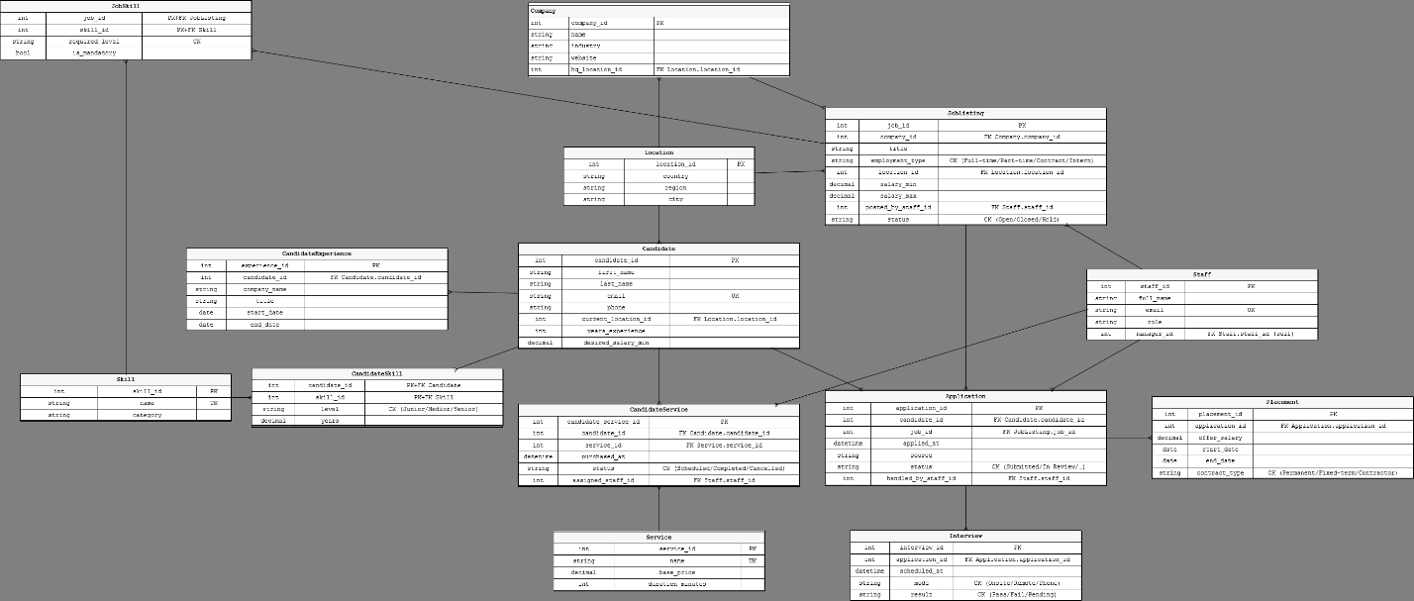

Objects

Table description:
- Company – Client companies posting jobs and stores HQ location.
- Location – Reusable places (country/region/city).
- Staff – Agency staff (recruiters/coaches) and optional manager.
- JobListing – Open roles (company, location, salary range, status).
- Candidate – Registered people (contact, location, experience, desired salary).
- CandidateExperience – Work history entries per candidate.
- Skill – Skill list.
- CandidateSkill – Bridge: Candidate↔Skill with level and years.
- JobSkill – Bridge: JobListing↔Skill with required level and mandatory flag.
- Application – Candidate applies to a Job, owned by Staff, status and source.
- Interview – Scheduled interviews for an Application.
- Placement – Final outcome for an Application (offer/start).
- Service – Paid services offered to candidates (coaching, CV).
- CandidateService – A purchased/scheduled service for a candidate, delivered by Staff.

Company:

Int | company_id | PK
string | name
string | industry
string | website
Int | hq_location_id | FK location.location_id
- Company.hq_location_id → Location.location_id (many companies can share one HQ location) - 1:N
- JobListing.company_id → Company.company_id (one company has many job listings) - 1:N
Example table:
company_id | name | industry | website | hq_location_id
12 | CompanyINC | manufacturing | companyinc.com | 10

Location:

int | location_id | PK
string | country
string | region
string | city

- Company.hq_location_id → Location.location_id (companies at a location) - 1:N
- JobListing.location_id → Location.location_id (jobs at a location) - 1:N
- Candidate.current_location_id → Location.location_id (candidates at a location) - 1:N

location_id | country | region | city
1 | Serbia | Eastern Serbia | Negotin

Staff:

int | staff_id | PK
string | full_name
string | email | UK
string | role
int | manager_id | FK staff.staff_id

- JobListing.posted_by_staff_id → Staff.staff_id (one staff member can post many jobs) - 1:N
- Application.handled_by_staff_id → Staff.staff_id (one staff member can own many applications) - 1:N
- CandidateService.assigned_staff_id → Staff.staff_id (one staff member delivers many service sessions) - 1:N
- Staff.manager_id → Staff.staff_id (many staff report to one manager) - 1:N (self) (Optional self-reference: manager_id → Staff.staff_id. (makes simple org chart without seperate managers table, if someone has no boss manager_id is NULL) )

staff_id | full_name | email | role | manager_id
5 | Petar Nikic | petarnikic@something.com | recruiter | 1

Job listing:

int | job_id | PK
int | company_id | FK company.company_id
string | title
string | employment_type | CK (full-time/part-time/intern)
int | location_id | FK location.location_id
decimal | salary_min
decimal | salary_max
int | posted_by_staff_id | FK staff.staff_id
string | status | CK (open/closed/hold)

- JobListing.company_id → Company.company_id (each job belongs to one company) - 1:N
- JobListing.location_id → Location.location_id (each job in one location) - 1:N
- JobListing.posted_by_staff_id → Staff.staff_id (job posted by one staff) - 1:N
- Application.job_id → JobListing.job_id (one job has many applications) - 1:N
- JobSkill.job_id → JobListing.job_id (one job has many required skills) - 1:N
⇒ JobListing ↔ Skill via JobSkill is M:N. (many to many)

job_id | company_id | title | employment_type | location_id | salary_min | salary_max | posted_by_staff_id | status
2 | 3 | data engineer | Full-time | 10 | 50000 | 100000 | 5 | open

Candidate:

int | candidate_id | PK
string | first_name
string | last_name
string | email | UK
string | phone
int | current_location_id | FK location.location_id
int | years_experience
decimal | desired_salary_min
- Candidate.current_location_id → Location.location_id (candidate lives in one location) - 1:N
- CandidateExperience.candidate_id → Candidate.candidate_id (one candidate has many experience rows) - 1:N
- Application.candidate_id → Candidate.candidate_id (one candidate has many applications) - 1:N
- CandidateSkill.candidate_id → Candidate.candidate_id (one candidate has many skill rows) - 1:N
⇒ Candidate ↔ Skill via CandidateSkill is M:N.
- CandidateService.candidate_id → Candidate.candidate_id (one candidate buys many services) - 1:N

candidate_id | first_name | last_name | email | phone | current_location_id | years_exp | desired_salary_min
14 | Petar | Nikic | petarnikic@something.com | +051/5535123 | Serbia | 5 | 50000

Candidate experience:

int | experience_id | PK
int | candidate_id | FK candidate.candidate_id
string | company_name
string | title
date | start_date
date | end_date
- CandidateExperience.candidate_id → Candidate.candidate_id (many experience rows per candidate) - 1:N

experience_id | candidate_id | company_name | title | start_date | end_date
51 | 14 | BigCompany | data engineer | 2022-1-1 | 2024-1-1

Skill:

int | skill_id | PK
string | name | UK
string | category
- CandidateSkill.skill_id → Skill.skill_id (one skill appears on many candidates) - 1:N
- JobSkill.skill_id → Skill.skill_id (one skill is required by many jobs) - 1:N
⇒ Supports both M:N bridges above.

skill_id | name | category
2 | Python | Programming

Candidate skill:

int | candidate_id | PK+FK candidate
int | skill_id | PK+FK skill
string | level | CK (junior/medior/senior)
decimal | years
- CandidateSkill has a composite primary key (candidate_id, skill_id). Each component is also a foreign key: candidate_id → Candidate(candidate_id), skill_id → Skill(skill_id). This prevents duplicate candidate–skill pairs

- CandidateSkill.candidate_id → Candidate.candidate_id (many rows per candidate) - 1:N
- CandidateSkill.skill_id → Skill.skill_id (many rows per skill) - 1:N
⇒ Candidate ↔ Skill is M:N through this table (composite PK: candidate_id + skill_id).

candidate_id | skill_id | level | years
301 | 23 | junior | 4

Job skill:

int | job_id | PK+FK JobLiting
int | skill_id | PK+FK skill
string | required_level | CK
bool | is_mandatory

- JobSkill.job_id → JobListing.job_id (many rows per job) - 1:N
- JobSkill.skill_id → Skill.skill_id (many rows per skill) - 1:N
⇒ JobListing ↔ Skill is M:N through this table (composite PK: job_id + skill_id).

job_id | skill_id | required_level | is_mandatory
15 | 24 | Medior | true

Application:

int | application_id | PK
int | candidate_id | FK candidate.candidate_id
int | job_id | FK joblisting.job_id
datetime | applied_at
string | source
string | status | CK (submitted, in review, etc)
int | handled_by_staff | FK staff.staff_id
- Application.candidate_id → Candidate.candidate_id (many applications per candidate) - 1:N
- Application.job_id → JobListing.job_id (many applications per job) - 1:N
- Application.handled_by_staff_id → Staff.staff_id (many applications per staff owner) - 1:N
- Interview.application_id → Application.application_id (one application can have many interviews) - 1:N
- Placement.application_id → Application.application_id (typically 0..1 placement per application) - 1:N (business rule 0..1), Each application can result in at most one placement

application_id | candidate_id | job_id | applied_at | source | status | handled_by_staff
123 | 321 | 2 | 2025-10-23 | Linkedin | Submited | 5

Interview:

int | interview_id | PK
int | application_id | FK application.
datetime | scheduled_at
string | mode | CK (onsite/remote/phone)
string | result | CK (pass/fail/pending)
- Interview.application_id → Application.application_id (many interviews for one application) - 1:N

interview_id | application_id | scheduled_at | mode | result
12 | 32 | 2024-12-12 12:00 | onsite | pending

Placement:

int | placement_id | PK
int | application_id | FK application.application_id
decimal | offer_salary
date | start_date
date | end_date
string | contract_type | CK (permanent/fixed)
- Permanent hires: end_date = NULL.
- Placement.application_id → Application.application_id (usually one placement per application) - 1:N (0..1)

placement_id | application_id | offer_salary | start_date | end_date | contract_type
12 | 32 | 50000.00 | 2

Service:

int | service_id | PK
string | name | UK
decimal | base_price
int | duration_minutes

- CandidateService.service_id → Service.service_id (one service type used in many bookings) - 1:N

service_id | name | base_price | duration_minutes
12 | Interview coaching | 100 | 60

Candidate Service:

int | candidate_service_id | PK
int | candidate_id | FK candidate.candidate_id
int | service_id | Fk service.service_id
datetime | purchased_at
string | status | CK (scheduled/completed/canceled)
int | assigned_staff_id | FK staff.staff_id

- CandidateService.candidate_id → Candidate.candidate_id (many bookings per candidate) - 1:N
- CandidateService.service_id → Service.service_id (many bookings per service type) - 1:N
- CandidateService.assigned_staff_id → Staff.staff_id (many bookings delivered by one staff) - 1:N

candidate_service_id | candidate_id | service_id | purchased_at | status | assigned_staff_id
123 | 32 | 41 | 2024-1-1 12:13 | completed | 15

