1. SELECT * FROM `tb_obat` ORDER BY nama DESC;

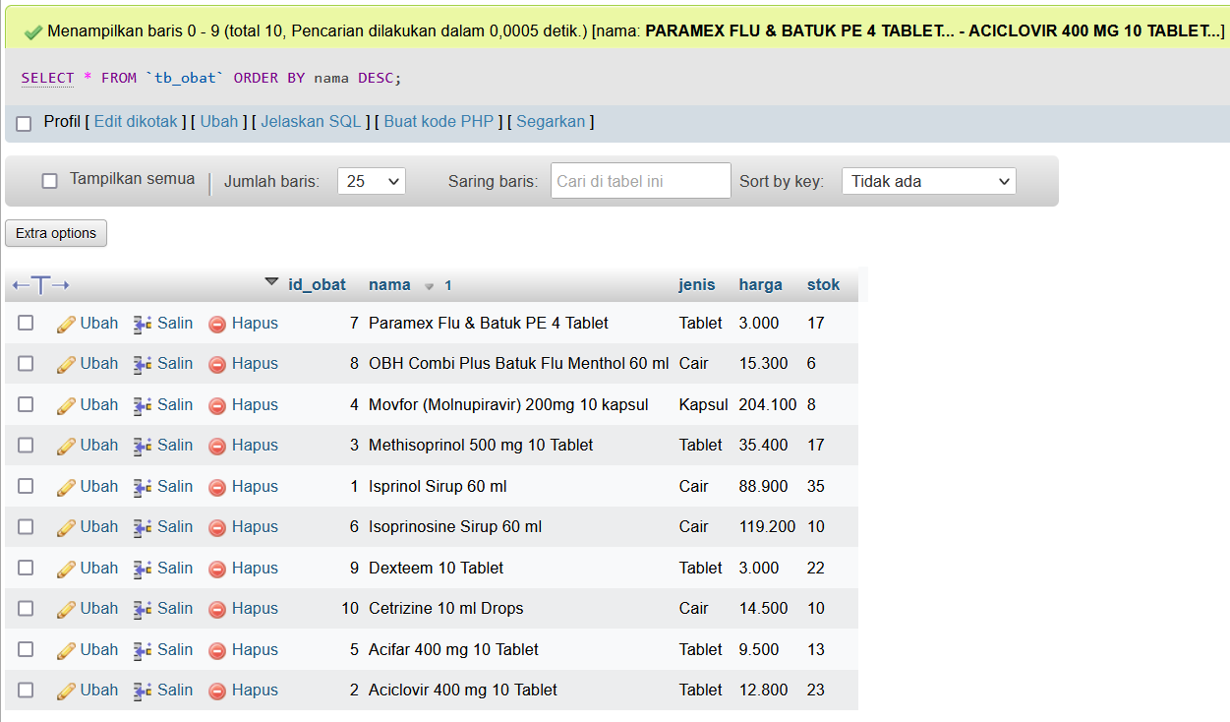

1. SELECT * FROM `tb_obat` WHERE jenis LIKE 'tablet';

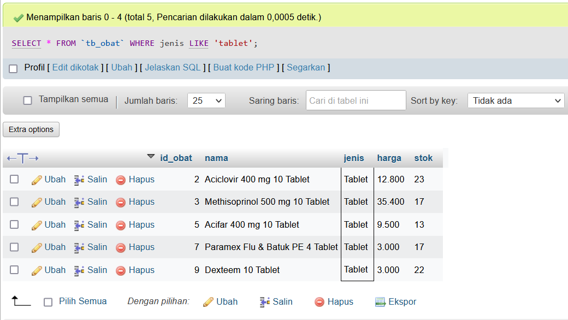

1. SELECT * FROM `tb_obat` WHERE nama LIKE '%ml%';

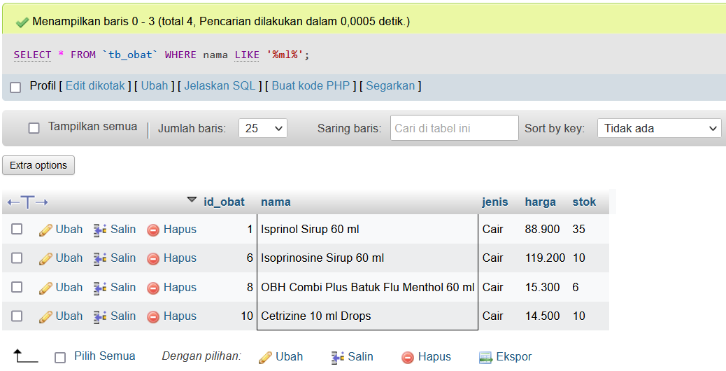

1. SELECT * FROM `tb_obat` WHERE harga >= 10.000;

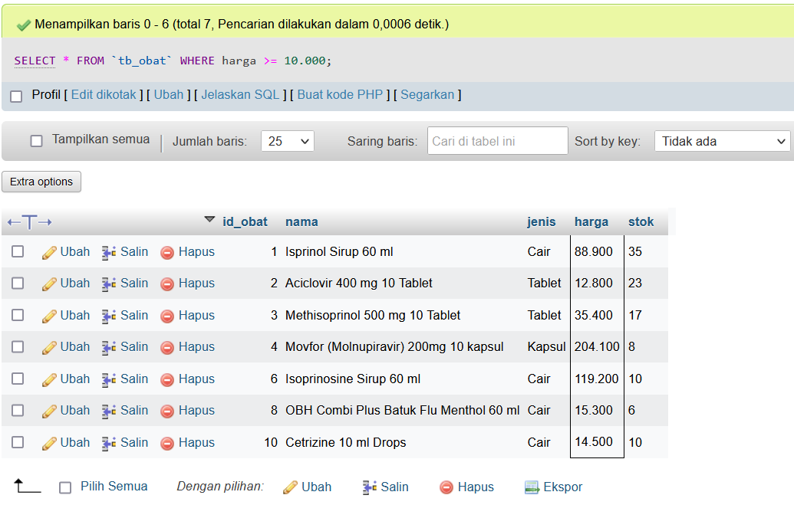

1. SELECT * FROM `tb_obat` WHERE harga < 20.000 ORDER BY nama DESC;

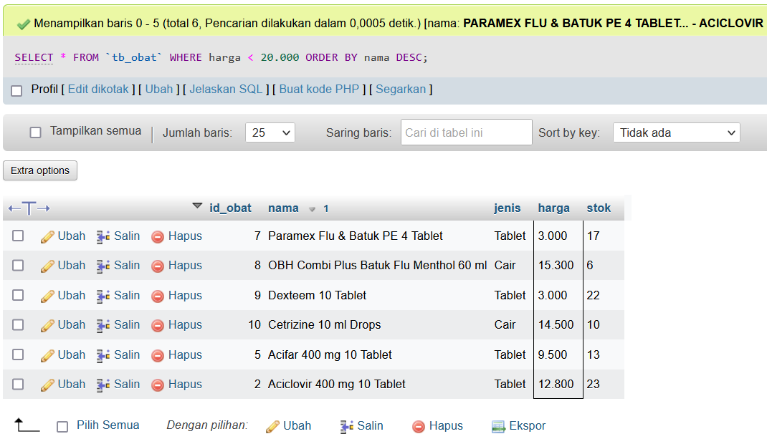

1. SELECT jenis, SUM(stok) as stok FROM `tb_obat` GROUP BY jenis;

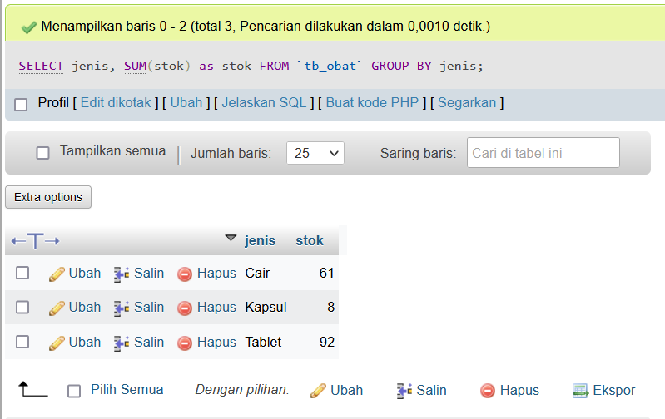

1. SELECT jenis, SUM(stok) as stok FROM `tb_obat` WHERE jenis LIKE '%cair%';

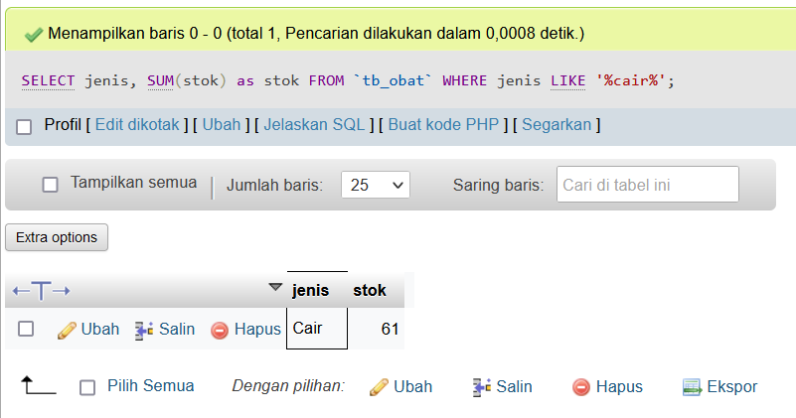

1. SELECT nama, jenis, harga FROM `tb_obat` WHERE jenis LIKE '%cair%' ORDER BY nama DESC;

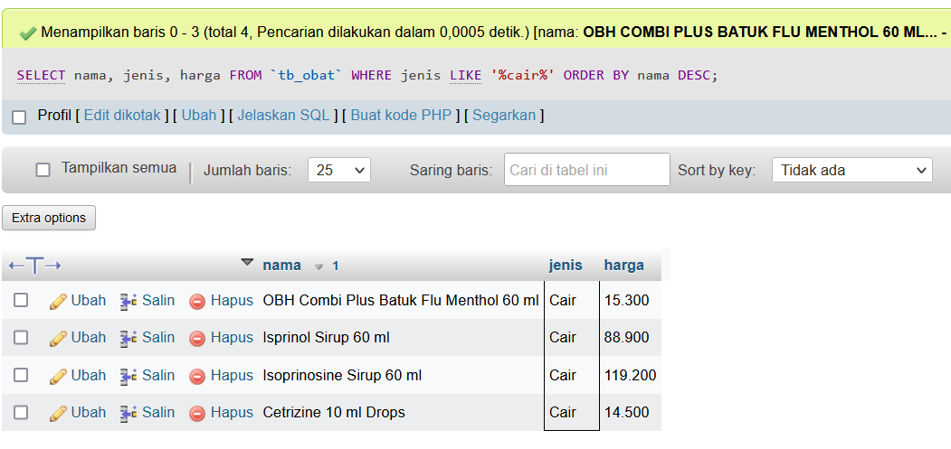

1. SELECT nama, jenis, harga FROM `tb_obat` WHERE harga > 100.000;

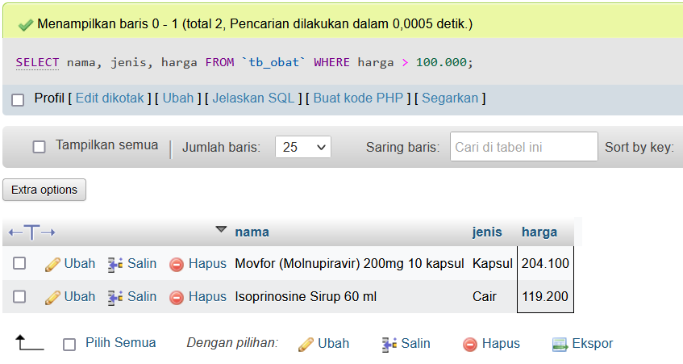

1. SELECT nama, jenis, harga, stok FROM `tb_obat` WHERE stok < 20 ORDER BY jenis DESC;

