1-

1. -2.5X 3Y
2. 1X 2Y
3. 2.5X 2Y
4. -1X 1Y
5. 0X 0Y
6. 2X -0.5Y
7. -0.5X -1.5Y
8. 0X -2Y
9. -3X -2Y

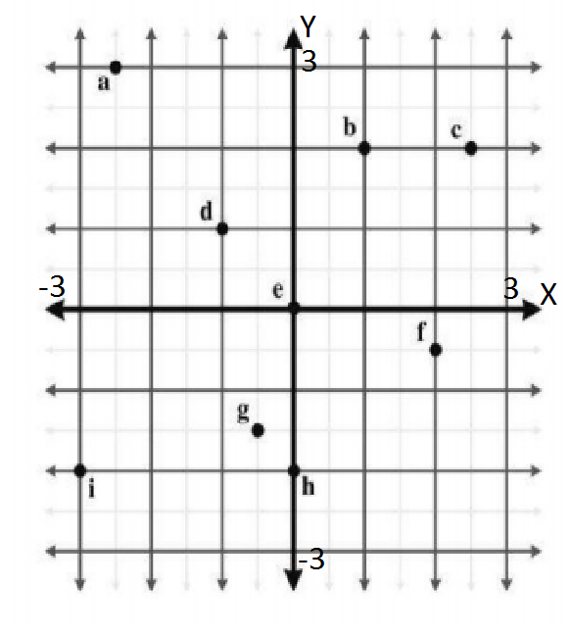

2-

1. 4Z 1X 2Y
2. -5Z -3X -3Y
3. 2.5Z -3X 6Y
4. -1Z 3X 0Y
5. 0Z 0X 0 Y
6. 3Z 0X 0Y
7. 0Z -3.5X 4Y
8. -1.5Z 5X -5Y

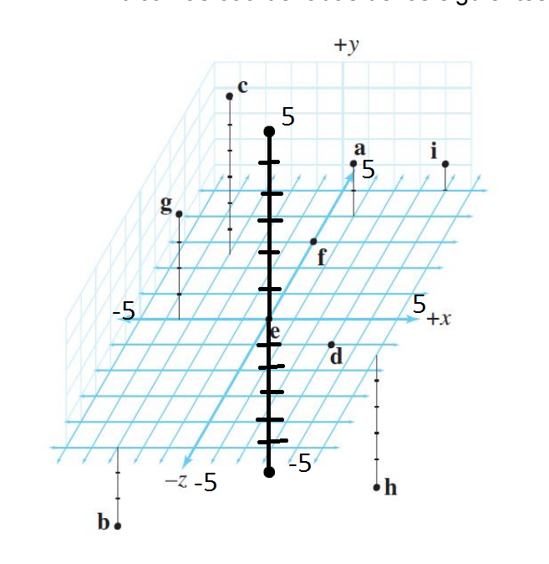

3-ZURDO

ESTE NORTE ARRIBA

|  |  |  |
| --- | --- | --- |
| X | Z | Y |
| Z | X- | Y |
| X- | Z- | Y |
| Z- | X | Y |
| X | Y | Z- |
| Y | X- | Z- |
| Y- | X | Z- |
| X- | Y- | Z- |
|  |  |  |
|  |  |  |
|  |  |  |
|  |  |  |
|  |  |  |
|  |  |  |
|  |  |  |
|  |  |  |
|  |  |  |
|  |  |  |
|  |  |  |
|  |  |  |
|  |  |  |
|  |  |  |
|  |  |  |
|  |  |  |

4-

1. DIESTRO
2. CAMBIAR EL SENTIDO DE X
3. QUEDA X-

5-

1. DIESTRO
2. CAMBIAR SENTIDO DE Y
3. QUEDA Y-

6-

1. CW
2. CCW

7-

1. CW
2. CCW

8-

1. 1+2+3+4+5 = 15
2. 2+4+6+8+10 = 30
3. 2*4*6*8*10 = 3840
4. 7*14*21*28 *35 = 2016840
5. 1+2+3+4….+100 =5050

9-

1. 0.16 π/rad
2. -0.25 π/rad
3. 0.33 π/rad
4. 0.5 π/rad
5. -1 π/rad
6. 1.25 π/rad
7. -1.5 π/rad
8. 0.93 π/rad
9. 2.92 π/rad
10. -6 π/rad

10-

1. -30°
2. 120°
3. 270°
4. -240°
5. 360°
6. 1°
7. 10°
8. -900°
9. 1800°
10. 36°

11-

Sin (a)/ (1/sin(a)) + cos(a)/ (1/cos(a)) = 1

Sin (a)/1/1/sin(a) + cos(a)/1/ 1/cos(a) = 1

Sin^2 (a) + cos^2(a)=1

(1/cos(θ))^2 – 1 / 1/cos(θ) = sin^2(θ)