CURRENT-STATE WEIGHTED / PUBLIC WEB  Dia  Current Brand System  & Public Asset Atlas  A working reference for visual language, voice, assets, motion, product storytelling, and historical lineage.  OBSERVED 03 AUG 2026  CURRENT 78% / LINEAGE 22% | 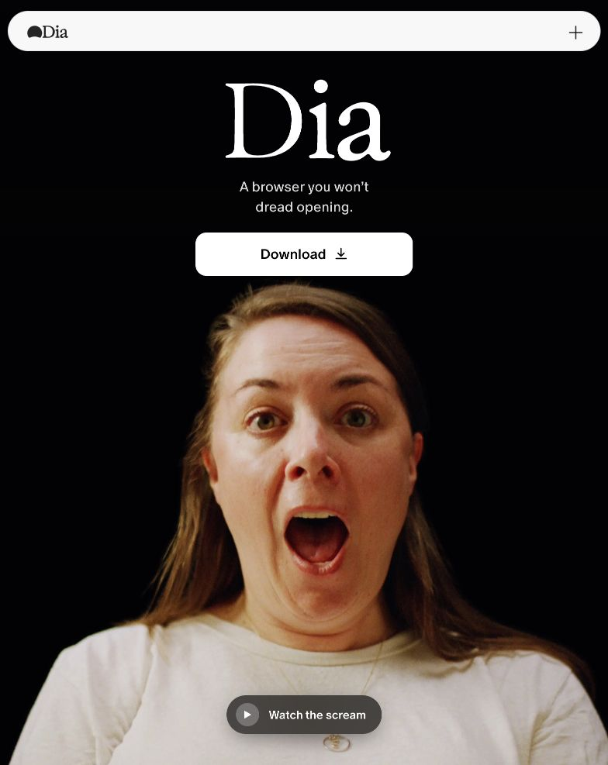

HOW TO READ THIS

A current brand guide with a forensic appendix
The main body explains Dia as it exists now. The historical section is retained to show which ideas persisted, which were discarded, and where the present system came from.
THE SHORT READ
Dia has moved from explaining an AI browser to dramatizing a better workday. The brand now makes a conspicuous emotional promise, then proves it through calm editorial outputs, browser-native context, and an unusually authored release culture.

Collection boundary
- Current public HTML and CSS across the main brand, product, work, students, skills, security, release-notes, Windows, and Reports surfaces.
- Public Sanity content and asset records, including images, Mux video references, downloadable animation files, skills, packs, and release systems.
- A deduplicated Wayback capture index from 2024–2026 plus selected rendered moments at major brand transitions.
- A filtered language corpus of brand pages and release communication, excluding the internal-looking public test article.

What this is not
This is not an official brand book and it does not grant reuse rights. It cannot recover authenticated, unpublished, privately held, deleted, or robots-blocked material. Fonts and third-party art are identified for reference; licensed binaries are not redistributed.
304  public content documents | 875  public image-asset records | 263  Mux video-asset records
7,902  deduplicated Wayback records | 563  downloaded image previews | ~395 MB  reference archive on disk

01 / NOW

The current brand in one sentence
Dia sells relief from the fragmented workday: the browser carries context across tabs, turns it into useful synthesis, and gives the user a calmer sense of readiness.

The present hierarchy
ORDER | JOB | CURRENT EXPRESSION
1 | Emotional tension | Dread, hunting, prep, fragmentation, doing it alone.
2 | Browser-native advantage | Dia can see the context already distributed across tabs and work surfaces.
3 | Useful synthesis | Briefs, reports, notes, answers, memory, and meeting readiness.
4 | Human resolution | Start ahead; show up; move faster; have a better day.
5 | Trust layer | Privacy, control, security, company readiness, and clear provenance.

Why it feels different from generic AI marketing
- The homepage leads with emotion rather than model capability.
- AI is explained through continuity and outputs, not spectacle or futurist vocabulary.
- The interface is quiet enough to make the authored content—not the chrome—the hero.
- Dia repeatedly describes ordinary work: tabs, meetings, groups, reports, context, and the day ahead.
CURRENT BRAND AXIS
Raw emotion ↔ calm competence. Dia earns memorability with the first half and trust with the second.

02 / HOMEPAGE

One loud idea, then authored proof
The current homepage behaves like an emotional cold open followed by an editorial product demonstration.
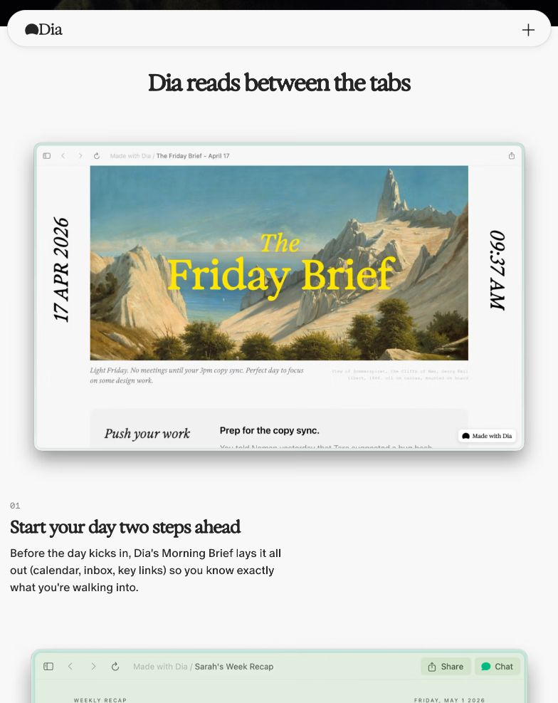
Figure 1. Current homepage after the hero: an authored “Friday Brief” inside browser chrome. Source: current Dia homepage, observed 2026-08-03.
Read: The product claim becomes credible when it is embodied as a designed artifact. The landscape illustration, vertical date, report typography, and browser frame make synthesis feel authored rather than autogenerated.

02 / HOMEPAGE

The scroll choreography is the argument
Dia stages the product as a sequence of situations, not a grid of equal-weight features.
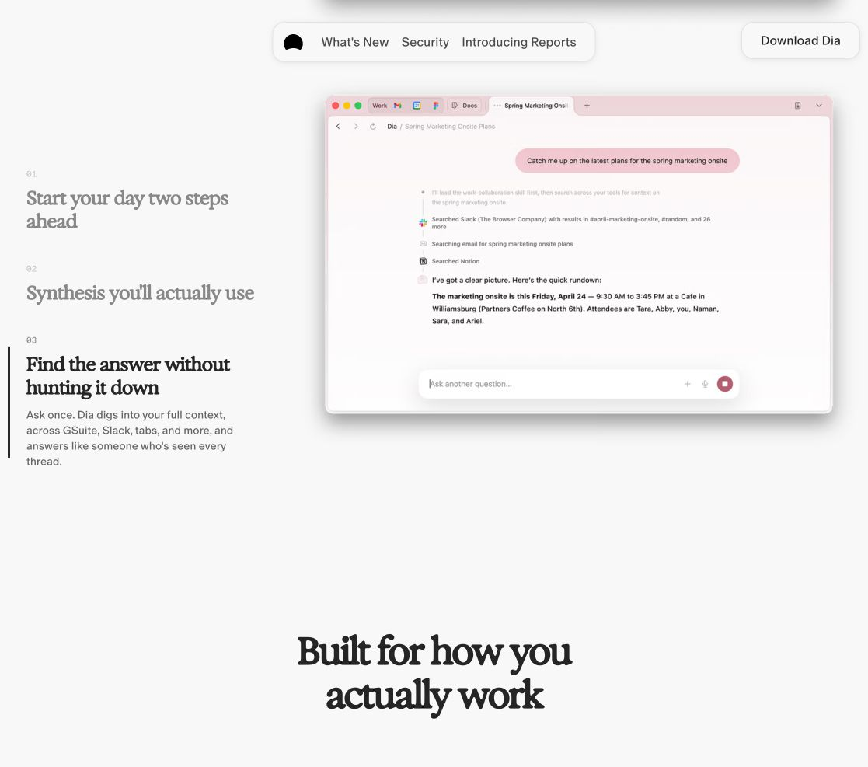
Figure 2. Current homepage use-case navigator: one active story, one product frame, one transition toward the broader work promise.

Observed sequence
- A black, emotionally extreme hero makes the brand impossible to ignore.
- A pale editorial section reframes Dia as a thoughtful interpreter of browser context.
- A controlled use-case sequence changes one example at a time inside a stable browser frame.
- The page zooms back out to the universal promise: a browser built around the user’s actual work.
TRANSFERABLE PRINCIPLE
Spend one special effect per viewport. Keep the product evidence compositionally quiet enough to be read.

03 / VISUAL SYSTEM

Typography separates feeling, function, and metadata
The current system uses type roles more strategically than a conventional display/body pairing.
FAMILY | ROLE | OBSERVED USE | EFFECT
Exposure Variable / Exposure VAR | Editorial display | Hero wordmark, emotional headlines, Reports, release-note titles | Highly expressive; unusual exposure axis and many static instances
ABC Oracle | Product sans | Body, work pages, product explanation, many current headings | Quiet, humanist, low-friction
ABC Favorit Mono | Utility mono | Navigation, footer, compact labels | Operational and browser-like
Quadrant Text Mono | Editorial metadata | Release issue, version, date, location | Makes shipping feel archived and collectible
ABC Oracle Triple | Accent display | Selected campaign or component accents | Use sparingly
SF Pro / system fallbacks | Interface support | Product-adjacent UI and resilience | Familiar platform texture

Current scale cues
- Home hero “Dia”: approximately 112 px on desktop; the word behaves as image and name at once.
- Major editorial sections: approximately 48 px Exposure; major product sections: approximately 54 px ABC Oracle.
- Product descriptions: approximately 18 px ABC Oracle with softened black.
- Release-note metadata and footer systems: approximately 13 px mono, often spaced and boxed.
LICENSING
Do not copy or redistribute these commercial fonts from the reference archive. Recreate the role contrast with licensed or open alternatives.

03 / VISUAL SYSTEM

The base is nearly colorless; the artifacts carry the chroma
Dia’s core page system is near-black, warm white, soft gray, and glassy browser chrome. Strong color arrives inside campaigns, reports, skills, and illustrations.
#020204 | #F8F8F8 | #FFFFFF | #D9D9D9 | #FFDC5C

Material grammar
- Pill-shaped navigation and controls echo browser chrome without reproducing a literal toolbar.
- Large radii, pale glow fields, thin gray rules, and sparse shadows keep surfaces soft rather than glossy.
- Browser screenshots are framed as finished scenes; the surrounding page rarely competes with the screen.
- Paper, postcards, painting, mono stamps, clips, and vertical metadata turn digital updates into editorial objects.

Motion grammar
- Pinned or staged scroll transitions hold one composition while the active narrative changes.
- The CSS includes authored easing families such as cubic-bezier(.76,0,.24,1) and cubic-bezier(.87,0,.13,1), alongside standard product easings.
- Motion reveals state and attention; it is not used as permanent ambient decoration.

04 / LANGUAGE

The voice is direct, second-person, and emotionally ordinary
Dia now talks like a thoughtful colleague who already knows the situation—not a lab explaining a breakthrough.
26,412  words in filtered corpus | 1,271  second-person uses | 294  first-person-plural uses
656  contractions | 92  questions | 127  em dashes

What the counts suggest
- Second-person language appears about 4.3× as often as first-person plural: the user’s situation is the grammatical center.
- Contractions keep the writing spoken and contemporary without becoming internet-slang heavy.
- Repeated concepts include tabs, work, chat, groups, meetings, context, open, day, without, and better.
- Questions are used to activate recognition and frame a job, not to manufacture mystery.

Current copy ladder
LAYER | PUBLIC EXAMPLE | JOB
Emotional hook | A browser you won’t dread opening. | Names the feeling before the feature.
Mechanism | Dia reads between the tabs. | Makes context continuity legible.
Fit | Built for how you actually work. | Rejects generic productivity theater.
Resolution | Ready for a better day? | Returns the product promise to lived experience.

COPY TEST
If a line could describe any AI tool, it is not yet Dia-shaped. Anchor the line in a browser situation, an authored output, or a familiar workday feeling.

04 / LANGUAGE

A usable writing formula
The current voice can be replicated as a decision sequence without copying any sentence.
STEP | MOVE | WHAT TO WRITE
1 | Name the friction | A human feeling or ordinary task: hunting, preparing, catching up, doing it alone.
2 | Reveal the contextual advantage | The browser already contains the tabs, history, people, and work needed to help.
3 | Materialize the intelligence | Show the brief, report, summary, answer, or next step.
4 | Resolve in life | Ahead, ready, focused, calmer, moving, or done.
5 | Prove control | When stakes rise, explain privacy, choice, source scope, and company readiness.
6 | Invite lightly | Download, try, ask, explore, or add it to the day.

Do
- Use familiar nouns and verbs before technical terms.
- Let one sentence carry one job.
- Write toward a concrete output or a changed state.
- Use contractions and direct address when they improve rhythm.

Avoid
- Generic superlatives, model worship, or claims that require trust before evidence.
- Feature pile-ups, autonomous-agent theater, or vague “transform your workflow” language.
- Permanent whimsy. Dia’s playful or raw gestures sit inside a disciplined system.

05 / SURFACE MAP

One brand, several levels of intensity
The current ecosystem does not use a single tone everywhere. Each surface carries a specific proof burden.
SURFACE | ROLE | ENERGY | PROMISE
Homepage | Emotional brand platform | Raw opening; calm authored proof | Dread → context → better day
Reports / Start | Campaign and routine | Documentary, local, warm | Bring synthesis into the morning
Dia Weekly | Release culture | Editorial, credited, collectible | Shipping is a publication
Work | Company readiness | Quiet, broad, reassuring | Context plus security and scale
Students | High-energy utility | Playful, direct, graphic | You do not have to do it alone
Skills | Extensibility | Gallery-like, modular | See possibilities and reusable packs
Windows | Platform expansion | Restrained beta utility | Join and stay informed
Security / Privacy | Trust infrastructure | Specific and controlled | User agency and evidence

SYSTEM RULE
Intensity belongs to the surface’s job. The homepage can scream; the company page should reassure; the release system can become an authored magazine.

05 / SURFACE MAP

Campaign worlds make the product socially believable
Reports is staged in a real café and a real morning. Work is staged as calm product evidence. Together they connect emotional brand to practical adoption.
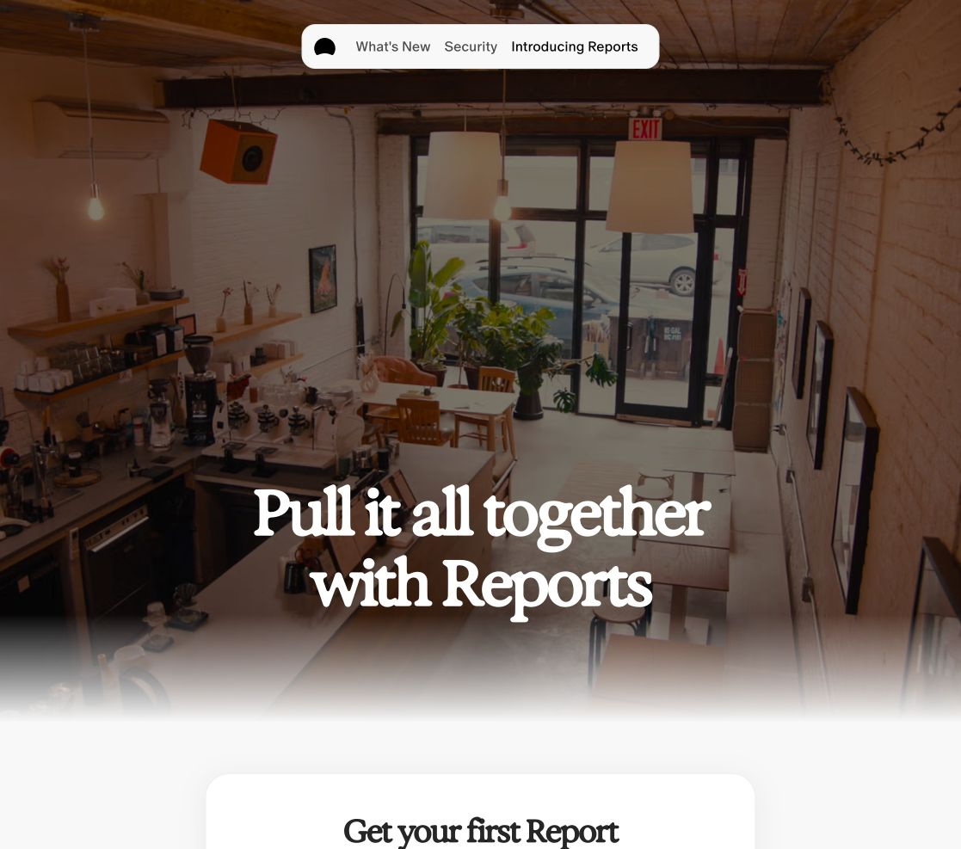  REPORTS / DOCUMENTARY ROUTINE | 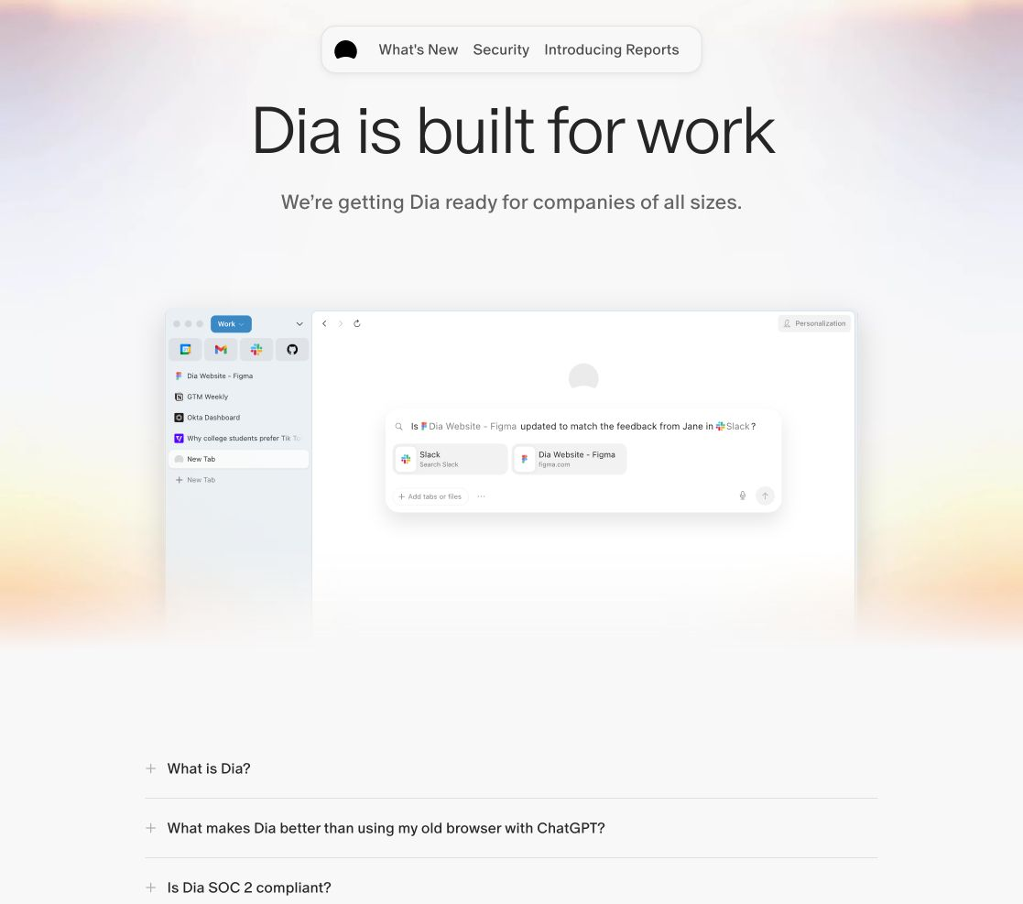  WORK / QUIET PROOF

Design implication
Dia does not ask one visual system to carry every level of proof. It alternates between authored cultural settings and precise product frames, then lets a consistent type hierarchy and navigation system hold the family together.

05 / SURFACE MAP

Audience pages are allowed to change costume
Students uses pixel icons and high-chroma prompt cards. Skills uses a gallery logic. Both remain recognizable through type roles, spacing, chrome, and direct utility copy.
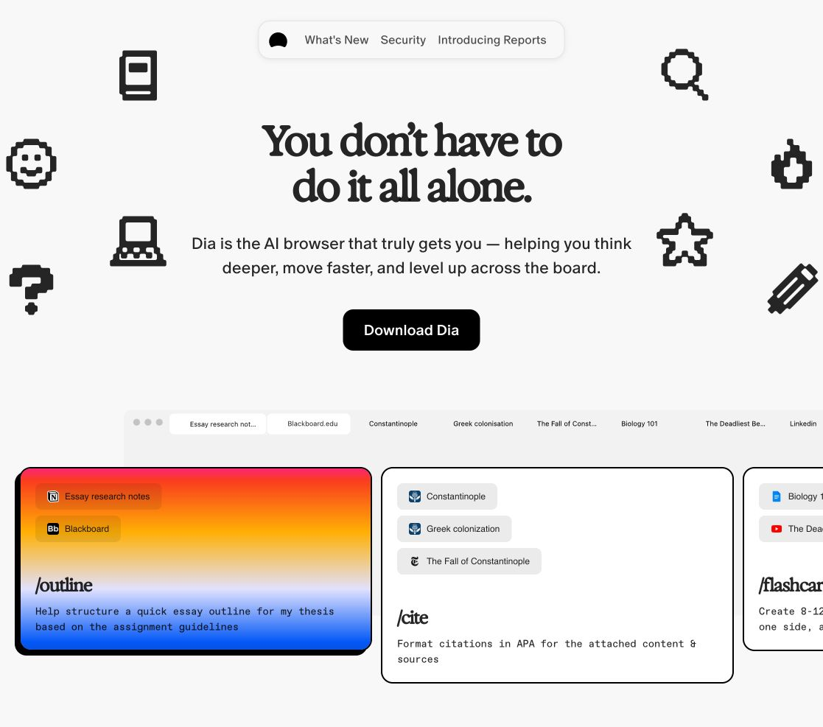  STUDENTS / PLAYFUL ASSISTANCE | 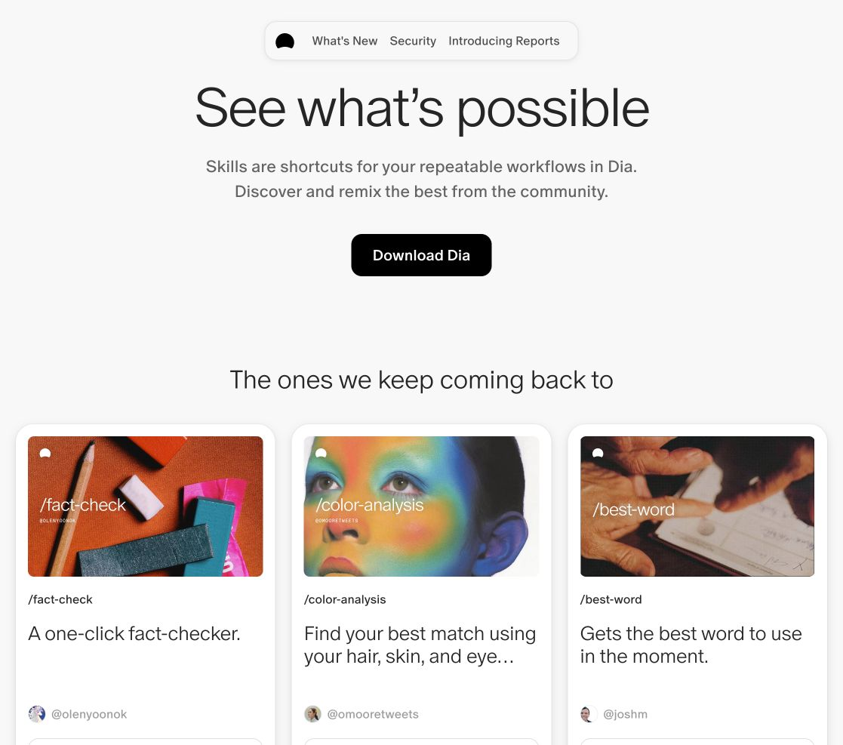  SKILLS / MODULAR POSSIBILITY
BRAND RANGE
Consistency is structural, not cosmetic: type roles, direct address, browser-native context, and authored outputs survive even when the illustration style changes.

06 / RELEASE CULTURE

Dia Weekly turns shipping into editorial memory
The release system is the strongest example of Dia’s brand language becoming an operating system rather than a campaign.
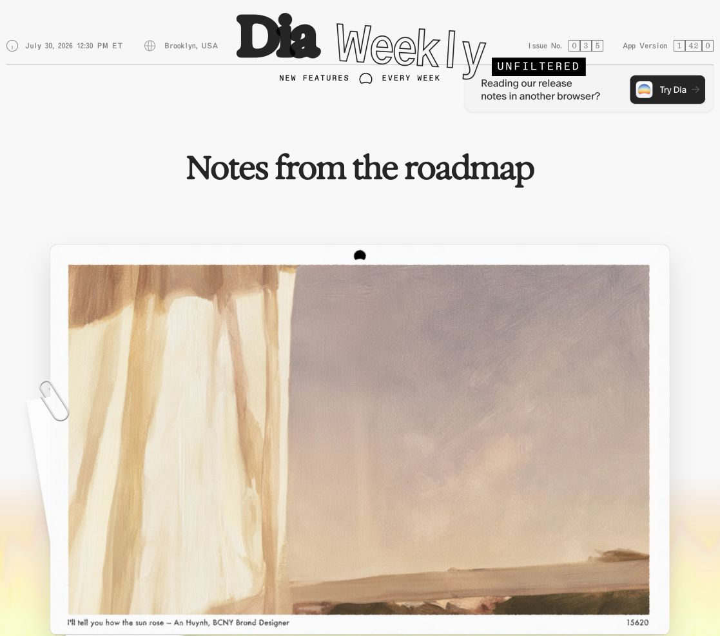
Figure 3. Dia Weekly Unfiltered, issue 035 / app 1.42.0: publication masthead, date, time, location, version, art, and a story-led title.

Recurring anatomy
- Issue number, app version, release date/time, and location establish provenance.
- Story-led titles replace purely functional version labels.
- Builder credits, teammate modules, postcards, art, and personal cultural recommendations make the company visible.
- Wide media, showcases, lists, grids, and notes let each issue have a composed rhythm.
35  issues | 2025-11-11  first issue | 2026-07-30  latest | 80  video refs | 215  image uses | 22  legacy docs

07 / IMAGE LANGUAGE

Five image families carry most of the brand
The archive is large, but the current imagery becomes manageable when grouped by the job each image performs.
FAMILY | EXAMPLES | BRAND JOB
Emotional human | Scream cutout and expressive figures | Instant memory; names felt friction
Documentary setting | Café, team, morning, city, real rooms | Places AI inside lived routine
Authored output | Reports, briefs, notes, study cards | Makes synthesis visible and desirable
Product proof | Browser frames, dialogs, groups, skills | Shows the mechanism without overexplaining
Editorial ephemera | Postcards, paper, clips, painting, mono stamps | Gives release history provenance and culture

Selection rules
- Prefer images that establish a situation or output, not generic visual mood.
- Let the dominant image have a clear editorial crop and enough quiet space around it.
- Credit artists and builders when the release system treats the work as authored.
- Keep high-chroma imagery inside a neutral frame so color reads as content, not decoration.
- Avoid mixing multiple novelty styles in the same viewport.
ARCHIVE PRACTICE
Use the 563 preview images to browse visual families. Use images.csv to recover dimensions, IDs, original URLs, and usage context before choosing a production reference.

08 / FOR OURS

Borrow the grammar, not the skin
Dia is useful to Parosayshi because both can turn product history into authored physical evidence. The opportunity is translation, not imitation.
DIA GRAMMAR | PAROSAYSHI TRANSLATION | GUARDRAIL
Expressive cold open | One tactile or human gesture that names the project’s tension | Do not copy the scream or black hero literally
Editorial output | A proof card, field note, receipt, report, or annotated artifact | Use real case evidence, not ornamental filler
Mono provenance | Issue/date/version/role stamps on case-study objects | Keep it subordinate to the tactile object
Calm browser proof | Stable reader or device frame for decision evidence | Avoid over-polished SaaS mockup sameness
Release culture | Case notes and process drops that accumulate over time | Credit ownership and distinguish fact from contribution
One effect per viewport | Let a special interaction own the moment, then settle | Preserve the cutting mat, paper, folders, and reader

The strongest existing bridge
The earlier Dia-inspired postcard direction already translated release-note metadata—issue, date, version, authorship—into a physical portfolio object. The next useful step is to turn that from a one-off reference into a reusable provenance layer for selected case studies, while keeping the existing material world dominant.
DECISION
Use Dia to sharpen hierarchy, provenance, and authored proof. Do not use it to replace Parosayshi’s tactile identity with a generic AI-browser aesthetic.

09 / LINEAGE

The brand moved from possibility to utility to emotional relief
History matters because the current system is not a visual reskin; it changes what Dia believes needs to be sold.
MOMENT | BRAND TASK | VISUAL / SYSTEM CUE | MESSAGE
2024-12 | Recruiting / vision | Warm beige, GT Ultra Median, minimal page | Come build Dia
2025-05 | Pre-beta / waitlist | Warm restraint; early audience activation | Stay in the loop
2025-06 | Beta explanation | ABC Oracle, job-based sections, testimonials | Chat with your tabs
2025-11 | General availability | Broader jobs-to-be-done; Arc provenance | Dia. Do it all.
2025-11 → 2026-07 | Editorial shipping | Dia Weekly, issue/version metadata, credits | Release notes as publication
2026-08 | Workday relief | Scream hero, reports, better-day narrative | Emotion → synthesis → readiness

What persisted
- Editorial serif authority, direct writing, and a belief that the browser can become a personal context layer.
- Warmth and humanity, even as the palette moved toward black, white, and more authored campaign worlds.
- A consistent refusal to make technical AI language the emotional center of the brand.

What changed
- The promise narrowed from doing many things to feeling better prepared for the actual day.
- Feature explanation matured into output-led storytelling and an editorial release institution.

09 / LINEAGE

Selected archived states
These are representative pivots, not every Wayback frame. The complete deduplicated capture index is retained in the archive.
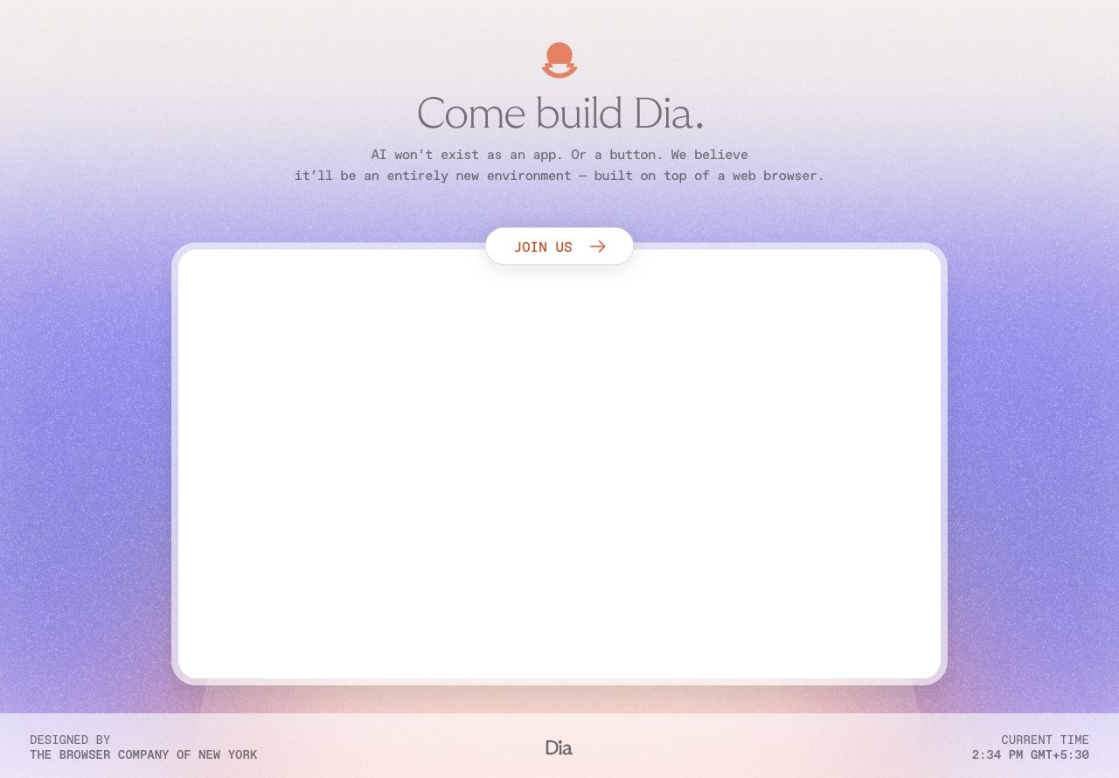  2024-12 / RECRUITING REVEAL | 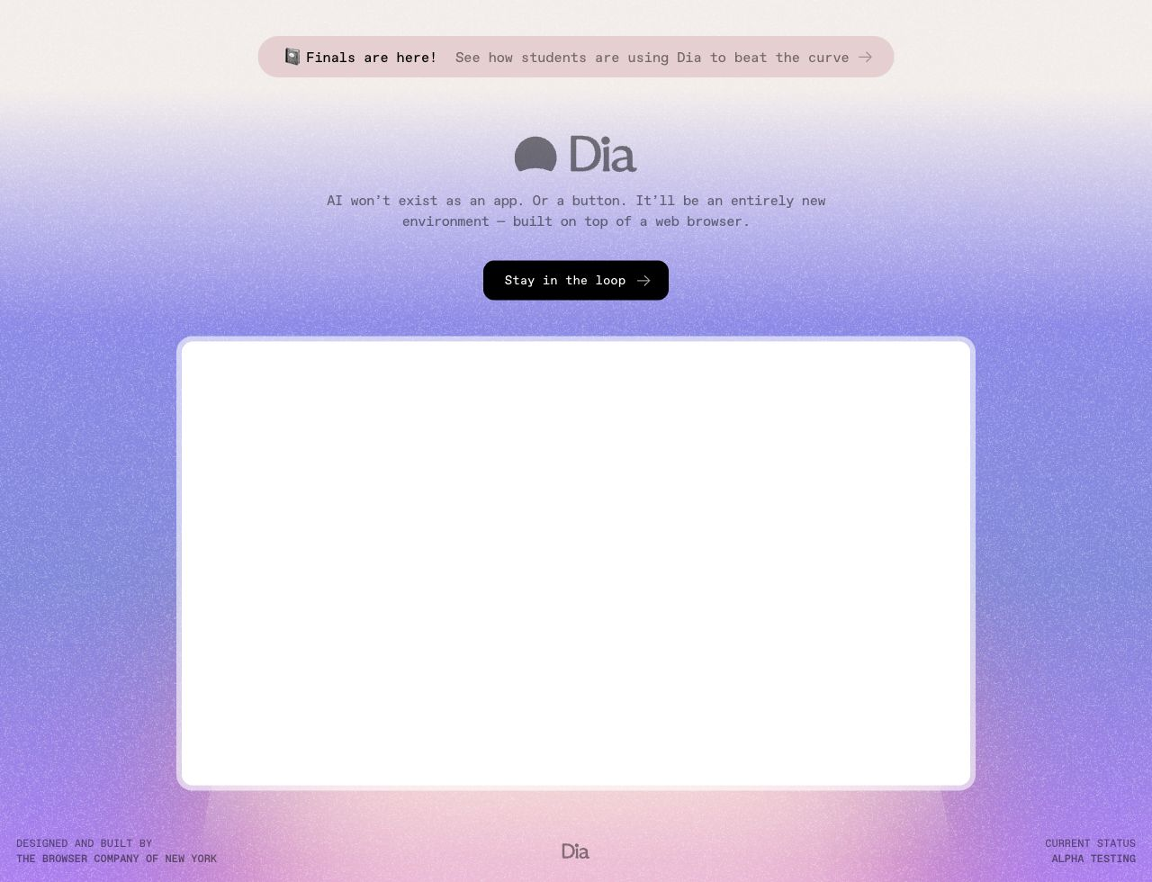  2025-05 / PRE-BETA
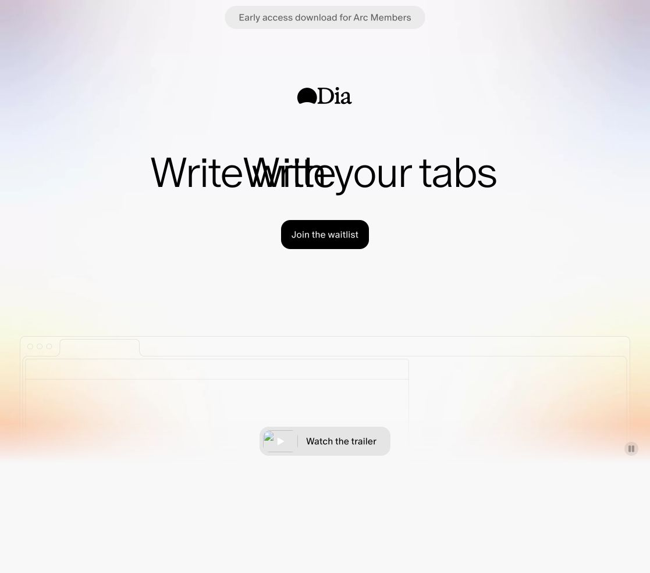  2025-06 / BETA LAUNCH | 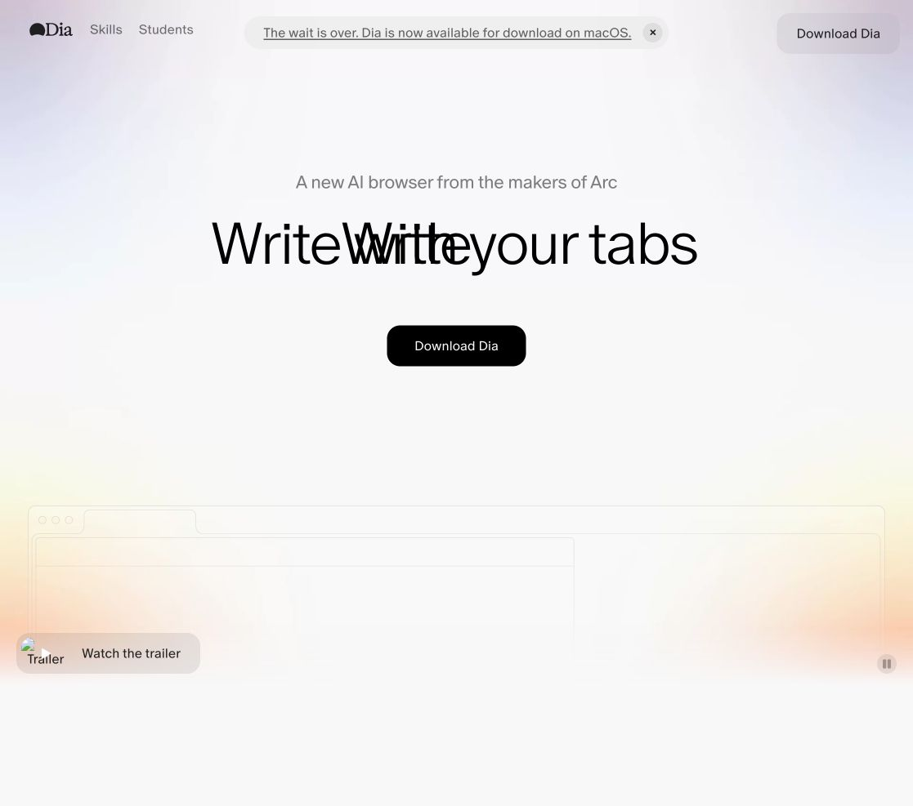  2025-11 / GENERAL AVAILABILITY
HISTORY WEIGHT
The guide uses these states to explain lineage. It does not recommend returning to their warm-beige minimalism or their feature-by-feature launch structure.

10 / ARCHIVE

What was captured and how to use it
The archive is designed for browsing, tracing, and refreshing—not just storing screenshots.
PATH | CONTENTS | BEST USE
previews/images/ | 563 current content-linked previews | Visual browsing and contact-sheet work
manifests/images.csv | 875 image asset records | IDs, dimensions, sizes, URLs, filenames
manifests/videos.csv | 263 Mux video records / 2h 15m 26s | Stream and poster reference; motion audit
files/ + manifests/files.csv | 16 public animation JSON files | Inspect motion assets and implementation
raw/sanity/ | 304 content docs plus asset records | Trace images and copy back to content
raw/site/ | Current public HTML and CSS | Typography, color, layout, route, and code signals
raw/wayback/ | 7,902 deduplicated capture records | Historical discovery and missing-state lookup
analysis/ | Copy corpus, records, stats, current brief | Language analysis and design synthesis
tools/collect-dia.mjs | Repeatable public collector | Refresh the current snapshot later

Rights-aware handling
- Treat all Dia, artist, photographer, and product assets as references unless permission is confirmed.
- Use the font endpoint catalog to identify families; do not copy the commercial binaries.
- Prefer transformed previews for research and recover original URLs from the manifests only when needed.
- Re-run the collector before a consequential design decision; the public corpus is live and can change.

11 / SOURCES

Primary source atlas
Official current pages, public structured data, and timestamped Wayback states form the evidence base. Company context is limited to official announcements.

Current official surfaces
S1 Dia homepage
S2 Dia Weekly / latest release notes
S3 Introducing Reports / Start
S4 Dia for Work
S5 Dia for Students
S6 Dia Skills Gallery
S7 Dia Security
S8 Dia Privacy

Official history and company context
S9 Early peek at Dia — recruiting video
S10 Letter to Arc members — The Browser Company
S11 Atlassian acquisition announcement

Selected Wayback states
W1 2024-12-02 Dia public reveal
W2 2025-05-15 pre-beta
W3 2025-06-11 beta launch
W4 2025-11-20 general-availability-era home
OBSERVATION DATE
Current-page claims, counts, and screenshots in this guide were observed or collected on 2026-08-03. Refresh before treating them as present-day facts.

