CIP-A106 Laboratory 3
Evidence Appendix
Screenshots and exports supporting the Technical Report
Student | Perry Koko, C1126EHIT17343
Contents | Section A isolation and snapshots; B static triage; C debugger and unpacking; D runtime and memory; T rebuilt text exports. Exhibit numbers E01 to E64 follow capture order and match the file names in the 05_Screenshots folder.
Capture method | Screenshots were taken on the host (the VM has no capture channel). Times in the captions are the clock shown in the screenshot or the capture time (VM local time, 2026-10-03 and 2026-10-04). Each caption shows the first 16 hex characters of the SHA-256; full values are in SHA256SUMS.txt. Images embedded here are reduced in size and colour depth; the full-resolution originals (the hashed files) are in 05_Screenshots.
Excluded | The sample, unpacked executable images, raw memory dumps, encrypted files and the raw ransom-note PNG/HTML files are not included. A duplicate screenshot (network adapter, identical hash) was dropped.

A. Environment, isolation and snapshots (Task A)
Host-only adapter with both connection boxes unchecked, VM Options, Guest Isolation as found (deviation), Shared Folders disabled, and the snapshot tree with one detail view per snapshot.
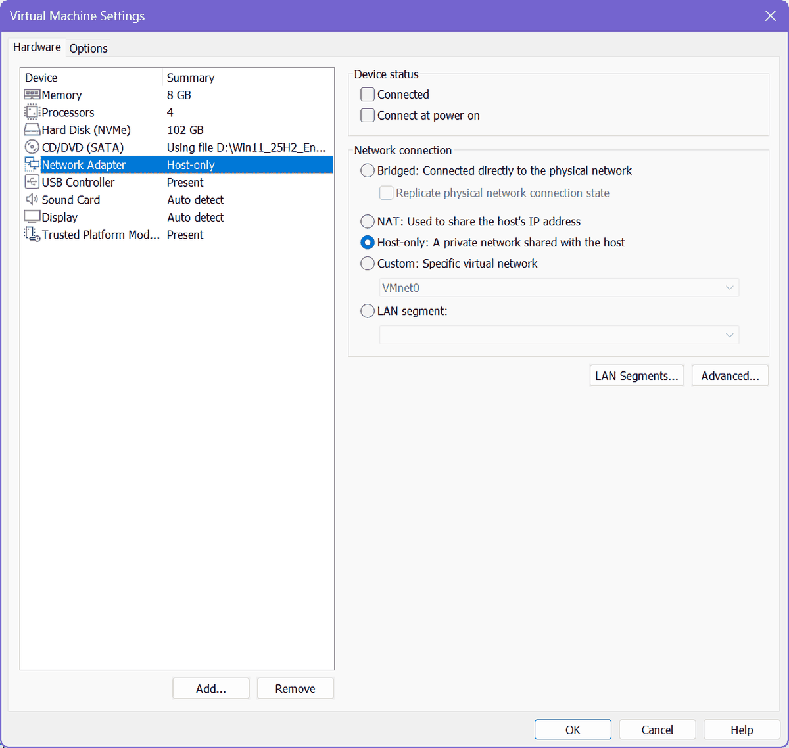
Ex. E09 | 2026-10-03 12:04 | VMware Workstation settings | VMware network adapter: Host-only, Connected and Connect at power on unchecked | E09_20261003-1204_vm_network_adapter.png | SHA-256 8BAEAC0C22548406...
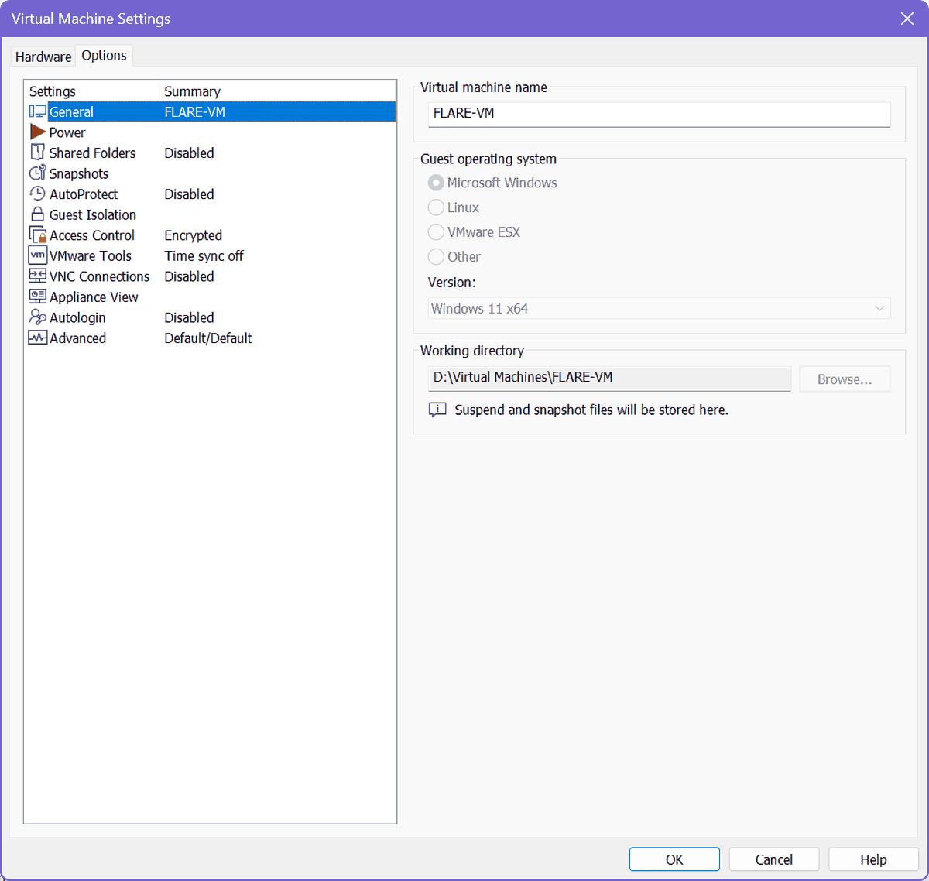
Ex. E10 | 2026-10-03 12:04 | VMware Workstation settings | VMware VM Options | E10_20261003-1204_vm_options.png | SHA-256 B0EAA507786CE24F...
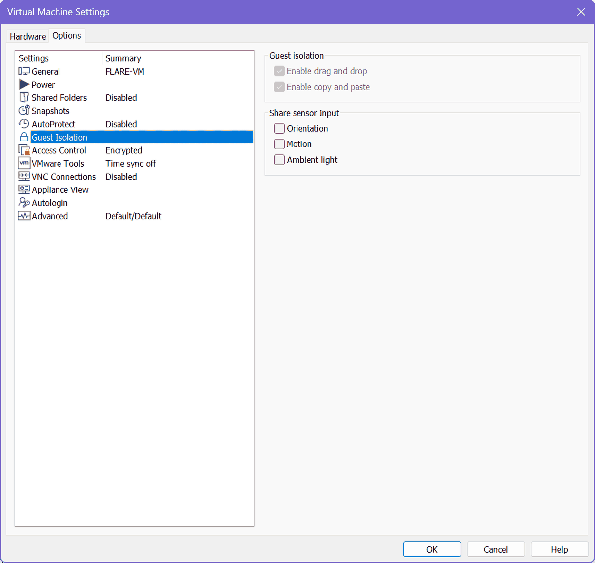
Ex. E63 | 2026-10-04 13:39 | VMware Workstation settings | VMware Guest Isolation: drag and drop and copy/paste enabled (as found) | E63_20261004-1339_vm_guest_isolation.png | SHA-256 F54EFDA2F8747C39...
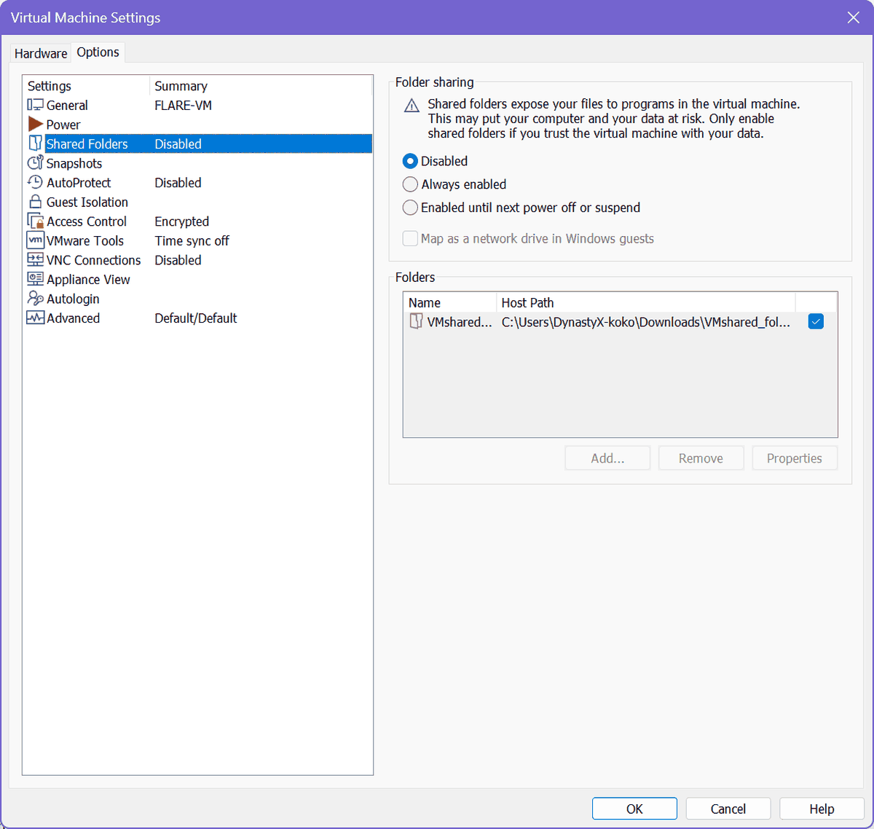
Ex. E64 | 2026-10-04 13:39 | VMware Workstation settings | VMware Shared Folders: Disabled | E64_20261004-1339_vm_shared_folders_disabled.png | SHA-256 AE85214F2DE609C0...
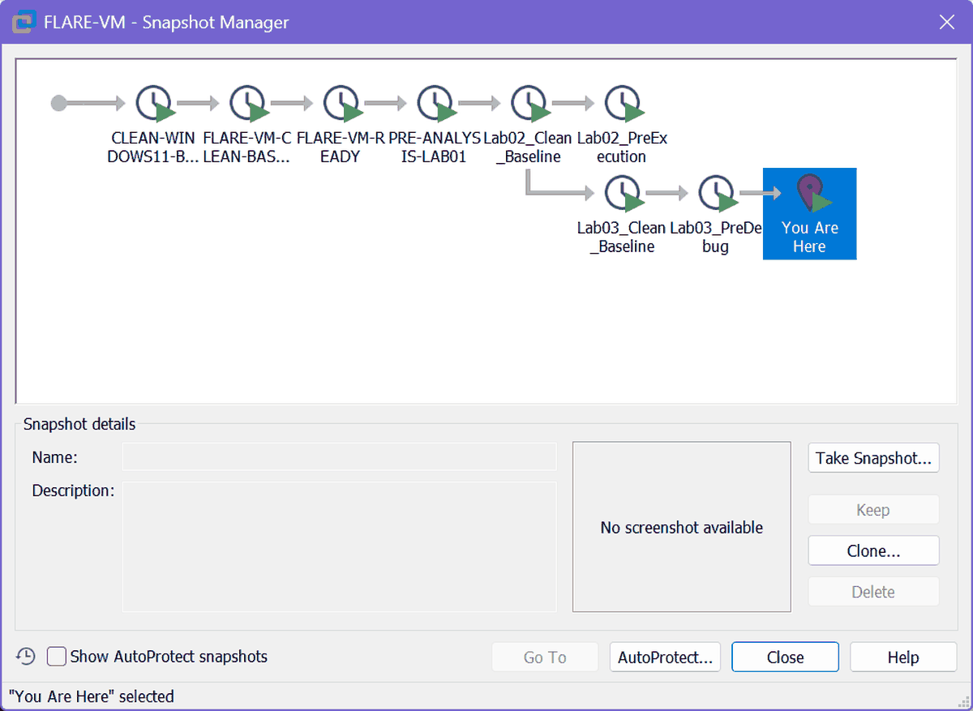
Ex. E11 | 2026-10-03 12:04 | VMware Snapshot Manager | Snapshot Manager: Lab03_Clean_Baseline and Lab03_PreDebug | E11_20261003-1204_vm_snapshot_manager_predebug.png | SHA-256 4CF32AB6E4C6F34C...
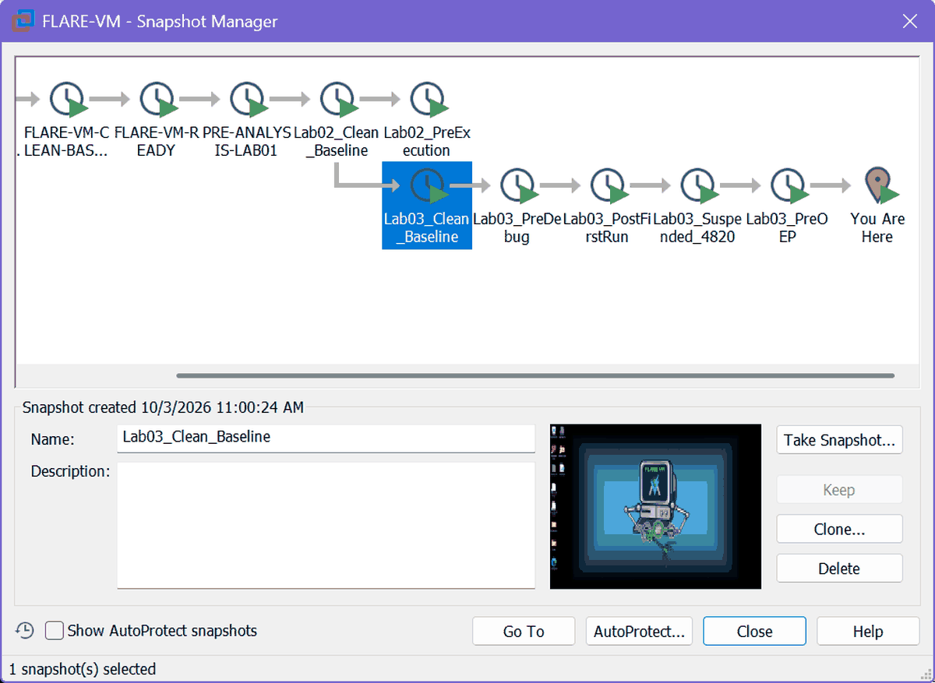
Ex. E58 | 2026-10-04 13:39 | VMware Snapshot Manager | Snapshot detail: Lab03_Clean_Baseline | E58_20261004-1339_vm_snapshot_detail_clean.png | SHA-256 83215FBE44C30F4F...
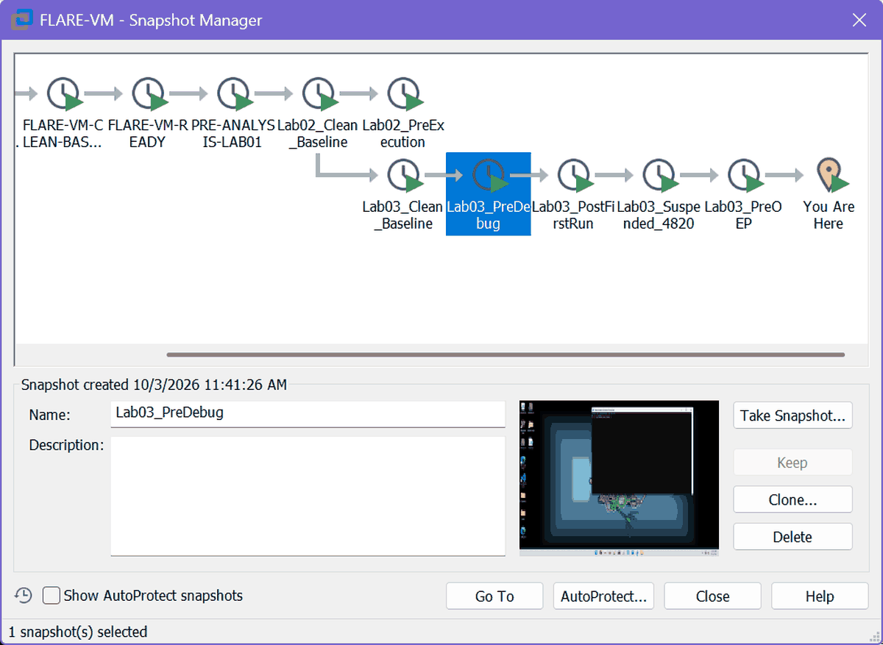
Ex. E59 | 2026-10-04 13:39 | VMware Snapshot Manager | Snapshot detail: Lab03_PreDebug | E59_20261004-1339_vm_snapshot_detail_predebug.png | SHA-256 4721A7D7FBC44924...
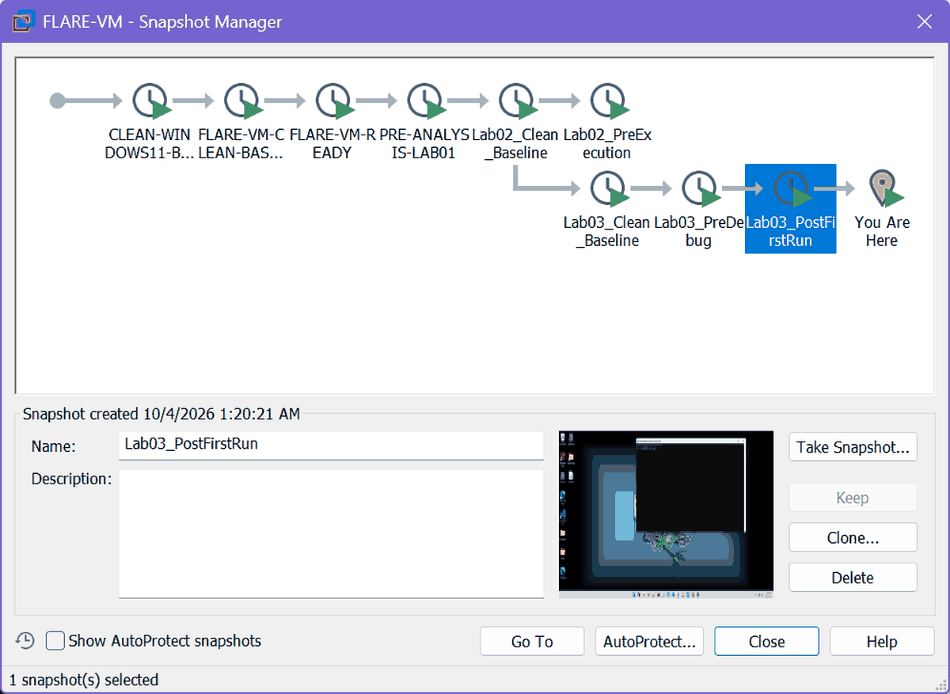
Ex. E21 | 2026-10-04 01:26 | VMware Snapshot Manager | Snapshot Manager: Lab03_PostFirstRun | E21_20261004-0126_vm_snapshot_postfirstrun.png | SHA-256 1384527F6B48501B...
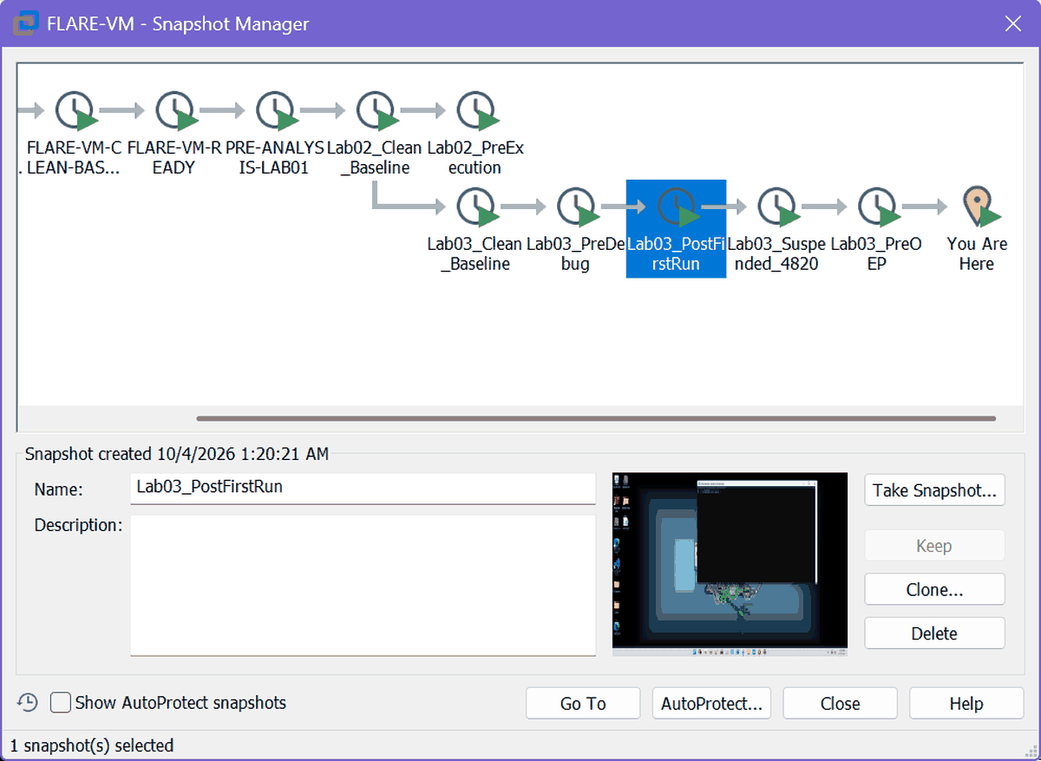
Ex. E60 | 2026-10-04 13:39 | VMware Snapshot Manager | Snapshot detail: Lab03_PostFirstRun | E60_20261004-1339_vm_snapshot_detail_postfirstrun.png | SHA-256 C7A35CA9ED41CC4C...
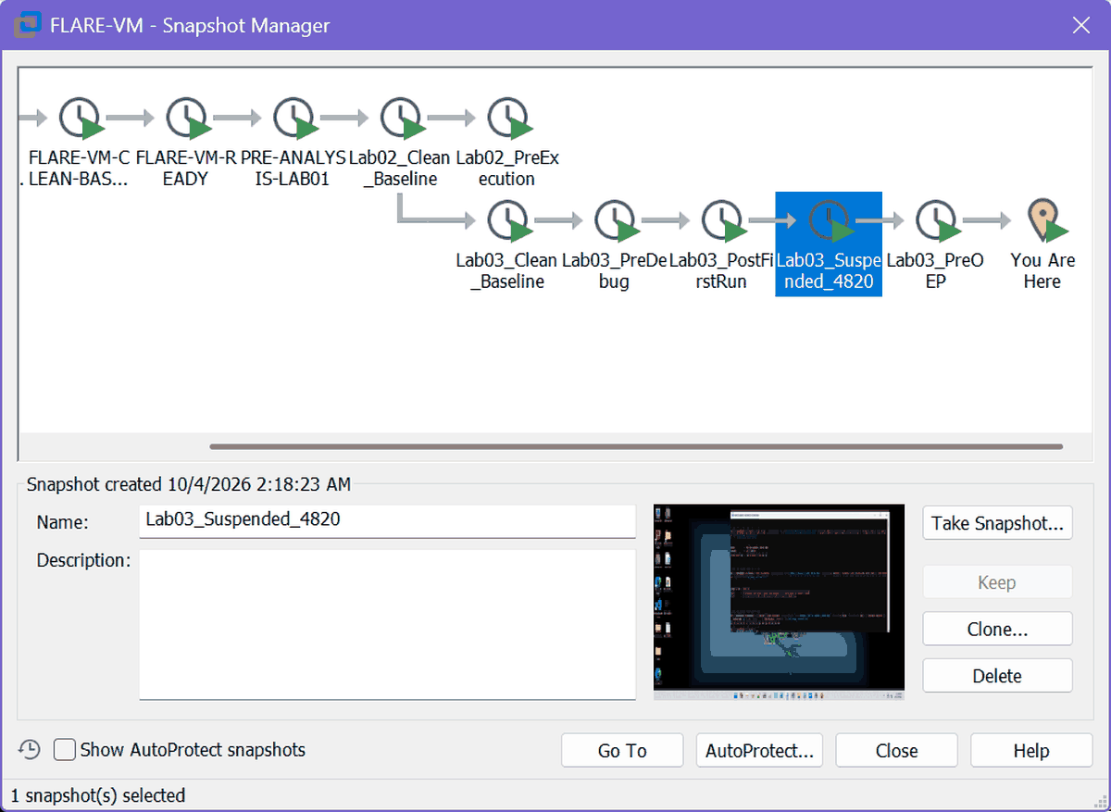
Ex. E61 | 2026-10-04 13:39 | VMware Snapshot Manager | Snapshot detail: Lab03_Suspended_4820 | E61_20261004-1339_vm_snapshot_detail_suspended4820.png | SHA-256 386FE71EE1C7AC6D...
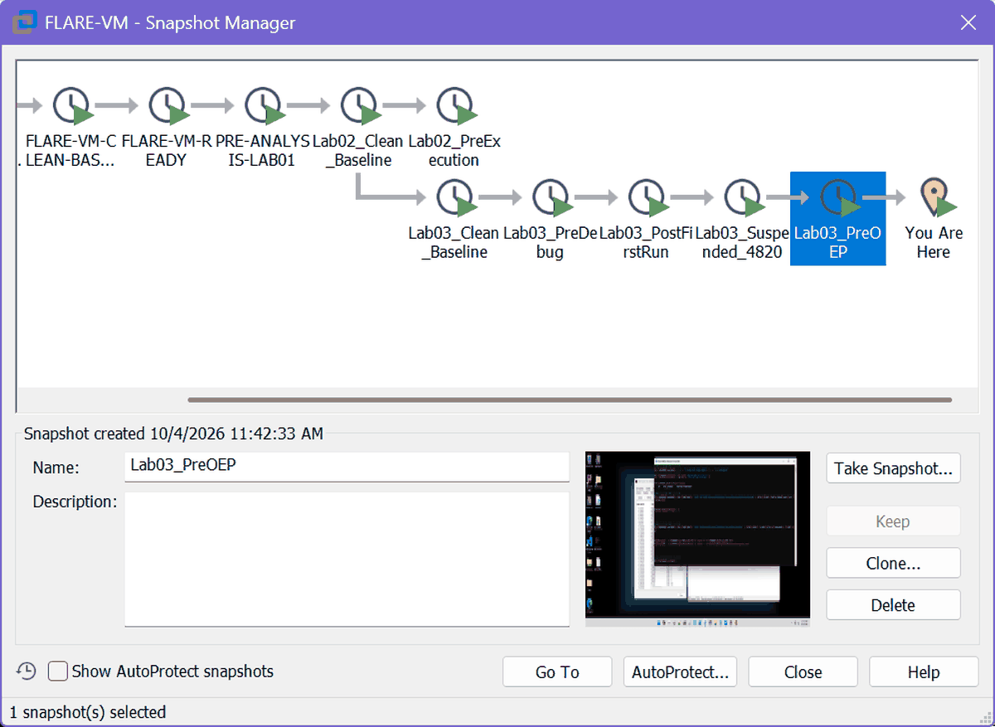
Ex. E62 | 2026-10-04 13:39 | VMware Snapshot Manager | Snapshot detail: Lab03_PreOEP | E62_20261004-1339_vm_snapshot_detail_preoep.png | SHA-256 48BF0C3329CEF14E...

B. Static triage and packer assessment (Task B)
PEStudio views of the packed source file: overview and hashes, indicators, imports, sections and entropy, strings, resources, debug directory.
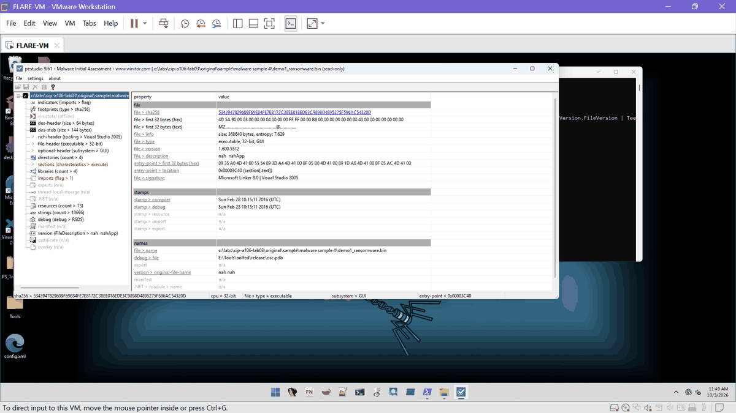
Ex. E01 | 2026-10-03 11:49 | PEStudio 9.61 | PEStudio file overview: SHA-256, entropy 7.629, timestamps, PDB path | E01_20261003-1149_pestudio_file_info.png | SHA-256 A747D5806294BD51...
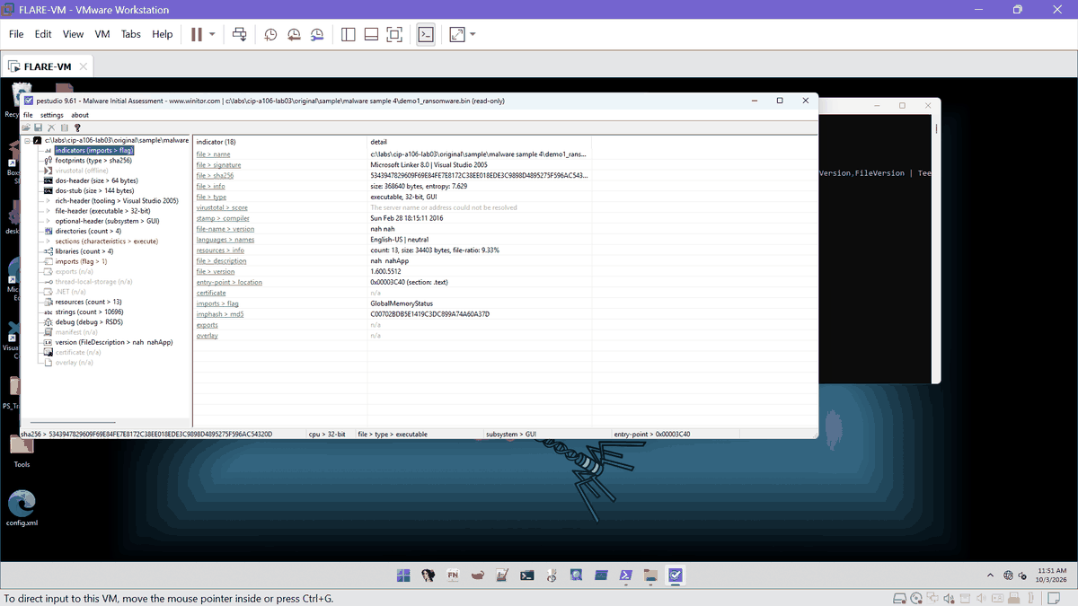
Ex. E02 | 2026-10-03 11:51 | PEStudio 9.61 | PEStudio indicators view | E02_20261003-1151_pestudio_indicators.png | SHA-256 959FFCE5E7CEE268...
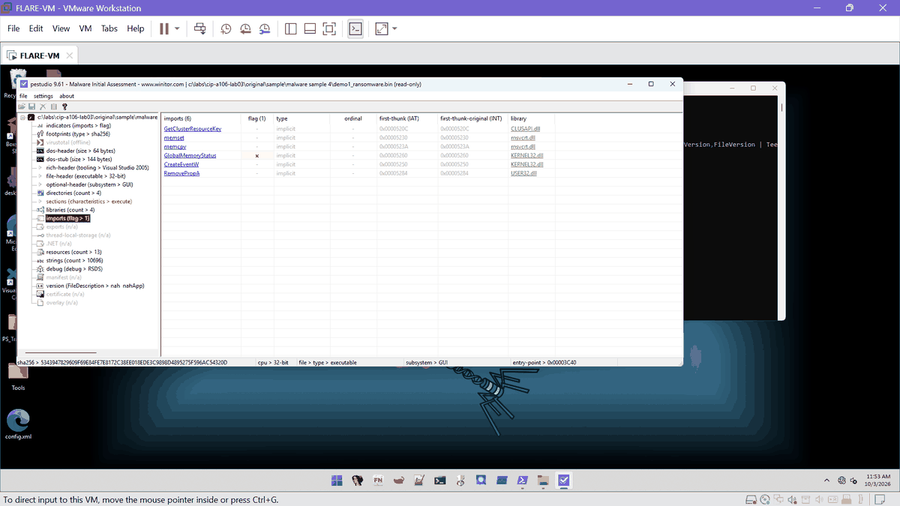
Ex. E03 | 2026-10-03 11:53 | PEStudio 9.61 | PEStudio imports: 6 imports in 4 libraries | E03_20261003-1153_pestudio_imports.png | SHA-256 7B9E62FC0CE65017...
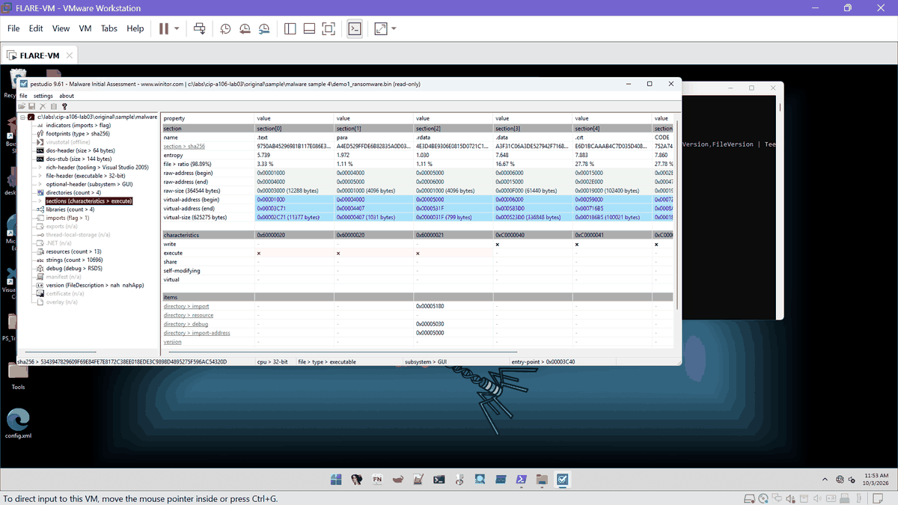
Ex. E04 | 2026-10-03 11:53 | PEStudio 9.61 | PEStudio sections: entropy per section | E04_20261003-1153_pestudio_sections.png | SHA-256 9805DA0136DCCE6F...
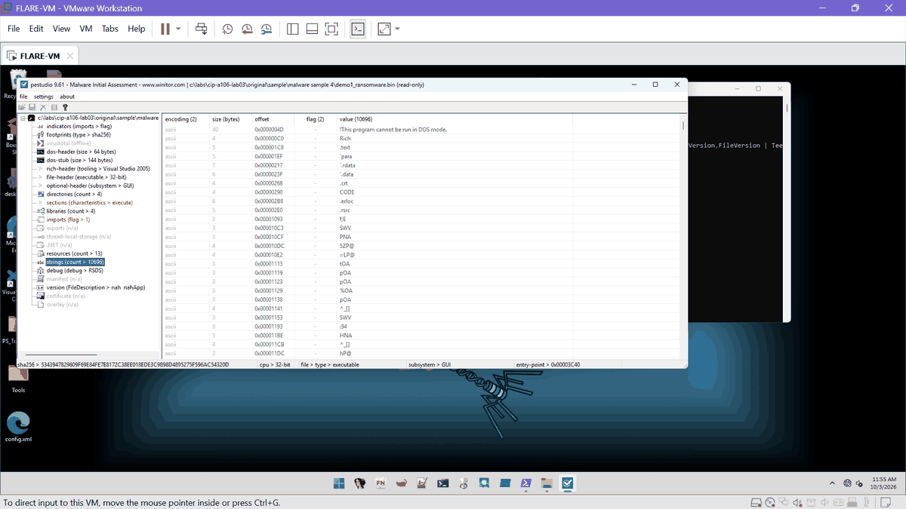
Ex. E05 | 2026-10-03 11:55 | PEStudio 9.61 | PEStudio strings: 10,696 strings | E05_20261003-1155_pestudio_strings.png | SHA-256 326086C80DF9E4FE...
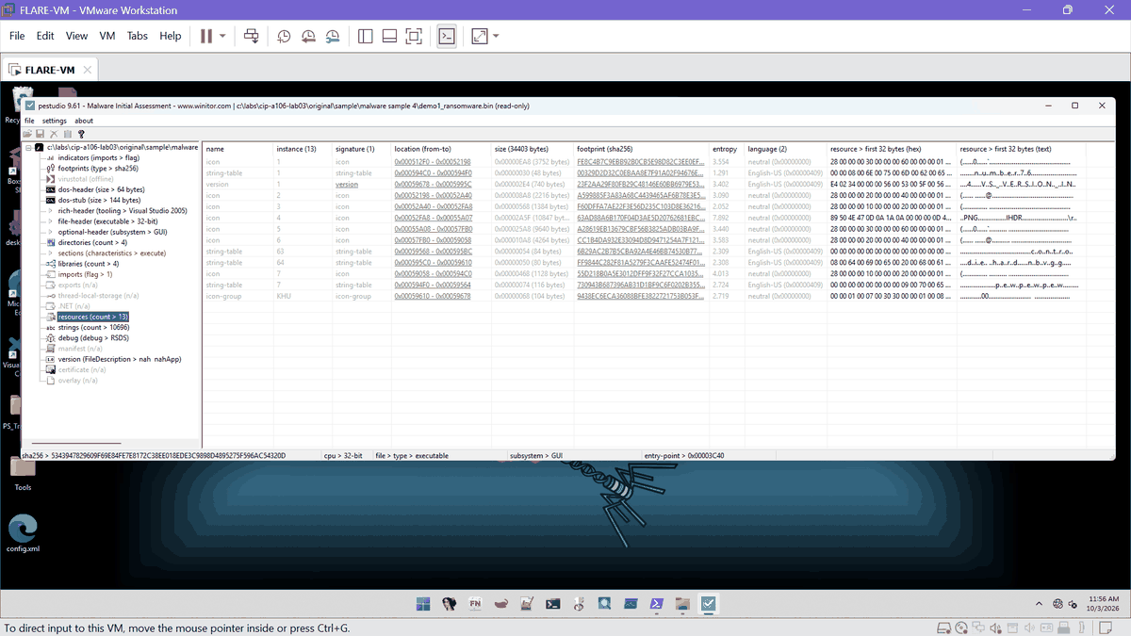
Ex. E06 | 2026-10-03 11:56 | PEStudio 9.61 | PEStudio resources: 13 entries, 34,403 bytes | E06_20261003-1156_pestudio_resources.png | SHA-256 8B620DFFD154D1D0...
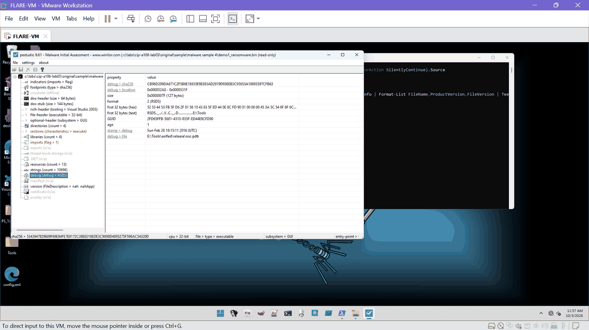
Ex. E07 | 2026-10-03 11:57 | PEStudio 9.61 | PEStudio debug directory: RSDS and PDB path | E07_20261003-1157_pestudio_debug.png | SHA-256 0E46CCC0EFEC84F5...
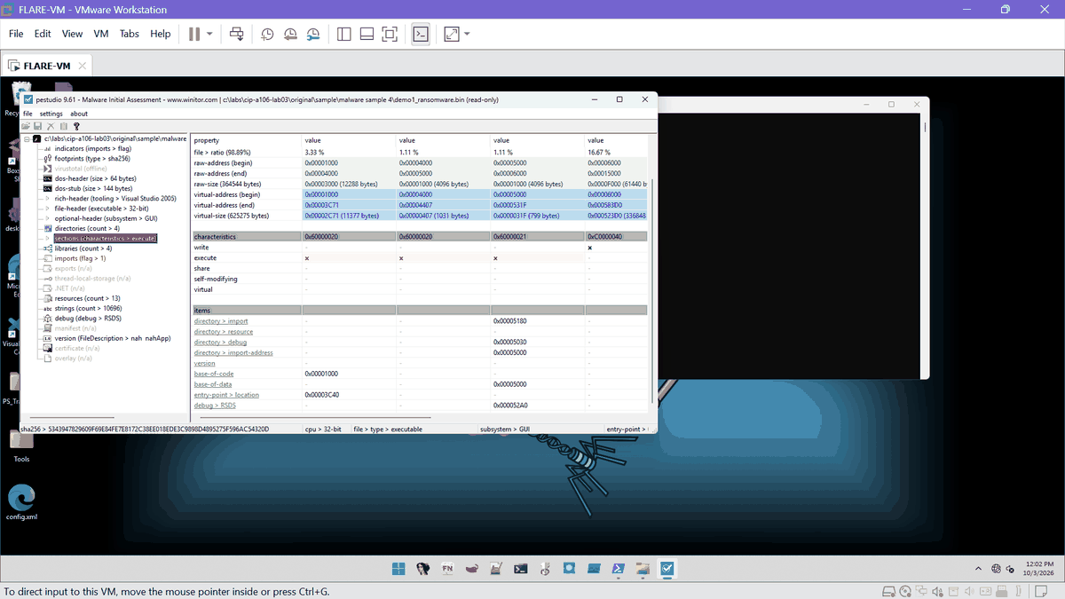
Ex. E08 | 2026-10-03 12:02 | PEStudio 9.61 | PEStudio sections with entry point 0x3C40 | E08_20261003-1202_pestudio_sections_entry.png | SHA-256 777F7EDD35A03F85...

C. Debugger observations and unpacking (Task C)
x32dbg sessions: PIDs 7380, 8360, 7784, 3848 (October 3 and early October 4), then S1 to S4 on October 4 (5348, 6068, 7152): entry stops, TLS stops, VirtualAlloc, six VirtualProtect calls, the hit at the OEP, breakpoint hit counts, memory maps and logs.
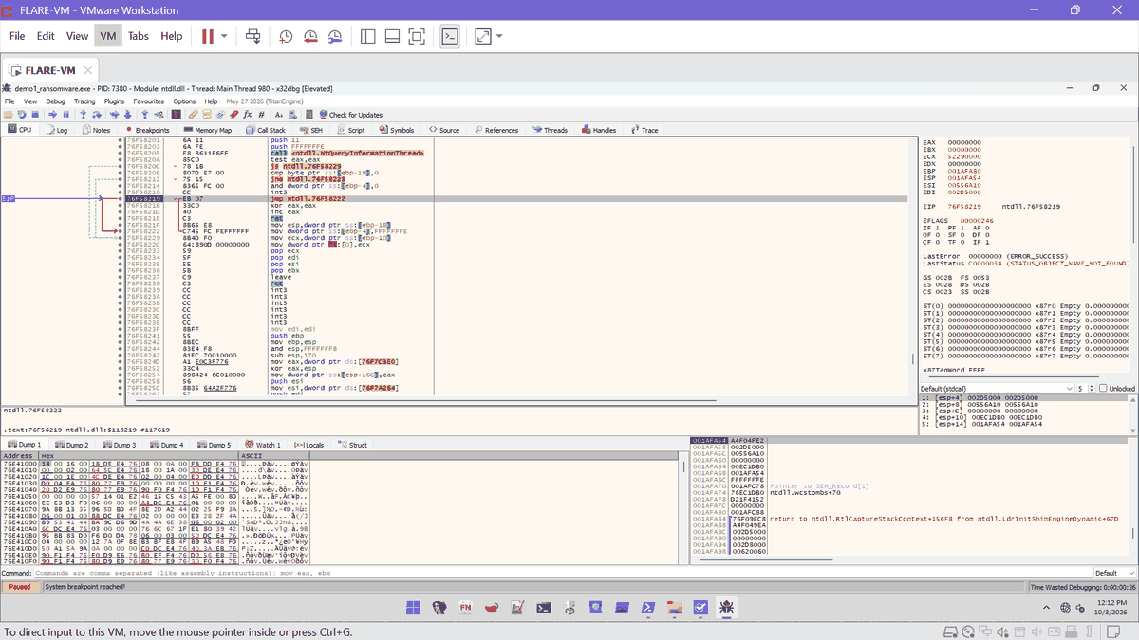
Ex. E12 | 2026-10-03 12:12 | x32dbg | x32dbg PID 7380 system breakpoint | E12_20261003-1212_x32dbg_pid7380_system_bp.png | SHA-256 34F755A7688C1CD0...
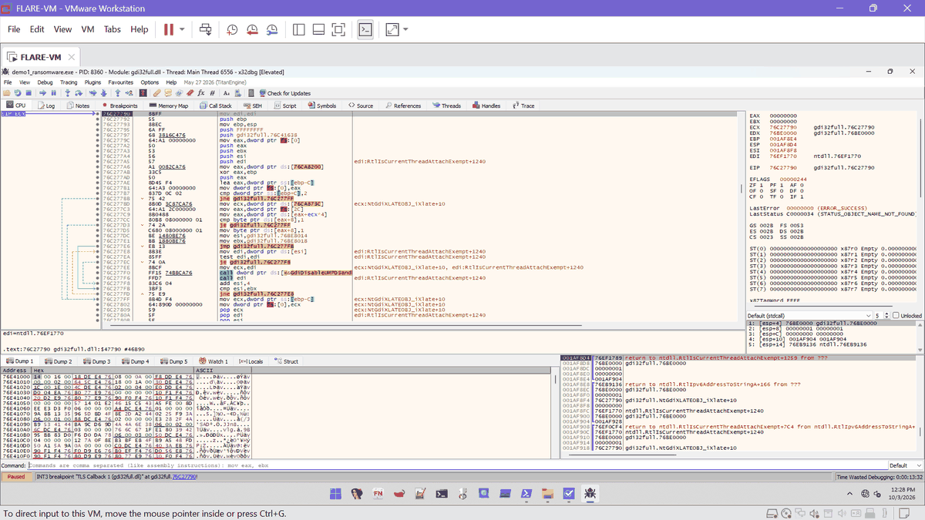
Ex. E13 | 2026-10-03 12:28 | x32dbg | x32dbg PID 8360 stopped at TLS callback | E13_20261003-1228_x32dbg_pid8360_tls.png | SHA-256 7F8E4D3D7B4F875B...
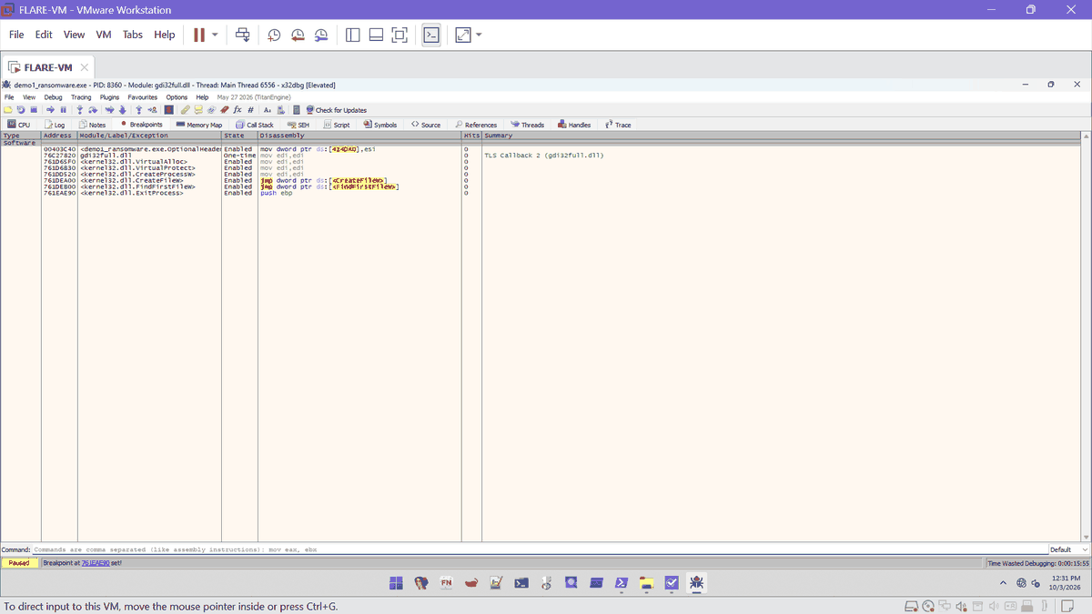
Ex. E14 | 2026-10-03 12:31 | x32dbg | x32dbg Breakpoints tab | E14_20261003-1231_x32dbg_breakpoints_8360.png | SHA-256 365DEAB9F12F7ED0...
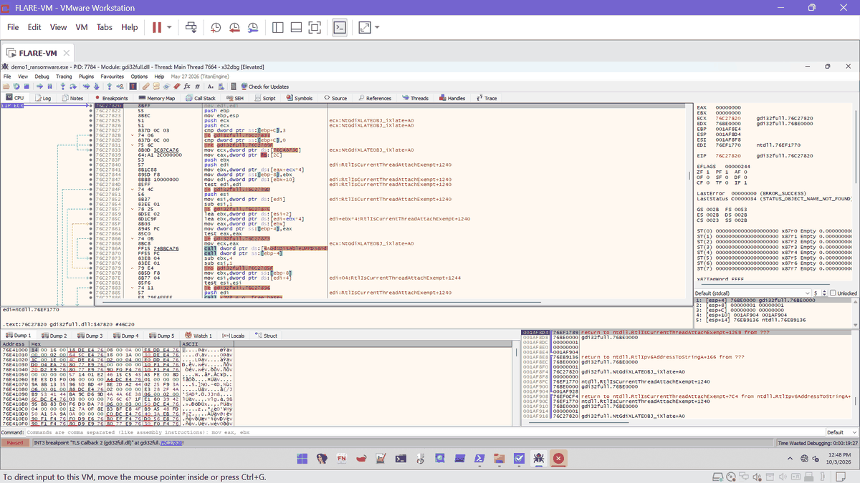
Ex. E15 | 2026-10-03 12:48 | x32dbg | x32dbg PID 7784 TLS callback 2 | E15_20261003-1248_x32dbg_pid7784_tls2.png | SHA-256 8E28B73088FE50F7...
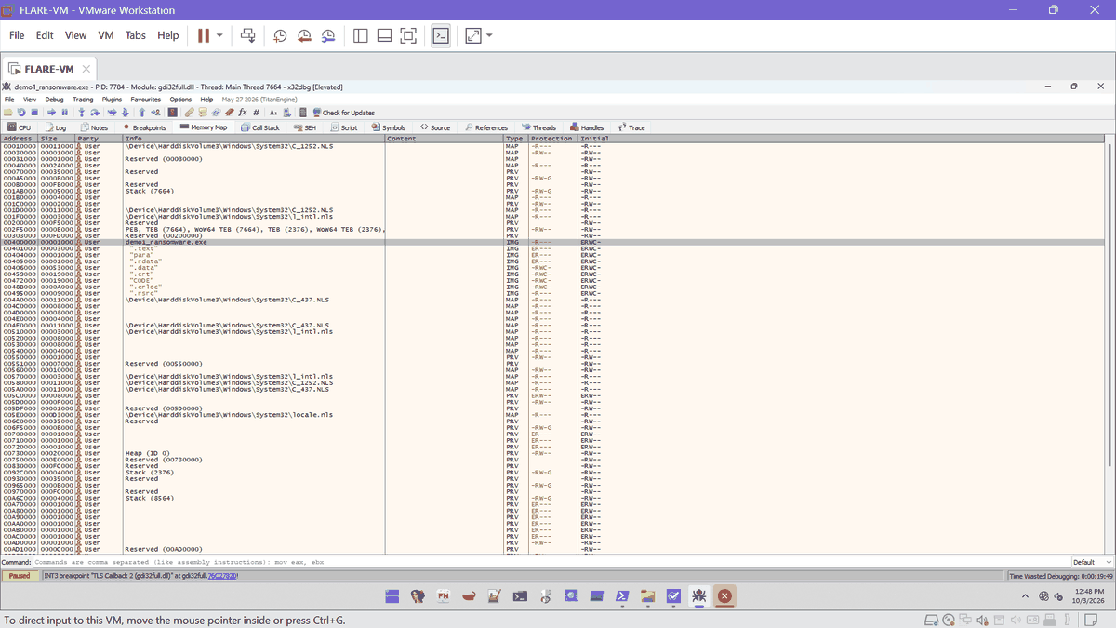
Ex. E16 | 2026-10-03 12:48 | x32dbg | x32dbg memory map PID 7784 | E16_20261003-1248_x32dbg_memmap_7784.png | SHA-256 3F6135DF81CA8083...
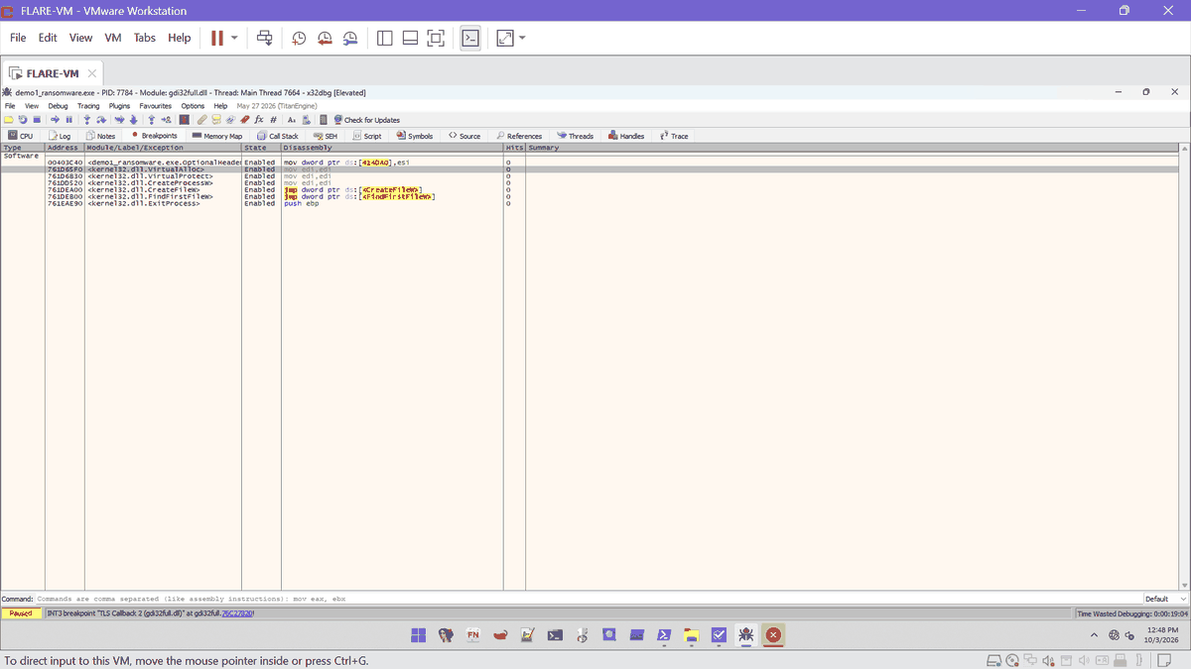
Ex. E17 | 2026-10-03 12:48 | x32dbg | x32dbg Breakpoints tab PID 7784 | E17_20261003-1248_x32dbg_breakpoints_7784.png | SHA-256 6CC59E26A7A7D708...
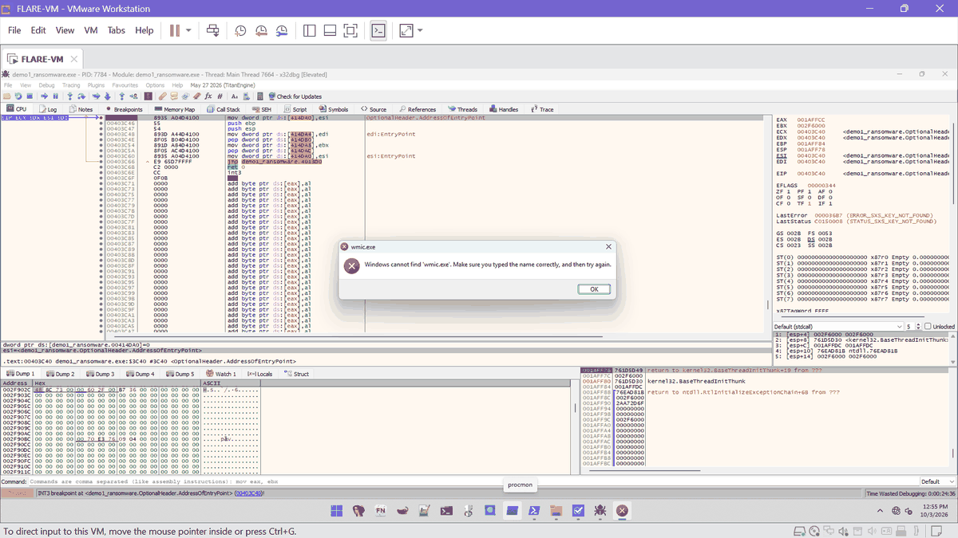
Ex. E19 | 2026-10-03 12:55 | x32dbg | x32dbg PID 7784 stopped at 00403C40 | E19_20261003-1255_x32dbg_pid7784_entry.png | SHA-256 562022B3E0755F56...
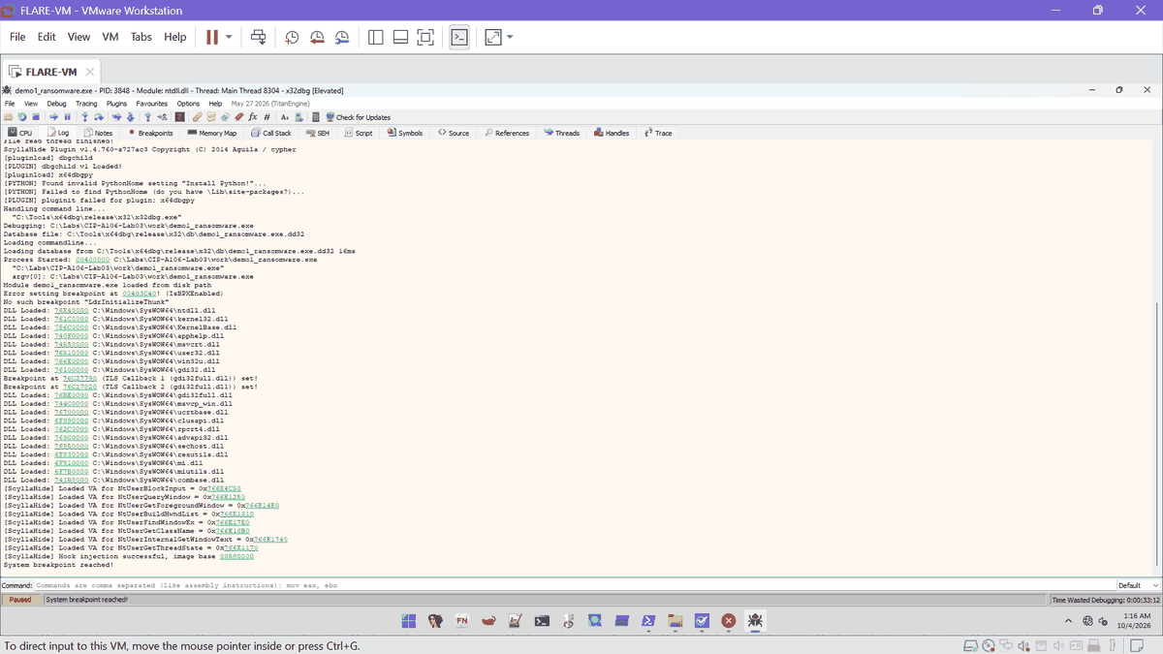
Ex. E20 | 2026-10-04 01:16 | x32dbg | x32dbg PID 3848 log | E20_20261004-0116_x32dbg_pid3848_log.png | SHA-256 DF7E43B1AA16F558...
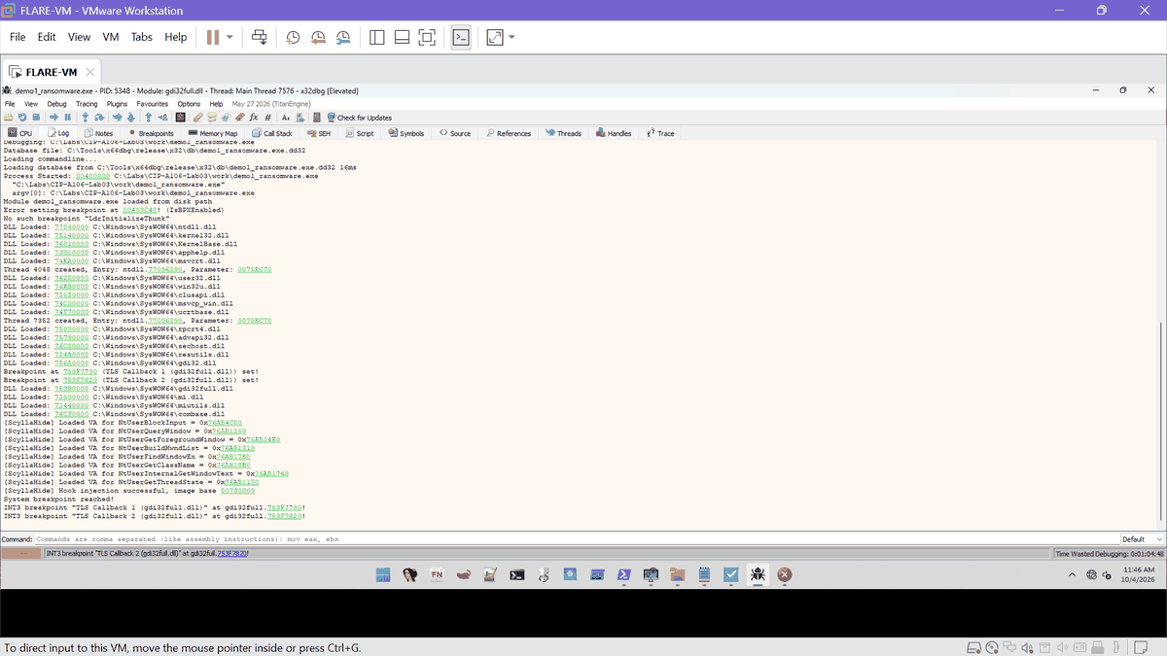
Ex. E34 | 2026-10-04 11:46 | x32dbg | x32dbg PID 5348 log | E34_20261004-1146_x32dbg_pid5348_log.png | SHA-256 9F8C7C5A42B80800...
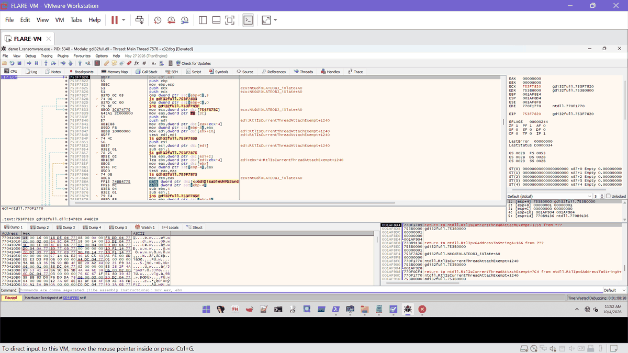
Ex. E35 | 2026-10-04 11:52 | x32dbg | x32dbg PID 5348 TLS stop | E35_20261004-1152_x32dbg_pid5348_tls.png | SHA-256 56E1821FC29B5678...
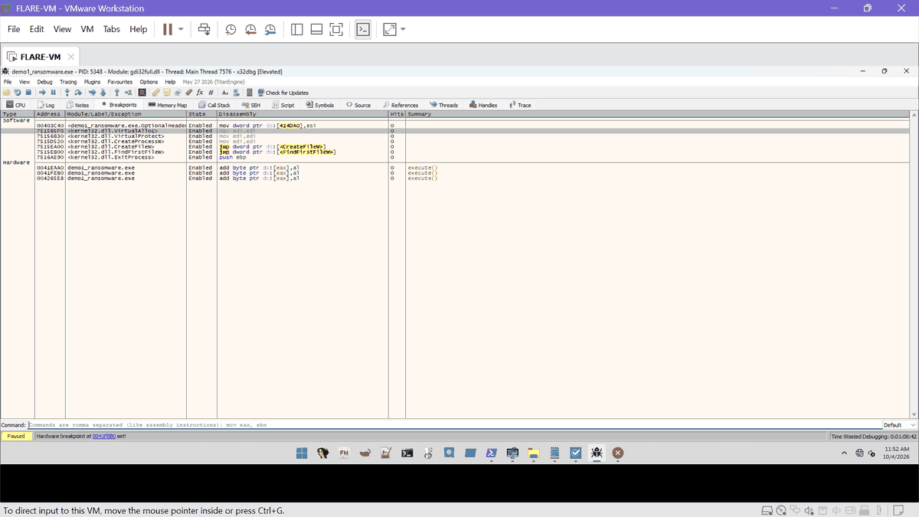
Ex. E36 | 2026-10-04 11:52 | x32dbg | x32dbg Breakpoints PID 5348 | E36_20261004-1152_x32dbg_breakpoints_5348.png | SHA-256 4463A226D9BC22DD...
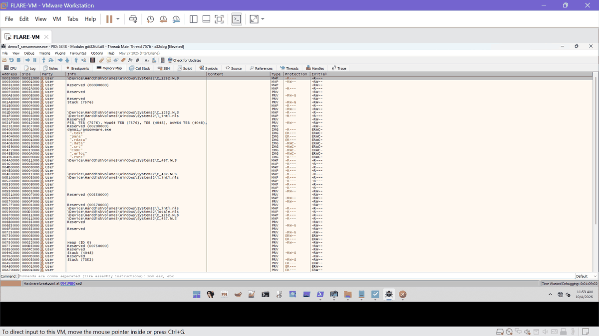
Ex. E37 | 2026-10-04 11:53 | x32dbg | x32dbg memory map PID 5348 | E37_20261004-1153_x32dbg_memmap_5348.png | SHA-256 E685153BB4A1E87E...
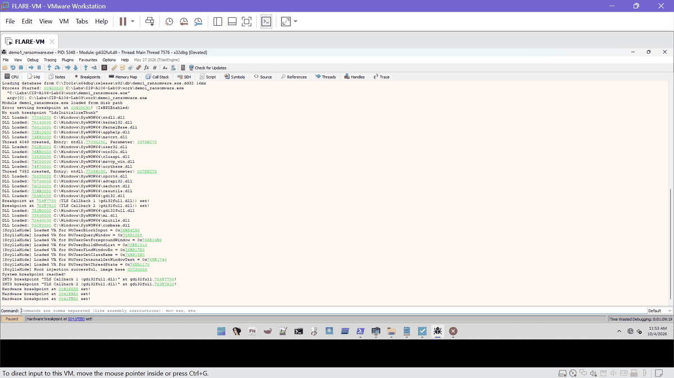
Ex. E38 | 2026-10-04 11:53 | x32dbg | x32dbg log PID 5348 | E38_20261004-1153_x32dbg_log_5348.png | SHA-256 E185C4A565901254...
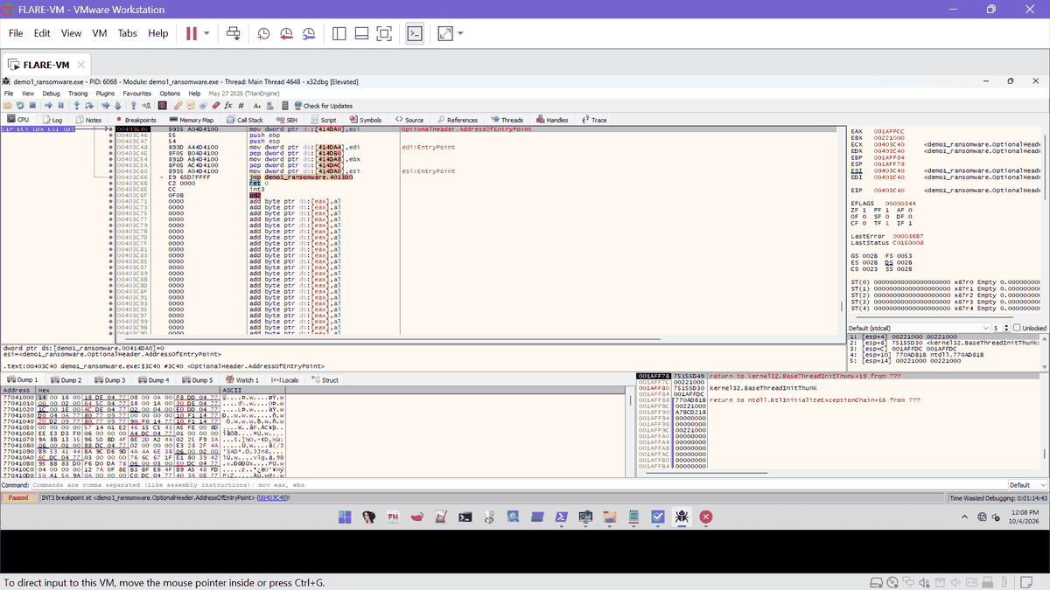
Ex. E39 | 2026-10-04 12:08 | x32dbg | x32dbg PID 6068 stopped at entry point 00403C40 | E39_20261004-1208_x32dbg_pid6068_entry.png | SHA-256 F030DF29A7D9AF7A...
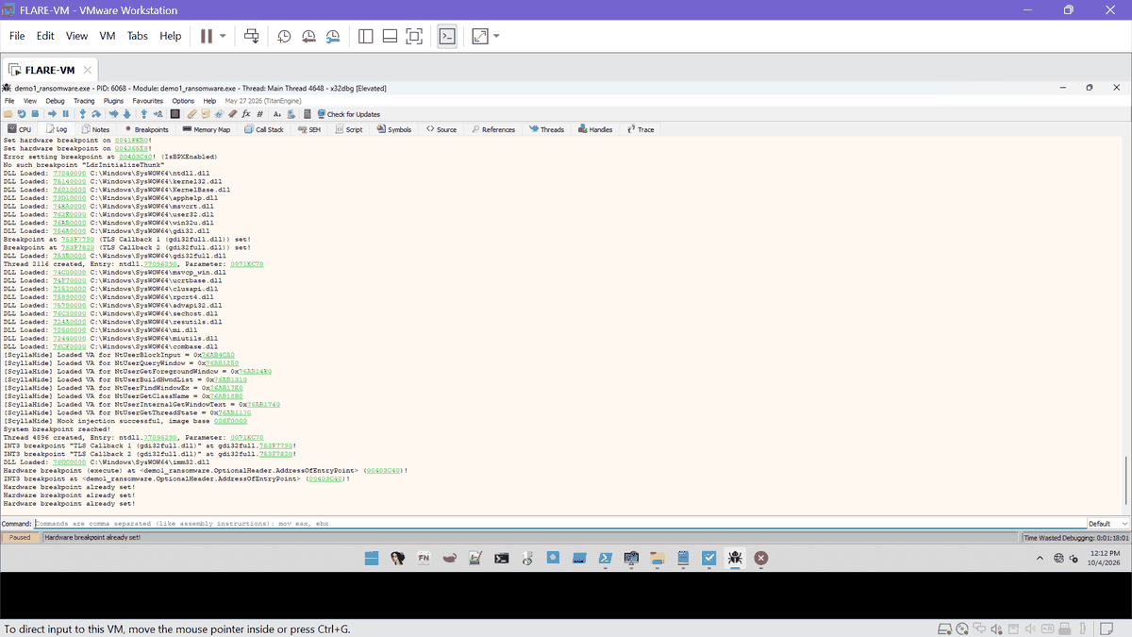
Ex. E40 | 2026-10-04 12:12 | x32dbg | x32dbg log PID 6068 | E40_20261004-1212_x32dbg_log_6068.png | SHA-256 8A4CE06C012C3F92...
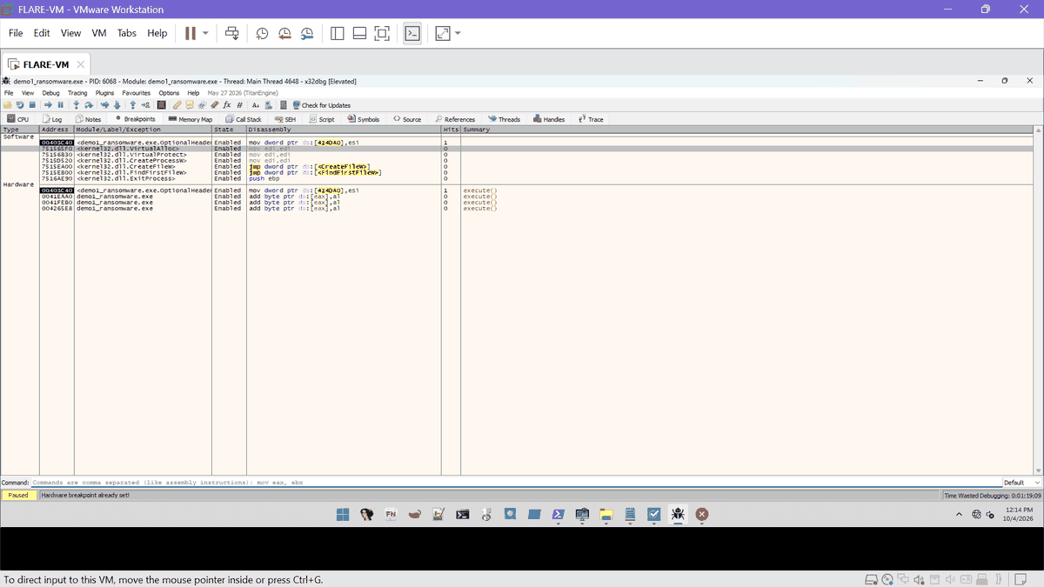
Ex. E41 | 2026-10-04 12:14 | x32dbg | x32dbg stopped at kernel32.VirtualAlloc | E41_20261004-1214_x32dbg_virtualalloc_a.png | SHA-256 CBB32CA36B3099E6...
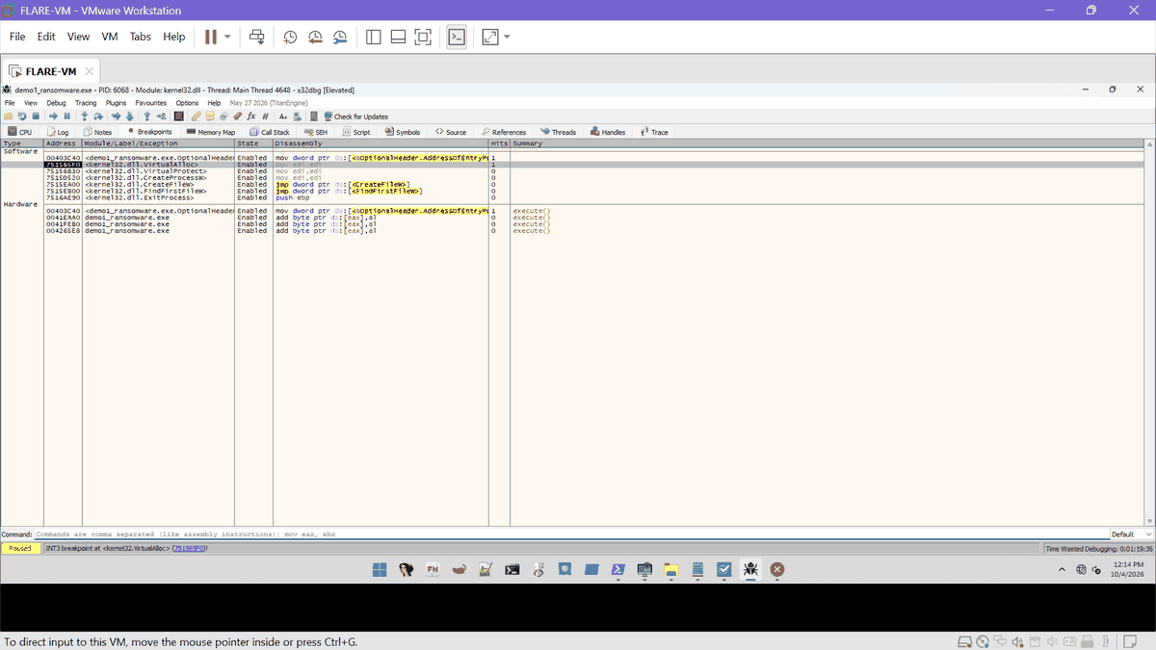
Ex. E42 | 2026-10-04 12:14 | x32dbg | x32dbg stopped at kernel32.VirtualAlloc (second view) | E42_20261004-1214_x32dbg_virtualalloc_b.png | SHA-256 A1FD0ACC3D0052DE...
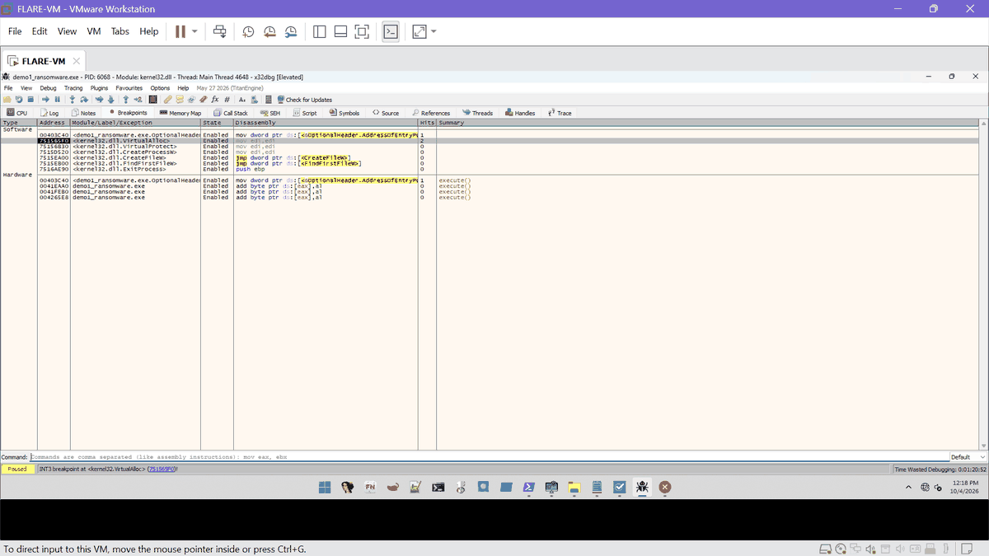
Ex. E43 | 2026-10-04 12:19 | x32dbg | x32dbg shlwapi TLS callback stop | E43_20261004-1219_x32dbg_tls_shlwapi_a.png | SHA-256 E9B80CDF69C4E698...
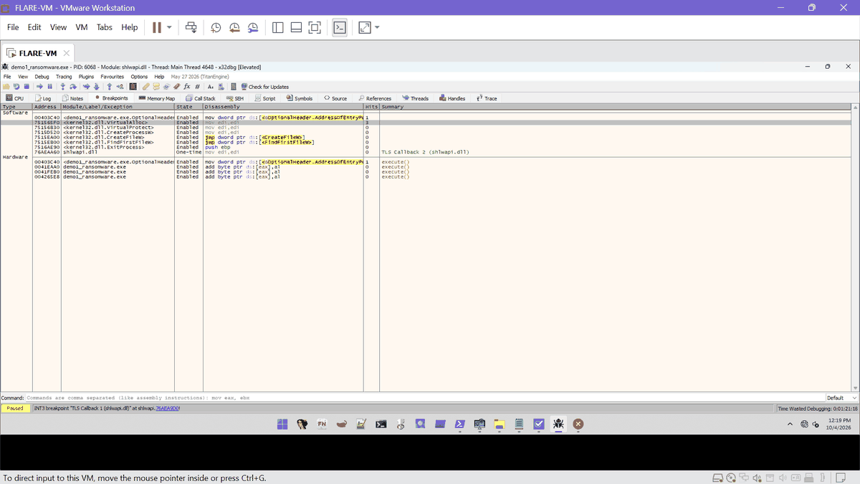
Ex. E44 | 2026-10-04 12:19 | x32dbg | x32dbg shlwapi TLS callback stop | E44_20261004-1219_x32dbg_tls_shlwapi_b.png | SHA-256 0608103B896524F7...
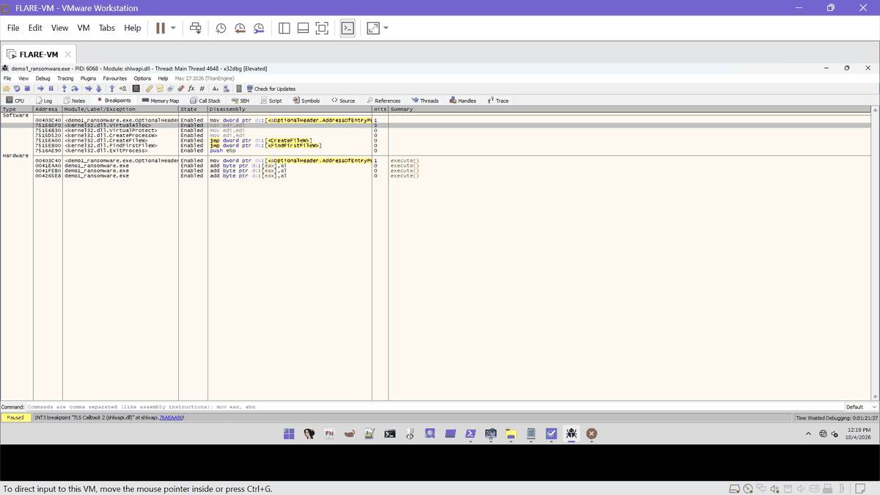
Ex. E45 | 2026-10-04 12:19 | x32dbg | x32dbg shlwapi TLS callback stop | E45_20261004-1219_x32dbg_tls_shlwapi_c.png | SHA-256 91F0CFFB74CB7491...
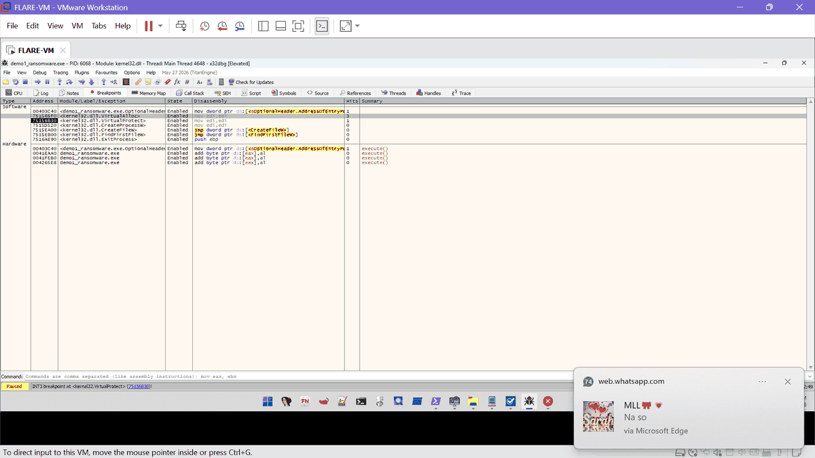
Ex. E46 | 2026-10-04 12:21 | x32dbg | x32dbg breakpoint on kernel32.VirtualProtect with hit counts | E46_20261004-1221_x32dbg_virtualprotect_breakpoint.png | SHA-256 145D639A7B8ABB06...
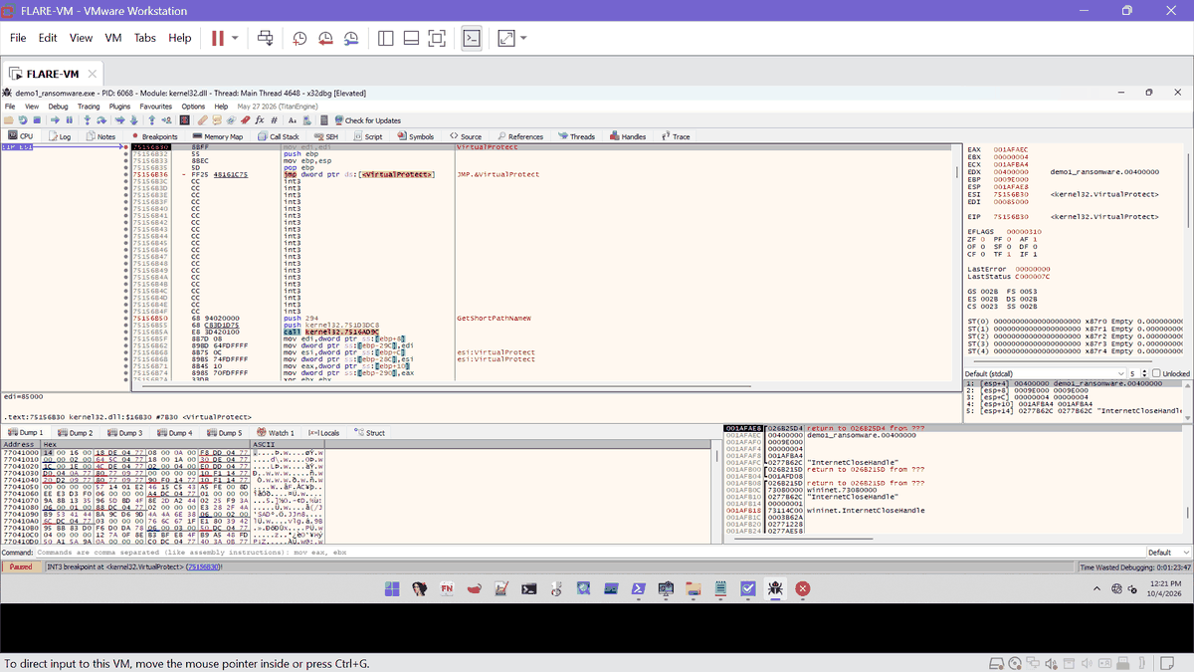
Ex. E47 | 2026-10-04 12:21 | x32dbg | VirtualProtect call 1 (0x400000, 0x9E000, PAGE_READWRITE) | E47_20261004-1221_x32dbg_virtualprotect_1.png | SHA-256 B82674503D31A9F6...
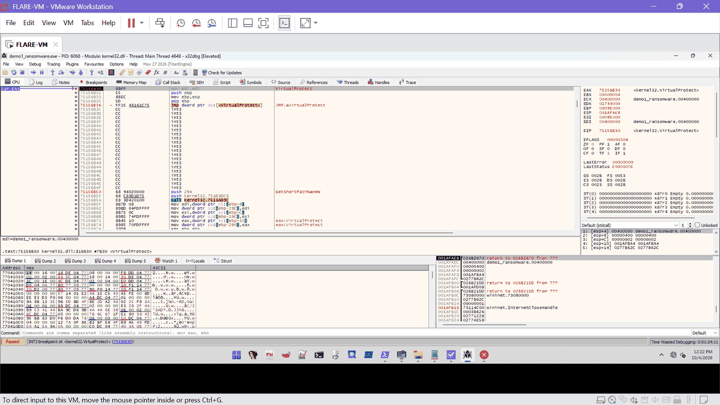
Ex. E48 | 2026-10-04 12:22 | x32dbg | VirtualProtect call 2 (0x400000, 0x400, PAGE_READONLY) | E48_20261004-1222_x32dbg_virtualprotect_2.png | SHA-256 28090E54D1A9C9C3...
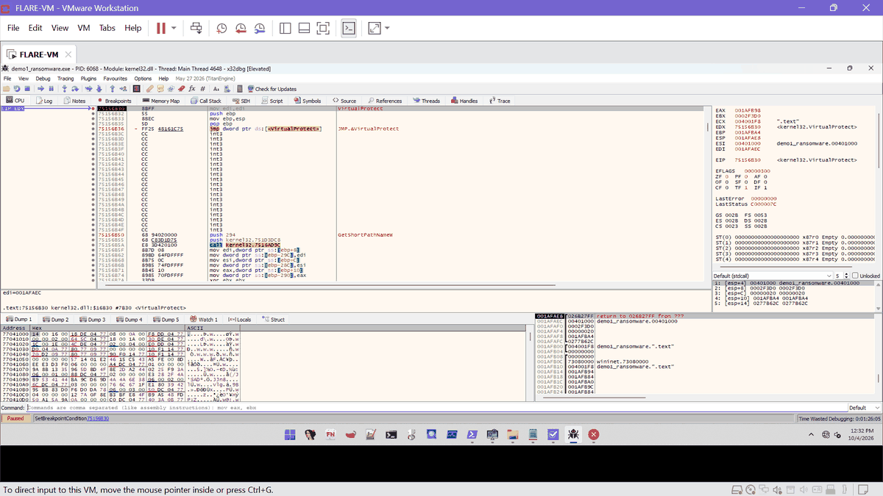
Ex. E49 | 2026-10-04 12:32 | x32dbg | VirtualProtect call 3 (.text, PAGE_EXECUTE_READ) | E49_20261004-1232_x32dbg_virtualprotect_3_text.png | SHA-256 423FD1814147F903...
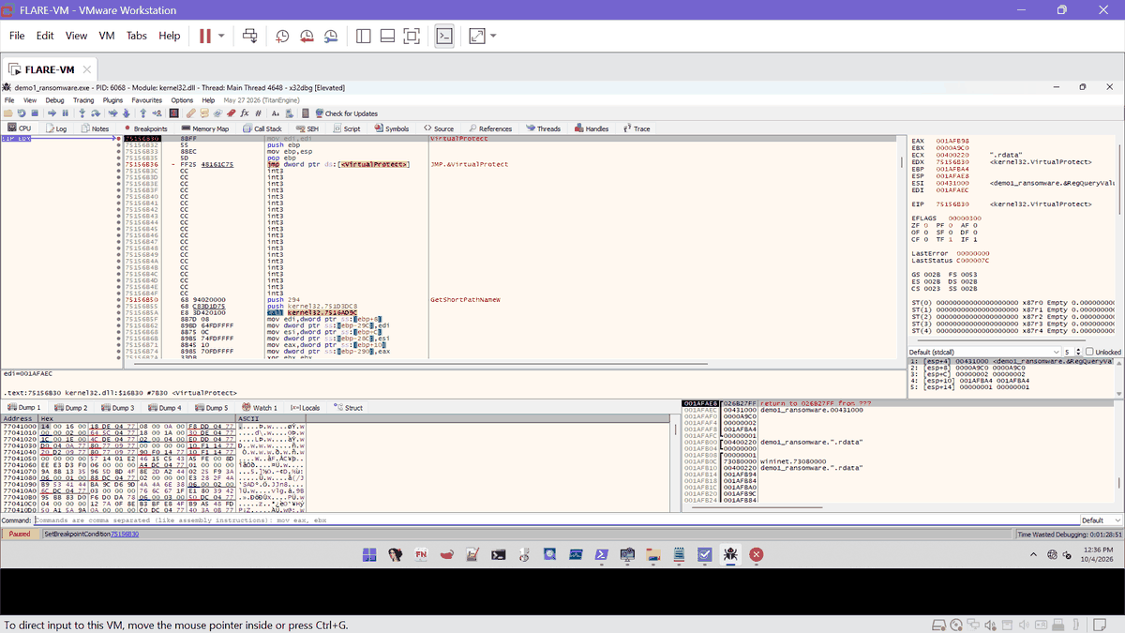
Ex. E50 | 2026-10-04 12:36 | x32dbg | VirtualProtect call 4 (.rdata, PAGE_READONLY) | E50_20261004-1236_x32dbg_virtualprotect_4_rdata.png | SHA-256 89F71FC3D73F9B8C...
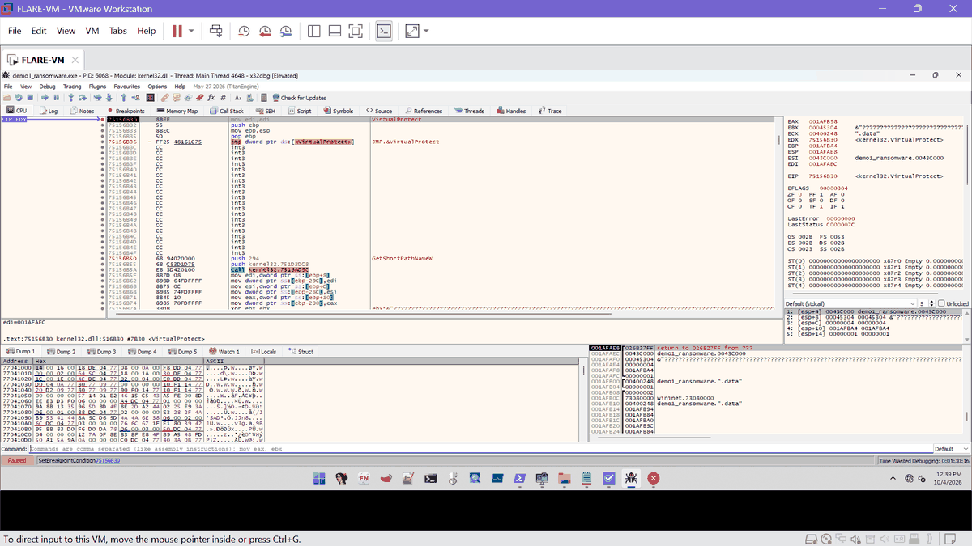
Ex. E51 | 2026-10-04 12:39 | x32dbg | VirtualProtect call 5 (.data, PAGE_READWRITE) | E51_20261004-1239_x32dbg_virtualprotect_5_data.png | SHA-256 486AA59FF1EB4090...
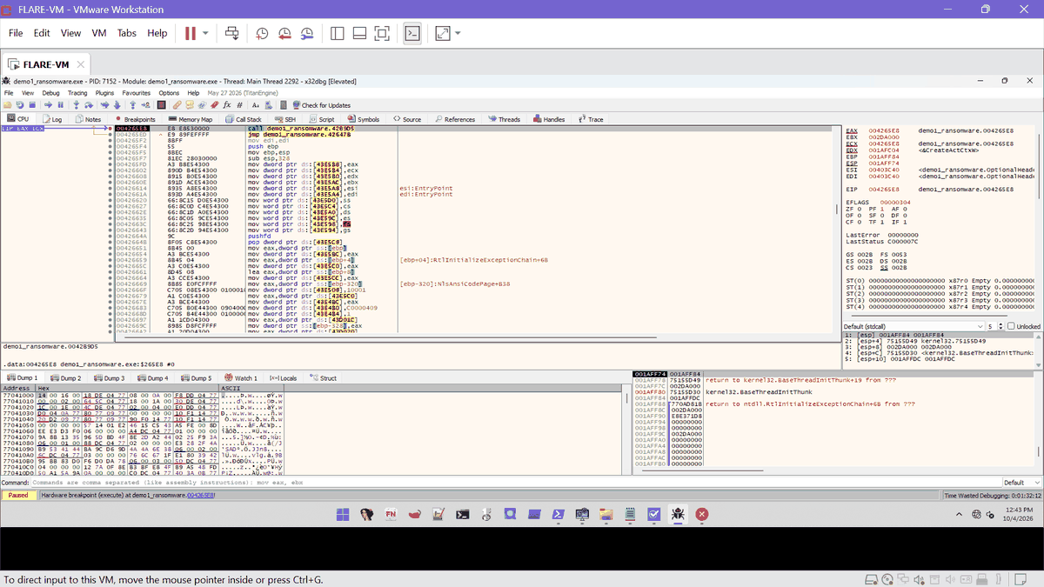
Ex. E52 | 2026-10-04 12:43 | x32dbg | Hardware breakpoint hit at 004265E8 (OEP), PID 7152 | E52_20261004-1243_x32dbg_oep_hit_7152.png | SHA-256 17E5E6E4E13D9439...
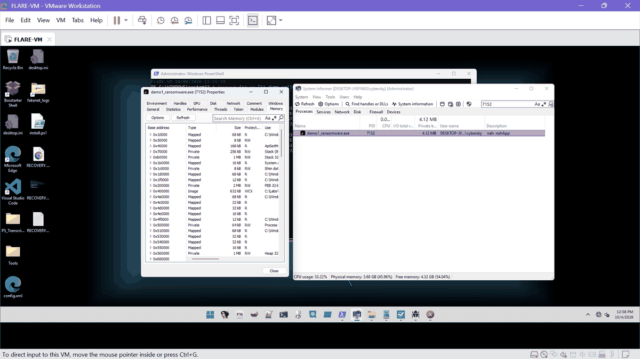
Ex. E53 | 2026-10-04 12:58 | System Informer 3.2 | System Informer PID 7152 Memory | E53_20261004-1258_sysinformer_7152_memory.png | SHA-256 79CB0643585391C3...
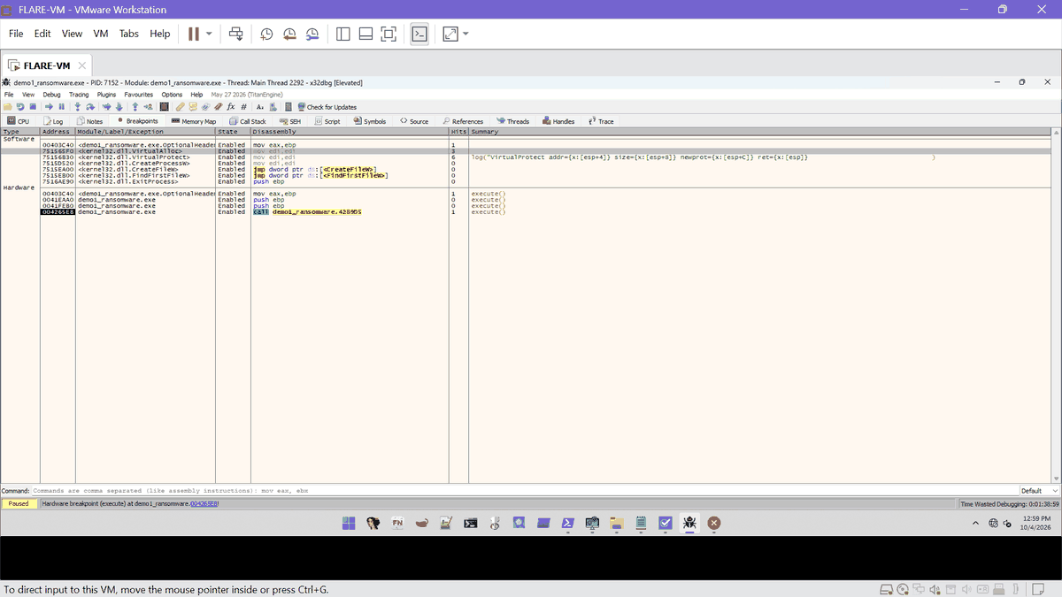
Ex. E54 | 2026-10-04 12:59 | x32dbg | Breakpoint hit counts: VirtualAlloc 3, VirtualProtect 6, 004265E8 1 | E54_20261004-1259_x32dbg_breakpoints_hits_7152.png | SHA-256 1D1F66A79697AD60...
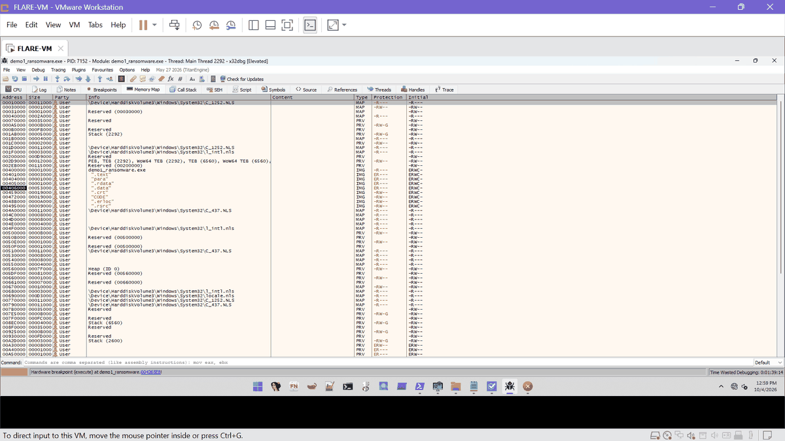
Ex. E55 | 2026-10-04 12:59 | x32dbg | x32dbg memory map PID 7152 | E55_20261004-1259_x32dbg_memmap_7152.png | SHA-256 4057014ED5084853...
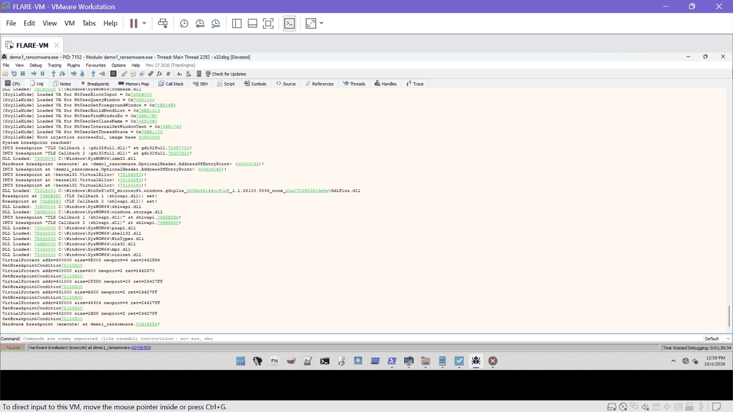
Ex. E56 | 2026-10-04 12:59 | x32dbg | x32dbg Log PID 7152 | E56_20261004-1259_x32dbg_log_7152_a.png | SHA-256 EBAC1A16370EBC2E...
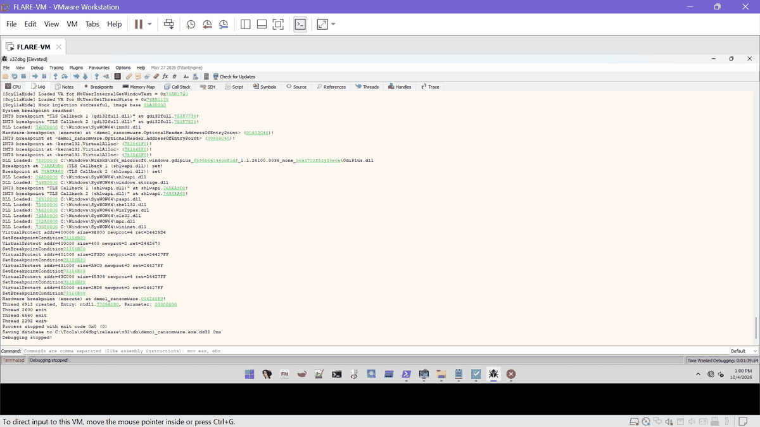
Ex. E57 | 2026-10-04 13:00 | x32dbg | x32dbg Log showing all six VirtualProtect calls | E57_20261004-1300_x32dbg_log_7152_virtualprotect.png | SHA-256 8F882B5797F35F3F...

D. Runtime behaviour and memory acquisition (Task D)
Windows dialogs (wmic), System Informer views of the uncontrolled run (PID 8532) and of the suspended PID 4820 used for the dump.
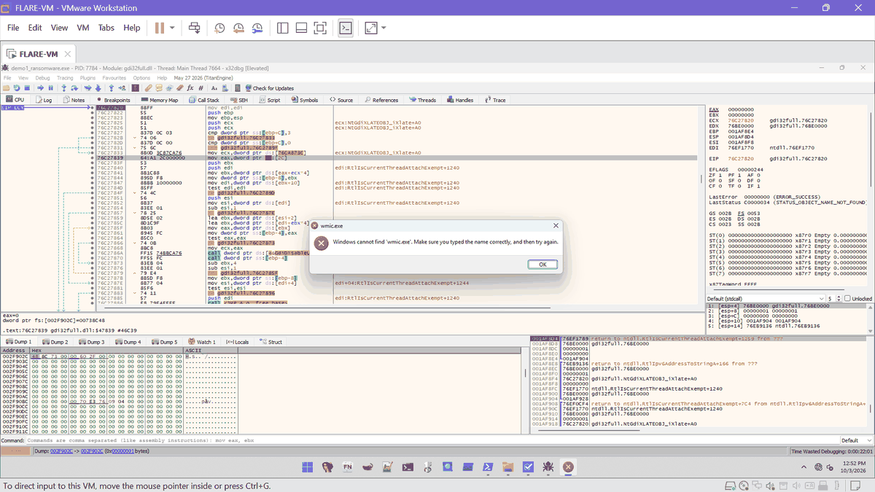
Ex. E18 | 2026-10-03 12:52 | Windows desktop | Windows dialog: Windows cannot find wmic.exe (originating process not attributed) | E18_20261003-1252_desktop_wmic_dialog.png | SHA-256 A5012E61AD7C06A6...
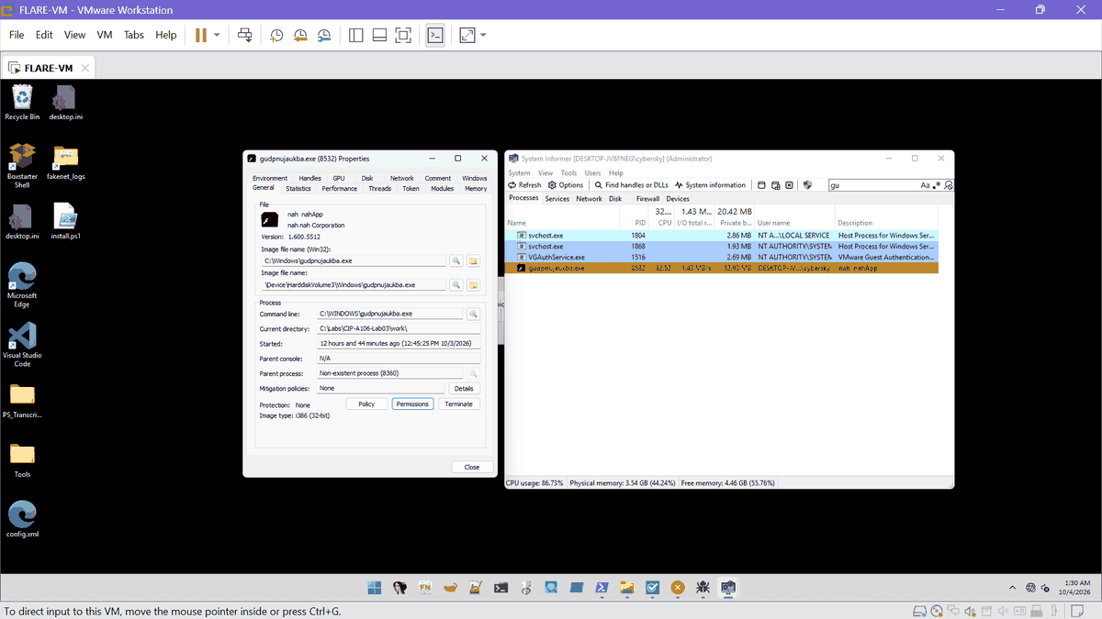
Ex. E22 | 2026-10-04 01:30 | System Informer 3.2 | System Informer PID 8532 General | E22_20261004-0130_sysinformer_8532_general.png | SHA-256 1BF96C54B731C63C...
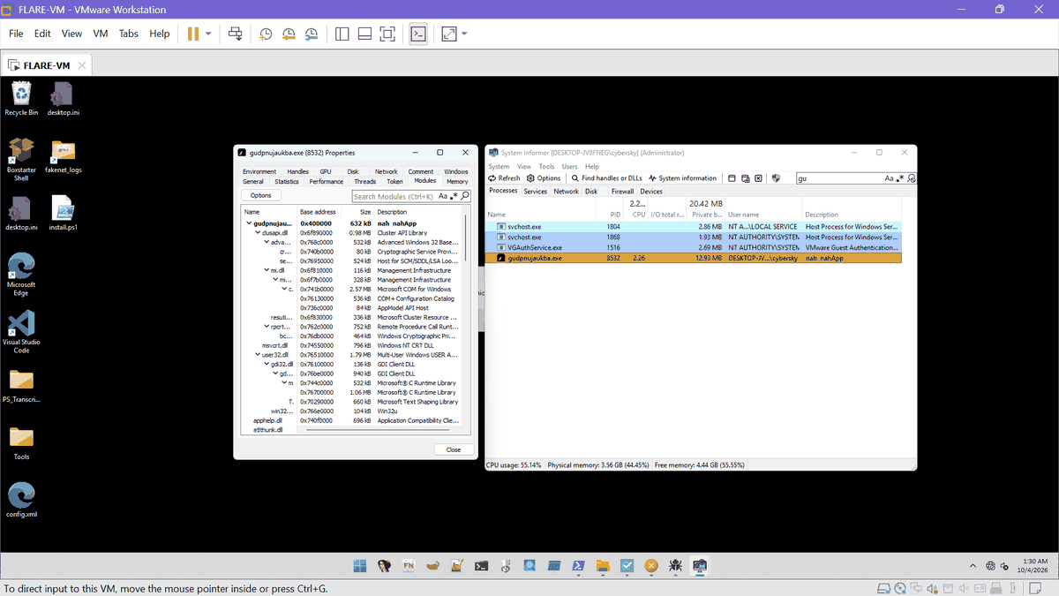
Ex. E23 | 2026-10-04 01:30 | System Informer 3.2 | System Informer PID 8532 Modules | E23_20261004-0130_sysinformer_8532_modules.png | SHA-256 5FC91F04A4DA7E54...
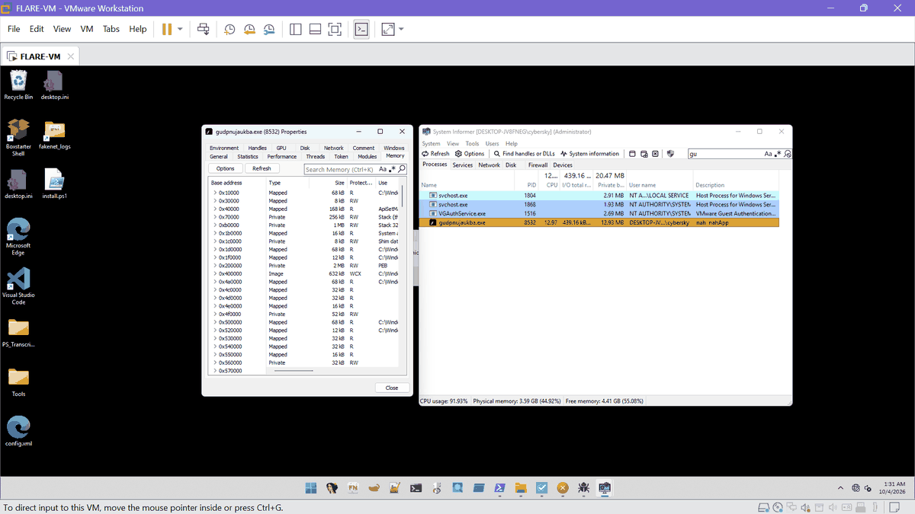
Ex. E24 | 2026-10-04 01:31 | System Informer 3.2 | System Informer PID 8532 Memory | E24_20261004-0131_sysinformer_8532_memory.png | SHA-256 5CF41ADB54A76BEA...
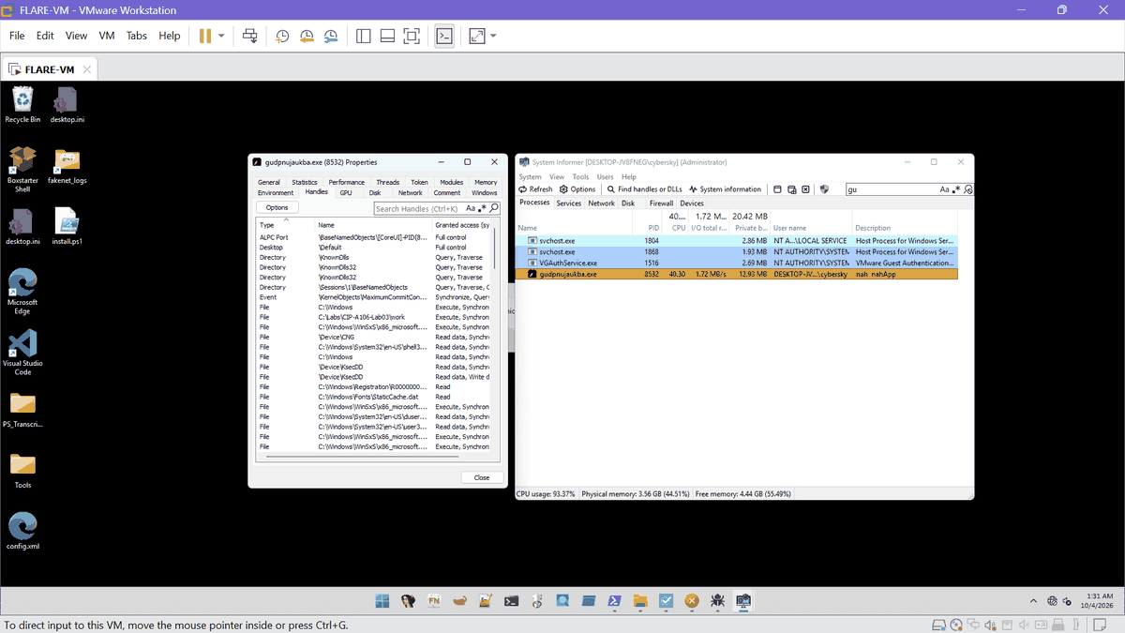
Ex. E25 | 2026-10-04 01:31 | System Informer 3.2 | System Informer PID 8532 Handles | E25_20261004-0131_sysinformer_8532_handles.png | SHA-256 EB2BF001DAD6684E...
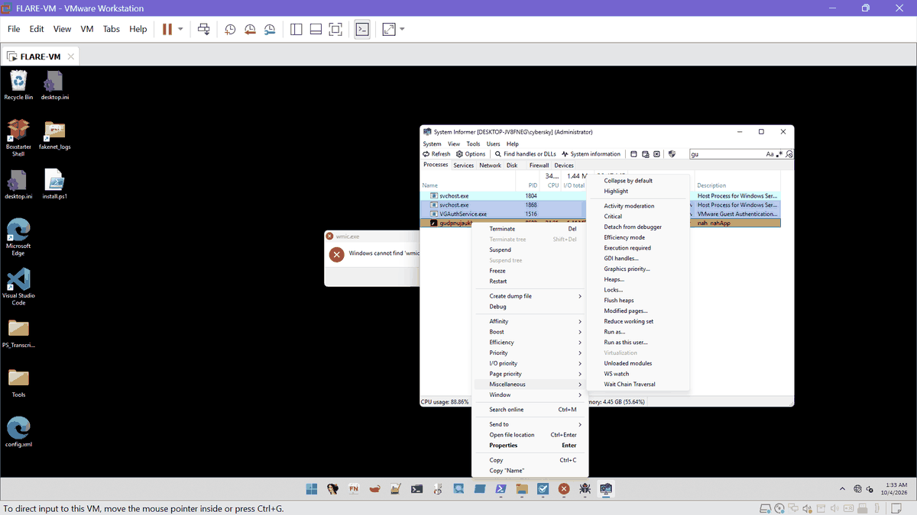
Ex. E26 | 2026-10-04 01:33 | System Informer 3.2 | System Informer PID 8532 menu with Create dump file | E26_20261004-0133_sysinformer_8532_dump_menu.png | SHA-256 48CD45C81CF57A18...
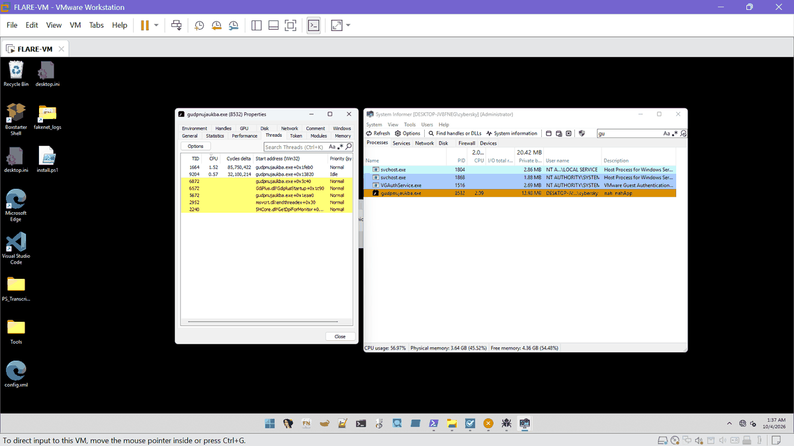
Ex. E27 | 2026-10-04 01:37 | System Informer 3.2 | System Informer PID 8532 Threads | E27_20261004-0137_sysinformer_8532_threads.png | SHA-256 9A3B514944C5CFEC...
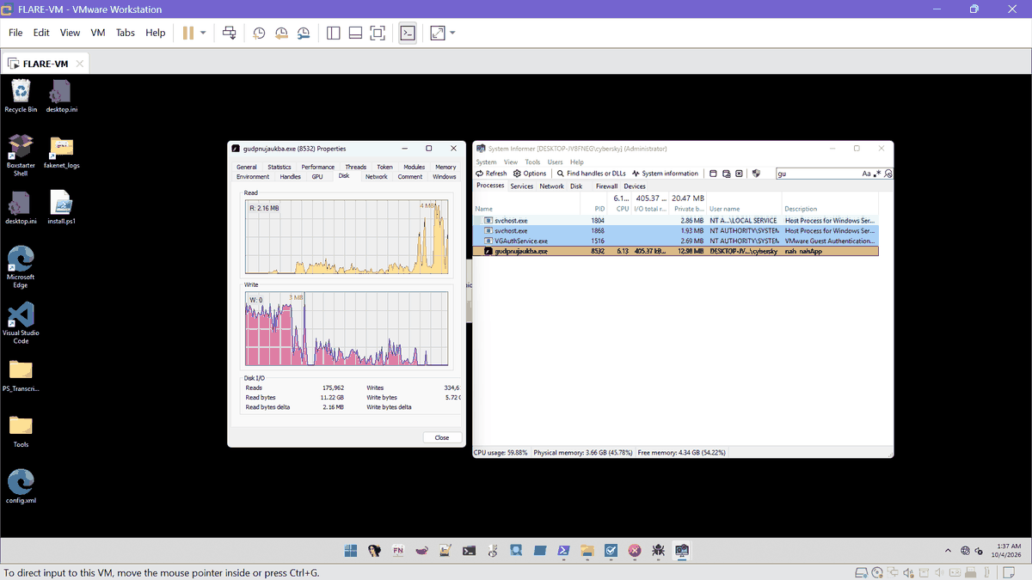
Ex. E28 | 2026-10-04 01:37 | System Informer 3.2 | System Informer PID 8532 Disk activity | E28_20261004-0137_sysinformer_8532_disk.png | SHA-256 9EA1D032BAF3B1B5...
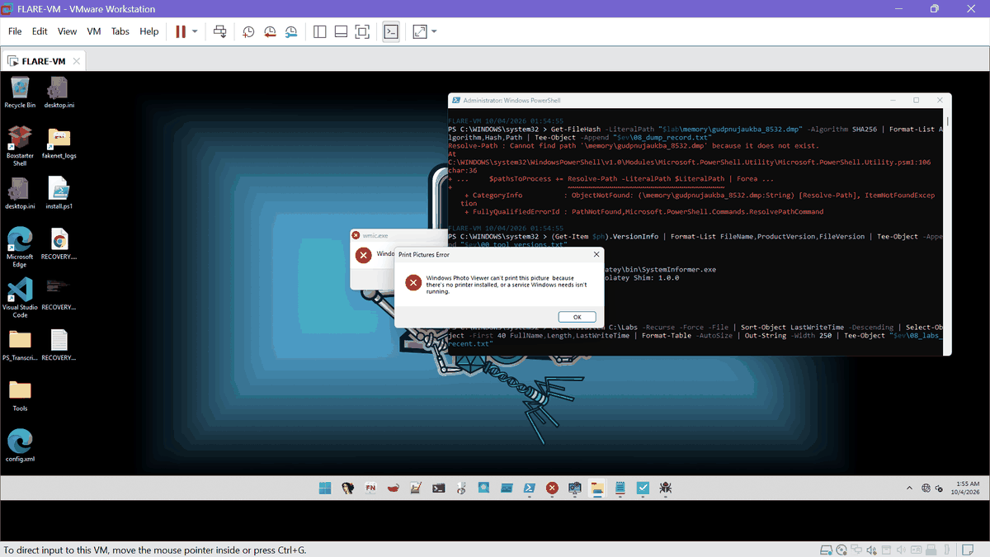
Ex. E29 | 2026-10-04 01:55 | Windows desktop, PowerShell | Desktop dialogs and PowerShell showing missing PID 8532 dump path | E29_20261004-0155_desktop_dialogs_missing_dump.png | SHA-256 8BAAD5AEE8A3E03F...
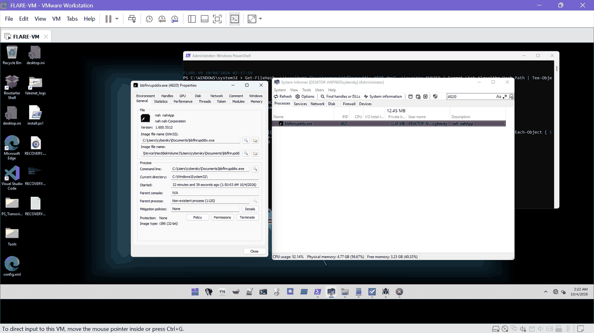
Ex. E30 | 2026-10-04 02:22 | System Informer 3.2 | System Informer PID 4820 General | E30_20261004-0222_sysinformer_4820_general.png | SHA-256 6C7525140B938962...
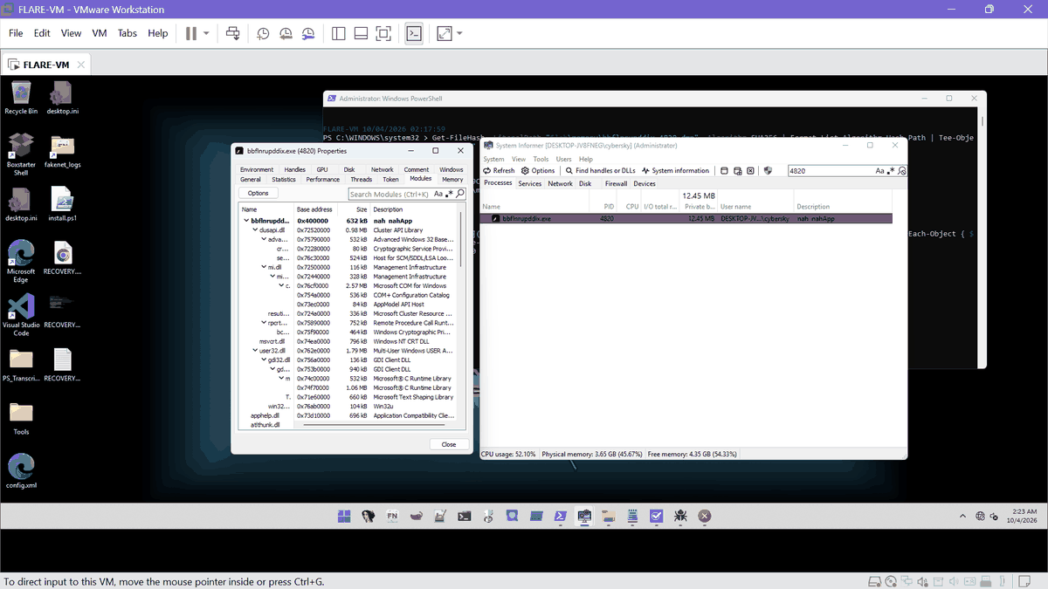
Ex. E31 | 2026-10-04 02:23 | System Informer 3.2 | System Informer PID 4820 Modules | E31_20261004-0223_sysinformer_4820_modules.png | SHA-256 03E5F9F6173EDC6B...
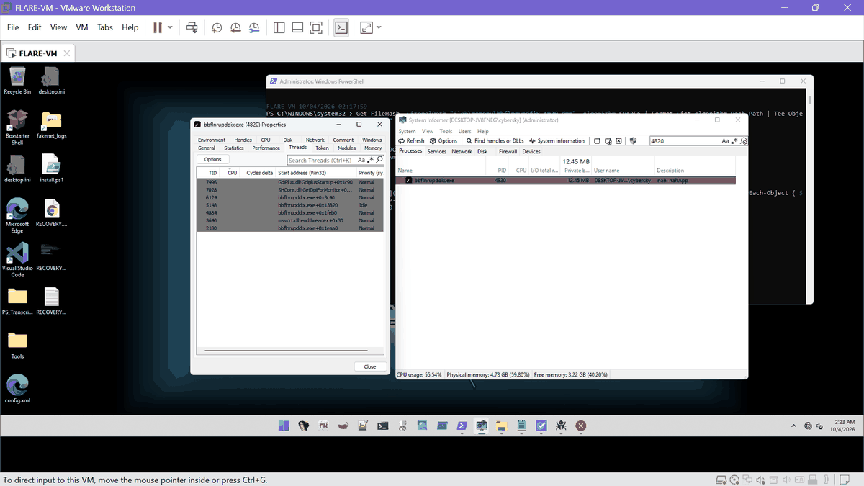
Ex. E32 | 2026-10-04 02:23 | System Informer 3.2 | System Informer PID 4820 Threads (suspended) | E32_20261004-0223_sysinformer_4820_threads.png | SHA-256 6BC268B6C996C827...
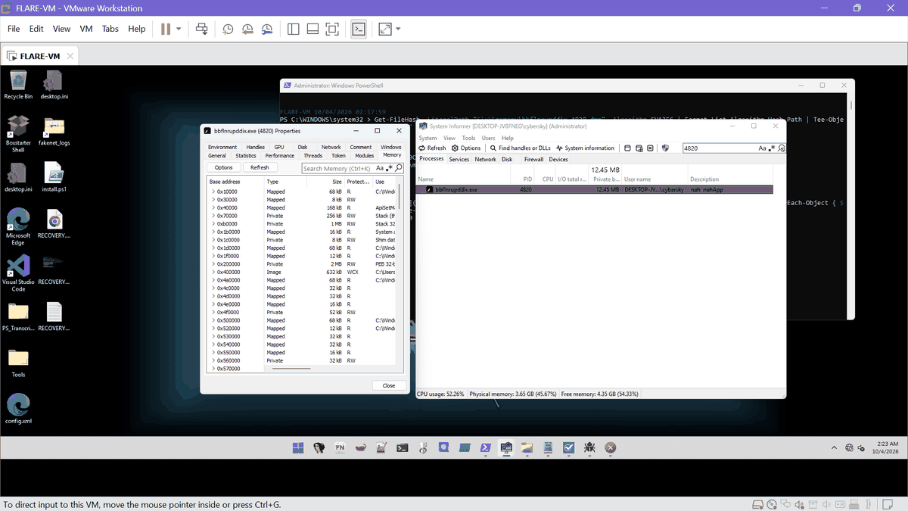
Ex. E33 | 2026-10-04 02:23 | System Informer 3.2 | System Informer PID 4820 Memory | E33_20261004-0223_sysinformer_4820_memory.png | SHA-256 CD0CF977F6899713...

T. Rebuilt text exports
These files were copied out of the VM as console text, so their line endings differ from the originals and their hashes differ. The hash of each VM original is in the Evidence Manifest. Domains and URLs are defanged in this appendix; the files in 06_Text_Exports_Rebuilt are unchanged.

T1. 15_hkcu_run_after.reg (HKCU Run after the five malicious values were removed, 13:32)
Windows Registry Editor Version 5.00

[HKEY_CURRENT_USER\Software\Microsoft\Windows\CurrentVersion\Run]
"OneDrive"="\"C:\\Program Files (x86)\\Microsoft OneDrive\\OneDrive.exe\" /background"
"ZoomIt"="C:\\Tools\\sysinternals\\ZoomIt64.exe"
"iorpyhcbjsja"="C:\\WINDOWS\\system32\\cmd.exe /c start \"\" \"C:\\WINDOWS\\gudpnujaukba.exe\""
"MicrosoftEdgeAutoLaunch_E430B68F8A79235BA6169AF5D61076AB"="\"C:\\Program Files (x86)\\Microsoft\\Edge\\Applic
"vylvawuyxpdy"="C:\\WINDOWS\\system32\\cmd.exe /c start \"\" \"C:\\Users\\cybersky\\Documents\\bbflnrupddix.ex
"lccjvxmpqmjl"="C:\\WINDOWS\\system32\\cmd.exe /c start \"\" \"C:\\WINDOWS\\vltxuvwdbsbu.exe\""
"objdqnybfhvp"="C:\\WINDOWS\\system32\\cmd.exe /c start \"\" \"C:\\WINDOWS\\raknlbaoydys.exe\""
"wikqxbughfcu"="C:\\WINDOWS\\system32\\cmd.exe /c start \"\" \"C:\\WINDOWS\\wlcdcfqqewfn.exe\""

T2. 10_dump_record.txt (PID 4820 dump: hash, header, and encrypted 8532 dump header)
Name : bbflnrupddix_4820.dmp
Length : 117739615
CreationTime : 10/4/2026 2:16:46 AM

Algorithm : SHA256
Hash : 6FA90986C74D9383B9FC0A9CC0AD3D06A92357E15EA95D4075AFEB4BFC79C0B8
Path : C:\Labs\CIP-A106-Lab03\memory\bbflnrupddix_4820.dmp

4D 44 4D 50 93 A7 F4 A0 10 00 00 00 20 00 00 00

T3. 13_oep_dump_record.txt (OEP dump: modules, header, section hashes, string tables). The "file" entropy and "differing" columns are not cited (mismatched section table).
Name : demo1_ransomware_7152_oep.dmp
Length : 43342498
CreationTime : 10/4/2026 12:50:14 PM

Algorithm : SHA256
Hash : C93F7330B0EC11CF22915D246F56BC59F51DAFDE17BE724613531358C5F192AB
Path : C:\Labs\CIP-A106-Lab03\memory\demo1_ransomware_7152_oep.dmp

4D 44 4D 50 93 A7 F4 A0 0F 00 00 00 20 00 00 00
MDMP signature OK
Stream types: 3,17,4,9,16,7,15,12,21,22,0
Memory regions: 218
Modules: 30
0x400000 85000 C:\Labs\CIP-A106-Lab03\work\demo1_ransomware.exe
0x77040000 1BF000 C:\Windows\System32\ntdll.dll
0x75140000 F0000 C:\Windows\System32\kernel32.dll
0x76010000 2C8000 C:\Windows\System32\KERNELBASE.dll
0x73D10000 AE000 C:\Windows\System32\apphelp.dll
0x74EA0000 C7000 C:\Windows\System32\msvcrt.dll
0x762E0000 1C9000 C:\Windows\System32\user32.dll
0x76AB0000 1A000 C:\Windows\System32\win32u.dll
0x756A0000 22000 C:\Windows\System32\gdi32.dll
0x753B0000 EB000 C:\Windows\System32\gdi32full.dll
0x74C00000 85000 C:\Windows\System32\msvcp_win.dll
0x74F70000 110000 C:\Windows\System32\ucrtbase.dll
0x72520000 FA000 C:\Windows\System32\clusapi.dll
0x75890000 BC000 C:\Windows\System32\rpcrt4.dll
0x75790000 85000 C:\Windows\System32\advapi32.dll
0x76C30000 83000 C:\Windows\System32\sechost.dll
0x724A0000 54000 C:\Windows\System32\resutils.dll
0x72500000 1D000 C:\Windows\System32\mi.dll
0x72440000 52000 C:\Windows\System32\miutils.dll
0x76CF0000 292000 C:\Windows\System32\combase.dll
0x76CC0000 25000 C:\Windows\System32\imm32.dll
0x722C0000 17C000 C:\Windows\WinSxS\x86_microsoft.windows.gdiplus_6595b64144ccf1df_1.1.26100.8036_none_b6a17
0x76AD0000 52000 C:\Windows\System32\shlwapi.dll
0x743B0000 6E4000 C:\Windows\System32\Windows.Storage.dll
0x76910000 6000 C:\Windows\System32\psapi.dll
0x75950000 636000 C:\Windows\System32\shell32.dll
0x75530000 F9000 C:\Windows\System32\WinTypes.dll
0x74AA0000 151000 C:\Windows\System32\ole32.dll
0x722A0000 19000 C:\Windows\System32\mpr.dll
0x73080000 224000 C:\Windows\System32\wininet.dll
MZ at 0x400000: True
PE signature: True
TimeDateStamp 0x56D208AF EntryRVA 0x265E8 SizeOfImage 0x85000
First 0x400 header bytes identical to disk: False
.text VA 0x1000 vsz 0x2F3D0 rawsz 0x2F400 | entropy mem 6.69 file 7.63 | differing 191541 of 193488 | mem sh
.rdata VA 0x31000 vsz 0xA9C0 rawsz 0xAA00 | entropy mem 6.18 file 7.92 | differing 43275 of 43456 | mem sha25
.data VA 0x3C000 vsz 0x45304 rawsz 0x2600 | entropy mem 0.30 file 7.88 | differing 9669 of 9728 | mem sha256
.reloc VA 0x82000 vsz 0x2BD8 rawsz 0x2C00 | entropy mem 5.11 file 7.88 | differing 11155 of 11224 | mem sha25
Extracted image: C:\Labs\CIP-A106-Lab03\unpacked\oep\mem_image_0x400000.bin 544768 bytes, zero-filled (not in
needle | dump ascii | dump utf16 | disk ascii | disk utf16 | first dump VA
zatcurr | 6 | 0 | 0 | 0 | 0x438C15
keratadze | 6 | 0 | 0 | 0 | 0x438C46
milerteddy | 6 | 0 | 0 | 0 | 0x438C78
.onion | 3 | 0 | 0 | 0 | 0x438D95
4855EB75F88FBD5 | 0 | 0 | 0 | 0 | -
1E3Hf3Mpy4g8zZUHPoAFwSarq5UxLbocT3 | 0 | 0 | 0 | 0 | -
_RECOVERY_ | 0 | 1 | 0 | 0 | -
wmic | 2 | 1 | 0 | 0 | 0x43A2A8
vssadmin | 0 | 0 | 0 | 0 | -
CurrentVersion\Run | 0 | 2 | 0 | 0 | -
gudpnujaukba | 0 | 0 | 0 | 0 | -
bbflnrupddix | 0 | 0 | 0 | 0 | -
.mp3 | 0 | 4 | 0 | 0 | -

T4. 12_payload_image.txt (unpacked image summary)
Hash : 42900DE68702ADB3E6802155AA416C7EEB5F19EBCC7D7387C08BAA4C51D7D9A8
Path : C:\Labs\CIP-A106-Lab03\unpacked\mem_image_0x400000.bin

RVA 0x265E8: E8 E8 53 00 00 E9 89 FE FF FF 8B FF 55 8B EC 81 EC 28 03 00 00 A3 B8 E5 43 00 89 0D B4 E5 43 00 8
RVA 0x13820: 55 8B EC 83 E4 F8 81 EC F4 04 00 00 A1 1C D0 43 00 33 C4 89 84 24 F0 04 00 00 53 56 57 6A 05 68 2
RVA 0x1EAA0: 55 8B EC 81 EC 48 02 00 00 A1 1C D0 43 00 33 C5 89 45 FC 68 FF 00 00 00 8D 85 F9 FD FF FF 6A 00 5
RVA 0x1FEB0: 55 8B EC B8 94 58 01 00 E8 73 DD 00 00 A1 1C D0 43 00 33 C5 89 45 FC 33 C0 68 FE 1F 00 00 50 8D 8

T5. 07_note_recovery_txt.txt (text of the 253-byte recover_file note)
NOT YOUR LANGUAGE? USE hxxps://translate.google[.]com

What happened to your files ?
All of your files were protected by a strong encryption with AES
More information about the encryption keys using AES can be found here: hxxp://en.wikipedia.org/wiki/AES

How did this happen ?
!!! Specially for your PC was generated personal AES KEY, both public and private.
!!! ALL YOUR FILES were encrypted with the public key, which has been transferred to your computer via the Int
!!! Decrypting of your files is only possible with the help of the private key and decrypt program , which is

What do I do ?
So, there are two ways you can choose: wait for a miracle and get your price doubled, or start obtaining BITCO
If You have really valuable data, you better not waste your time, because there is no other way to get your fi

For more specific instructions, please visit your personal home page, there are a few different addresses poin
1. hxxp://gwe32fdr74bhfsyujb34gfszfv.zatcurr[.]com/4855EB75F88FBD5
2. hxxp://tes543berda73i48fsdfsd.keratadze[.]at/4855EB75F88FBD5
3. hxxp://tt54rfdjhb34rfbnknaerg.milerteddy[.]com/4855EB75F88FBD5
If for some reasons the addresses are not available, follow these steps:
1. Download and install tor-browser: hxxp://www.torproject.org/projects/torbrowser.html.en
2. After a successful installation, run the browser
3. Type in the address bar: xlowfznrg4wf7dli[.]onion/4855EB75F88FBD5
4. Follow the instructions on the site.

---------------- IMPORTANT INFORMATION------------------------
*-*-* Your personal pages:
hxxp://gwe32fdr74bhfsyujb34gfszfv.zatcurr[.]com/4855EB75F88FBD5
hxxp://tes543berda73i48fsdfsd.keratadze[.]at/4855EB75F88FBD5
hxxp://tt54rfdjhb34rfbnknaerg.milerteddy[.]com/4855EB75F88FBD5
*-*-* Your personal page Tor-Browser: xlowfznrg4wf7dli.ONION/4855EB75F88FBD5

T6. x32dbg log excerpt, session S4 (lines 86 to 160 of 14_x32dbg_log_7152.txt, as pasted at 13:27)
Hardware breakpoint at 0041EAA0 set!
Hardware breakpoint at 0041FEB0 set!
Hardware breakpoint at 00403C40 set!
DLL Loaded: 76CC0000 C:\Windows\SysWOW64\imm32.dll
Thread 6540 created, Entry: ntdll.77096290, Parameter: 00751870
INT3 breakpoint at <demo1_ransomware.OptionalHeader.AddressOfEntryPoint> (00403C40)!
You can only set 4 hardware breakpoints
Thread 5948 created, Entry: ntdll.77096290, Parameter: 00751870
INT3 breakpoint at <kernel32.VirtualAlloc> (751565F0)!
INT3 breakpoint at <kernel32.VirtualAlloc> (751565F0)!
INT3 breakpoint at <kernel32.VirtualAlloc> (751565F0)!
DLL Loaded: 722C0000 C:\Windows\WinSxS\x86_microsoft.windows.gdiplus_6595b64144ccf1df_1.1.26100.8036_none_b6a1
Breakpoint at 76AEA9D0 (TLS Callback 1 (shlwapi.dll)) set!
Breakpoint at 76AEAA60 (TLS Callback 2 (shlwapi.dll)) set!
DLL Loaded: 76AD0000 C:\Windows\SysWOW64\shlwapi.dll
DLL Loaded: 743B0000 C:\Windows\SysWOW64\windows.storage.dll
INT3 breakpoint "TLS Callback 1 (shlwapi.dll)" at shlwapi.76AEA9D0!
INT3 breakpoint "TLS Callback 2 (shlwapi.dll)" at shlwapi.76AEAA60!
DLL Loaded: 76910000 C:\Windows\SysWOW64\psapi.dll
DLL Loaded: 75950000 C:\Windows\SysWOW64\shell32.dll
DLL Loaded: 75530000 C:\Windows\SysWOW64\WinTypes.dll
DLL Loaded: 74AA0000 C:\Windows\SysWOW64\ole32.dll
DLL Loaded: 722A0000 C:\Windows\SysWOW64\mpr.dll
DLL Loaded: 73080000 C:\Windows\SysWOW64\wininet.dll
INT3 breakpoint at <kernel32.VirtualProtect> (75156B30)!
INT3 breakpoint at <kernel32.VirtualProtect> (75156B30)!
INT3 breakpoint at <kernel32.VirtualProtect> (75156B30)!
INT3 breakpoint at <kernel32.VirtualProtect> (75156B30)!
INT3 breakpoint at <kernel32.VirtualProtect> (75156B30)!
INT3 breakpoint at <kernel32.VirtualProtect> (75156B30)!
DLL Loaded: 73EC0000 C:\Windows\SysWOW64\kernel.appcore.dll
DLL Loaded: 75F90000 C:\Windows\SysWOW64\bcryptprimitives.dll
DLL Loaded: 73460000 C:\Windows\SysWOW64\uxtheme.dll
DLL Loaded: 74DC0000 C:\Windows\SysWOW64\SHCore.dll
Thread 3040 created, Entry: gdiplus.7233C610, Parameter: 00770B38
DLL Loaded: 74CA0000 C:\Windows\SysWOW64\msctf.dll
DLL Loaded: 73EE0000 C:\Windows\SysWOW64\profapi.dll
INT3 breakpoint at <kernel32.CreateFileW> (7515EA00)!
INT3 breakpoint at <kernel32.CreateFileW> (7515EA00)!
DLL Loaded: 74380000 C:\Windows\SysWOW64\ntmarta.dll
INT3 breakpoint at <kernel32.CreateProcessW> (7515D520)!
DLL Loaded: 734F0000 C:\Windows\SysWOW64\propsys.dll
DLL Loaded: 75090000 C:\Windows\SysWOW64\oleaut32.dll
DLL Loaded: 754A0000 C:\Windows\SysWOW64\clbcatq.dll
Thread 4208 created, Entry: combase.76DDAE70, Parameter: 007801A0
Thread 1856 created, Entry: ntdll.77096290, Parameter: 00769C40
Thread 3044 created, Entry: ntdll.77096290, Parameter: 00769C40
DLL Loaded: 6FF50000 C:\Windows\SysWOW64\cfgmgr32.dll
DLL Loaded: 6F600000 C:\Windows\SysWOW64\edputil.dll
DLL Loaded: 6DBE0000 C:\Windows\SysWOW64\urlmon.dll
DLL Loaded: 6D990000 C:\Windows\SysWOW64\iertutil.dll
DLL Loaded: 72FB0000 C:\Windows\SysWOW64\srvcli.dll
DLL Loaded: 740A0000 C:\Windows\SysWOW64\netutils.dll
Thread 7424 created, Entry: shcore.74DF2A20, Parameter: 007A0BB8
DLL Loaded: 6E7E0000 C:\Windows\SysWOW64\Windows.StateRepositoryPS.dll
DLL Loaded: 740B0000 C:\Windows\SysWOW64\sspicli.dll
DLL Loaded: 74360000 C:\Windows\SysWOW64\virtdisk.dll
DLL Loaded: 74300000 C:\Windows\SysWOW64\wldp.dll
DLL Loaded: 742E0000 C:\Windows\SysWOW64\smartscreenps.dll
DLL Loaded: 74260000 C:\Windows\SysWOW64\shdocvw.dll
DLL Loaded: 74170000 C:\Windows\SysWOW64\winhttp.dll
INT3 breakpoint at <kernel32.CreateProcessW> (7515D520)!
INT3 breakpoint at <kernel32.ExitProcess> (7516AE90)!
Thread 4048 exit
Thread 7352 exit
Thread 6540 exit
Thread 5948 exit
Thread 3040 exit
Thread 4208 exit
Thread 1856 exit
Thread 3044 exit
Thread 7424 exit
Process stopped with exit code 0x1 (1)
Saving database to C:\Tools\x64dbg\release\x32\db\demo1_ransomware.exe.dd32 31ms
Debugging stopped!

H. Hash list of the screenshots
The full list, in the same order as the exhibits, is also saved as SHA256SUMS.txt in the 05_Screenshots folder (verify with sha256sum -c).
Ex. | File | SHA-256
E01 | E01_20261003-1149_pestudio_file_info.png | A747D5806294BD51D65F9C3D4F51901C5CE8C150D5DF7D4837DC7B80A038C1F5
E02 | E02_20261003-1151_pestudio_indicators.png | 959FFCE5E7CEE268AC3A3FC64679D771B2540B6B1C668BF71E5685BFFD8C1962
E03 | E03_20261003-1153_pestudio_imports.png | 7B9E62FC0CE65017048D3906A3CDF0E0A1C9ACBF7AB59713EB5CC881E85DBF95
E04 | E04_20261003-1153_pestudio_sections.png | 9805DA0136DCCE6FAE9FB75D6101ED8E2CBA3B298023C940987AC4ADE119530A
E05 | E05_20261003-1155_pestudio_strings.png | 326086C80DF9E4FE4DEA1692986A8A47F7E94F8E4B535F93EEEEC5BBE159731D
E06 | E06_20261003-1156_pestudio_resources.png | 8B620DFFD154D1D067A5DD2CDF127B2242C7F9A5951D9E73F4A39BB04A66A1FD
E07 | E07_20261003-1157_pestudio_debug.png | 0E46CCC0EFEC84F53710AA4416252766D43624CDAC4A4CF3D85A03873D97D455
E08 | E08_20261003-1202_pestudio_sections_entry.png | 777F7EDD35A03F8539EBC89F48A7D3DC7877A69D2C8FFCE30F39B3F54DF4C765
E09 | E09_20261003-1204_vm_network_adapter.png | 8BAEAC0C22548406FDFACC25247BEBB6551EC2CBA17DE008B7D4B0D8AC8B26EB
E10 | E10_20261003-1204_vm_options.png | B0EAA507786CE24FAD32F6697502771E5EC88FAA878D17B71E3DDCC9C5DB892B
E11 | E11_20261003-1204_vm_snapshot_manager_predebug.png | 4CF32AB6E4C6F34CD90FADE479C593E8EF6B53E52CBFAEDD06DB0A01919FBA0C
E12 | E12_20261003-1212_x32dbg_pid7380_system_bp.png | 34F755A7688C1CD07A90686B1A5DDEADDD3A3213FA7B57C1C9D37FA627E13B8C
E13 | E13_20261003-1228_x32dbg_pid8360_tls.png | 7F8E4D3D7B4F875BE7F517B642B9F312C8300AAC7F624C95C576EC2311D3D48F
E14 | E14_20261003-1231_x32dbg_breakpoints_8360.png | 365DEAB9F12F7ED02F2B1BF6940BAC2F6F0D7B719B8C074EF66FA7E79B9988EF
E15 | E15_20261003-1248_x32dbg_pid7784_tls2.png | 8E28B73088FE50F76DCA6802F65DE3FF7D0E5A7A7A02E9E6F404787C9B4AADC6
E16 | E16_20261003-1248_x32dbg_memmap_7784.png | 3F6135DF81CA8083E25EE6CD418525A90F2E55F1303B03FD770449B4A42A0A45
E17 | E17_20261003-1248_x32dbg_breakpoints_7784.png | 6CC59E26A7A7D708F51E9476B845526C548016D288602833244AF9EF7840B35B
E18 | E18_20261003-1252_desktop_wmic_dialog.png | A5012E61AD7C06A670D8DAB66AA364B4C58045E97A5D54A93B211A7051952137
E19 | E19_20261003-1255_x32dbg_pid7784_entry.png | 562022B3E0755F56C2D45C745CA2FB7D07C743273D8B08BB08B2611B4EB7EDED
E20 | E20_20261004-0116_x32dbg_pid3848_log.png | DF7E43B1AA16F55874B5C95DA56B45AE41BB79429000D87D34B6EDAF8B073B13
E21 | E21_20261004-0126_vm_snapshot_postfirstrun.png | 1384527F6B48501B5CC34EAFF2CAAAF26804D59DF01A5DC4F11C252D81BCA6BE
E22 | E22_20261004-0130_sysinformer_8532_general.png | 1BF96C54B731C63C17ACAFBEF3D139EDECDD38520FC3C4EC042F52D27CCF8B29
E23 | E23_20261004-0130_sysinformer_8532_modules.png | 5FC91F04A4DA7E54C97F111BD0516D6717CE316F64160642B807333B2E705B89
E24 | E24_20261004-0131_sysinformer_8532_memory.png | 5CF41ADB54A76BEAAC377C46DC517EB5E10EAC65AE107DA88288BD99F8DD858E
E25 | E25_20261004-0131_sysinformer_8532_handles.png | EB2BF001DAD6684E1C17DC80289C6B8AF406A40ED66BCE05A7BF3D5211EEB60B
E26 | E26_20261004-0133_sysinformer_8532_dump_menu.png | 48CD45C81CF57A188A3B4FE5CFD23F84DB67BC0239C11A830E5E26E9B789B20D
E27 | E27_20261004-0137_sysinformer_8532_threads.png | 9A3B514944C5CFEC960ED00BC51F26B7B84C09FD69186E5474AD0191717C22FF
E28 | E28_20261004-0137_sysinformer_8532_disk.png | 9EA1D032BAF3B1B557F29D5C7DD4E98E390475D4947AEF7E29C68FE3A2D1DDC0
E29 | E29_20261004-0155_desktop_dialogs_missing_dump.png | 8BAAD5AEE8A3E03FC549650AD543B1F80EF4130468BE2ED11FCAEA01A9D76F8B
E30 | E30_20261004-0222_sysinformer_4820_general.png | 6C7525140B93896298B2DEDACAA388CAF969061096D01E62DF5ACF9A22949012
E31 | E31_20261004-0223_sysinformer_4820_modules.png | 03E5F9F6173EDC6BE2B3DEDA004FAC71DFE806A07314B0FF788451345E8DF83F
E32 | E32_20261004-0223_sysinformer_4820_threads.png | 6BC268B6C996C8278C5E8E308F9675C57AB3458995C16B565000A9CD786912AB
E33 | E33_20261004-0223_sysinformer_4820_memory.png | CD0CF977F6899713D6E1839C539F9D648878195E46C9EB5D508184434F88344A
E34 | E34_20261004-1146_x32dbg_pid5348_log.png | 9F8C7C5A42B80800535E099AE2E905560178257E8818CA0324A4D0198CE7AC08
E35 | E35_20261004-1152_x32dbg_pid5348_tls.png | 56E1821FC29B5678BDAE0CF595F0382F05C5A1A825F85F642A47858362399078
E36 | E36_20261004-1152_x32dbg_breakpoints_5348.png | 4463A226D9BC22DD0BEFC6EB4A830C097F3F0F52F1FE894369908DA37FAD8784
E37 | E37_20261004-1153_x32dbg_memmap_5348.png | E685153BB4A1E87E6971B8264162152C43E5A1B423020171BE4A2563B2CDCD30
E38 | E38_20261004-1153_x32dbg_log_5348.png | E185C4A56590125472047D9A546C7311D98FA399414EB4831524206D940C465D
E39 | E39_20261004-1208_x32dbg_pid6068_entry.png | F030DF29A7D9AF7AB7F16960D4F4EB35CD71719B253F70C841A8848648959F36
E40 | E40_20261004-1212_x32dbg_log_6068.png | 8A4CE06C012C3F928BC8078E53247B0EE1A7142E5989124CD8C25D172EFF1A85
E41 | E41_20261004-1214_x32dbg_virtualalloc_a.png | CBB32CA36B3099E653BFAA0E7E60A5B1977F28113376CFFD1D6C48894FFCE50C
E42 | E42_20261004-1214_x32dbg_virtualalloc_b.png | A1FD0ACC3D0052DE68DC57F23959CD8506EC273A8A0CC8AE32BEF316125673DC
E43 | E43_20261004-1219_x32dbg_tls_shlwapi_a.png | E9B80CDF69C4E6981F37E0262AFC11903EE723F4C42600E6FB7374999481B669
E44 | E44_20261004-1219_x32dbg_tls_shlwapi_b.png | 0608103B896524F7ED49CE4C10D5AB802F68BF8E3AF374B26A9FA0D90860B2E3
E45 | E45_20261004-1219_x32dbg_tls_shlwapi_c.png | 91F0CFFB74CB7491F7BC1E72A07712D150B50742A8639F7AD7F18A02E7830299
E46 | E46_20261004-1221_x32dbg_virtualprotect_breakpoint.png | 145D639A7B8ABB06D502510796FD997F7E788549910A28FB73FC0036E9151952
E47 | E47_20261004-1221_x32dbg_virtualprotect_1.png | B82674503D31A9F6AB3553A7EDFCEE67D59A12029A7F4C9C7A96430624D9289E
E48 | E48_20261004-1222_x32dbg_virtualprotect_2.png | 28090E54D1A9C9C3FF344EE134CB0C5C6F25691E08BD9DFB35C39FEAC1AB8F94
E49 | E49_20261004-1232_x32dbg_virtualprotect_3_text.png | 423FD1814147F90375EC001CE3728ADB5380C911E521699501B14F20B353EB46
E50 | E50_20261004-1236_x32dbg_virtualprotect_4_rdata.png | 89F71FC3D73F9B8C91BC8538A57AD9554B3DDEB327ED2A4C007D6BA2A72A7351
E51 | E51_20261004-1239_x32dbg_virtualprotect_5_data.png | 486AA59FF1EB4090B1D1759E1D9EBD9A8876995E5D3DB0B3F20B5E116E2A9584
E52 | E52_20261004-1243_x32dbg_oep_hit_7152.png | 17E5E6E4E13D94390980FCE13C80B00B7D59441141FB18198E6DA08AA81D81DC
E53 | E53_20261004-1258_sysinformer_7152_memory.png | 79CB0643585391C33787BE34594024B097AE912ED27B7FC5A65A32FED85D5D05
E54 | E54_20261004-1259_x32dbg_breakpoints_hits_7152.png | 1D1F66A79697AD60B7DAE160AB044CD00982A0A453C8445F9827790C53154D01
E55 | E55_20261004-1259_x32dbg_memmap_7152.png | 4057014ED5084853FC908118F54AFEB57272190A66A13E50FAE3A7AA2805FA6F
E56 | E56_20261004-1259_x32dbg_log_7152_a.png | EBAC1A16370EBC2E43E5A0E9825DBC249672FBBEC5A28E246315C6D1F11A7AA3
E57 | E57_20261004-1300_x32dbg_log_7152_virtualprotect.png | 8F882B5797F35F3FDDEF66DD513D01868E1A4B8502E27C9DA64EEDB6F3238FF0
E58 | E58_20261004-1339_vm_snapshot_detail_clean.png | 83215FBE44C30F4F4162EC8FEFB077CA039299B2D7D3AD9659079ED86EBAA082
E59 | E59_20261004-1339_vm_snapshot_detail_predebug.png | 4721A7D7FBC44924E9A4DD02D74C9B1D2BE569133B9A85AEE36C22E2349103EE
E60 | E60_20261004-1339_vm_snapshot_detail_postfirstrun.png | C7A35CA9ED41CC4C9C2A21FDDEECD4599E35580ACF3C4C9177683ABA6E29FE96
E61 | E61_20261004-1339_vm_snapshot_detail_suspended4820.png | 386FE71EE1C7AC6DB413FABB8692C9902CF871AA39B297B75D3A944C340F5A38
E62 | E62_20261004-1339_vm_snapshot_detail_preoep.png | 48BF0C3329CEF14EC3C620DC5C52205C0B57D71E1FF7AE5774D5C8850E166924
E63 | E63_20261004-1339_vm_guest_isolation.png | F54EFDA2F8747C39D443F75CD86CBCCF6DC2029E8771F62A94AAC61B6179D646
E64 | E64_20261004-1339_vm_shared_folders_disabled.png | AE85214F2DE609C0ECE07BE0D354ED8A5E6BDA7E660660C7691B274F9C0B373F

