CIP-A106 Laboratory 4
Lokibot Trojan Decompilation and Controlled Debug Analysis
Technical report, evidence-based and confidence-qualified
Student | Perry Koko, C1126EHIT17343 (perrynkoko@gmail.com)
Sample | Course-provided "Sample 3" archive, claimed by the exercise to be a Lokibot Trojan. The claim is treated as a hypothesis to test.
Source executable | sample.bin, 1,217,024 bytes, SHA-256 0DA91175E7D72A7FF2BCB3FD93F2BA7BBE4045F9C4DEE5C9685C7FDF6DA622A6
Environment | FLARE-VM in VMware Workstation, Windows 11 Pro 10.0.26200, host DESKTOP-JV8FNEG, VM user cybersky, adapter Host-only and disconnected
Dates (VM local time) | 2026-10-07 22:53 to 2026-10-08 05:27
Companion files | Evidence Appendix (exhibits E01 to E53 and text exports T1 to T9), Evidence Manifest and Findings Matrix. Exhibit and finding numbers below refer to them.

1. Summary and conclusion
The sample is a compiled AutoIt executable: the generic AutoIt runtime with an encrypted 359,376-byte script resource. autoit-ripper recovered a 5,551-line obfuscated script. Static evidence does not show any Lokibot-specific content, and no payload was seen, so the Lokibot label is neither supported nor excluded (confidence in any family conclusion: Low).
The debugger work found one clear anti-analysis behaviour: the startup code calls IsDebuggerPresent (address 00403b7a) and, when a debugger is reported, shows the message "This is a third-party compiled AutoIt script." and ends. With ScyllaHide off the program stopped at that dialog in two runs, so the script never ran under observation. A first run with an as-found ScyllaHide profile went further and showed two VirtualAlloc breakpoint hits and five private copies of system DLLs, but no allocation arguments were captured. A full process dump taken at the dialog contains the AutoIt runtime, not a payload.
Question | Confidence | Answer in one line
Is the file AutoIt-compiled? | High | Yes: PEStudio signature, SCRIPT resource, and a script recovered by autoit-ripper.
Is it Lokibot? | Low | Not supported by the evidence collected; not ruled out. AutoIt packaging is common in many families.
Does it check for a debugger? | High | Yes: IsDebuggerPresent at 00403b7a leads to a dialog and exit. This is the AutoIt runtime behaviour.
Does it allocate memory? | High / Low | Two VirtualAlloc hits in run 1 (observed); sizes and protections not captured (Low for meaning).
Persistence, injection, network behaviour? | Low | Candidates from static text only; nothing observed in any run.

How to read this report. Each statement is labelled Observed (a tool showed it, with an exhibit), Inferred (my reasoning from observed facts) or Not observed (looked for and not seen). Capability is not intent, and intent is not effect. Limits are listed in section 11.

2. Environment and methodology (Task A)

2.1 Isolation proof and clean snapshot
- Observed (Ex. E02): network adapter is Host-only with "Connected" and "Connect at power on" both unchecked; Bridged, NAT and Custom are not selected.
- Observed (Ex. E03): Shared Folders Disabled, VNC Connections Disabled, and Guest Isolation shows drag and drop and copy and paste both unchecked.
- Observed (Ex. E04, E05): snapshot Lab04_Clean_Baseline created 10/7/2026 10:53:06 PM, before the archive entered the VM. A second snapshot Lab04_PreDebug was created at 11:49:54 PM (Ex. E14) before any debugging.
- The clean snapshot is restored only after this package has been downloaded and confirmed (section 11 and README).
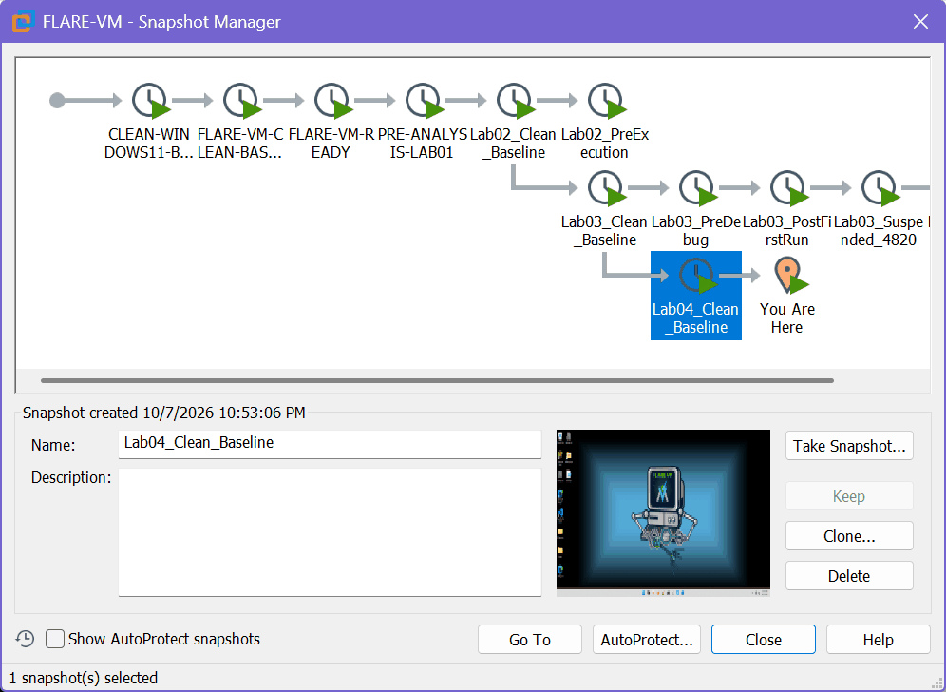
Figure E05. Snapshot Manager with Lab04_Clean_Baseline (10/7/2026 10:53:06 PM).

2.2 Analyst, system and tool versions
Item | Value
Analyst | Perry Koko, C1126EHIT17343
Operating system | Windows 11 Pro 10.0.26200 (FLARE-VM), 8 GB RAM, 4 vCPU, 102 GB NVMe; host DESKTOP-JV8FNEG
Date and time | VM local time, 2026-10-07 22:53 to 2026-10-08 05:27 (the time shown by each screenshot or console prompt)
Unpacking tool | autoit-ripper 1.1.2 (declared substitute for Exe2Aut, see 4.1)
Static tools | PEStudio 9.61; Ghidra 12.1.2 (PUBLIC, project "lab04")
Debugger | x32dbg (build "May 27 2026 (TitanEngine)"), run elevated, with the ScyllaHide plugin
Memory tool | System Informer 3.2.25113.1114 (successor of Process Hacker), full process dump
Shell | Windows PowerShell 5.1 (hashes, baselines, checks)

2.3 Evidence-handling method
- One-way transfer. The course archive was fetched and hashed on the host (SHA-256 of the zip 6EE4E1834DE2CC07C9BB2DFD7FC90B64AF8ACA131A862C0D8676AF1349CA8606), wrapped in an ISO (SHA-256 85B05D9BA00CD16DD370B628F8943D3C85EB87C23178CD30CCEECF00FB49974C), and attached to the VM CD/DVD drive for a short window (Ex. E06, E07). No shared folder, clipboard or drag and drop was used.
- Hash chain. The extracted file is kept read-only as original\sample.bin; a copy work\sample3.bin (same SHA-256) is the only file given to PEStudio, autoit-ripper, Ghidra and x32dbg.
- Text leaving the VM. There is no clipboard, so text comes out only as host screenshots or as console text pasted from the VM console. Files rebuilt from pasted text are marked "rebuilt" and their original hashes are in the manifest.
- Baselines. File, process, Run-key and scheduled-task baselines were recorded before the first run (20_baseline_*, hashes in the manifest) and compared after the runs.
- No bypass or patching. Only breakpoints and the debugger display were used. No code was written to defeat a check, no bytes of the sample were changed, and no register or flag was altered to steer execution.

3. Initial identification assessment (Task A.3 and A.4)
Source executable: 1,217,024 bytes, SHA-256 0DA91175E7D72A7FF2BCB3FD93F2BA7BBE4045F9C4DEE5C9685C7FDF6DA622A6, SHA-1 70AD543FAECB496CA4C2318E0C8F81A8CBB8FB62, MD5 66F33597CBF097345C51891AB951B641. Observed in PEStudio (Ex. E08, E09, E10, E12):
Characteristic | Observed value | Reading (Inferred)
Type | 32-bit GUI executable (PE), entry point 0x27DCD in .text, manifest asInvoker | Normal user-mode program
Signature | "AutoIt compiled script (2.XX-3.XX)", Microsoft Linker 12.0, Visual Studio 2013 | AutoIt runtime, not a custom loader
Script resource | RCDATA SCRIPT, 359,376 bytes, entropy 7.999, at 0xC9DB8 | Encrypted/compressed script that the runtime decrypts
Sections | .text 6.676, .rdata 5.760, .data 1.199, .rsrc 7.903 (32.52 % of file), .reloc 6.779; file entropy 7.199 | Only .rsrc is high entropy: the compiled script
Time stamps | Compiler 2020-02-26 11:25:12 UTC; debug 2015-07-10 09:42:07 UTC | Differ by almost five years: stock runtime reused
Imports | 527 imports (163 flagged); the 6 flagged libraries are WSOCK32, WINMM, MPR, WININET, PSAPI and IPHLPAPI; imphash MD5 733BD1E4C7463E0FD92D0EA34CBFA027 | Broad API surface that comes with the AutoIt runtime
Strings | 27,341 strings; url pattern 255.255.255.255 | Nothing family-specific on first view

Supports a malware-loader reading: compiled AutoIt, an encrypted script, and an anti-debug dialog are all common in loaders. Challenges the Lokibot claim: the file is a stock AutoIt runtime and the first static pass shows none of the strings usually associated with that family. Section 5.3 and T1 test this with 18 patterns (none of the family-style ones is present). The only family-neutral statement the evidence supports is: an obfuscated AutoIt-compiled program, identity unconfirmed.
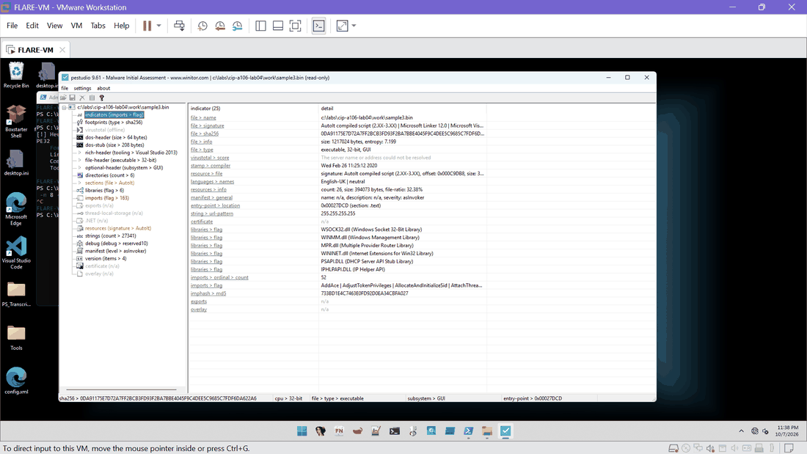
Figure E12. PEStudio indicators: AutoIt signature, library list, imphash.

4. AutoIt unpacking and decompilation (Task B)

4.1 Tool record
Item | Record
Source hash | 0DA91175E7D72A7FF2BCB3FD93F2BA7BBE4045F9C4DEE5C9685C7FDF6DA622A6 (work\sample3.bin, identical to original\sample.bin)
Tool and version | autoit-ripper 1.1.2. Exe2Aut was not used; autoit-ripper reads the same compiled-AutoIt resource and is declared here as the substitute. The brief names Exe2Aut, so this is a recorded deviation.
Processing time | Not recorded (the run is short; no timer was kept)
Output location | C:\Labs\CIP-A106-Lab04\exe2aut_out\script.au3
Result type | Script output (decompiled source). It is not an unpacked executable; the sample has no packed PE inside.
Output size and hash | 514,737 bytes, 5,551 lines, SHA-256 788D259BE4F29DE5865FA18C4B0089F6A1F0D10C910376250AE6924F1E5B6099
Keeping artefacts apart | Original (original\), working copy (work\) and tool output (exe2aut_out\) are separate folders and separate manifest rows.

4.2 What the output shows and does not prove
- Observed: the script is heavily obfuscated. It has 1,324 hex string literals of 40 or more characters, junk code, and API names stored in variables (for example CallWindowProc at line 945, CallWindowProcW at line 1696 and GdiplusStartup at line 3186; Ex. T3).
- Observed: decoding the printable hex literals (T4, T5) gives two templates, an [InternetShortcut] file with URL=file:///... and a VBScript that sleeps a random 5000 to 15000 ms and then runs a path with WshShell.Run. Both are text only: no .url or .vbs file appeared in any run (T2, T6).
- Observed: other hex literals are x86 machine code. Their stack-built strings spell API names: NtCreateMutant, NtOpenProcessToken, NtAdjustPrivilegesToken, NtProtectVirtualMemory, NtDelayExecution, CryptDecrypt, CryptDestroyHash, CoCreateInstance, LoadLibraryA, GetProcAddress, RtlFormatCurrentUserKeyPath and the folder \KnownDlls32. The names are rebuilt from 4-byte pieces of the first 80 pasted lines, so some are partial (Table T5).
- Inferred: the script carries embedded native code and uses native APIs. AutoIt loaders run such code through CallWindowProc. This is a lead, not a capability conclusion: the code was not disassembled or run.
- Not observed: any of the 18 indicator patterns for command-and-control or credential theft (T1).
Limit. Decompilation output proves what the script contains. It does not prove what ran. Section 6 shows the script did not run under observation.

5. Ghidra static analysis and indicator assessment (Task C)

5.1 Project record
Item | Record
Project and program | Project "lab04"; program sample3.bin (Ex. E15, E16)
Imported artefact hash | SHA-256 0da91175e7d72a7ff2bcb3fd93f2ba7bbe4045f9c4dee5c9685c7fdf6da622a6, MD5 66f33597cbf097345c51891ab951b641 (shown by Ghidra and equal to the working copy)
Format | Portable Executable, x86:LE:32:default, compiler id windows, "visualstudio:unknown"; analysed with Ghidra 12.1.2 on 2026-10-07 23:56:52
Analysis result | 263 functions, 572 symbols, 6 memory blocks; image base 00400000 in Ghidra (x32dbg showed 00300000 because of ASLR, a difference of 0x100000)
Notes | Import summary reports a failed TerminatedCString at 00527518 (harmless data-typing message) and "Library not saved to project" for ADVAPI32.DLL
Execution | None: Ghidra was used on the file only, never to run it

5.2 Relevant functions, strings and imports
- Entry point 00427dcd calls __security_init_cookie and jumps to FUN_00427c56: standard Microsoft C runtime start-up (Ex. E17).
- FUN_00403b3a is the start-up routine that holds the anti-debug check (5.4).
- Imports include WININET HttpOpenRequestW, HttpQueryInfoW, HttpSendRequestW (Ex. E18) and WSOCK32 sockets. These are runtime imports (every build of the AutoIt runtime links the same libraries).
- Strings: the message text "This is a third-party compiled AutoIt script." has one reference, at 0043d279 (Ex. E41).

5.3 Indicator table
Defanged where needed. "Confidence" is confidence that the item is a true indicator of this sample, not just that the value exists.
Indicator | Type | Source artefact | Evidence | Assessment
0DA91175...622A6 (SHA-256), MD5 66F33597..., SHA-1 70AD543F... | File hash of sample (O and W) | PowerShell, PEStudio, Ghidra | E08, E15 | High: identifies the file, not the family
733BD1E4C7463E0FD92D0EA34CBFA027 | Import hash (MD5) | PEStudio indicators | E12 | High as a value; Low as family evidence (any file built from the same AutoIt runtime shares it)
AutoIt compiled script (2.XX-3.XX); RCDATA SCRIPT 359,376 B, entropy 7.999 | Packaging marker | PEStudio, autoit-ripper | E10, E09 | High
Compiler stamp 2020-02-26 11:25:12 UTC; debug stamp 2015-07-10 09:42:07 UTC | PE timestamps | PEStudio | E08 | Medium: stamps differ by almost five years, which fits a stock AutoIt runtime, not a bespoke build
"This is a third-party compiled AutoIt script." | String (dialog text) | Ghidra, x32dbg | E41, E37 | High: shown when a debugger is reported
IsDebuggerPresent call at 00403b7a (and four other call sites) | API, anti-debug | Ghidra, x32dbg | E42, E45, E35 | High for the check at 00403b7a; Medium for the others (not reviewed)
HttpOpenRequestW, HttpQueryInfoW, HttpSendRequestW (WININET); socket, connect, send, recv (WSOCK32) | Imports, network capability | Ghidra, PEStudio | E18, E11 | Low as an indicator: present in every compiled AutoIt executable that links the runtime; no traffic observed
255.255.255.255 | String pattern (IP) | PEStudio indicators | E12 | Low: broadcast address, a literal in the AutoIt runtime; not a contact address
Domains, URLs, IP addresses of a command server | Network IOC | script.au3, decoded strings, Ghidra, dump | T1, T4 | Not found (0 hits for .php, Mozilla, User-Agent, POST, wininet, InternetOpen, HttpSendRequest)
LEQMOPUPON ( $FILE , $STARTUP , $RES , $RUN ) | Script function (line 437) | script.au3 | E53, T3 | Low: name and parameters only; behaviour not reviewed or executed
"[InternetShortcut]" with URL=file:/// and a VBS template (WScript.Shell, WScript.Sleep random 5000-15000, WshShell.Run) | Script string templates (decoded hex) | decoded strings | T4 | Medium that the templates exist; Low that they run: no .url or .vbs file was written in any run
CallWindowProc, CallWindowProcW, GdiplusStartup (variables holding API names) | Script strings (lines 945, 1696, 3186) | script.au3 | E53, T3 | Medium: AutoIt pattern for running machine code; payload not run
Embedded x86 code as hex literals (546, 530 and many 300-character strings) that spell API names on the stack: NtCreateMutant, NtOpenProcessToken, NtAdjustPrivilegesToken, NtProtectVirtualMemory, NtDelayExecution, CryptDecrypt, CryptDestroyHash, CoCreateInstance, LoadLibraryA, GetProcAddress, \KnownDlls32\kernel32.dll, user32.dll | Embedded code, API names | decoded strings | T4, T5 | Medium that machine code is embedded; Low for purpose (names are partial; code was not disassembled)
Private copies of advapi32, ntdll, kernel32, user32, ole32 at 050B0000, 05140000, 05310000, 05410000, 055E0000 | Runtime module addresses | x32dbg log (run 1) | E28 | High (observed); Low for the reason
kernel32.VirtualAlloc 76D765F0 (two breakpoint hits in run 1) | Observation point and hits | x32dbg | E28, E34, E51 | High that the hits happened; arguments not captured
Mutexes, registry paths, dropped file names | Host IOCs | baselines, post-run checks | T2, T6, 21_after1_run_keys | Not observed (no new scripts, shortcuts or executables; Run keys unchanged after run 1)

5.4 Two findings in plain language

Finding 1: the start-up code checks for a debugger
Observed: in FUN_00403b3a, address 00403b7a is CALL dword ptr [IsDebuggerPresent]; 00403b80 is TEST EAX,EAX; 00403b82 is JNZ LAB_0043d272. At 0043d272 the code pushes the text "This is a third-party compiled AutoIt script." and calls MessageBoxA (0043d281), then jumps to the exit path (Ex. E45, E46, E43). In plain words: if Windows says a debugger is attached, show a message and quit.
Inferred: this is the stock check in the AutoIt runtime that stops people from debugging compiled scripts. The text refers to "a third-party compiled AutoIt script", which is the runtime speaking about every script it hosts, so the check says little about this sample's author. Four other IsDebuggerPresent call sites exist (00428d43, 004358bc, 00435b6f, 0043b2f4); 0043b2f4 sits inside the library function CAtlBaseModule, an initialisation check, and is benign (Ex. E44, E42). The other three were not reviewed.
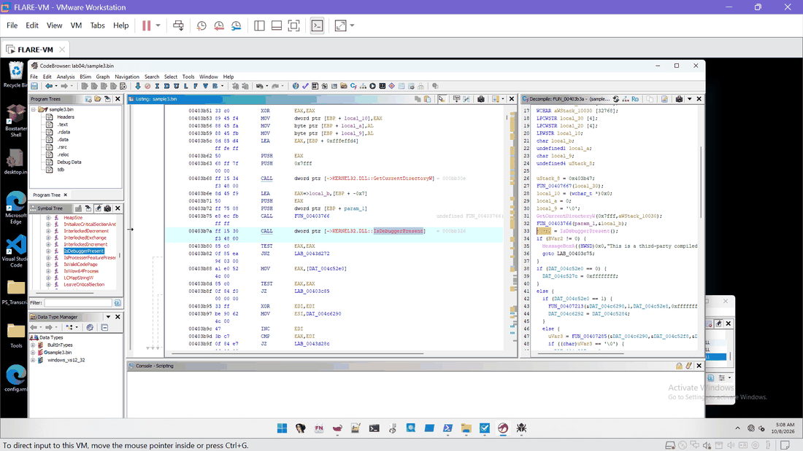
Figure E45. Ghidra FUN_00403b3a: IsDebuggerPresent call and decompiled test.

Finding 2: network functions are imported, but not evidence of communication
Observed: the import table lists WININET HTTP functions and WSOCK32 socket functions (Ex. E18, E11). Inferred: the AutoIt runtime supports HTTP and sockets for any script, so these imports exist in a harmless compiled AutoIt program as well. Not observed: any server name, URL, user-agent or HTTP method string in the script or decoded strings (T1: 0 hits for .php, Mozilla, User-Agent, POST, wininet, InternetOpen, HttpSendRequest), and no traffic (the adapter was disconnected and no capture was made). A reader should not treat the imports as a communications finding.

6. Controlled debugger observations (Task D)

6.1 Session record
Debugger: x32dbg, elevated, on work\sample3.bin. Source SHA-256 0DA91175E7D72A7FF2BCB3FD93F2BA7BBE4045F9C4DEE5C9685C7FDF6DA622A6. Observation breakpoints only: kernel32 VirtualAlloc (76D765F0), IsDebuggerPresent (76D7D980), CheckRemoteDebuggerPresent (76D90060), ntdll NtSetInformationThread (770B9220), NtQueryInformationProcess (770B92E0) and the entry point (00327DCD).
Run | PID | Time | ScyllaHide | Result
1 | 3844 | 00:20 to 00:27 | As found: profile "VMProtect x86/x64", PEB hiding, NtSetInformationThread, NtQueryInformationProcess, NtQueryObject, NtClose ticked | Ran to exit code 0x0. NtQueryInformationProcess hit counts 1, 3, 4 and 10 on successive stops, 2 VirtualAlloc lines, 5 private DLL copies, NtSetInformationThread x8. Dialog not captured.
(1b) | 5576 | 00:49 | Options changed after launch (all unticked) | Aborted and killed: options apply only at process creation. Not used as evidence (Ex. E29).
2 | 3848 | 00:56 to 01:08 | Unticked (plugin still prints "Loaded VA" lines) | System breakpoint 01:00, entry 01:01, IsDebuggerPresent hit 01:04, dialog 01:06, exit code 0x0 after OK. 0 VirtualAlloc hits.
3 | 3784 | 05:12 to about 05:25 | Unticked | IsDebuggerPresent hit 05:13, call stack 05:14, Breakpoints tab 05:15 (VirtualAlloc 0 hits), held at the dialog while the dump was taken at 05:21:30, then OK.

6.2 Evidence of anti-debugging and its effect
- Observed (run 2): the breakpoint on IsDebuggerPresent is hit with the sample as the caller (Ex. E35); the process continues and a message box "This is a third-party compiled AutoIt script." appears (Ex. E37); after OK the log shows the process stopped with exit code 0x0 (Ex. E38).
- Observed (run 3): IsDebuggerPresent is hit again (Ex. E49); the Call Stack shows the call from sample3.00304864, with a caller frame at sample3.00327D53 (Ex. E50). Hit count 1 (Ex. E51).
- Observed effect: no VirtualAlloc hit, no further module or thread activity from the script in runs 2 and 3. The observed behaviour of the program, not the script, is to stop at the dialog.
- Not captured: the value of EAX after the call and the return address 00403B7B in the Call Stack (the stack view skips leaf frames; the displayed return 00304864 is probably the caller of FUN_00403b3a).
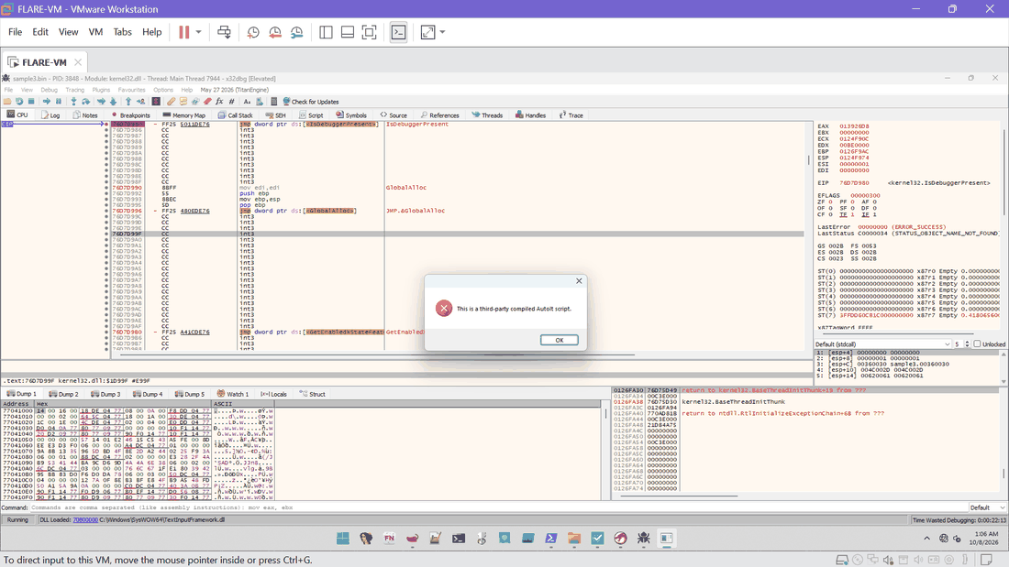
Figure E37. Run 2: the AutoIt dialog while the debugger is attached (01:06).

6.3 Handling the block: approved controls only
The brief says: if an anti-analysis check prevents observation, document it and use only instructor-approved debugger controls. The block is documented above. No bypass code was written and no byte was patched. The debugger-hiding plugin ScyllaHide was present in the tool as found, so run 1 used its as-found profile; I did not obtain written instructor approval for it, so run 1 is reported as an observation under a plugin of unverified approval status, and the conclusions in this report do not depend on run 1 alone. The cleaner runs 2 and 3 used the debugger with the plugin options unticked.
Limit. The plugin still printed "[ScyllaHide] Loaded VA ..." lines in run 3 with its options unticked (Ex. E52). Loading is not hiding, but I cannot prove from the screenshots that no hook was active.

6.4 Host-side checks
- Run 1: only the Recent .lnk files, an IE history container and WebCache changed (T6). Run keys unchanged (hash of 21_after1_run_keys.txt equals the baseline).
- Scheduled tasks: the text comparison was unreliable because of column wrapping, so it is inconclusive; I switched to System32\Tasks file write times. After run 2 two Windows-owned task files changed (SvcRestartTask 01:18:08, Schedule Work 03:53:35), both after the sample had exited and not attributed to it. After run 3 no task files changed after 05:00 (26_after_run3_task_files.txt was not created because the output was empty).
- Run 3: no .vbs, .url, .lnk (other than Recent), .js, .bat, .cmd, .ps1, .exe, .dll, .tmp, .au3 or .dat file written after 05:00 apart from caches (T2).

6.5 VirtualAlloc observation
Only values the tool displayed are recorded: module kernel32.dll, address 76D765F0.
Run | Breakpoint state | Hits | Requested size / protection
1 | Set, enabled (Ex. E22) | 2 log lines "INT3 breakpoint at <kernel32.VirtualAlloc> (76D765F0)!" in the log (Ex. E28) | Not recorded: the log line shows no arguments and no pause screenshot was captured
2 | Enabled (Ex. E34) | 0 | Not applicable
3 | Enabled (Ex. E51) | 0 | Not applicable
Observed order in run 1 (log, Ex. E28): NtQueryInformationProcess hits, then the two VirtualAlloc lines, then five modules loaded again from SysWOW64: advapi32 at 050B0000, ntdll at 05140000, kernel32 at 05310000, user32 at 05410000, ole32 at 055E0000; then NtQueryInformationProcess at 051B92E0 (x4) and NtSetInformationThread at 051B9220 (x8) before exit. The two addresses equal the real stubs (770B92E0, 770B9220) moved by the copy offset, so the calls went through the private ntdll copy. Inferred (Low): the script mapped fresh copies of system DLLs, which fits the \KnownDlls32 and Nt* name pieces found in the script (F12). The reason is not established, and the call arguments were not read.
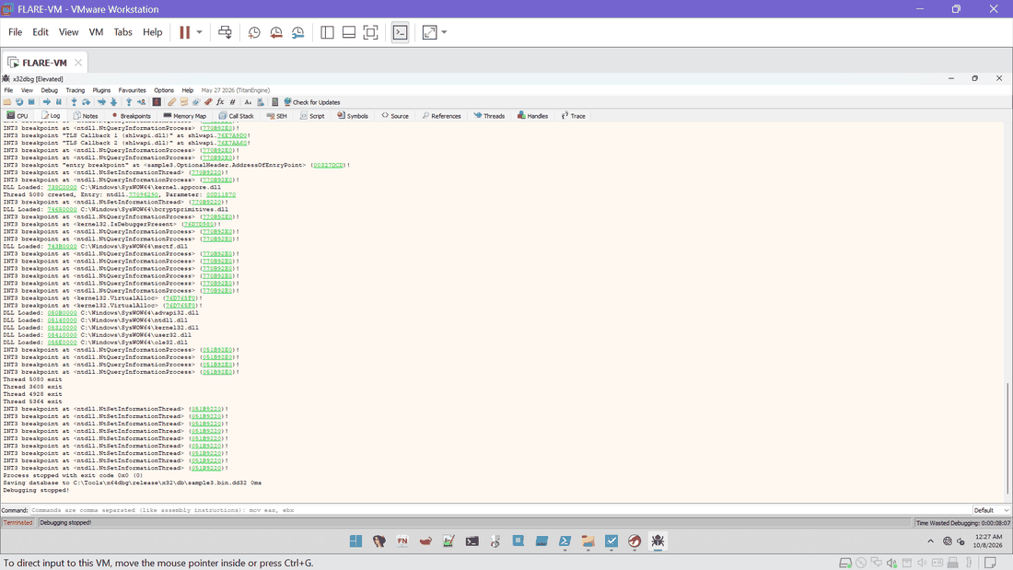
Figure E28. Run 1 final log: VirtualAlloc lines, private DLL copies, Nt* hits, exit code 0x0 (00:27).

7. Memory artefact validation (Task E)

7.1 Hardware breakpoint
A hardware breakpoint on an allocated region is relevant only if an allocation is reached. In runs 2 and 3 the program stopped at the dialog before any VirtualAlloc hit; in run 1 the allocation address and size were not displayed. No region was available to watch, so no hardware breakpoint was set and no access event is claimed. If an allocation had been shown, the method would be: note the base address, set a hardware breakpoint on write (or on execute), continue, and record the access event without changing the sample.

7.2 Process selection and acquisition
Field | Record
Tool | System Informer 3.2.25113.1114: process selected, "Create dump file" (full dump). The process-selection screenshot was not captured; the identity below comes from PowerShell Win32_Process (T7).
Process | sample3.bin, PID 3784, path C:\Labs\CIP-A106-Lab04\work\sample3.bin, created 05:12:12
Parent | PID 3092, x32dbg.exe (C:\Tools\x64dbg\release\x32\x32dbg.exe)
Acquisition time | 2026-10-08 05:21:30, with the AutoIt dialog on screen (run 3)
Output file | C:\Labs\CIP-A106-Lab04\memory\run3_blocked.dmp
Size | 97,956,974 bytes
SHA-256 | 3DFEF5111364B61EC8345DBC835964E1A88216D335B2114C7EBA026381EAD5E5
Scope | Only the sample process. No other process and no user data was dumped.

7.3 Validation and its limits
The dump was checked in the VM by PowerShell (24_dump_validation.txt, SHA-256 D04E10B4...BD421; output in T9). Format-Hex with -Count failed in Windows PowerShell 5.1 and was replaced by reading bytes through [IO.File]::ReadAllBytes; this is a tool limitation, not a finding. The validation output shows:
- Observed: the first 16 bytes are 4D 44 4D 50 ("MDMP"), the signature of a Windows minidump.
- Observed: the text "This is a third-party compiled AutoIt script" is in the dump as ASCII at offset 805858 and as UTF-16 at offset 2840286, which fits a process held at that dialog.
- Observed: the AutoIt script signature "AU3!EA06" is present as ASCII at offset 904246 (not found as UTF-16).
- Not observed: "Mozilla/4.08", "Charon", "Inferno", "fre.php" and "Content-Key" were not found, as ASCII or UTF-16.
- Observed: the 128-byte DOS header and stub of the original file are found in the dump at offset 54382, so the program image is present in the dump.
- Observed: the artefact is a dump of the AutoIt runtime at the dialog (Observed, since the process was held there).
- Not observed: a decrypted script, an unpacked payload or a Lokibot configuration. The sample never reached the point where such content exists.
- Limit: a dump taken at the dialog cannot show later behaviour; comparison with an "approved unpacked copy" is not possible because the sample has no unpacked executable, only the decompiled script.
- Limit: the raw dump is not in this package (not authorised) and stays in the VM.
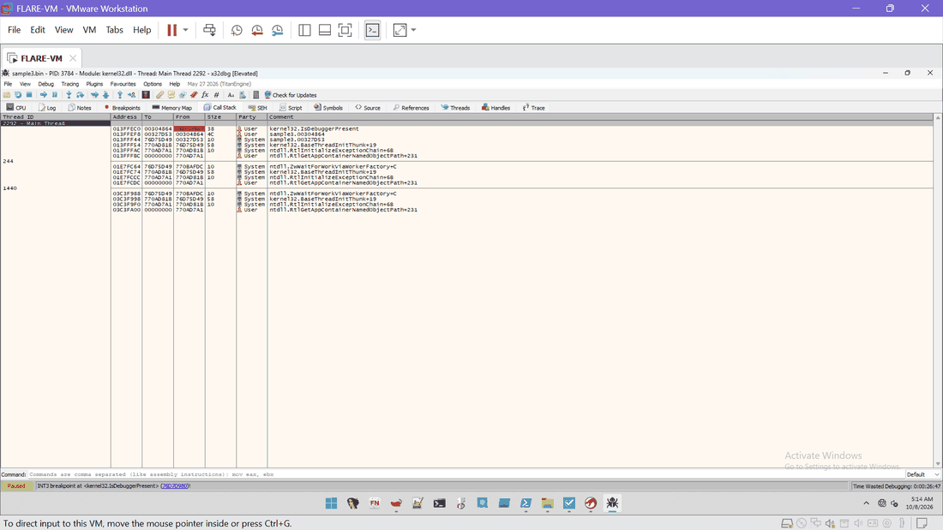
Figure E50. Run 3: Call Stack at IsDebuggerPresent (05:14).

8. ATT&CK mapping
ID | Technique | Basis | Confidence | Limit
T1027 | Obfuscated Files or Information | Encrypted SCRIPT resource, hex-encoded strings and code, junk code, API names held in variables | High | Obfuscation is observed; its purpose in this sample is inferred
T1622 | Debugger Evasion | IsDebuggerPresent then MessageBoxA and exit when a debugger is attached; execution stopped at the dialog in runs 2 and 3 | Medium | The check is part of the stock AutoIt runtime and not shown to be added by the author
T1106 | Native API | Calls to NtQueryInformationProcess and NtSetInformationThread observed in run 1 through private copies of ntdll; Nt* names spelled in embedded code | Medium | Arguments not captured; one run, ScyllaHide on
T1055 (candidate) | Process Injection | Nt* names for process and memory handling and CallWindowProc in a script that embeds machine code | Low | No injection observed; candidate only
T1547 / T1112 (candidate) | Persistence by Run key or registry | Function LEQMOPUPON with $STARTUP, NtSetValueKey and RtlFormatCurrentUserKeyPath fragments | Low | Run keys unchanged after run 1; runs 2 and 3 were stopped by the dialog; not mapped as supported

Only T1027 is mapped with high confidence. T1622 and T1106 are mapped with medium confidence, and the two candidates are listed so a reader can see what was considered and not supported. No technique is mapped to Lokibot as a family.

9. Findings matrix
Each finding links to its source artefact, confidence and limitation. The same table is in the Evidence Manifest and in findings_matrix.csv.
ID | Type | Finding | Source artefact | Confidence | Limitation
F01 | Identification | The executable is an AutoIt-compiled program (AutoIt runtime plus an encrypted SCRIPT resource) | PEStudio E10, E12; autoit-ripper output | High | AutoIt version only given as the range 2.XX-3.XX
F02 | Identification | Claimed Lokibot identity is neither supported nor excluded: no Lokibot-typical strings in the script or decoded strings and no payload observed | T1 (18 patterns, all 0 except Startup 3 and CallWindowProc 2); Ghidra; dump | Low (for identity) | Payload and configuration were never observed; script encrypted/obfuscated; execution blocked by the debugger check
F03 | Unpacking | autoit-ripper 1.1.2 recovered script.au3 (514,737 B, 5,551 lines) | exe2aut_out\script.au3, SHA-256 788D259BE4F29DE5... | High | Exe2Aut itself not used; processing time not recorded
F04 | Unpacking | The recovered script is heavily obfuscated (1,324 hex literals, junk code, variable-held API names) | T4, T3 | High | Counted by pattern, not by full review
F05 | Capability | Script embeds x86 machine code as hex strings with API names built on the stack (NtCreateMutant, NtOpenProcessToken, NtAdjustPrivilegesToken, NtProtectVirtualMemory, NtDelayExecution, CryptDecrypt, CoCreateInstance, LoadLibraryA, GetProcAddress, \KnownDlls32) | T4, T5 | Medium | First 80 decoded lines only; fragments reconstructed; no disassembly or execution
F06 | Capability | Script holds an [InternetShortcut] template and a WScript relaunch template with a random 5 to 15 second delay | T4 | Medium (text exists) | Not executed; no .url or .vbs file written in any run (T2, T6)
F07 | Capability | Persistence is only a candidate: function LEQMOPUPON takes $STARTUP; Startup appears 3 times (437, 533 and GdiplusStartup at 3186) | T3, T1 | Low | Static text; one of three hits is GdiplusStartup
F08 | Anti-analysis | FUN_00403b3a calls IsDebuggerPresent at 00403b7a; TEST EAX,EAX and JNZ to 0043d272 lead to MessageBoxA with "This is a third-party compiled AutoIt script." and the exit path | E46, E45, E43 | High | Static reading plus the run 2 and run 3 observations; EAX after the call not captured
F09 | Anti-analysis | With a debugger attached and ScyllaHide off, execution stopped at the message box and the process ended with exit code 0 after OK (run 2); run 3 was held at the dialog | E35, E37, E38 | High | Run 3 dialog not photographed; the analyst saw it
F10 | Anti-analysis | The other four IsDebuggerPresent call sites were located but not individually reviewed; 0043b2f4 is ATL library code | E42, E44 | Medium | Three sites unreviewed
F11 | Runtime | Run 1 (ScyllaHide as found) continued past the check: threads, two VirtualAlloc breakpoint hits, private copies of five system DLLs, NtQueryInformationProcess and NtSetInformationThread through the copies, exit code 0 | E28, E26, E25 | High (observations) | ScyllaHide profile was as found, not confirmed as instructor-approved; the dialog was not captured in run 1
F12 | Runtime | Private copies of ntdll, kernel32, user32, advapi32, ole32 were loaded from SysWOW64 at new bases; this fits the \KnownDlls32 and Nt* name fragments in the script | E28, T5 | Low (interpretation) | Reason not established; call arguments not captured
F13 | Memory | VirtualAlloc (kernel32 76D765F0): run 1 logged 2 hits with no size or protection shown; runs 2 and 3 set the breakpoint and had 0 hits | E28, E34, E51 | High (counts) | Requested size and protection not recorded
F14 | Memory | No hardware breakpoint set: no allocated region was reached in the blocked runs | E51 | High | Run 1 did not stop at VirtualAlloc with arguments; method documented as not relevant
F15 | Memory | run3_blocked.dmp (97,956,974 B, SHA-256 3DFEF5111364B61E...) acquired from PID 3784, parent 3092 (x32dbg.exe), at 05:21:30 | T7; T9 (24_dump_validation.txt) | High (acquisition) | Captures the runtime at the dialog; no payload; raw dump not submitted
F16 | Host effects | No script, shortcut or executable was written outside Recent .lnk files and browser caches; Run keys unchanged after run 1 | T2, T6, 21_after1_run_keys | Medium | Run keys re-checked after run 1 only; task comparison inconclusive (report 6.4)
F17 | Network | No domain or IP address of a server found; WININET and WSOCK32 imports are runtime imports | T1, E18, E11 | Low | No packet capture; adapter Host-only and disconnected

10. Final assessment and confidence
Putting the identification, decompilation, Ghidra, debugger and memory evidence together:
- The file is an AutoIt-compiled program with an encrypted, obfuscated script (High).
- The script embeds machine code and API-name strings that point to native-API use, a Run-key style name and cryptographic calls; these remain leads (Medium that they exist, Low for what they do).
- The program checks for a debugger at start-up and stops at a dialog when it finds one (High observed; Medium that the author added it, as the check is the stock runtime behaviour).
- No payload, command server or Lokibot marker was observed. The Lokibot classification therefore rests on the exercise label alone (Low). It is consistent with an AutoIt-based loader, which is a common way to deliver many families, but that is not evidence for this one.
To raise confidence, the next safe steps are: run the script content under an approved controlled setting that survives the check (instructor approval needed), capture VirtualAlloc arguments when stopped, set the hardware breakpoint on the allocated region, and compare a later dump with the script. None of these was done here.

11. Limitations and deviations
- Exe2Aut was not used; autoit-ripper 1.1.2 was the declared substitute. Processing time was not recorded.
- ScyllaHide ran with an as-found profile in run 1, without confirmed approval; runs 2 and 3 had its options unticked, but the plugin still initialised.
- VirtualAlloc: run 1 shows two hits without arguments; runs 2 and 3 have 0 hits. No hardware breakpoint was set.
- The memory artefact is the AutoIt runtime at the dialog; the process-selection screenshot and the final run 3 log screenshot are missing (PowerShell Win32_Process and the dump record were used).
- Call-stack detail: the displayed return 00304864 is probably the caller of FUN_00403b3a; the immediate return 00403B7B was not shown; the Ghidra caller check of FUN_00403b3a was not completed; EAX after the call was not captured.
- The sample archive and ISO existed briefly on the host (C:\iso_src, D:\sample3.iso). A Windows Defender exclusion for C:\iso_src was set on the host and is to be removed with the host files after submission. Defender real-time protection in the VM was off as found. No packet capture was taken.
- Text exhibits are rebuilt from console text or transcribed from screenshots (no clipboard); the original files are in the VM with the hashes listed in the manifest.
- Decoded-string work covers the first 80 lines pasted; the encrypted payload blob was never examined; the embedded machine code was not disassembled.
- The clean snapshot Lab04_Clean_Baseline is restored, and the host copies are deleted, only after this package is downloaded and confirmed.

