CIP-A106 Laboratory 4
Evidence Appendix
Screenshots and exports supporting the Technical Report
Student | Perry Koko, C1126EHIT17343
Contents | A isolation, snapshots, transfer; B static identification (PEStudio); C Ghidra; D debugger runs; E memory and script context; T rebuilt text exports. Exhibits E01 to E53 follow capture order and match the file names in 05_Screenshots.
Capture method | Screenshots were taken on the host (the VM has no capture channel). The time in each caption is the clock visible in the screenshot (VM local time). A time marked with * is the capture time of the file, because no clock is visible. Each file has a SHA-256 in SHA256SUMS.txt and in screenshots_manifest.csv.
Excluded | The sample, the decompiled script, raw memory dumps and the ISO are not included. Domains and URLs shown are text from decoded strings and are not links.

A. Isolation, snapshots and transfer (Task A)
Host-only adapter with both connection boxes unchecked, Shared Folders and VNC disabled, guest isolation unchecked, the two snapshots, and the CD/DVD transfer window.
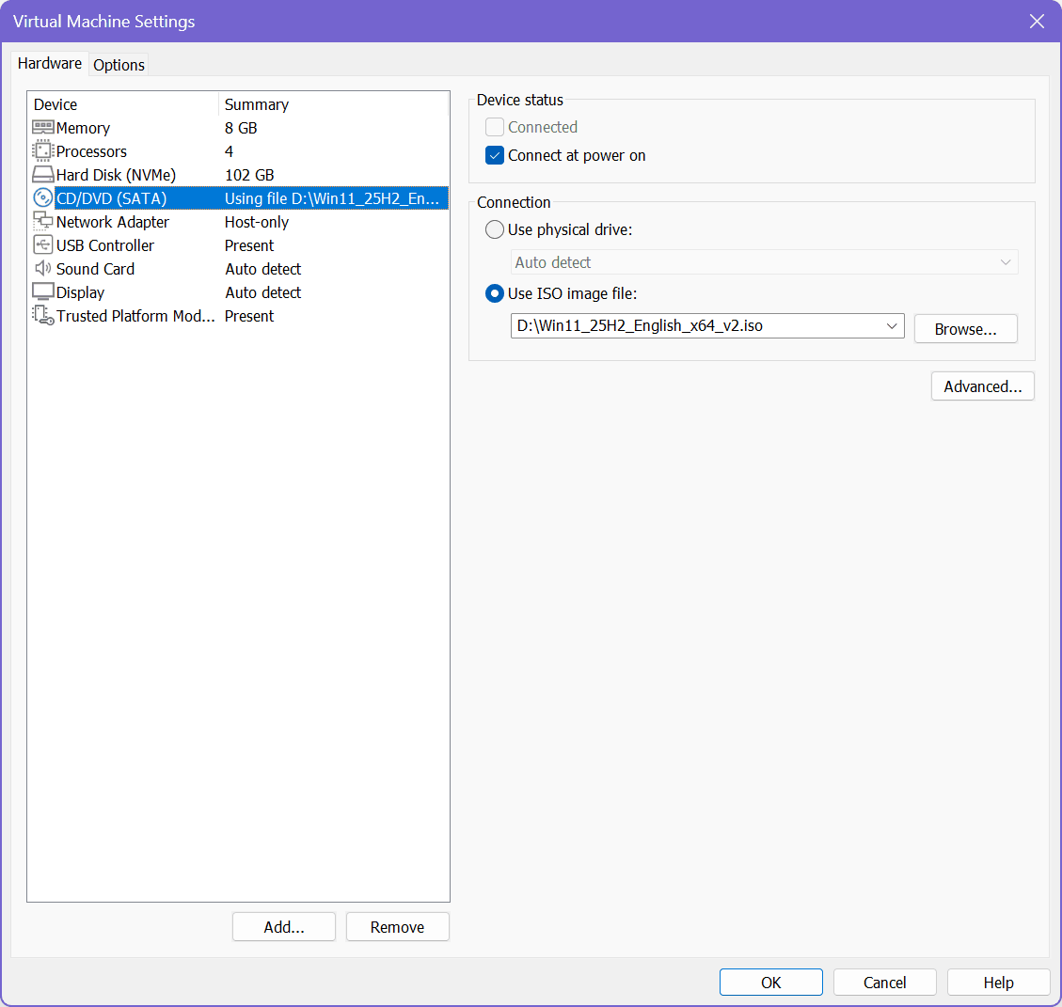
Ex. E01 | 2026-10-07 22:56* | VMware Workstation | VM settings, CD/DVD drive as found: Windows 11 installation ISO attached (Connected unchecked, Connect at power on checked) | SHA-256 331C600223B8F78F...
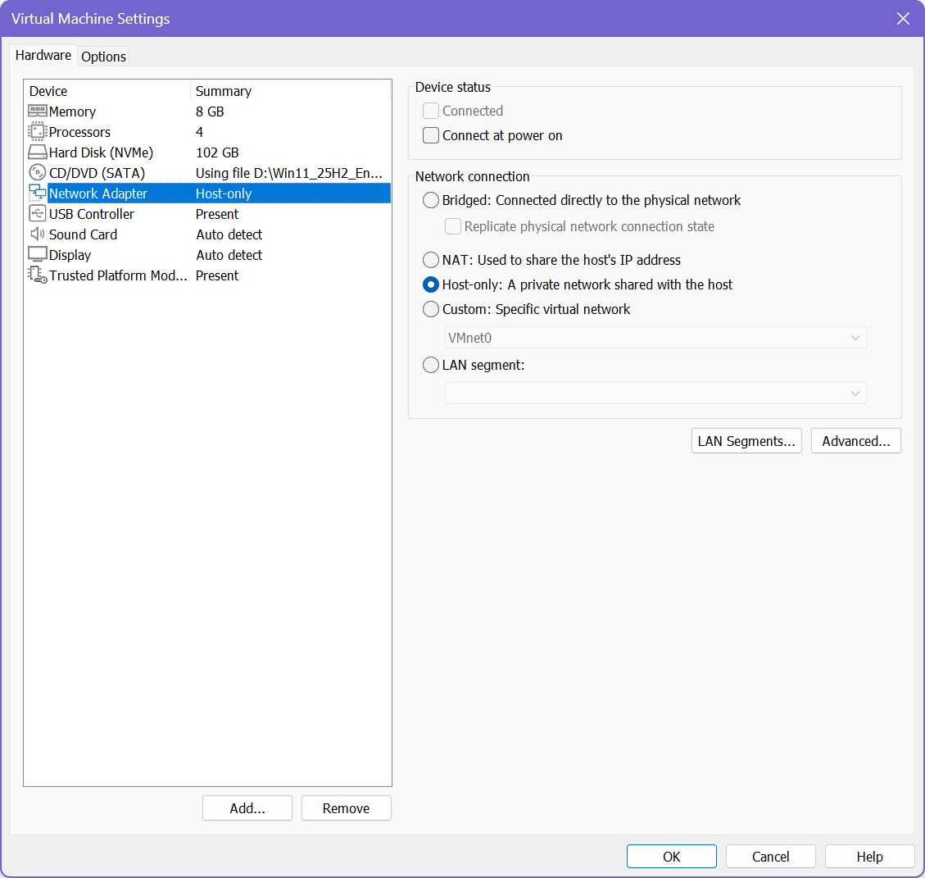
Ex. E02 | 2026-10-07 22:56* | VMware Workstation | VM settings, Network Adapter: Host-only; Connected and Connect at power on both unchecked; Bridged, NAT and Custom not selected | SHA-256 83F1DC9115CF9C6C...
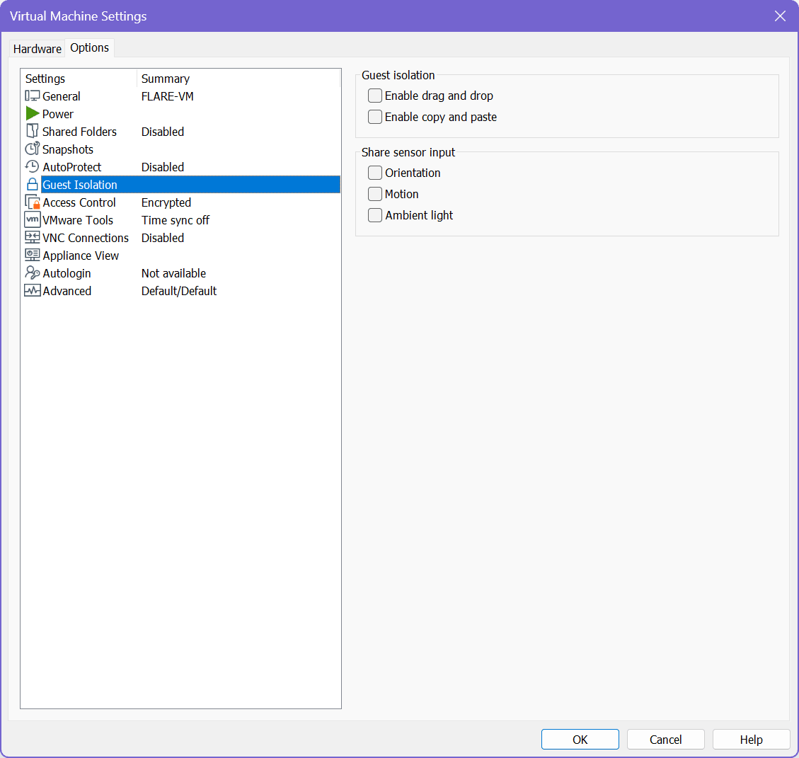
Ex. E03 | 2026-10-07 22:56* | VMware Workstation | VM Options: Shared Folders Disabled, VNC Connections Disabled, Guest Isolation with drag and drop and copy and paste both unchecked | SHA-256 2929EF808D67914B...
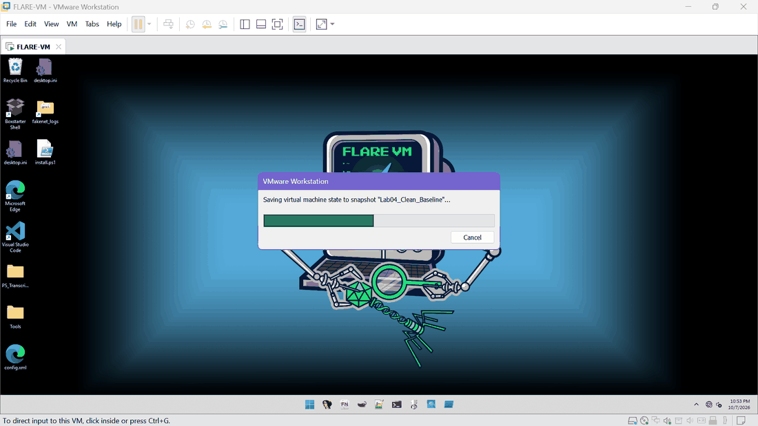
Ex. E04 | 2026-10-07 22:53 | VMware Workstation | Saving virtual machine state to snapshot "Lab04_Clean_Baseline" (clock 10:53 PM, 10/7/2026) | SHA-256 990E5B8B715ACE4F...
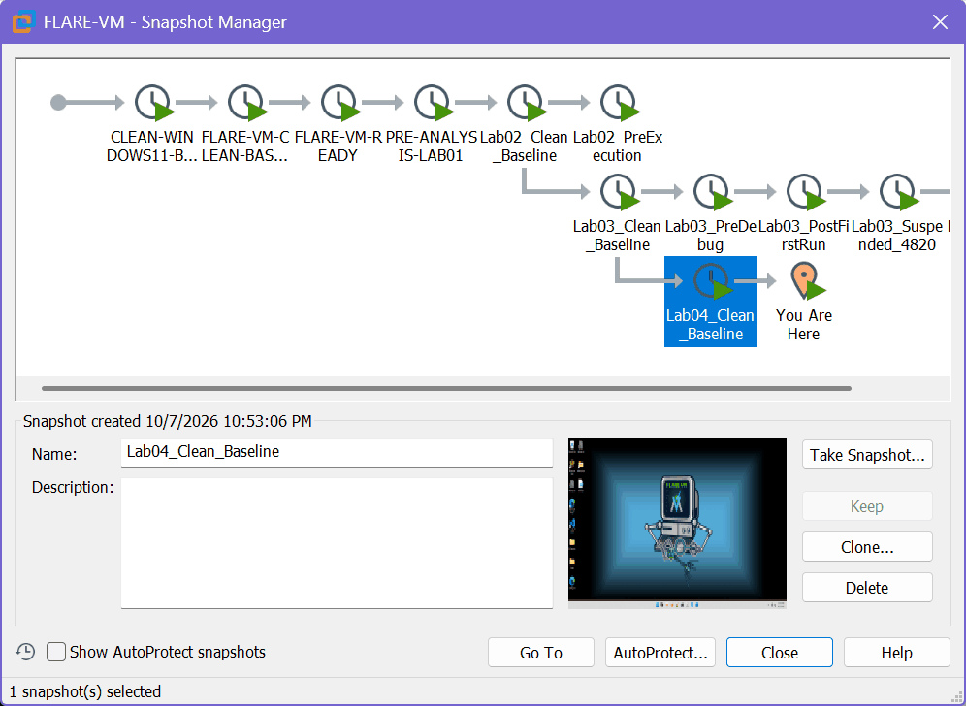
Ex. E05 | 2026-10-07 22:53:06 | VMware Workstation | Snapshot Manager: Lab04_Clean_Baseline created 10/7/2026 10:53:06 PM, child of Lab03_Clean_Baseline; You Are Here after it | SHA-256 687B7F51236CAAED...
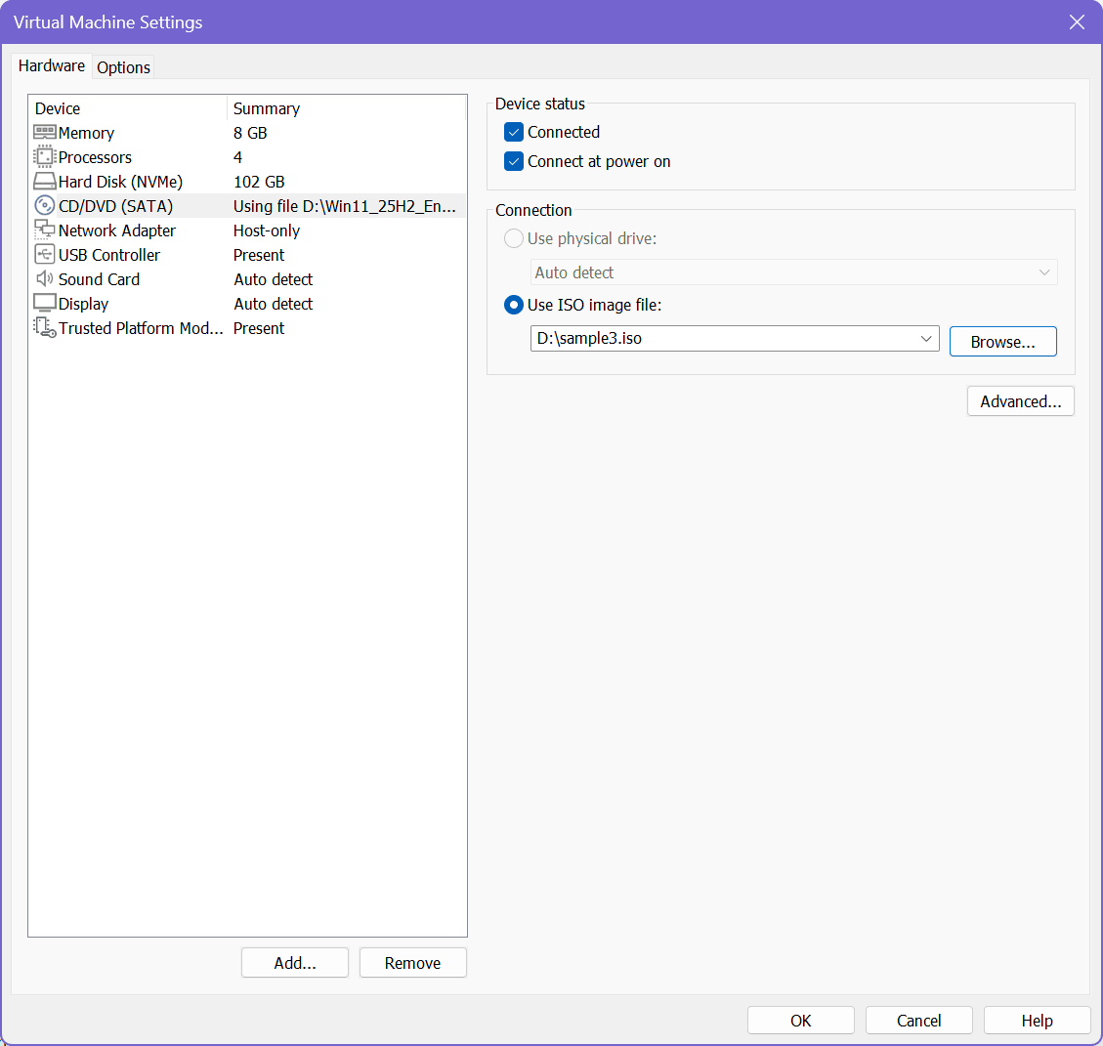
Ex. E06 | 2026-10-07 23:14* | VMware Workstation | CD/DVD drive set to D:\sample3.iso with Connected checked (one-way transfer window opened) | SHA-256 C3408A26284BE6CA...
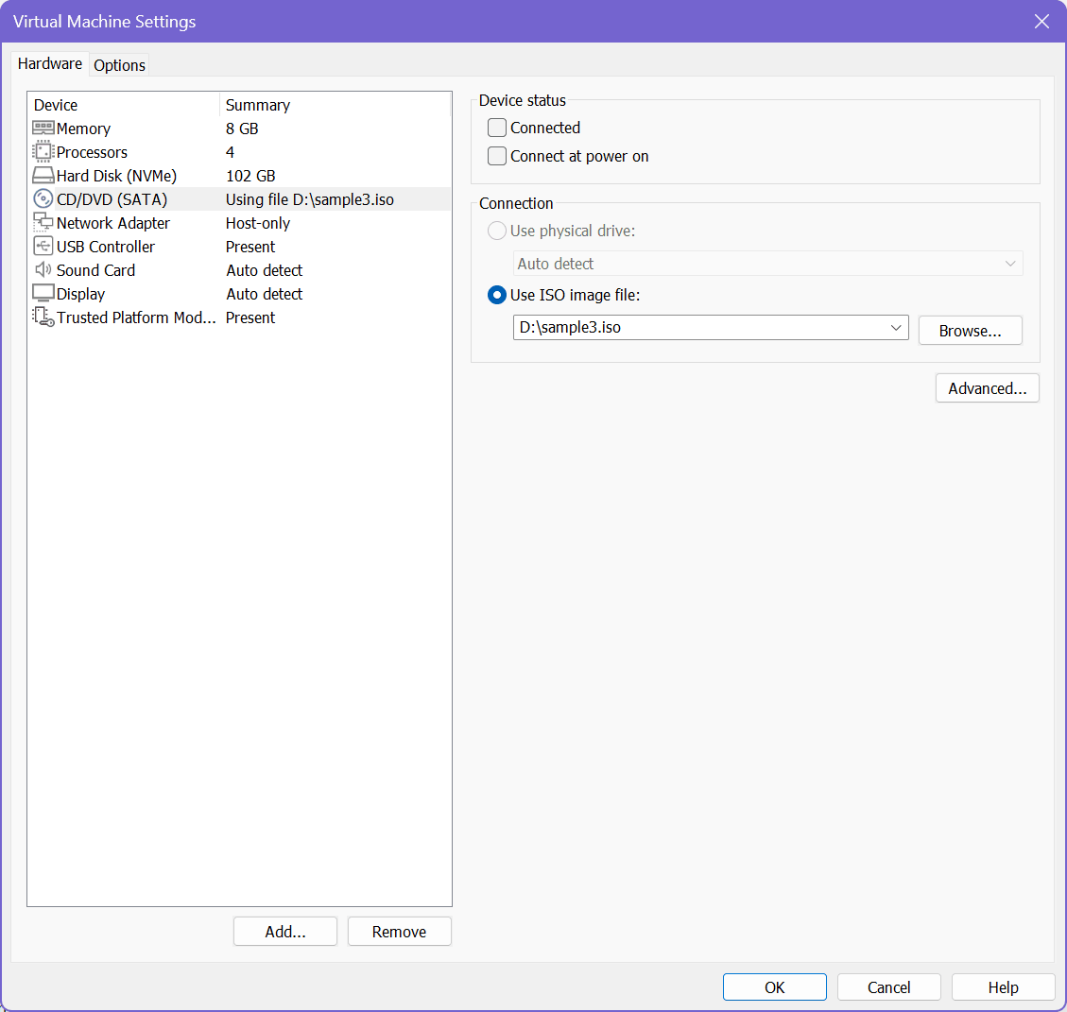
Ex. E07 | 2026-10-07 23:17* | VMware Workstation | CD/DVD drive Connected unchecked again after the transfer (transfer window closed) | SHA-256 981A58E0B76D0402...
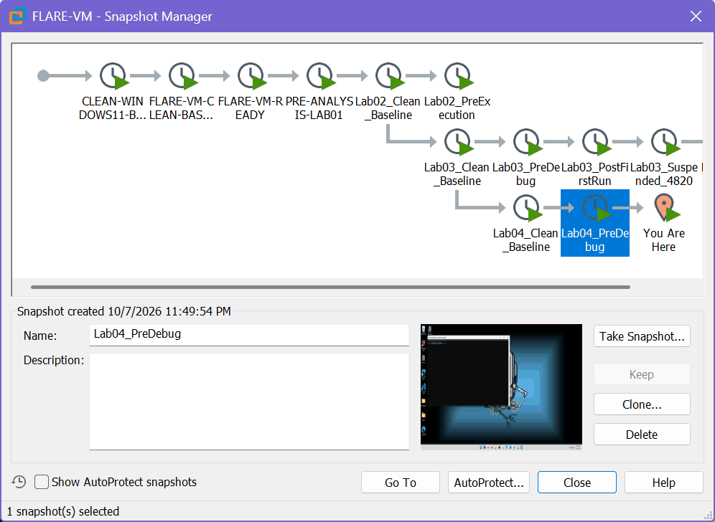
Ex. E14 | 2026-10-07 23:49:54 | VMware Workstation | Snapshot Manager: Lab04_PreDebug created 10/7/2026 11:49:54 PM (second snapshot, before any debugging) | SHA-256 EEAC3C035E498F16...

B. Static identification, PEStudio (Task A.4)
File header, sections and entropy, resources, imports, indicators and strings of the working copy.
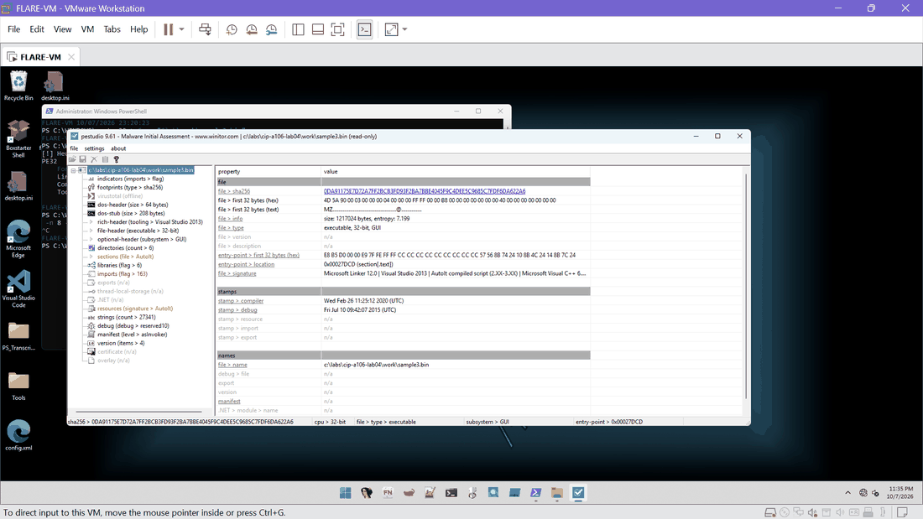
Ex. E08 | 2026-10-07 23:35 | PEStudio 9.61 | PEStudio header view of work\sample3.bin: SHA-256 0DA91175...622A6, size 1,217,024 bytes, entropy 7.199, 32-bit GUI executable, first 32 bytes MZ, entry point 0x27DCD (.text), signature string lists AutoIt compiled script, compiler stamp Wed Feb 26 11:25:12 2020 UTC, debug stamp Fri Jul 10 09:42:07 2015 UTC | SHA-256 A63427FAC1EE1CDF...
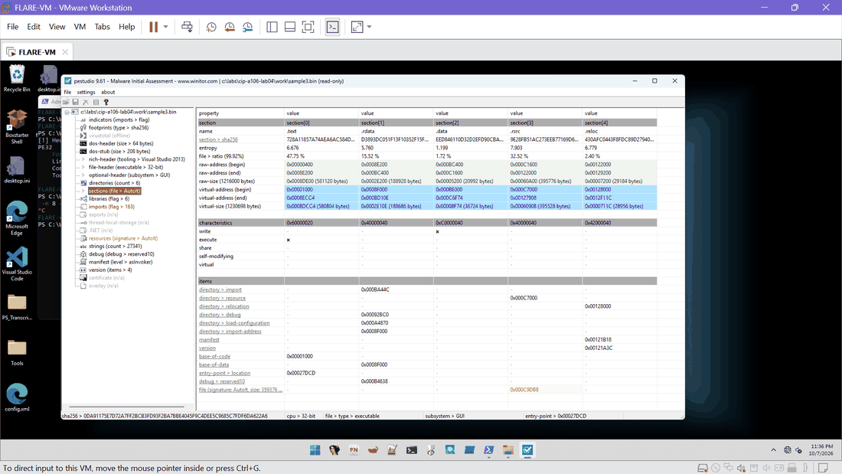
Ex. E09 | 2026-10-07 23:36 | PEStudio 9.61 | PEStudio sections: .text 6.676, .rdata 5.760, .data 1.199, .rsrc 7.903 (32.52 % of the file), .reloc 6.779; file signature AutoIt at 0xC9DB8 | SHA-256 258DC45996CDD428...
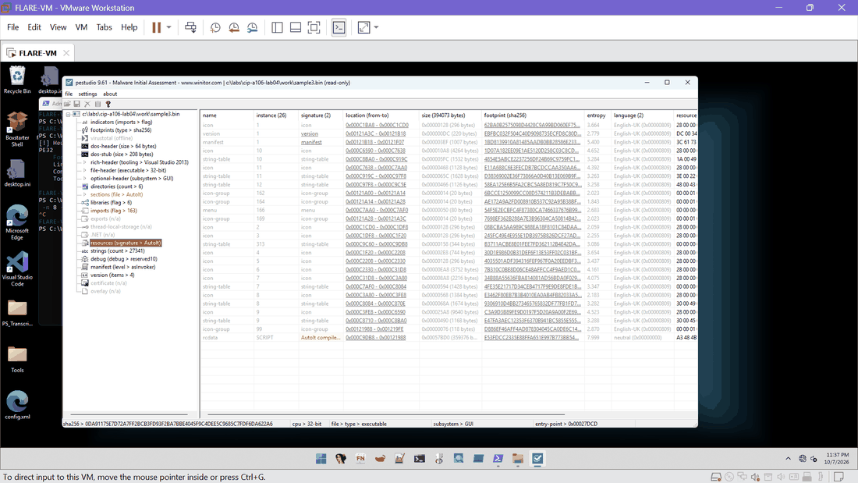
Ex. E10 | 2026-10-07 23:37 | PEStudio 9.61 | PEStudio resources: 26 resources; RCDATA SCRIPT of 359,376 bytes, entropy 7.999, signature "AutoIt compiled script" | SHA-256 CC96DC548F947F88...
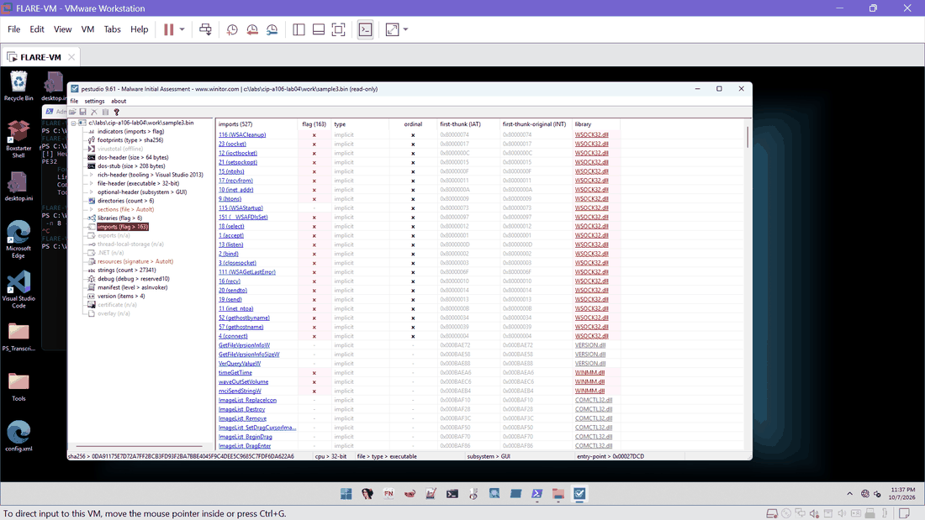
Ex. E11 | 2026-10-07 23:37 | PEStudio 9.61 | PEStudio imports (527, 163 flagged): WSOCK32 socket functions, VERSION, WINMM, COMCTL32 and others | SHA-256 3A6BB46F2A6D3FF0...
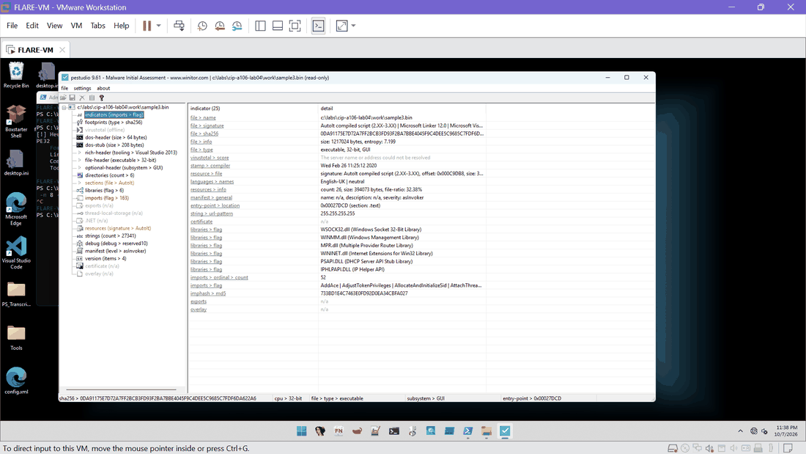
Ex. E12 | 2026-10-07 23:38 | PEStudio 9.61 | PEStudio indicators (25): AutoIt compiled script signature, libraries WSOCK32, WINMM, MPR, WININET, PSAPI, IPHLPAPI, string pattern 255.255.255.255, imphash MD5 733BD1E4C7463E0FD92D0EA34CBFA027 | SHA-256 E19A19FCAFA1B40D...
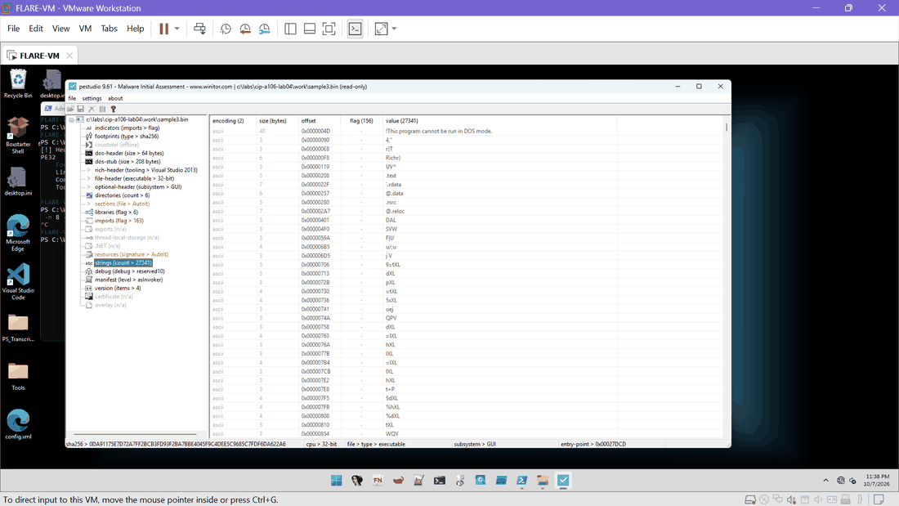
Ex. E13 | 2026-10-07 23:38 | PEStudio 9.61 | PEStudio strings view (27,341 strings): the first entries are compiler and section-name artefacts | SHA-256 6B4A1107425AD386...

C. Ghidra static analysis (Task C)
Project import and hash, program information, entry point, WININET imports, and the reference checks for the dialog string and IsDebuggerPresent.
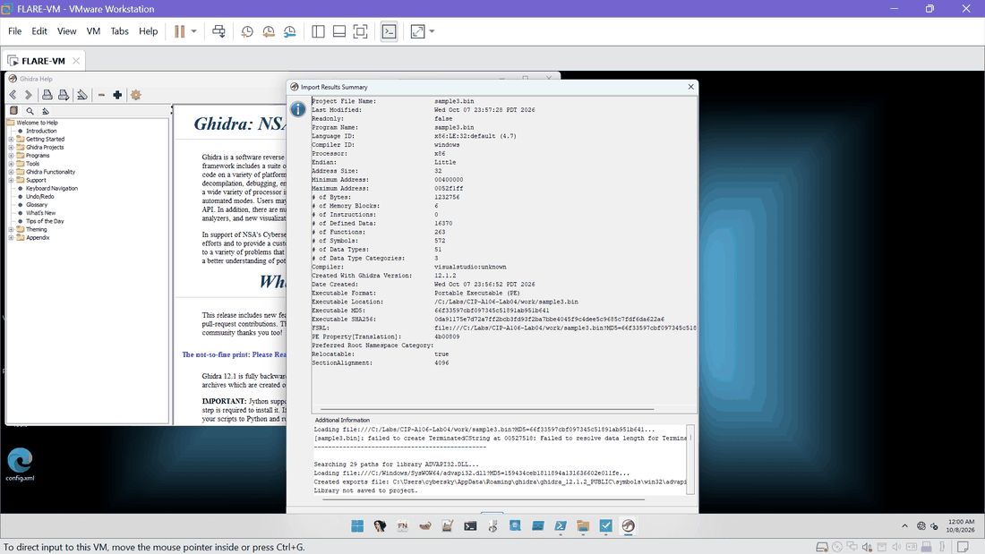
Ex. E15 | 2026-10-08 00:00 | Ghidra 12.1.2 | Ghidra Import Results Summary for sample3.bin: x86:LE:32:default, MD5 66f33597cbf097345c51891ab951b641, SHA256 0da91175...622a6, location C:/Labs/CIP-A106-Lab04/work/sample3.bin | SHA-256 FC4512A59117F6AF...
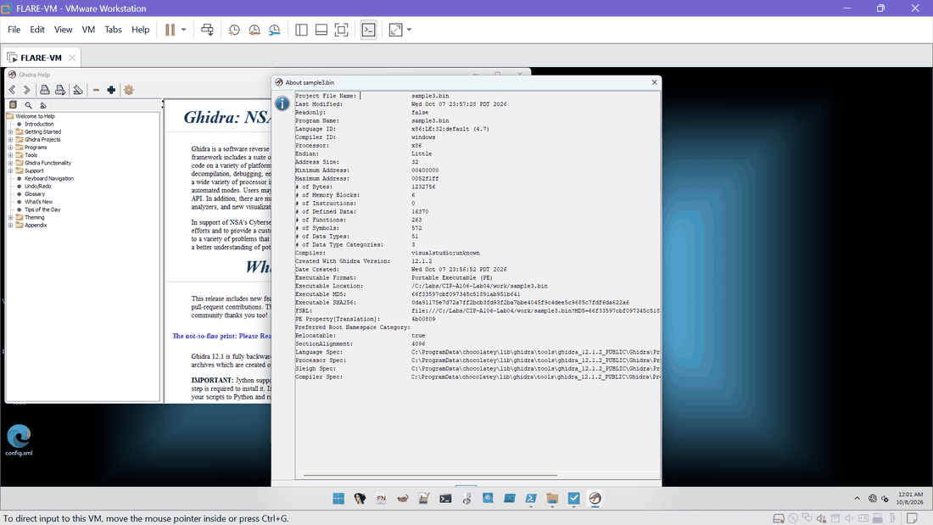
Ex. E16 | 2026-10-08 00:01 | Ghidra 12.1.2 | Ghidra program information after analysis: 263 functions, 572 symbols, 6 memory blocks, created with Ghidra 12.1.2, same MD5 and SHA256 | SHA-256 D8194FFE5B7A81F3...
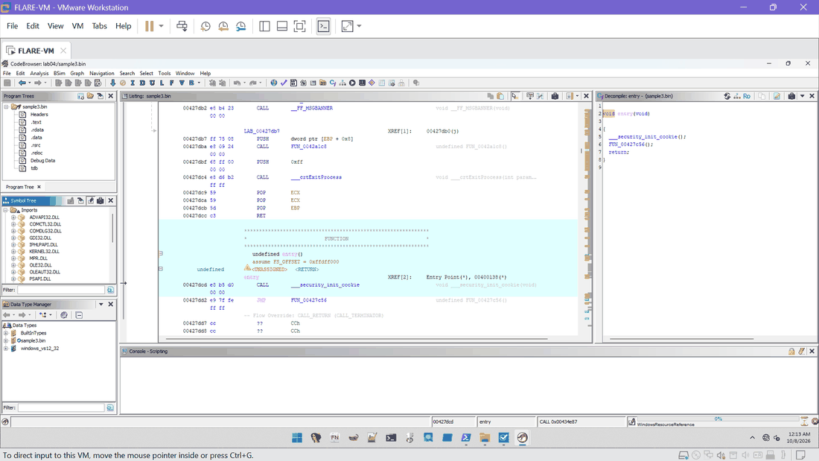
Ex. E17 | 2026-10-08 00:13 | Ghidra 12.1.2 | Ghidra CodeBrowser: entry at 00427dcd calls __security_init_cookie then jumps to FUN_00427c56 (standard MSVC startup) | SHA-256 5BD9C8C9842322AE...
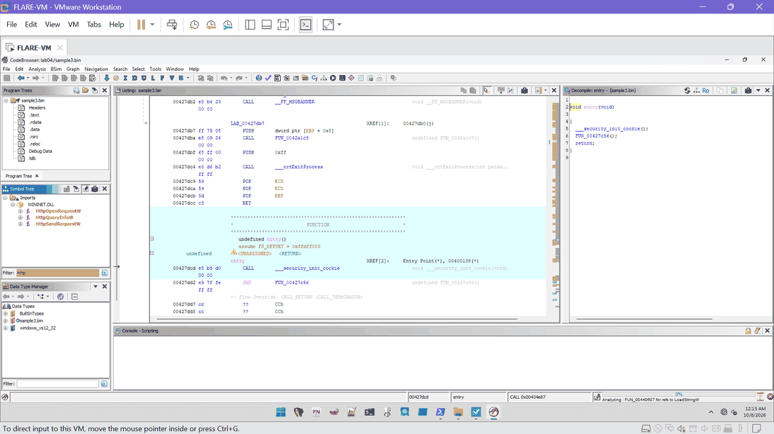
Ex. E18 | 2026-10-08 00:13 | Ghidra 12.1.2 | Ghidra Symbol Tree filtered on "http": WININET imports HttpOpenRequestW, HttpQueryInfoW, HttpSendRequestW | SHA-256 AC446C483204DAEB...
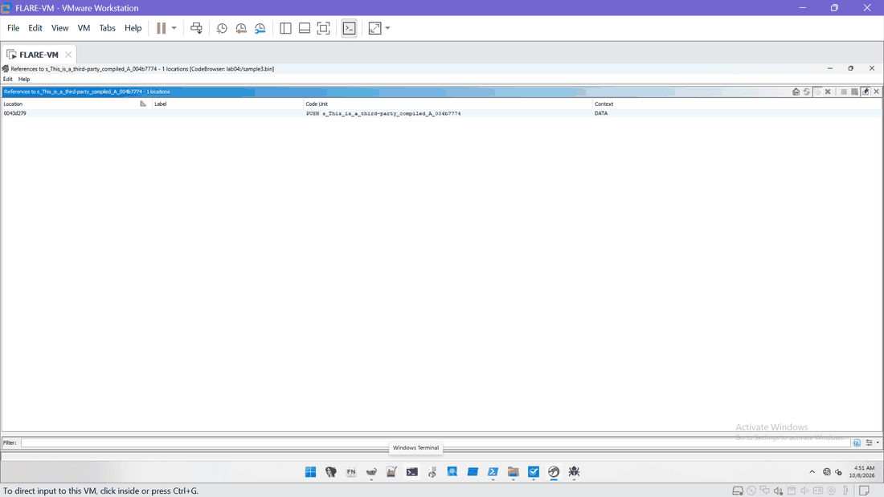
Ex. E41 | 2026-10-08 04:51 | Ghidra 12.1.2 | Ghidra references to the string "This is a third-party compiled AutoIt script.": one location, 0043d279 (PUSH) | SHA-256 E9196209DC13BB6F...
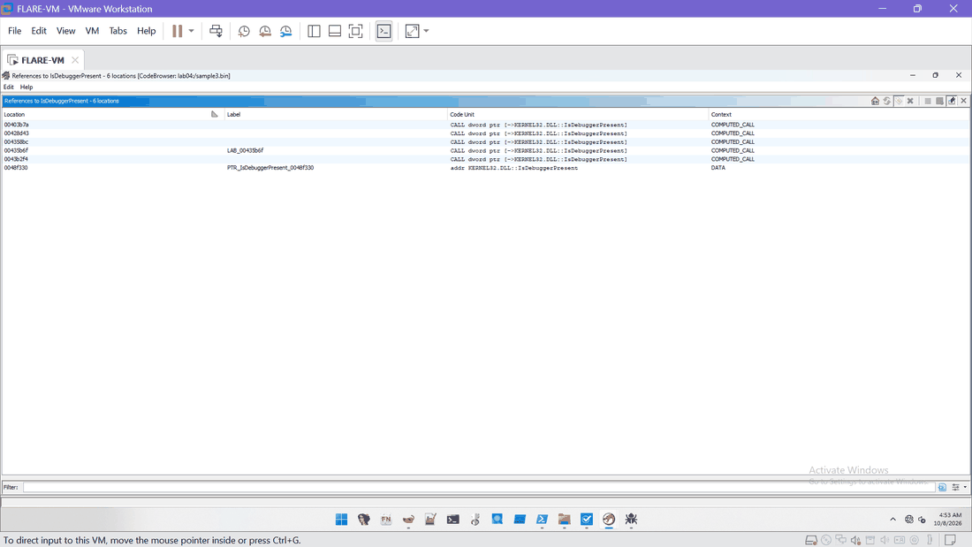
Ex. E42 | 2026-10-08 04:53 | Ghidra 12.1.2 | Ghidra references to IsDebuggerPresent: six locations (00403b7a, 00428d43, 004358bc, 00435b6f, 0043b2f4 and the import pointer 0048f330) | SHA-256 F775B6A8F409E24F...
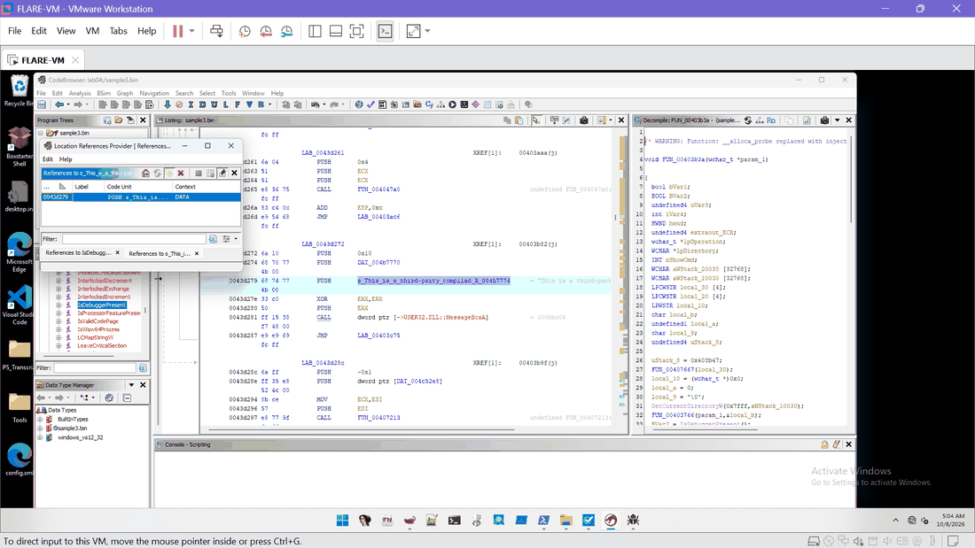
Ex. E43 | 2026-10-08 05:04 | Ghidra 12.1.2 | Ghidra listing at 0043d272 to 0043d281: PUSH of the dialog string then CALL MessageBoxA; decompile of FUN_00403b3a on the right | SHA-256 8C4166B20759976B...
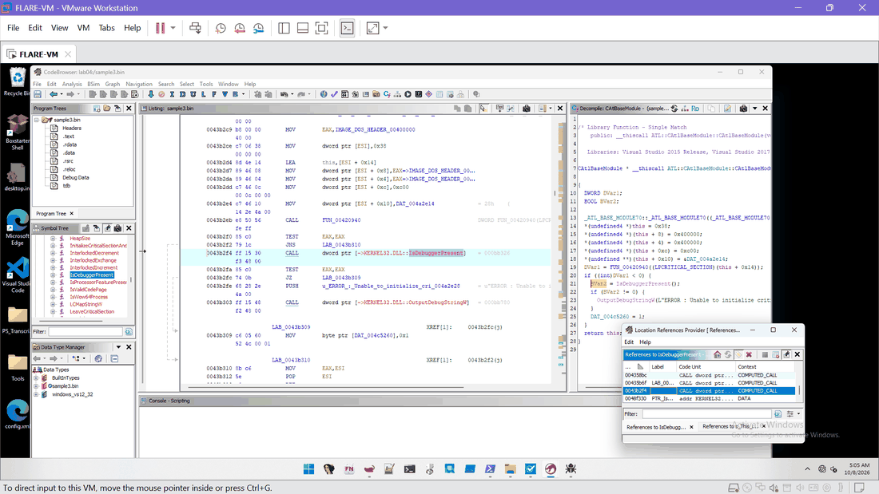
Ex. E44 | 2026-10-08 05:05 | Ghidra 12.1.2 | Ghidra call site 0043b2f4 inside CAtlBaseModule (library function, single match, Visual Studio 2015/2017): a benign ATL initialisation check, not a sample-specific anti-debug check | SHA-256 8520CFB8D91AB524...
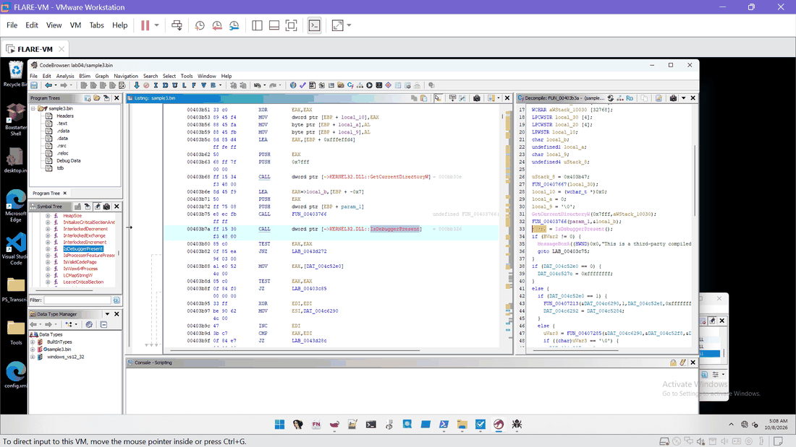
Ex. E45 | 2026-10-08 05:08 | Ghidra 12.1.2 | Ghidra FUN_00403b3a: CALL IsDebuggerPresent at 00403b7a; decompile shows BVar2 = IsDebuggerPresent(); if (BVar2 != 0) MessageBoxA(...); goto exit | SHA-256 F179DDB0DBAE4390...
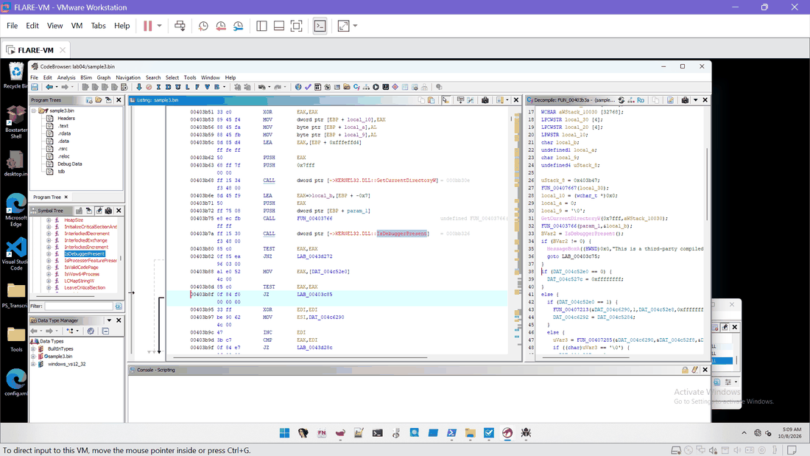
Ex. E46 | 2026-10-08 05:09 | Ghidra 12.1.2 | Ghidra FUN_00403b3a: TEST EAX,EAX at 00403b80, JNZ to LAB_0043d272 at 00403b82 (the branch taken when a debugger is reported) | SHA-256 1A65085FADD2DACD...

D. Debugger observations (Task D)
x32dbg runs 1, 2 and 3: ScyllaHide settings, breakpoints, system and entry stops, IsDebuggerPresent hit, the AutoIt dialog, call stack and logs.
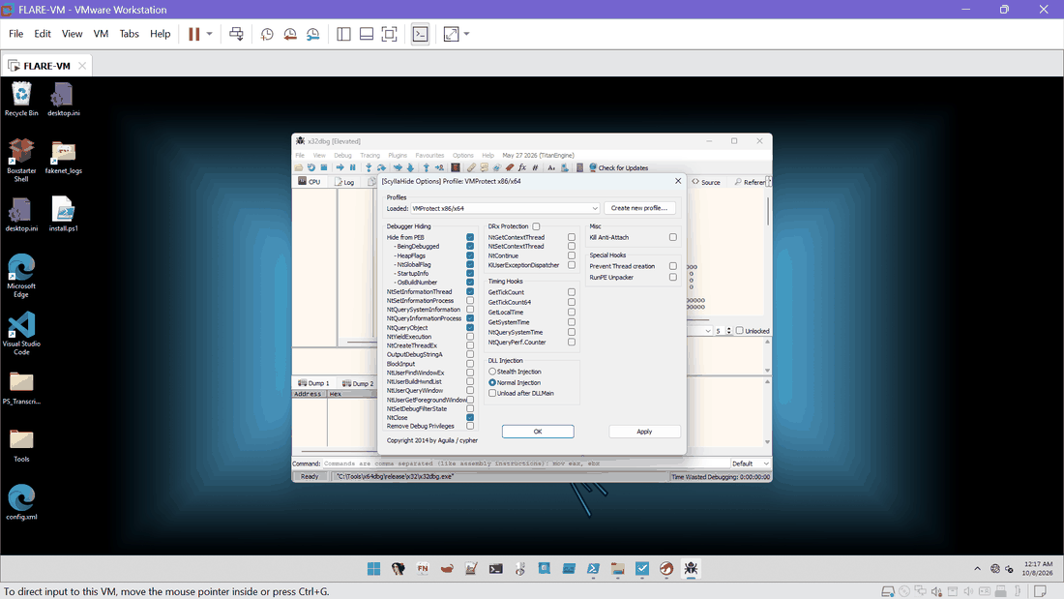
Ex. E19 | 2026-10-08 00:17 | x32dbg / ScyllaHide | ScyllaHide Options as found (profile VMProtect x86/x64): Hide from PEB items, NtSetInformationThread, NtQueryInformationProcess, NtQueryObject and NtClose ticked | SHA-256 426649D9A90FC3B9...
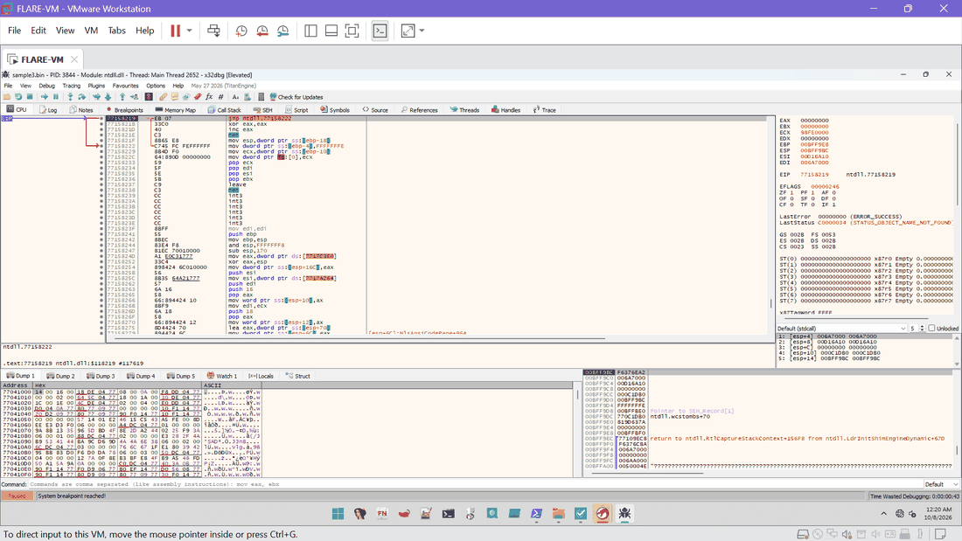
Ex. E20 | 2026-10-08 00:20 | x32dbg | Run 1, PID 3844: system breakpoint reached in ntdll (EIP 77158219); first stop after process creation | SHA-256 31D8B8BE26AF9A3F...
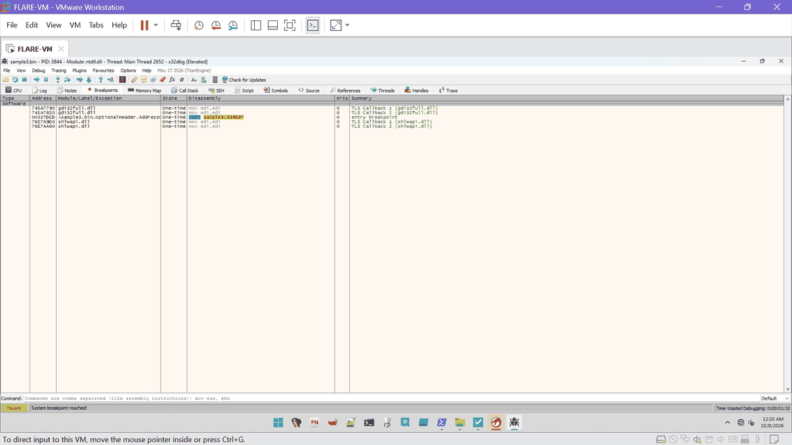
Ex. E21 | 2026-10-08 00:20 | x32dbg | Run 1 Breakpoints tab at the system breakpoint: only TLS callback and entry breakpoints, all hit counts 0 | SHA-256 10E47C6D63748BA3...
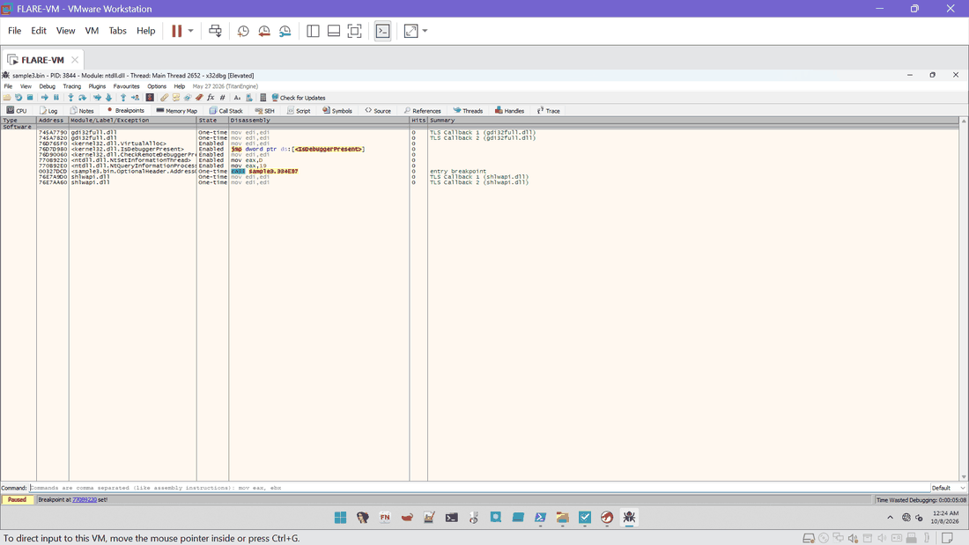
Ex. E22 | 2026-10-08 00:24 | x32dbg | Run 1 Breakpoints tab: VirtualAlloc 76D765F0, IsDebuggerPresent 76D7D980, CheckRemoteDebuggerPresent 76D90060, NtSetInformationThread 770B9220, NtQueryInformationProcess 770B92E0 and entry breakpoint 00327DCD (observation breakpoints, no code changed) | SHA-256 1991341E418945B2...
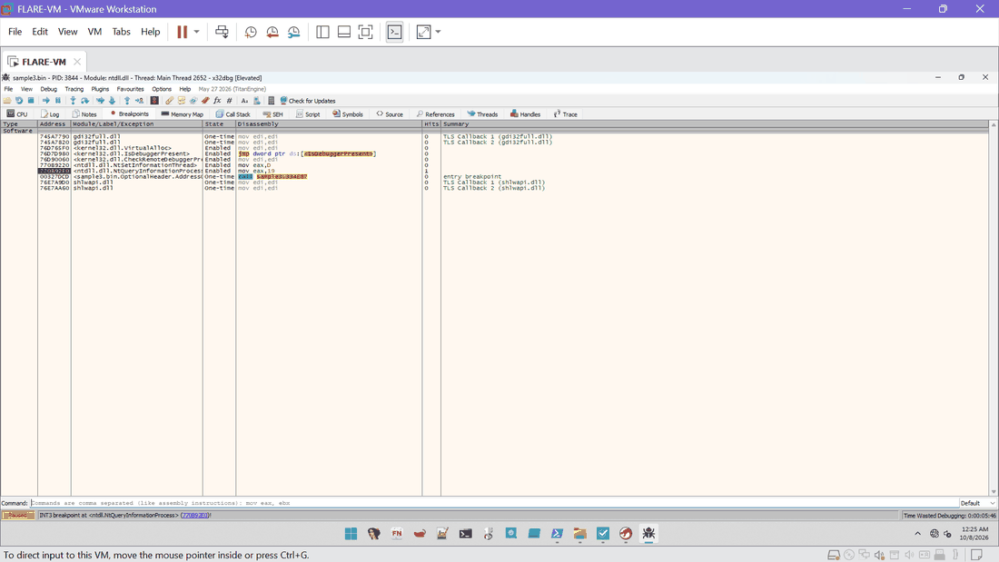
Ex. E23 | 2026-10-08 00:25 | x32dbg | Run 1: INT3 breakpoint at ntdll.NtQueryInformationProcess (770B92E0), hit count 1 | SHA-256 F004CED93B6C7987...
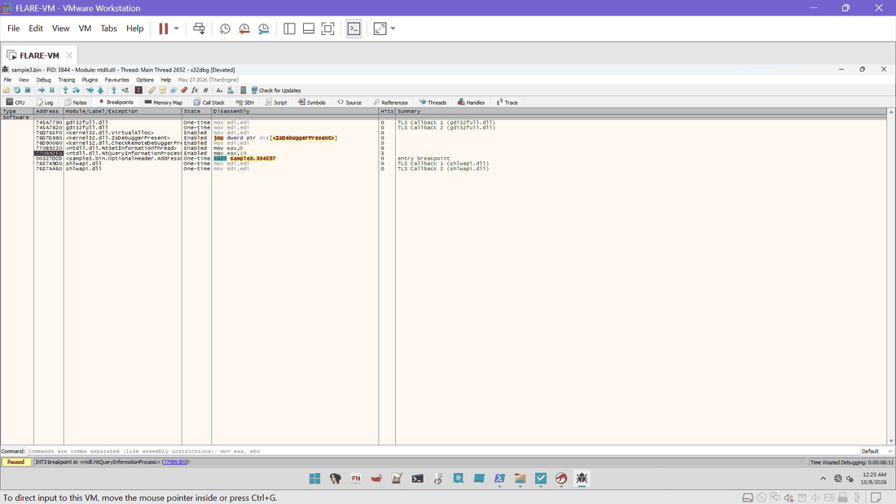
Ex. E24 | 2026-10-08 00:25 | x32dbg | Run 1: NtQueryInformationProcess hit count 3 | SHA-256 EA2E0F6E8251CA89...
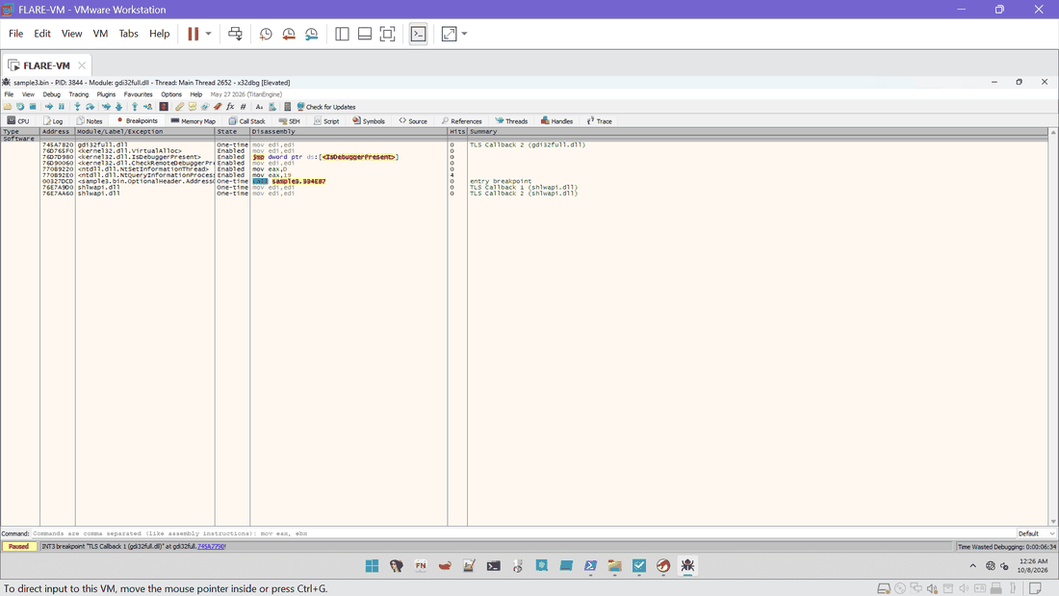
Ex. E25 | 2026-10-08 00:26 | x32dbg | Run 1: TLS callback 1 (gdi32full) stop; NtQueryInformationProcess hit count 4 | SHA-256 37FC54D3E063785A...
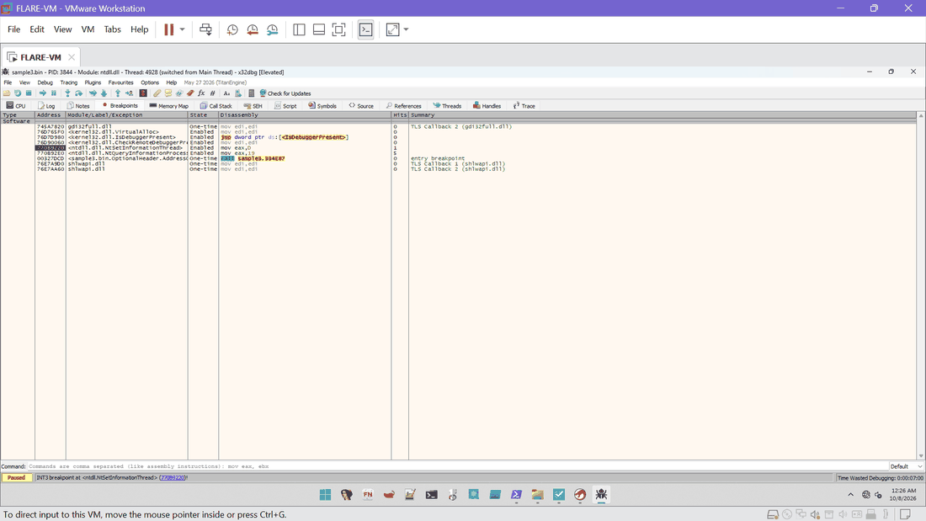
Ex. E26 | 2026-10-08 00:26 | x32dbg | Run 1: breakpoint at ntdll.NtSetInformationThread (770B9220) from thread 4928, hit count 1 | SHA-256 8F19CF007BA1CC11...
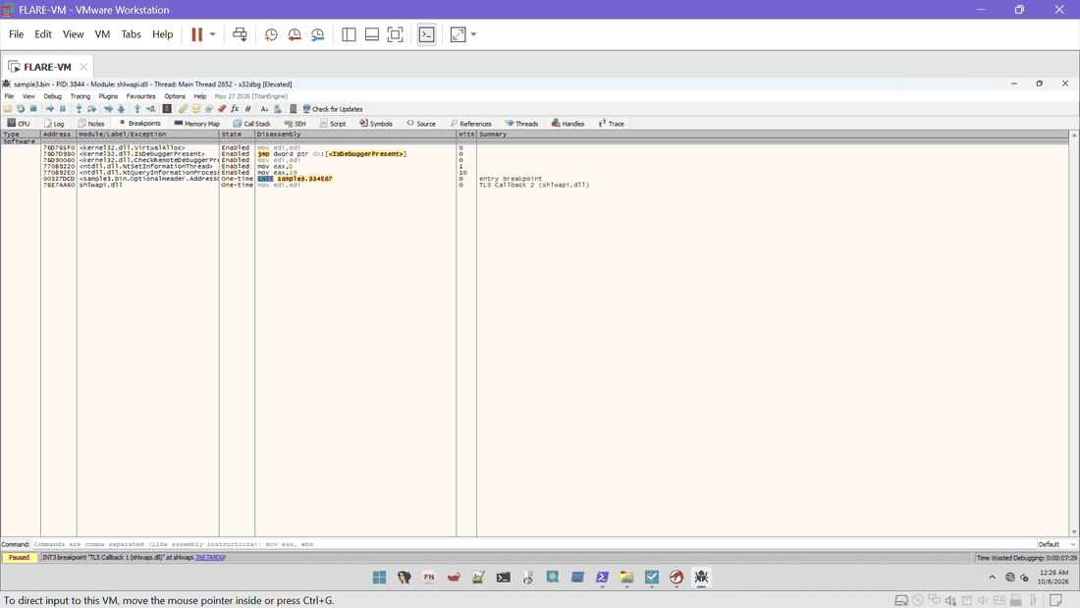
Ex. E27 | 2026-10-08 00:26 | x32dbg | Run 1: TLS callback 1 (shlwapi) stop; NtQueryInformationProcess hit count 10 | SHA-256 C8898D8E46912630...
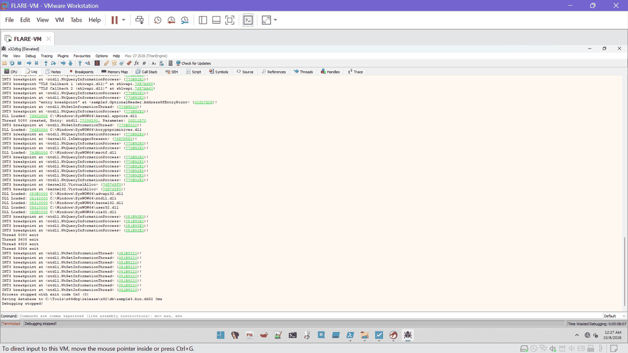
Ex. E28 | 2026-10-08 00:27 | x32dbg | Run 1 final log: two VirtualAlloc breakpoint lines (76D765F0), five private copies of advapi32, ntdll, kernel32, user32 and ole32 loaded from SysWOW64, NtQueryInformationProcess at 051B92E0, NtSetInformationThread at 051B9220, process stopped with exit code 0x0 | SHA-256 49B6DC3CC58B2AF9...
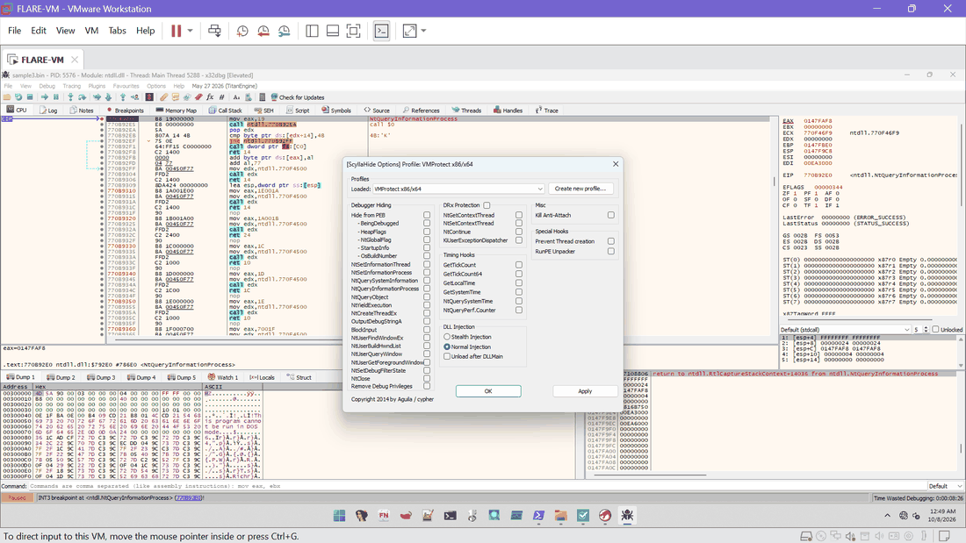
Ex. E29 | 2026-10-08 00:49 | x32dbg / ScyllaHide | Aborted start, PID 5576: ScyllaHide options changed after launch (all unticked); this start was killed and is not used as evidence | SHA-256 BA234FEDDF9D9B31...
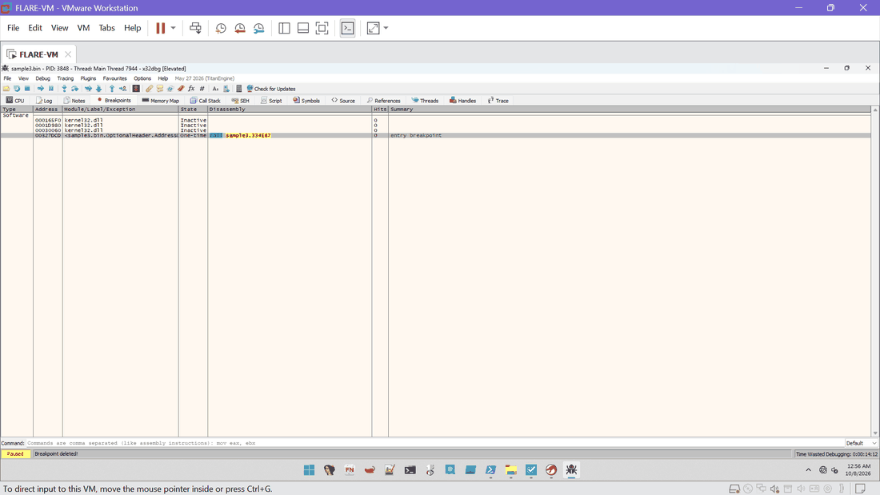
Ex. E30 | 2026-10-08 00:56 | x32dbg | Run 2, PID 3848: Breakpoints tab, kernel32 breakpoints Inactive until the module loads; entry breakpoint 00327DCD | SHA-256 3A0217C83B233EE5...
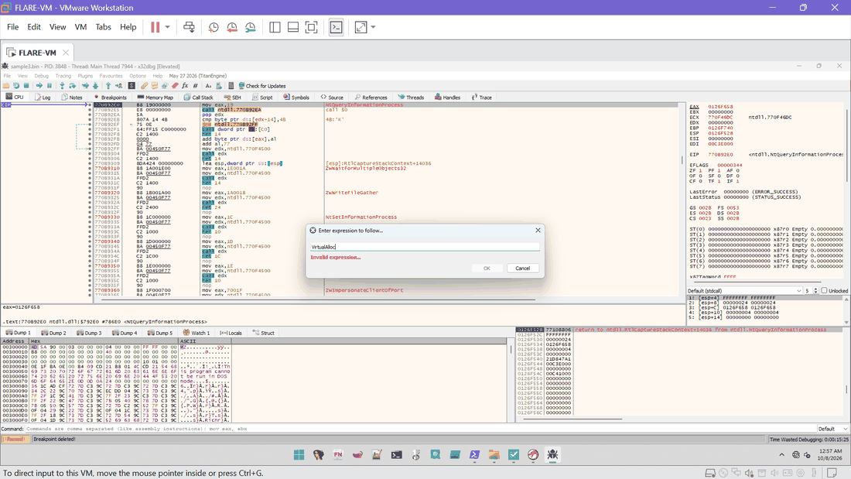
Ex. E31 | 2026-10-08 00:57 | x32dbg | Run 2: "Enter expression to follow" with VirtualAlloc returns Invalid expression (kernel32 not yet loaded at the system stop) | SHA-256 901F4C9B30528A8D...
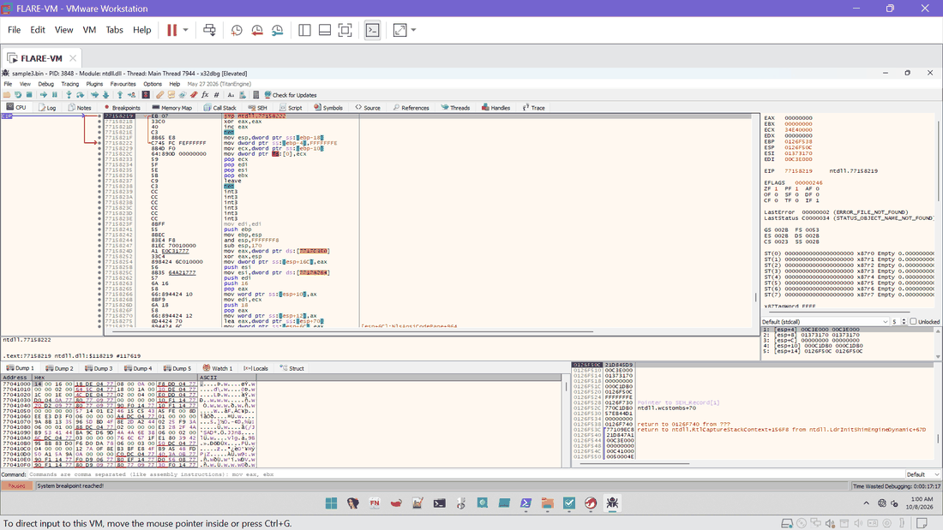
Ex. E32 | 2026-10-08 01:00 | x32dbg | Run 2: system breakpoint reached (PID 3848, ntdll 77158219) | SHA-256 A4DFC85CF6DB0AAC...
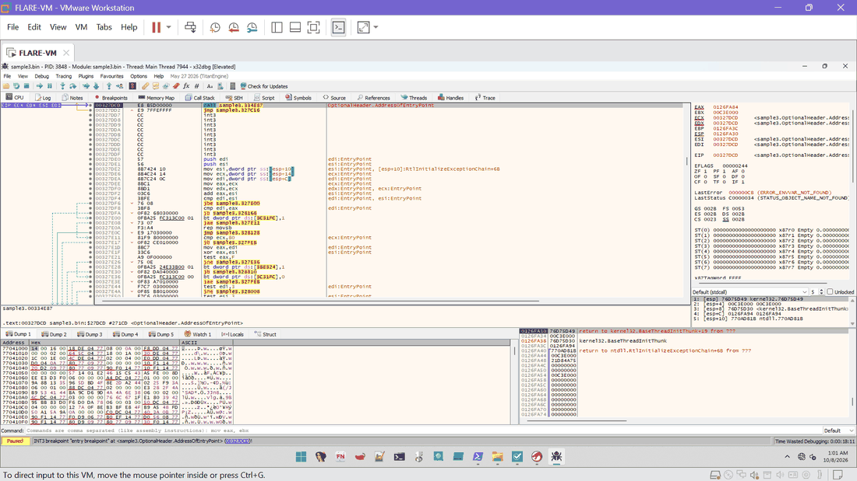
Ex. E33 | 2026-10-08 01:01 | x32dbg | Run 2: entry breakpoint at sample3.00327DCD; CALL sample3.334E87 at the entry point | SHA-256 C4C74F5A88CD9546...
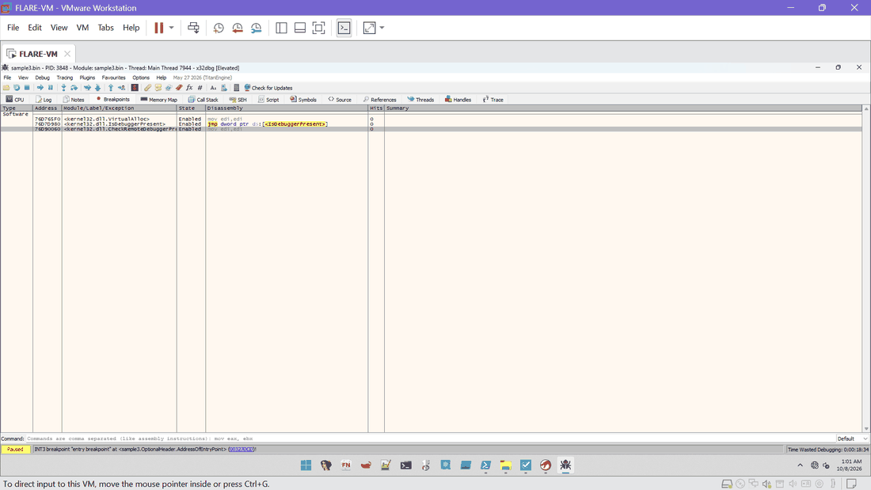
Ex. E34 | 2026-10-08 01:01 | x32dbg | Run 2 Breakpoints tab: kernel32.VirtualAlloc, IsDebuggerPresent and CheckRemoteDebuggerPresent Enabled with 0 hits | SHA-256 C22E4947051A2EFC...
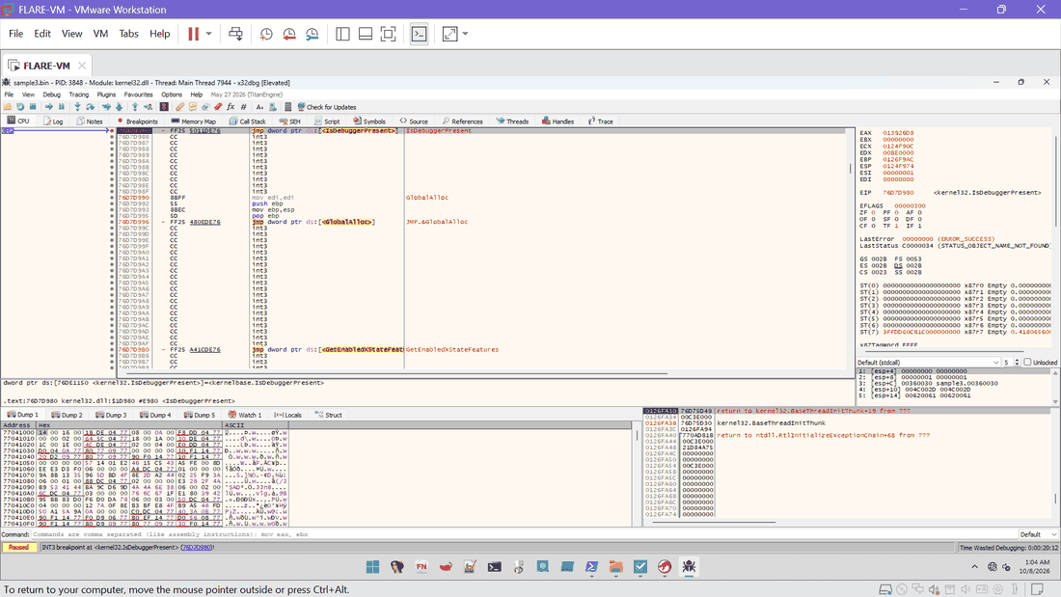
Ex. E35 | 2026-10-08 01:04 | x32dbg | Run 2: INT3 breakpoint at kernel32.IsDebuggerPresent (76D7D980), first instruction JMP dword ptr [IsDebuggerPresent], called from the sample | SHA-256 1769CB8E622B32FA...
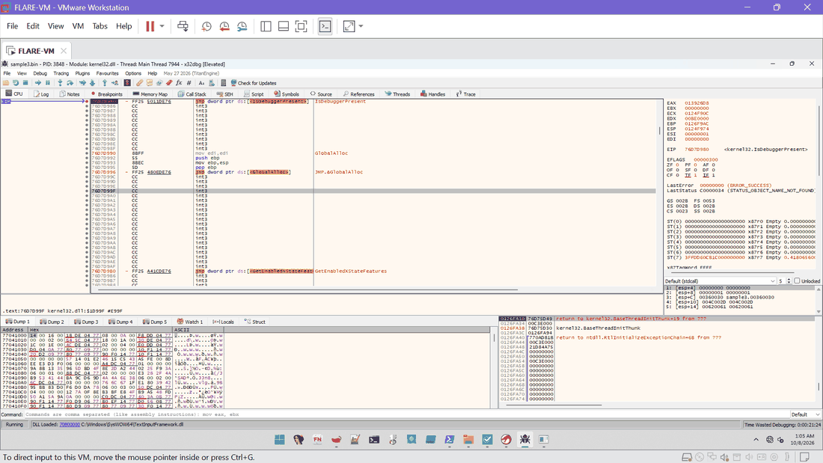
Ex. E36 | 2026-10-08 01:05 | x32dbg | Run 2: process continued (Running), TextInputFramework.dll loaded | SHA-256 B52960D6F250897F...
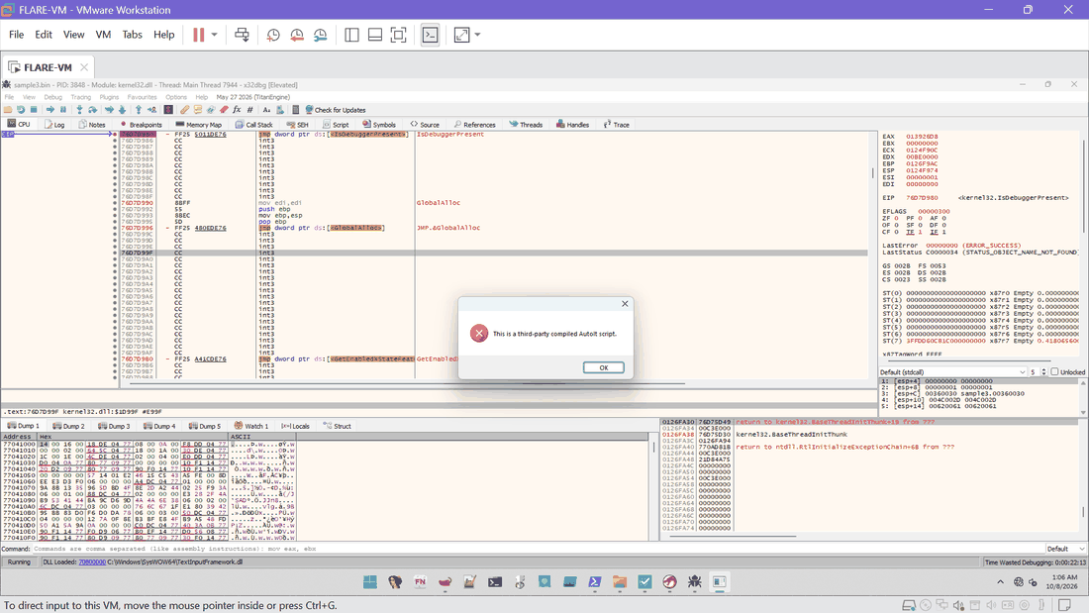
Ex. E37 | 2026-10-08 01:06 | x32dbg | Run 2: message box "This is a third-party compiled AutoIt script." shown while the debugger is attached | SHA-256 CC829E716B545417...
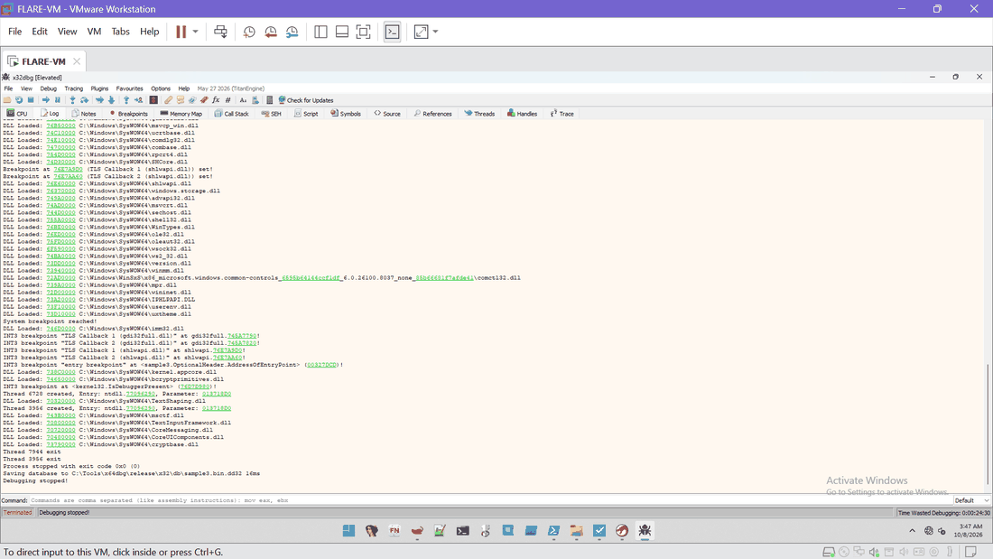
Ex. E38 | 2026-10-08 03:47 | x32dbg | Run 2 final log: IsDebuggerPresent breakpoint at 76D7D980, threads, process stopped with exit code 0x0, database saved; no VirtualAlloc line | SHA-256 0DD5E7DC7C96FEA8...
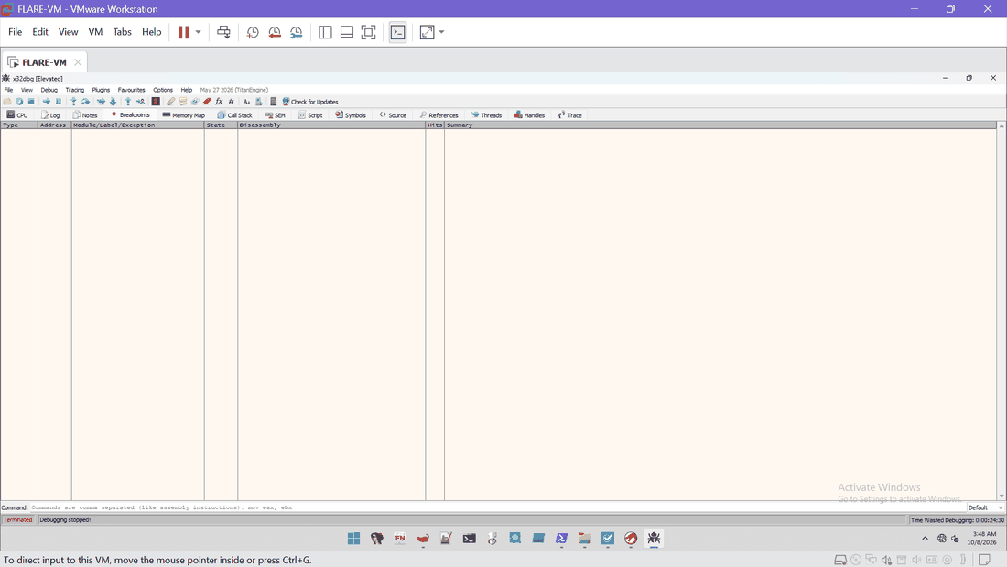
Ex. E39 | 2026-10-08 03:48 | x32dbg | After run 2: Breakpoints tab empty (session terminated) | SHA-256 9061C14FF999391C...
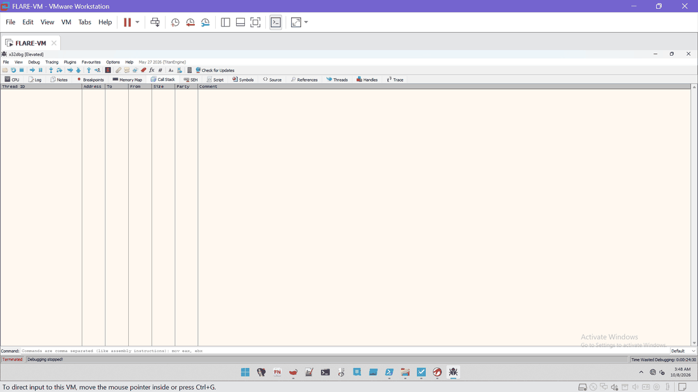
Ex. E40 | 2026-10-08 03:48 | x32dbg | After run 2: Threads tab empty (session terminated) | SHA-256 17A50E45BE9C0AF4...
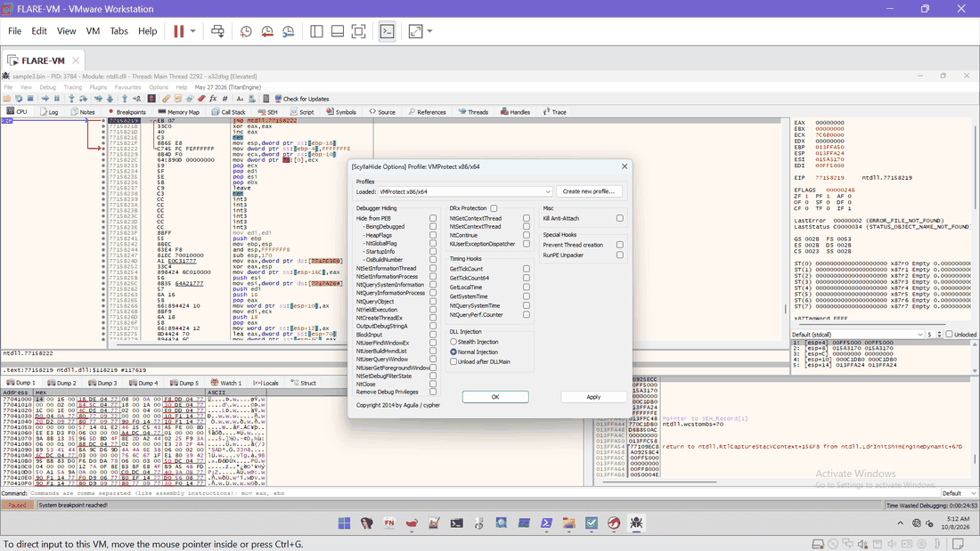
Ex. E47 | 2026-10-08 05:12 | x32dbg / ScyllaHide | Run 3 at the system breakpoint: ScyllaHide options with all boxes unticked | SHA-256 7529C6E1BA43C700...
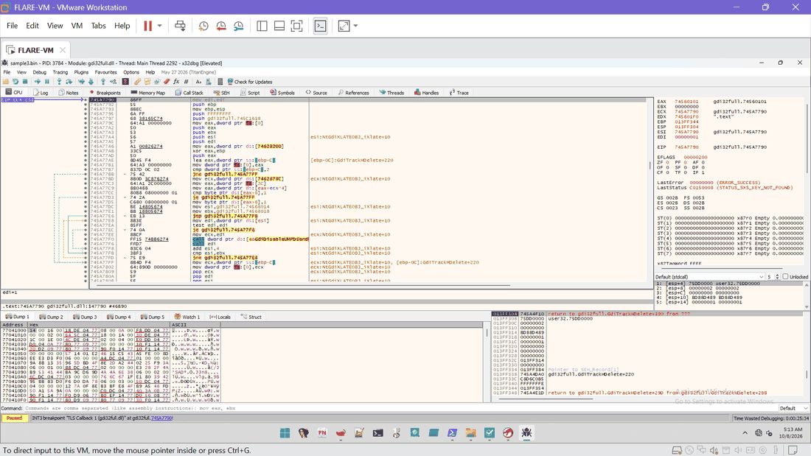
Ex. E48 | 2026-10-08 05:13 | x32dbg | Run 3, PID 3784: TLS callback 1 (gdi32full) stop | SHA-256 C181B4542038A408...
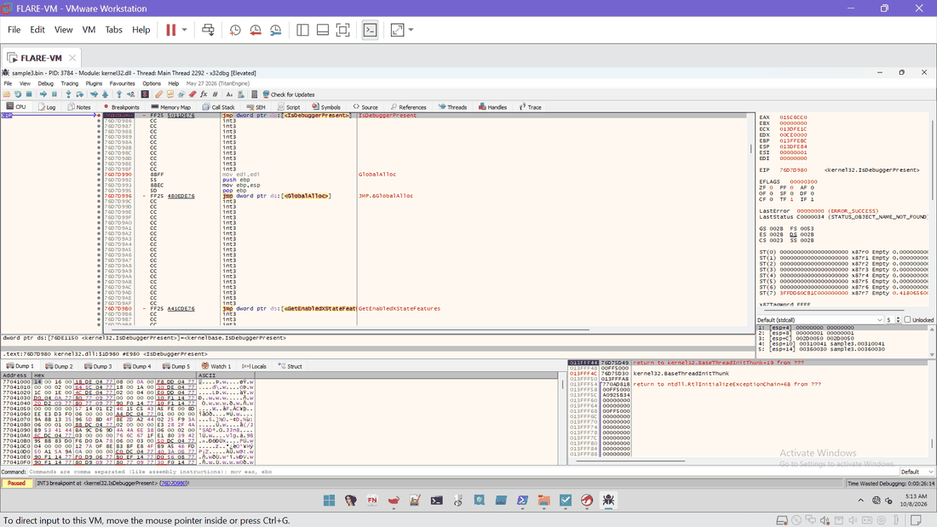
Ex. E49 | 2026-10-08 05:13 | x32dbg | Run 3: INT3 breakpoint at kernel32.IsDebuggerPresent (76D7D980) | SHA-256 D2D1E4F06C5682B4...
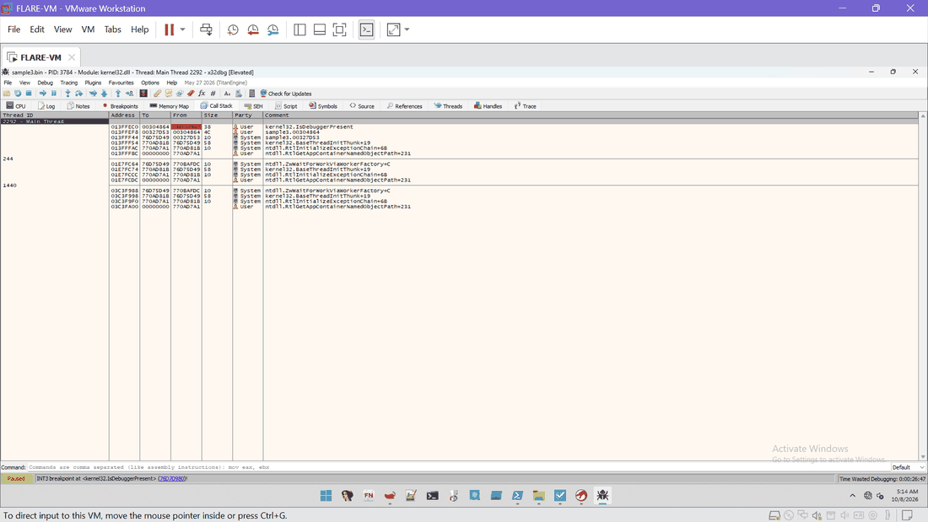
Ex. E50 | 2026-10-08 05:14 | x32dbg | Run 3 Call Stack at IsDebuggerPresent: return to sample3.00304864 (from 76D7D980), caller frames sample3.00304864 and sample3.00327D53 | SHA-256 8C250F0181B257E4...
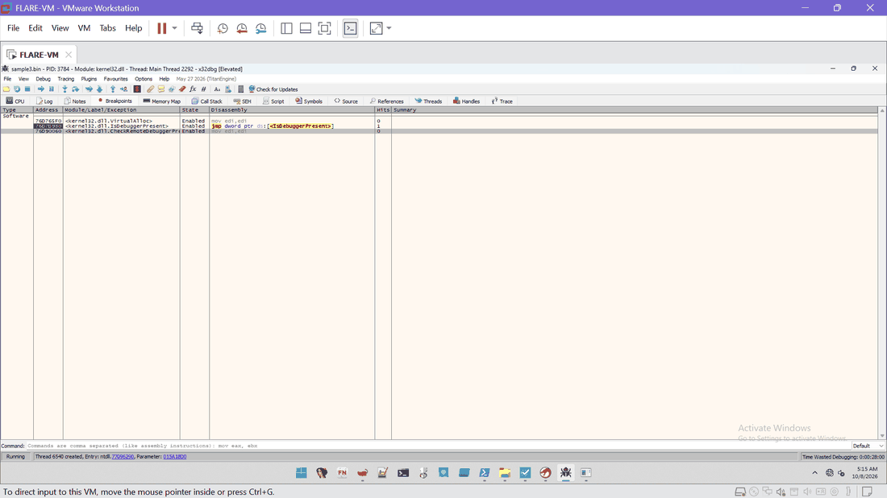
Ex. E51 | 2026-10-08 05:15 | x32dbg | Run 3 Breakpoints tab: VirtualAlloc 76D765F0 with 0 hits, IsDebuggerPresent hit count 1 | SHA-256 BAD8AA0748A0622F...
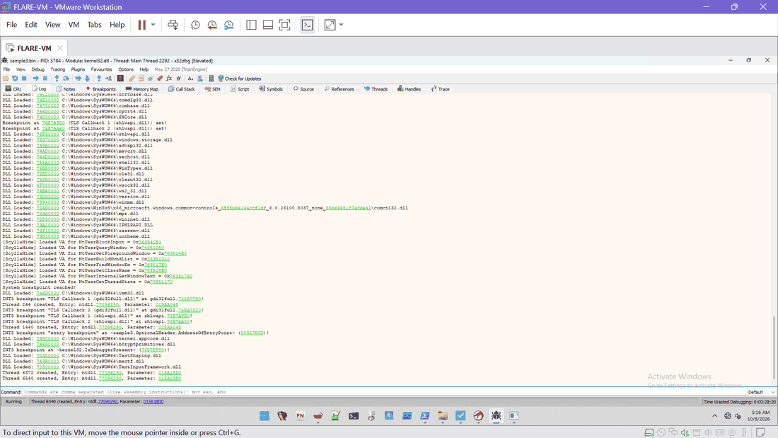
Ex. E52 | 2026-10-08 05:16 | x32dbg | Run 3 log: ScyllaHide "Loaded VA" lines still printed with options unticked, TLS callbacks, entry breakpoint, IsDebuggerPresent breakpoint, TextInputFramework loaded | SHA-256 D06EA2AE156E5468...

E. Memory and script context (Tasks B and E)
System Informer and the PowerShell record of the script lines (27_script_context).
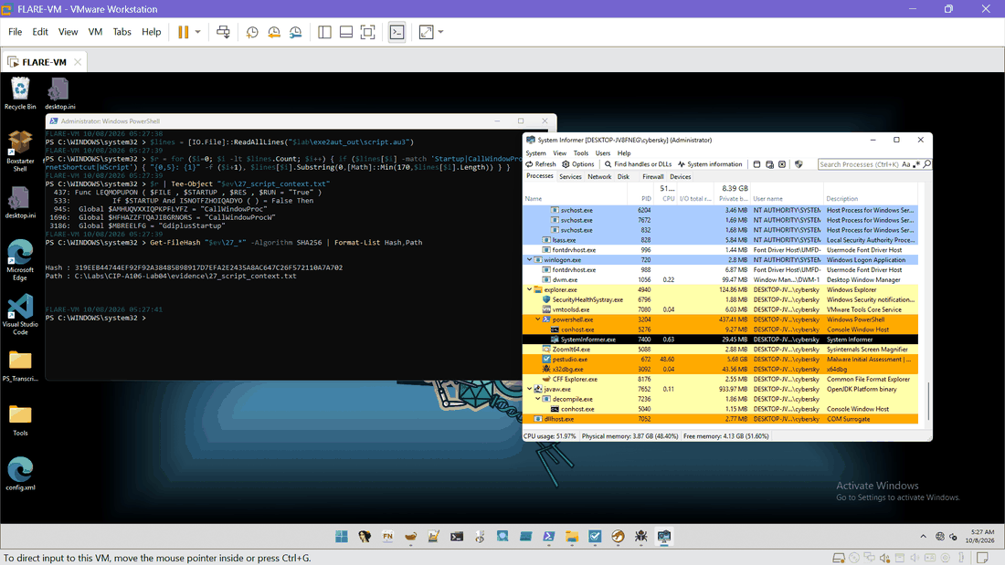
Ex. E53 | 2026-10-08 05:27 | System Informer / PowerShell | System Informer process tree (sample no longer running; x32dbg PID 3092, PowerShell 3204) beside PowerShell showing 27_script_context.txt: LEQMOPUPON function (line 437), $STARTUP test (line 533), CallWindowProc, CallWindowProcW and GdiplusStartup variables (lines 945, 1696, 3186), file SHA-256 319EEB44...A702 | SHA-256 AB46327BBC4CE5CA...

T. Rebuilt text exports
These files were copied out of the VM as console text (or transcribed from a screenshot where marked), because there is no clipboard. Line endings differ from the VM originals, so their hashes differ; the VM hash of each original is in the Evidence Manifest.

T1. 25_indicator_counts.txt (18 patterns counted in script.au3 and the decoded strings, 05:25:52)
script.au3 Charon 0
script.au3 Inferno 0
script.au3 Mozilla 0
script.au3 fre.php 0
script.au3 .php 0
script.au3 Content-Key 0
script.au3 MachineGuid 0
script.au3 wininet 0
script.au3 InternetOpen 0
script.au3 HttpSendRequest 0
script.au3 User-Agent 0
script.au3 POST 0
script.au3 Startup 3
script.au3 .url 0
script.au3 .vbs 0
script.au3 KnownDlls 0
script.au3 CallWindowProc 2
script.au3 DllCall 0
30_au3_decoded_strings.txt Charon 0
30_au3_decoded_strings.txt Inferno 0
30_au3_decoded_strings.txt Mozilla 0
30_au3_decoded_strings.txt fre.php 0
30_au3_decoded_strings.txt .php 0
30_au3_decoded_strings.txt Content-Key 0
30_au3_decoded_strings.txt MachineGuid 0
30_au3_decoded_strings.txt wininet 0
30_au3_decoded_strings.txt InternetOpen 0
30_au3_decoded_strings.txt HttpSendRequest 0
30_au3_decoded_strings.txt User-Agent 0
30_au3_decoded_strings.txt POST 0
30_au3_decoded_strings.txt Startup 0
30_au3_decoded_strings.txt .url 0
30_au3_decoded_strings.txt .vbs 0
30_au3_decoded_strings.txt KnownDlls 0
30_au3_decoded_strings.txt CallWindowProc 0
30_au3_decoded_strings.txt DllCall 0

T2. 26_after_run3_new_files.txt (files written after 05:00, run 3 check, 05:25:34)
PS > Get-ChildItem $env:USERPROFILE,$env:ProgramData,"C:\Users\Public","C:\Windows\Temp" -Recurse -File -Force -Includ

FullName
--------
C:\Users\cybersky\AppData\Local\Microsoft\Windows\WebCache\WebCacheV01.dat
C:\Users\cybersky\AppData\Local\Packages\MicrosoftWindows.Client.CBS_cw5n1h2txyewy\AC\Temp\1a07b68b-c481-4d15-aca3-f..
C:\Users\cybersky\AppData\Roaming\Microsoft\Windows\Recent\sample3.bin.lnk
C:\Users\cybersky\AppData\Roaming\Microsoft\Windows\Recent\work.lnk

(26_after_run3_task_files.txt was not created: the System32\Tasks query returned no files newer than 05:00)

Get-FileHash result (console, 05:25:55):
772088FB4D38AD26805F60784635622F58C92A0248779B7D87BD4BCCB67021D7 25_indicator_counts.txt
47F745757DB87941F21333647658417581731F69E364483FA612DA77B07B4FB2 26_after_run3_new_files.txt

T3. 27_script_context.txt (script lines with Startup, CallWindowProc, GdiplusStartup, 05:27:39; transcribed from E53)
FLARE-VM 10/08/2026 05:27:38
PS C:\WINDOWS\system32 > $lines = [IO.File]::ReadAllLines("$lab\exe2aut_out\script.au3")
PS C:\WINDOWS\system32 > $r = for ($i=0; $i -lt $lines.Count; $i++) { if ($lines[$i] -match 'Startup|CallWindowPro[cut
PS C:\WINDOWS\system32 > $r | Tee-Object "$ev\27_script_context.txt"
437: Func LEQMOPUPON ( $FILE , $STARTUP , $RES , $RUN = "True" )
533: If $STARTUP And ISNOTFZHOIQADYO ( ) = False Then
945: Global $AMHUQVXXIQPKPFLYFZ = "CallWindowProc"
1696: Global $HFHAZZFTQAJIBGRNORS = "CallWindowProcW"
3186: Global $MBREELFG = "GdiplusStartup"
PS C:\WINDOWS\system32 > Get-FileHash "$ev\27_*" -Algorithm SHA256 | Format-List Hash,Path
Hash : 319EEB44744EF92F92A38485B98917D7EFA2E2435A8AC647C26F572110A7A702
Path : C:\Labs\CIP-A106-Lab04\evidence\27_script_context.txt
(Transcribed from the VM screenshot E53; the middle of the -match pattern is cut off on screen. Three lines contain th

T4. 30_au3_decoded_strings.txt (first lines of the decoded hex literals, 23:45:20; the full file stays in the VM)
FLARE-VM 10/07/2026 23:45:17
PS C:\WINDOWS\system32 > $lab = "C:\Labs\CIP-A106-Lab04"; $ev = "$lab\evidence"; $sc = "$lab\exe2aut_out\script.au3"
FLARE-VM 10/07/2026 23:45:19
... (hex-literal count and length table, see the VM transcript) ...
PS C:\WINDOWS\system32 > $m | ForEach-Object { $h=$_.Groups[2].Value; if ($h.Length % 2 -eq 0) { $b = for($i=0;$i -lt
"[InternetShortcut]" & @CR & "URL=file:///" & StringReplace($hpudqgyrglybjztszujdupnyzjggzoyrledakhmgmngedexblxlu, "\"
"Set WshShell = WScript.CreateObject(" & Chr(34) & "WScript.Shell" & Chr(34) & ")" & @CRLF & "WScript.Sleep(" & Round(
$aagbrrpusetqgmijhtlv & "FFFF4E744372C78538FCFFFF65617465C7853CFCFFFF4D75746166C78540FCFFFF6E7488"
$aaimblpftybmllkrzjb & "C78554FDFFFF43727970C78558FDFFFF74446563C7855CFDFFFF72797074888560FDFFFF"
$afqiwxhbpqvgmqjanjpbumxzy & "C78514FCFFFF43727970C78518FCFFFF74446573C7851CFCFFFF74726F79C78520FCFFFF"
$aibrhlgprwbpuoyosluscjlnbchc & "BCEEFFFFE88CEBFFFF89450C8D85DCF6FFFFE87EEBFFFF89451485C0750E8D85ACEAFFFF"
$ampprdjio & "7D2981EC780100006A5E598BFCFF750C8D8424040300008DB4248C01000050F3A5E8CFFC"
$aqcvkvefl & "280345F8898540FCFFFF8D8590FBFFFF50FF75ECFF95600100005785C00F8831FFFFFFFF"
$ascikbidnjxeatwjmwyetkibgqnpdpmoeflzel = False
$asnzapvlzadkpbvs & "C78574FBFFFF436F4372C78578FBFFFF65617465C7857CFBFFFF496E7374C78580FBFFFF"
$avonnjn & "FF7357888592FCFFFFC78514FDFFFF52746C5AC78518FDFFFF65726F4DC7851CFDFFFF65"
$baewlspkneiucpinovcxaezpusywp & "8D8594FDFFFF508D85DCF6FFFF50FFD78D8510FEFFFF83C40C50FFD65940508D8510FEFF"
$bappvblh & "FF72656E74C785FCF8FFFF55736572C78500F9FFFF4B657950C78504F9FFFF61746800C7"
$bclbkflc & "8550FDFFFFC745BC6B65726EC745C0656C33328845C88845A8888580FDFFFF64A1300000"
... (remaining lines of the 80 shown are similar hex fragments)
FLARE-VM 10/07/2026 23:45:26
PS C:\WINDOWS\system32 >

T5. Stack-string fragments read from the decoded hex literals (derived by the analyst, not tool output)
Derived by the analyst from the decoded hex literals in the paste (first 80 lines only).
The 4-byte ASCII fragments are read in order out of mov dword ptr [ebp-X],imm32 patterns
(opcode C7 85). The last fragment of a name can be cut by the line length, so the names
are reconstructions, not tool output. Nothing was disassembled or executed.

FFFF4E744372C785... NtCr | eate | Mutaf
C78554FDFFFF4372... Cryp | tDec | rypt
C78514FCFFFF4372... Cryp | tDes | troy
C78574FBFFFF436F... CoCr | eate | Inst
FF7357888592FCFF... RtlZ | eroM
FF72656E74C785FC... rent | User | KeyP | ath
8550FDFFFFC745BC... kern | el32
6F6164C745B04C69... oad | Libr | aryA | GetP
C745F070693332C7... pi32 | .dll | lstr | len
74696F66C78520FA... tiof | LdrG | etPr
C7858CFBFFFF7444... tDes | troy | Hash
8001000085C0790C... F4u
458C7763736366C7... wcscf | memsf
856CF9FFFF6E7361... nsac | tion | ZwRo
4B657900C78584FA... Key | Cryp | tRel | ease
C785B8FAFFFF7254... rThr | ead | NtOp
FFFF61746550C785... ateP | rocef
6C735C75C78594FE... ls\u | ser3 | 2.dlf
B0FBFFFF4E744465... NtDe | layE | xecu
656E5072C78554FB... enPr | oces | sTokf
FBFFFFC785ACF9FF... NtAd | just | Priv
C78584FCFFFF4372... Crea | tePr | ocesf
F9FFFF696C6567C7... ileg | esTo | ken | Rtl
F9FFFF45787061C7... Expa | ndEn | viro | nme
FFFF6579888562FC... memcf | Cryp
57888538FFFFFFC7... NtPr | otec | tVi
4B6E6FC78598FDFF... Kno | wnDl | ls32 | \ker
32C78504FFFFFF2E... .dll | user | 32.df
FF7300C78504FDFF... GetS | yste | mInff
750C8BF8F3A55F5E... SVW
FFFF74655769C785... teWi | ndow | ExW | Regi
7233322EC78524FE... r32. | dll | \Kno | wnDl
45C4774F6653C745... wOfS | ectif
7CFAFFFF63657373... cess | ZwCr | eate
6366C74598707988... NtCr | eate
4765744DC78514FB... GetM | odul | eFil | eNamf
D4FF958401000085... PWWW
53565781EC780100... SVW
6EC78528FCFFFF69... itia | lizef
4F70C785E8FCFFFF... enSe | ctiof
859CF9FFFF746556... teVi | rtua | lMem
6164888582FCFFFF... NtSe | tCon
DAFEFFFFC78534FD... NtSe | tVal | ueKef
6D6F7266C78520FD... morf | NtTe | rmin
8510FAFFFF6C6C62... llba | ckTr | ansa

T6. 21_after_run1_new_files.txt and the post-run-1 comparison (00:45 to 00:48)
FLARE-VM 10/08/2026 00:45:09
PS > Get-ChildItem $env:USERPROFILE,$env:ProgramData,"C:\Users\Public","C:\Windows\Temp" -Recurse -File -Force
-Include *.vbs,*.url,*.lnk,*.js,*.bat,*.cmd,*.ps1,*.exe,*.dll,*.tmp,*.au3,*.dat
| Where-Object LastWriteTime -gt (Get-Date "2026-10-08 00:19:00") | Sort-Object LastWriteTime

FullName Length
-------- ------
C:\Users\cybersky\AppData\Roaming\Microsoft\Windows\Recent\sample3.bin.lnk 908
C:\Users\cybersky\AppData\Local\Microsoft\Windows\History\History.IE5\MSHist012026100820261009\container.dat 0
C:\Users\cybersky\AppData\Roaming\Microsoft\Windows\Recent\work.lnk 718
C:\Users\cybersky\AppData\Local\Microsoft\Windows\WebCache\WebCacheV01.dat 14680064

FLARE-VM 10/08/2026 00:47:36 Run keys saved to 21_after1_run_keys.txt
FLARE-VM 10/08/2026 00:48:08 Scheduled tasks saved to 21_after1_tasks.txt
Compare-Object on run_keys : no differences
Compare-Object on tasks : printed the whole task list (column wrapping made the text differ); judged inconclusive
(LastWriteTime column cut off in the console paste; the lines above are rebuilt from the pasted text)

T7. Process and memory artefact record for run 3 (PID 3784, dump hash)
Values recorded for the run 3 process and the memory artefact. Rebuilt from console output noted during the lab;
the original console text is in the VM evidence folder (00_transcript.txt).

Process
Name sample3.bin
ProcessId 3784
Path C:\Labs\CIP-A106-Lab04\work\sample3.bin
Created 2026-10-08 05:12:12
Parent ProcessId 3092 (x32dbg.exe, C:\Tools\x64dbg\release\x32\x32dbg.exe)

Memory artefact
File C:\Labs\CIP-A106-Lab04\memory\run3_blocked.dmp
Written 2026-10-08 05:21:30
Size 97,956,974 bytes
SHA-256 3DFEF5111364B61EC8345DBC835964E1A88216D335B2114C7EBA026381EAD5E5
Tool System Informer 3.2.25113.1114, Create dump file (full dump)
Validation evidence\24_dump_validation.txt, SHA-256 D04E10B488B7F334ECB2C20C2EACE70E1202876FF5E1F5BC2ED26195
Note Format-Hex -Count is not supported in Windows PowerShell 5.1; bytes were read with [IO.File]::Rea

T8. SHA-256 values of the evidence files recorded in the VM
Evidence file hashes recorded in the VM (SHA-256, file name). Rebuilt from the manifest.

85B05D9BA00CD16DD370B628F8943D3C85EB87C23178CD30CCEECF00FB49974C D:\sample3.iso
0DA91175E7D72A7FF2BCB3FD93F2BA7BBE4045F9C4DEE5C9685C7FDF6DA622A6 original\sample.bin
0DA91175E7D72A7FF2BCB3FD93F2BA7BBE4045F9C4DEE5C9685C7FDF6DA622A6 work\sample3.bin
788D259BE4F29DE5865FA18C4B0089F6A1F0D10C910376250AE6924F1E5B6099 exe2aut_out\script.au3
476D83A1B7835D9CA91ED156CEDE641BA3E1C74E627149A9F706C90EDF987DD6 evidence\20_baseline_files.csv
EE560871671E6361CFEA2ABC20CE1EA6D22E7CF6B87D8827C7144ADA60197C0A evidence\20_baseline_processes.txt
92FDE6438637300E6BF7697941572765D573ACE69C03C83907AF6795A5D86E98 evidence\20_baseline_run_keys.txt
A746B5CD178FF855162B7EE0936DFD3CF735CDC5FD9C9AA8E007E7F640A29D44 evidence\20_baseline_tasks.txt
C0D62A7DE7B90D05814AE575136990A74E3394589646799244231E4B698DCE46 evidence\21_after_run1_time.txt
BDC3E8DDF892E45D2A2DB0DB38A9551F8828E23E2C77E04E5CC5FF9F392FB1F9 evidence\21_after_run1_new_files.txt
92FDE6438637300E6BF7697941572765D573ACE69C03C83907AF6795A5D86E98 evidence\21_after1_run_keys.txt
88B2112200BA6A698CDCC70306E12EF111EA2FCB449E3484C40439D4071258DB evidence\21_after1_tasks.txt
674CEDF5EC162581252725FE9C4CBFD1EF71825EE0129B446F41C707D3EF4FF8 evidence\22_run1_x32dbg_db.dd32
952A9BAD1CFFC081D90DB925D60AD8E0933A4727DB87BB5048EEDCBC70B56B25 evidence\23_after_run2_new_files.txt
D551A91A2B99A0FE0A7A73D3BEF5BC348E49F7339A63764520755D722E4AB365 evidence\23_after_run2_task_files.txt
3DFEF5111364B61EC8345DBC835964E1A88216D335B2114C7EBA026381EAD5E5 memory\run3_blocked.dmp
D04E10B488B7F334ECB2C20C2EACE70E1202876FF5E1F5BC2ED26195014BD421 evidence\24_dump_validation.txt
47F745757DB87941F21333647658417581731F69E364483FA612DA77B07B4FB2 evidence\26_after_run3_new_files.txt
772088FB4D38AD26805F60784635622F58C92A0248779B7D87BD4BCCB67021D7 evidence\25_indicator_counts.txt
319EEB44744EF92F92A38485B98917D7EFA2E2435A8AC647C26F572110A7A702 evidence\27_script_context.txt

T9. 24_dump_validation.txt (validation of run3_blocked.dmp, output shown at 05:54:30)
FLARE-VM 10/08/2026 05:54:30
PS C:\WINDOWS\system32 > Get-Content "$ev\24_dump_validation.txt"
First 16 bytes: 4D 44 4D 50 93 A7 F4 A0 0F 00 00 00 20 00 00 00 ASCII: MDMP
This is a third-party compiled AutoIt script ascii offset: 805858 utf16 offset: 2840286
AU3!EA06 ascii offset: 904246 utf16 offset: -1
Mozilla/4.08 ascii offset: -1 utf16 offset: -1
Charon ascii offset: -1 utf16 offset: -1
Inferno ascii offset: -1 utf16 offset: -1
fre.php ascii offset: -1 utf16 offset: -1
Content-Key ascii offset: -1 utf16 offset: -1
Original file DOS header and stub (128 bytes) found in dump at offsets: 54382

FLARE-VM 10/08/2026 05:54:30
PS C:\WINDOWS\system32 > Get-FileHash "$ev\24_dump_validation.txt" -Algorithm SHA256
SHA256 D04E10B488B7F334ECB2C20C2EACE70E1202876FF5E1F5BC2ED26195014BD421 C:\Labs\CIP-A106-Lab04\eviden...

(Offset -1 means the pattern was not found. Offsets are byte positions in run3_blocked.dmp. Rebuilt from the console t

