CIP-A107 SOC Laboratory
Introduction to Wazuh: Threat Detection and File Integrity Monitoring
Technical report: deployment, agent registration, FIM configuration, alert investigation
Student | Perry Koko, C1126EHIT17343 (perrynkoko@gmail.com)
Course and module | CIP-A107 Security Operations Centre (SOC) Essentials: Wazuh SIEM Deployment, Endpoint Monitoring and File Integrity Analysis. Lab manual "SOC Lab: Introduction to Wazuh for Threat Detection & Monitoring", instructor Aminu Idris.
Platform | Wazuh 4.12.0 all-in-one (manager, indexer, dashboard, Filebeat) on Ubuntu 20.04 in VMware Workstation; Wazuh agent 4.12.0 on a Windows 11 Pro host (10.0.26200).
Dates | Installation attempts 15 and 18 October 2026; agent registration, FIM and tests 19 October 2026. VM and manager clocks are UTC; the Windows host clock is UTC-7.
Companion files | Evidence Appendix (exhibits E01 to E47 and text exports T01 to T13), Evidence Manifest and Findings Matrix, README. Exhibit (E) and text (T) numbers below refer to them.

1. Summary and conclusions
A single-node Wazuh 4.12.0 server was installed on an Ubuntu VM after five installation runs (four failed, the fifth finished). A Windows 11 host was registered as agent 001 and monitored in real time on one folder. A file was created, modified and deleted twice. Wazuh raised the three expected alerts each time (rule 554 level 5, rule 550 level 7, rule 553 level 7) within about 0.4 seconds of the action. For the second run, the size and SHA-256 values in the alerts match the values recorded locally by the test script.
Requirement | Result | Evidence
Part 1 Deploy the manager | Done (run 5) | E27, E28, T13
Part 2 Reach the dashboard | Done | E40, E41
Parts 3 and 4 Install and register the agent | Done, agent Active | E42, E43, E44, T02 to T04
Part 5 Configure FIM | Done, one line added | T05, T06
Part 6 Verify and analyse alerts | Done, two runs | E46, E47, T07 to T12
Questions 1 to 4 | Answered (section 9) | Alert fields T10, T11; reasoning in section 9

How to read this report. Statements are labelled Observed (a tool or screenshot shows it, with an exhibit), Inferred (my reasoning from observed facts) or Not observed (looked for, not seen). The ransomware rule in answer 3 is a proposal, not deployed or tested. Deviations from the lab manual are listed in section 2.3, and limits in section 12.

2. Architecture and environment
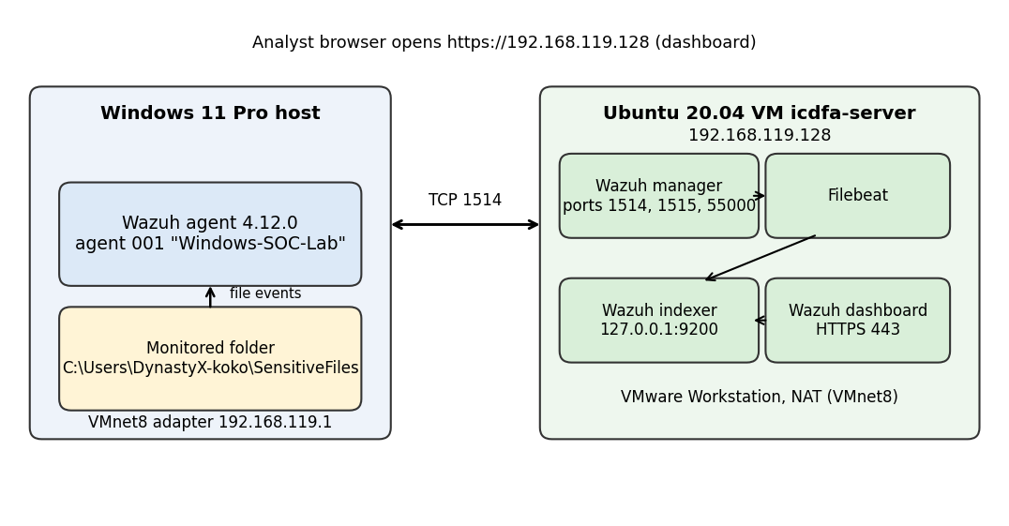
Figure 1. Lab architecture as built: agent on the Windows host, all Wazuh server components on one Ubuntu VM.

2.1 Components
Component | Detail
Wazuh server VM | Ubuntu 20.04 LTS, hostname icdfa-server, VMware Workstation, NAT network, interface ens33 192.168.119.128/24 (dynamic). Resized to 8.6 GB RAM, 4 vCPU, 50 GB disk (LVM root grown from 24 to 48 GiB), 8 GiB swap, after run 1 (E07, E10).
Services | wazuh-manager, wazuh-indexer, wazuh-dashboard and Filebeat, all active (E37).
Ports | Manager 1514/tcp (agent events), 1515/tcp (enrollment, not used: the agent was registered with manage_agents), 55000/tcp (API); dashboard 443/tcp; indexer 9200 on 127.0.0.1 only.
Endpoint | Windows 11 Pro 10.0.26200, agent 4.12.0, name Windows-SOC-Lab, ID 001; host VMware Network Adapter VMnet8 192.168.119.1.
Time | Manager and VM: UTC. Windows host: UTC-7. The dashboard shows times in the browser time zone. Both clocks are shown in the test script output (T08).
Snapshot | Wazuh_Clean_Baseline taken before the later install runs (E09).

2.2 Network history
The VM was first set to Bridged, then to NAT (E03). The NAT subnet was 192.168.152.0/24 (VM 192.168.152.131). On 18 October the host adapter VMnet8 was "Not Present" (E32, T01); after Virtual Network Editor > Restore Defaults it came back at 192.168.119.1 and the VM leased 192.168.119.128 (E35, E36). All agent work used the final addresses.

2.3 Deviations from the lab manual
Manual says | Done here | Reason or effect
VirtualBox | VMware Workstation | Hypervisor available on the host. No effect on Wazuh.
Bridged network | NAT (Bridged tried first) | Bridged was tried first (E03); the VM was then moved to NAT. The exact reason for the change was not recorded.
Windows 10 | Windows 11 Pro | Host OS in use. The 4.12.0 agent supports it.
-i means interactive | -i printed "Hardware checks ignored" (E11, E26) | In this version -i skips the hardware check; -o overwrites a previous install. Command used: sudo bash ./wazuh-install.sh -a -i -o
Agent Manager "Management tab / Apply" | Fields Manager IP, Authentication key, Save | Layout of the 4.12 GUI (E42).
GPG key with apt-key | gpg --import into /usr/share/keyrings/wazuh.gpg | apt-key is deprecated on Ubuntu 20.04 and later.
<directories realtime="yes"> | realtime="yes" check_all="yes" report_changes="yes" | Extra options give hashes, owner and the content diff in the alert. Only this one line was added (T06).

3. Installation of the Wazuh server (Part 1)
The assisted installer was downloaded from packages.wazuh.com and run as sudo bash ./wazuh-install.sh -a -i -o 2>&1 | tee ~/install.log. The installer rolls back everything on any error, so each failure cost a full restart.
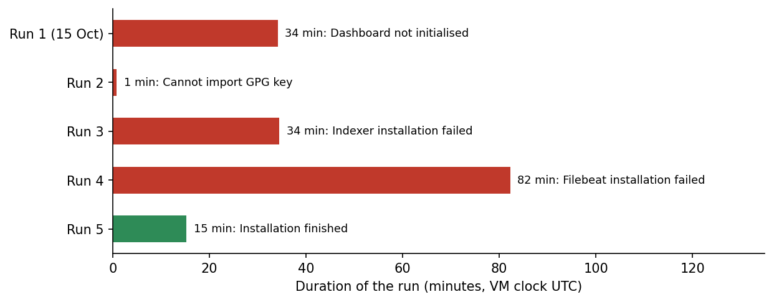
Figure 2. The five installation runs (VM clock, UTC). Red = failed, green = finished.
Run | Start (UTC) | Result (observed) | Cause and action
1 | 15 Oct 14:09:26 | Dashboard "not yet initialized", ERROR 14:41:23, cleaned 14:43:35 (E06) | VM had 4.3 GiB RAM, 2 vCPU (E07); no out-of-memory kill found. Inferred: resource shortage. RAM, CPU, disk and swap raised.
2 | 18 Oct 19:19:22 | "Cannot import Wazuh GPG key" 19:20:09 (E11) | ens33 had no IPv4 address (E13). Address restored with dhclient.
3 | 18 Oct 19:29:08 | Indexer installation failed 20:03:37 (E14, E16) | apt connection refused and IPv6 unreachable to packages.wazuh.com; netplan named enp0s3 instead of ens33 (E15) and was corrected.
4 | 18 Oct 20:41:06 | Indexer 20:41:42 to 21:53:59; Filebeat installation failed 21:59:55; rollback to 22:03:20 (E19, E20) | Slow, interrupted downloads. apt forced to IPv4 with retries and timeouts (E18).
5 | 18 Oct 22:32:46 | Installation finished 22:48:01 (E26, E27) | Packages pre-downloaded (185 MB in 9 min 40 s, E24) and copied to ~/wazuh-debs (E25).
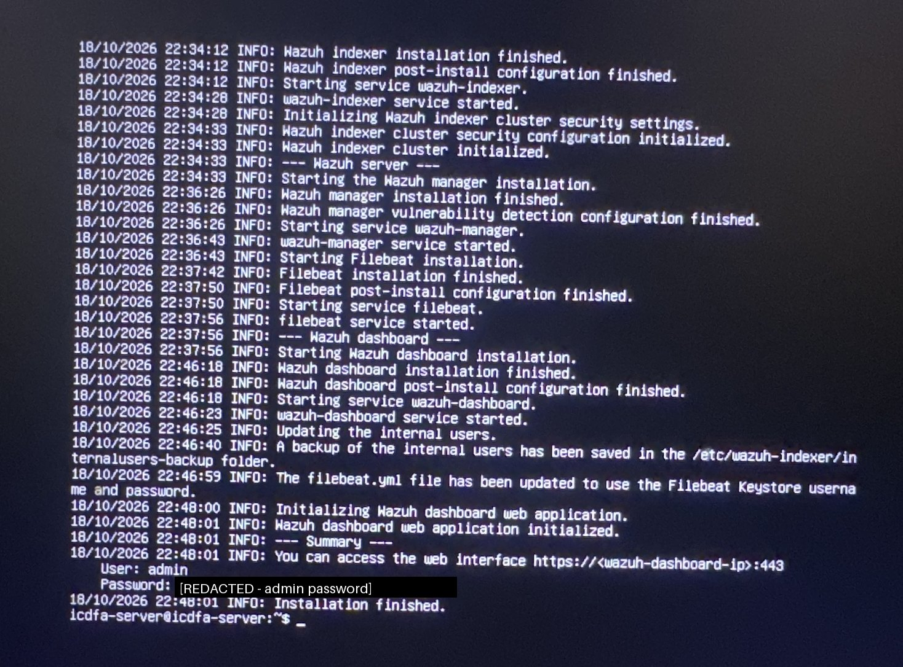
Ex. E27. Run 5 summary: components installed and "Installation finished". The administrator password line is covered by a black box.
After run 5 the indexer showed "failed" at the first check (E28). The journal showed "start operation timed out" at 23:01:57 UTC (E30). A manual start made it active and port 9200 listened on 127.0.0.1 (E31). Inferred: slow start under load. A systemd drop-in with TimeoutStartSec=900 was created at /etc/systemd/system/wazuh-indexer.service.d/timeout.conf (T13; a first attempt had a typo and was redone). It was not tested by another reboot.
An earlier attempt on 14 October is suggested only by package-cache dates; it was not photographed and is not claimed as evidence.

4. Accessing the dashboard (Part 2)
From the Windows host, TCP 443 and 22 on 192.168.119.128 were reachable (E38). The dashboard login page loaded at https://192.168.119.128/app/login with a browser "Not secure" warning, because Wazuh uses a self-signed certificate (E40). Login with user admin succeeded. The administrator password is not recorded in this package.
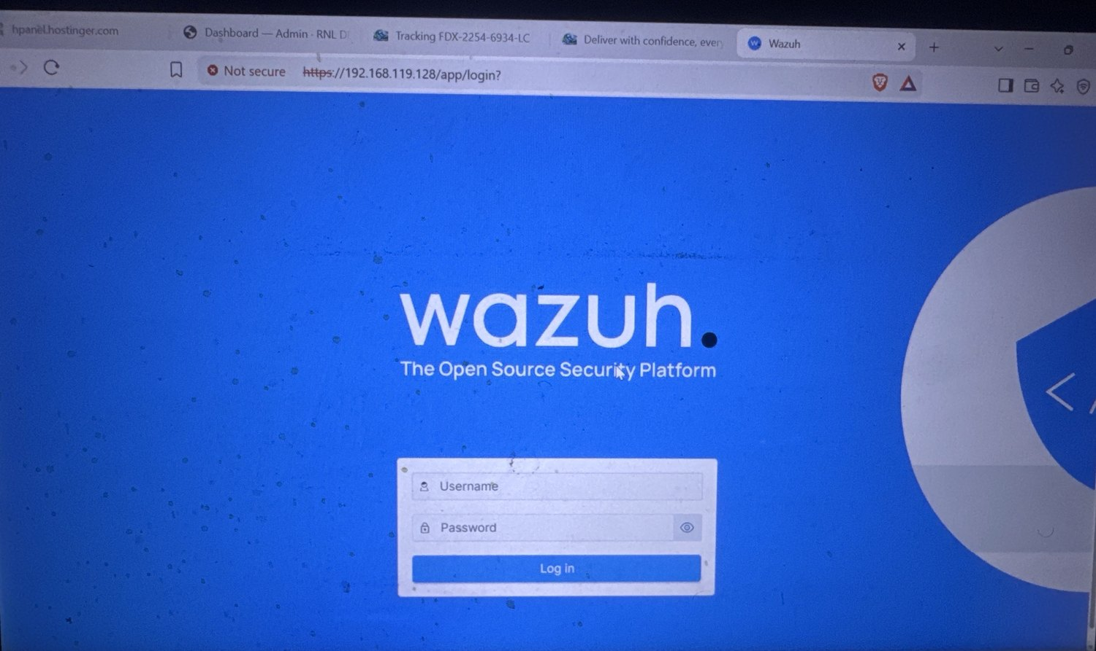
Ex. E40. Wazuh login page over HTTPS with the self-signed certificate warning.

5. Agent installation and registration (Parts 3 and 4)

5.1 Registration on the manager
On the manager, manage_agents option A created agent Windows-SOC-Lab with IP any and ID 001. A repeated A was refused as "Duplicate name" (T02). Option E printed the key, which is not stored in this package (T02 shows a marker). agent_control -l lists the agent (T03).

5.2 Installation on Windows
The MSI (5,406,720 bytes) was downloaded with Start-BitsTransfer and installed with msiexec /i ... /q (T04). In the Wazuh Agent Manager, the Manager IP 192.168.119.128 and the key were entered and saved; the key field is covered in the screenshot (E42). The status showed Stopped, so the service was started with Start-Service WazuhSvc.
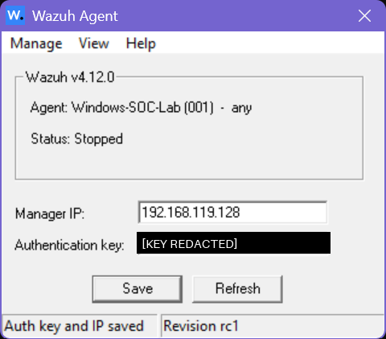
Ex. E42. Wazuh Agent Manager after Save: "Auth key and IP saved", status Stopped. The key is covered.
Observed: Test-NetConnection to port 1514 succeeded; ossec.log shows "Connected to the server ([192.168.119.128]:1514/tcp)" at 08:34:16 local (T04). The dashboard lists the agent as Active (E43); its registration time is 08:24:41 local (E44). The agent IP shown is 192.168.119.1, the source address seen by the manager.
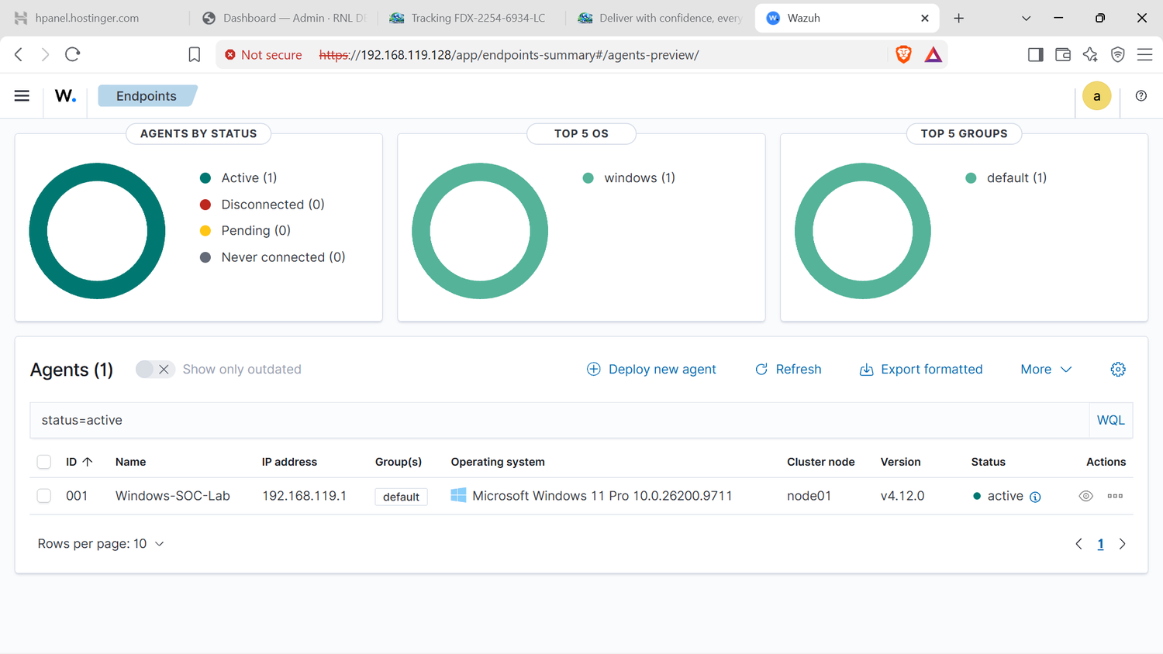
Ex. E43. Dashboard Endpoints: one active agent, Windows 11 Pro, version 4.12.0.

6. FIM configuration (Part 5)
Steps (T05, T06): create C:\Users\DynastyX-koko\SensitiveFiles; copy ossec.conf to ossec.conf.bak; add one line inside the <syscheck> block with Notepad; restart the service. Compare-Object of the backup against the new file shows exactly one line changed:
<directories realtime="yes" check_all="yes" report_changes="yes">C:\Users\DynastyX-koko\SensitiveFiles</directories>

Observed in ossec.log after the restart: real-time FIM started at 08:34:55 local, and the path c:\users\dynastyx-koko\sensitivefiles was monitored from 08:45:43 with MD5, SHA-1 and SHA-256 hashes (T05). The options check_all and report_changes go beyond the manual, which names only realtime="yes". They were added so that the alert carries hashes and the content difference. There is no Notepad screenshot of the edit; the text output T05 and T06 is the evidence.

7. Test procedure (Part 6)
Two helper functions timestamp each step in local and UTC time and print the SHA-256 and size of the file. The test file is C:\Users\DynastyX-koko\SensitiveFiles\secret_plan.txt.
function Mark($step) { $n = Get-Date
"{0} | local {1} | UTC {2}" -f $step, $n.ToString("yyyy-MM-dd HH:mm:ss"), $n.ToUniversalTime().ToString("yyyy-MM-dd HH:mm:ss") | Tee-Object -FilePath $log -Append }
function Show-Hash {
" SHA256={0} size={1} bytes" -f (Get-FileHash $f -Algorithm SHA256).Hash, (Get-Item $f).Length | Tee-Object -FilePath $log -Append }
Mark "1 CREATE"; Set-Content -Path $f -Value "CONFIDENTIAL: Project plan v1"; Show-Hash; Start-Sleep 45
Mark "2 MODIFY"; Add-Content -Path $f -Value "Revision: budget increased, new target date added"; Show-Hash; Start-Sleep 45
Mark "3 DELETE"; Remove-Item -Path $f

Run 1 (about 08:50 to 08:52 local) produced valid alerts, but its local log could not be written because C:\Users\DynastyX-koko\Documents does not exist (T07). The file operations still ran. Run 2 wrote its record to C:\Users\DynastyX-koko\Lab05_Evidence\Lab05_FIM_run2.txt (T08, T09) and is the run used for hash comparison.
Step (run 2) | Local / UTC time | SHA-256 (first 16) | Size | Alert expected
1 CREATE | 08:58:10 / 15:58:10 | 482BC551AFE2DB96... | 31 bytes | Rule 554
2 MODIFY | 08:58:55 / 15:58:55 | EADB58EBA2E7FF70... | 82 bytes | Rule 550
3 DELETE | 08:59:40 / 15:59:40 | n/a | n/a | Rule 553
Sizes: the first content is 29 characters plus CRLF (31 bytes); the added line is 49 characters plus CRLF (51 bytes); 31 + 51 = 82.

8. Observed alerts and investigation
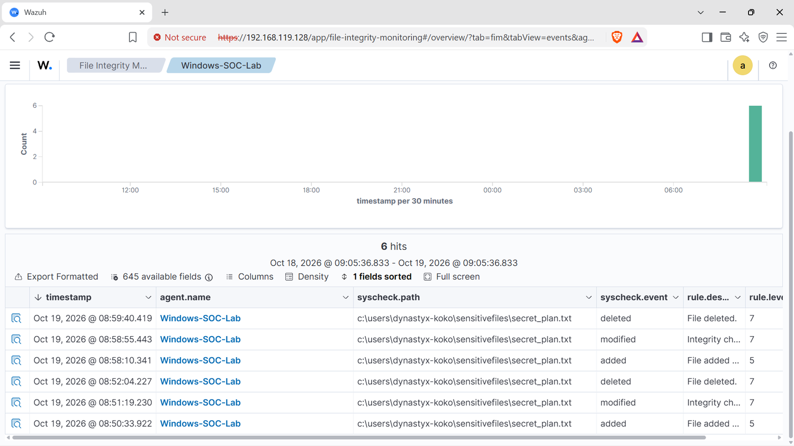
Ex. E47. FIM Events: six alerts for secret_plan.txt (runs 1 and 2) with rule levels.

8.1 Alert timeline
Run | Alert time | Rule | Level | Description
1 | 08:50:33.922 local | 554 | 5 | File added to the system.
1 | 08:51:19.230 local | 550 | 7 | Integrity checksum changed.
1 | 08:52:04.227 local | 553 | 7 | File deleted.
2 | 15:58:10.341 UTC | 554 | 5 | File added to the system.
2 | 15:58:55.443 UTC | 550 | 7 | Integrity checksum changed.
2 | 15:59:40.419 UTC | 553 | 7 | File deleted.
The manager copy in /var/ossec/logs/alerts/alerts.log shows the same two sequences of rules 554, 550, 553 (T12). The deleted-event JSON was not exported; the level 7 "File deleted" alerts are in E46, E47 and T12.

8.2 Cross-check of run 2 (script versus alert)
Step | Script time (UTC) | Alert time (UTC) | Values compared
Create | 15:58:10 | 15:58:10.341 | size 31; SHA-256 equals the script value
Modify | 15:58:55 | 15:58:55.443 | size_before 31, size_after 82; sha256_before equals the create hash; sha256_after equals the modify hash
Delete | 15:59:40 | 15:59:40.419 | time only (JSON not exported)
Observed: every compared value matches exactly (T08, T10, T11). The delay between action and alert was 0.34 to 0.44 s. Script times have 1 s resolution, so the delay is approximate. Only SHA-256 and size were compared with the local record; MD5 and SHA-1 come from the alert alone.

8.3 Fields of the modified alert (rule 550)
Field | Value (T11)
syscheck.path | c:\users\dynastyx-koko\sensitivefiles\secret_plan.txt
syscheck.event / mode | modified / realtime
size_before / size_after | 31 / 82
md5_before / md5_after | c44b78358b834b1fa4760c96f5fd4ac9 / 6098bc161a45d5886d2815ab0e218861
sha1_before / sha1_after | af9685f7be653653b608b4367a8a418c8fc81330 / 0d455b03ec6c1a7aa3cade58cf747613ab79a51a
sha256_before | 482bc551afe2db96869b81591ba670607a158636d4211a8e0b8dcd34de6c1a5d
sha256_after | eadb58eba2e7ff70a59fd9521cb523222b5f614bc7c6bd834a2bbfb99a13085c
changed_attributes | size, mtime, md5, sha1, sha256
mtime_before / after | 2026-10-19T15:58:10 / 2026-10-19T15:58:55
diff | > Revision: budget increased, new target date added
uname_after / uid_after | Administrators / S-1-5-32-544 (the file owner, not the person who made the change)
rule.mitre | T1565.001 Stored Data Manipulation, tactic Impact
rule compliance tags | PCI DSS 11.5; HIPAA 164.312.c.1, c.2; GDPR II_5.1.f; NIST 800-53 SI.7; TSC; GPG13 4.11
agent | Windows-SOC-Lab, 001, 192.168.119.1; manager icdfa-server
The long win_perm_after block (permissions of SYSTEM, Administrators and the user) is omitted from the display in the appendix; the complete file is T11. Not observed: the process or user account that wrote the file. Real-time mode without whodata does not provide it, and whodata was not tested.
Context. The dashboard overview showed 484 medium and 391 low severity alerts in 24 hours for this single endpoint (E41); only six were these FIM events. The other alerts were not broken down by rule group.

9. Answers to the lab questions

Question 1. Alert triage
In the rule 550 alert (T11) the details that say what changed are: the checksums (md5, sha1 and sha256 before and after: all three differ), the size (31 bytes before, 82 after), the modification time (15:58:10 to 15:58:55), the list changed_attributes (size, mtime, md5, sha1, sha256), and, because report_changes was enabled, the diff that shows the added line. The event type, path and mode (modified, realtime) say where and how it was seen. A changed hash proves that the content changed even when size and time are copied back. These values match the local record (section 8.2).

Question 2. False positives
Two folder groups that generate too many alerts in a corporate environment:
- Temporary folders (C:\Windows\Temp and each user's %LOCALAPPDATA%\Temp). Installers, browsers, Office and updaters create, change and delete files there all day. Each event is a normal rule 554, 550 or 553 alert with no security meaning, so real changes are buried.
- Log, cache and update folders (C:\Windows\Logs, C:\Windows\SoftwareDistribution, browser caches). The system writes to them constantly, so a modified alert is expected behaviour and the content (logs) changes by design, so a hash change tells nothing.
Reduction (recommended, not applied here): monitor only high-value paths (system binaries, configuration, Startup folders, sensitive data shares); use <ignore> entries for noisy paths; use <nodiff> for files that may hold secrets; set noisy rules to level 0 with a local rule override; use scheduled scans instead of real-time for large trees. The default Windows configuration already monitors the Startup folder in real time, which is a good example of a high-value path (T05).

Question 3. Proactive defence against ransomware behaviour
Ransomware encrypts many user files quickly, often renames them with a new extension, and drops a ransom note. FIM sees file events but cannot stop the process, so the use is early detection and triage. This is a design, built on what this lab observed (real-time alerts in under half a second, rules 554/550/553):
- Real-time monitoring of user data folders (Documents, Desktop, Downloads, shares) with report_changes, as done on SensitiveFiles.
- Burst pattern. Many rule 550 alerts, or paired 554 (new encrypted or renamed file) and 553 (original removed), in a short time from one endpoint.
- Ransom-note creation. Rule 554 on file names such as readme, decrypt or recover text files.
- Canary (decoy) files. A few files that no user touches, in each folder; any 550 or 553 on them is high confidence.
<!-- PROPOSED, not deployed or tested in this lab. Validate with /var/ossec/bin/wazuh-logtest. -->
<group name="syscheck,ransomware,">
<rule id="100100" level="12" frequency="15" timeframe="30">
<if_matched_sid>550</if_matched_sid>
<same_location />
<description>Possible ransomware: many files modified in 30 seconds on one agent</description>
<mitre><id>T1486</id></mitre>
</rule>
</group>

Caveats. The rule id 100100, the thresholds (15 events in 30 s) and the exact option name for matching the same agent are placeholders that must be validated with wazuh-logtest on a test host. The Wazuh project describes a similar approach with real-time FIM on Downloads, Documents and Desktop and custom rules for mass modification, ransom notes and correlation (references 2). FIM cannot see actions such as shadow-copy deletion, so it should be combined with process and command-line logging, and the response should be an active response or an analyst ticket.

Question 4. Centralised Wazuh FIM versus Windows Event Logs alone
Aspect | Windows Event Logs only | Wazuh centralised FIM
Content evidence | No hashes, no content, no diff. Event 4663 says access happened. | Hashes and size before and after, diff (T11).
Setup | Needs auditing policy and a SACL on each folder, otherwise no event is written. | One syscheck line per path; central agent.conf can push it.
Location of data | On the same machine. An attacker with admin rights can clear it (event 1102). | Alerts are sent to the manager at once (0.34 to 0.44 s observed) and kept there.
Correlation and search | Per host, manual. | Many endpoints in one dashboard, filters, rule levels, MITRE and compliance tags (T11).
Noise control | Per machine audit settings. | Central ignore lists and rule overrides.
Attribution | Can show user and process when auditing is on. | Not in this lab (owner only); whodata can add it but was not tested.
Event Logs are not worthless: they identify who and which process, and they are built in. The advantage of Wazuh is the content proof, central tamper-resistant retention, correlation and speed, and the best design uses both.

10. Technical challenges and resolutions
No. | Challenge (observed) | Resolution | Exhibit
C1 | ens33 lost its IPv4 address; netplan named enp0s3 | dhclient; sed to ens33; netplan apply | E13, E15
C2 | Run 1: dashboard not initialised on 4.3 GiB / 2 vCPU | RAM, CPU, disk and swap raised | E06, E10
C3 | Run 2: GPG key import failed (no IPv4) | Address restored | E11
C4 | Runs 3 and 4: package downloads refused or too slow; IPv6 unreachable | apt ForceIPv4, Retries 10, Timeout 60 | E16, E18
C5 | Rollback after every failure cost up to 80 minutes | Pre-downloaded packages, then run 5 in 15 minutes | E24, E25
C6 | NO_PUBKEY after rollback; typo in the repository line | Key imported with gpg --import; line corrected | E21, E22, E23
C7 | Indexer start timeout after the install | Manual start; drop-in with TimeoutStartSec=900 | E30, E31, T13
C8 | curl returned Unauthorized | The password had been mistyped; retyped | E31
C9 | SSH and ping timed out; VMnet8 "Not Present" | Restore Defaults in Virtual Network Editor; new subnet 192.168.119.0/24 | E32, E35, T01
C10 | Agent Manager showed Stopped after Save | Start-Service WazuhSvc | E42
C11 | Duplicate agent name on a repeated Add | Kept agent 001 | T02
C12 | Run 1 local log could not be written (no Documents folder) | Run 2 logged to Lab05_Evidence | T07, T08
C13 | Two time zones (UTC and UTC-7) | Script prints both; report states both | T08
C14 | Ubuntu 20.04 past standard support; changelogs.ubuntu.com unreachable | Noted; no action in the lab | E39

11. Conclusions and recommendations
Wazuh FIM detected every create, modify and delete of the test file in real time, and the alert values matched an independent local record. The deployment took five runs because of the network path and VM resources rather than Wazuh itself.
Recommendations (none applied unless stated):
- Rotate the administrator password (it appeared on the console and in working notes) and replace the self-signed certificate.
- Enable the firewall (UFW) with only 22, 443, 1514, 1515 and 55000 allowed; it was inactive (E34).
- Upgrade Ubuntu to a supported release; reserve a DHCP address or use a static address for the manager.
- Enable whodata where the audit subsystem is available, to record the user and process.
- Add ignore rules and central agent.conf settings before scaling to more endpoints; keep real-time only for high-value paths.
- Plan capacity: at least 8 GB RAM and 4 vCPU for the all-in-one node; keep an offline package cache and snapshots.
- Set up NTP and agree one reporting time zone.

12. Limitations
- Screenshot times are the times shown on screen where visible; otherwise the receipt time of the photo is used and marked "not visible" in the appendix.
- The 14 October attempt, the installer files and the agent MSI are not in the package.
- Two Inventory screenshots (host name, board serial, software list) were excluded for privacy; the administrator password and the agent key are redacted.
- No screenshot of the ossec.conf edit; the deleted-event JSON was not exported; run 1 has no local hash record.
- The ransomware rule is a proposal. Single endpoint, single test file, two runs.

References
- 1. Wazuh documentation, File integrity monitoring and Installation guide (documentation.wazuh.com), version 4.12.
- 2. Wazuh blog, "Ransomware protection on Windows with Wazuh" (https://wazuh.com/blog/ransomware-protection-on-windows-with-wazuh/).
- 3. Lab manual: SOC Lab: Introduction to Wazuh for Threat Detection & Monitoring, instructor Aminu Idris.

