Questions and Exercises to work out and turn in:

Grading Guidelines (See Appendix):

A right answer will get full credit when:

1. It is right (worth 25%)
2. It is right **AND** neatly presented making it easy and pleasant to read. (worth an **extra** 15%)
3. There is an **obvious and clear link[1]** between 1) the information provided in the exercise and in class and 2) the final answer. A clear link is built by properly writing, justifying, and documenting an answer (worth an **extra** 60%).
4. Calculation mistakes will be minimally penalized (2 to 5% of full credit) while errors on units will be more heavily penalized.

**Late Submission** : as specified in the syllabus. Day counting starts one minute after the deadline.

**Check Your Submission:**  after submitting, download your submission to check whether it is the right version and it is complete.

You are welcome/encouraged to discuss exercises with other students or the instructor. But, ultimately, **personal** writing is expected.

* USE THIS FILE AS THE STARTING DOCUMENT YOU WILL TURN IN. **KEEP IN THE QUESTIONS** AND INSERT YOUR ANSWERS.
* IF USING HAND WRITING (STRONGLY DISCOURAGED), REWRITE THE QUESTIONS.
* FAILING TO FOLLOW TURN IN DIRECTIONS /GUIDELINES WILL COST A 30% PENALTY.

Objectives of this assignment:

* to get a sense of round-trip time of packets over the network
* to explore the topology of the Internet.

What you need to do:

Answer the questions and/or solve the exercises described below.

Exercise 1 (60 points)

The ping program allows you to send a test packet to a given location and see how long it takes to get there and back. Try using ping to see how long it takes to get from your location to several known locations. From these data, plot the one-way transit time over the Internet as a function of distance. It is best to use universities since the location of their servers is known very accurately. For example, usc.edu is in Los Angeles, California; mit.edu is in Cambridge, Massachusetts; www.uam.es (*Universidad Autonoma de Madrid*); www.mq.edu.au (Macquarie University, Australia); and blcu.cucas.cn is in Beijing, China.

Add three other universities of your choice (must respond to your pings).

(10 points) Provide **one** **screenshot** (*document*) of ONE ping to any of the above destinations. Insert the screenshot in this document

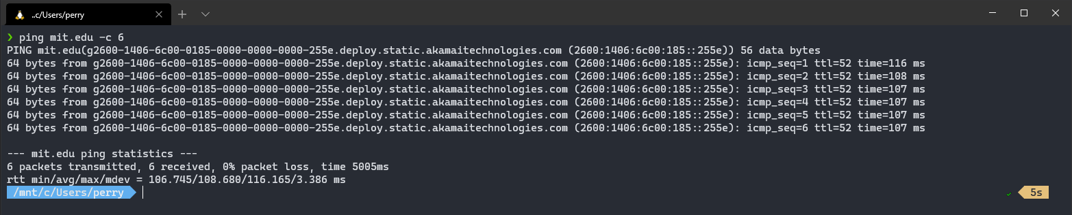

(30 points) Sort on the x-axis the locations in increasing distance from Auburn and plot the one-way transit time.

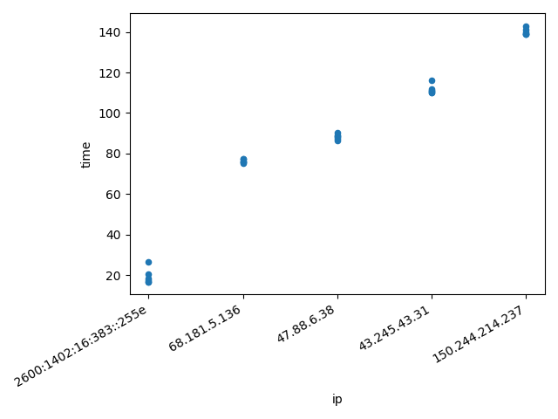

(20 points) Discuss the plot

So ive written a python program that will take a text file of ping results and plot them, <https://gist.github.com/perryBunn/42066a125c7dc01487e3635fc7603c99>. Ive sorted the results by the smallest time for the ping to take. Mit.edu was first with uam.es taking the longest. What I noticed is that just because the ping might take the longest to compete it might not be the farthest away from the source location. The same can be said for time to live(TTL) of the ping, some routes are more optimized than others and need fewer intermediary nodes to reach the destination. It seems that there is not a direct correlation

between the time to complete and the TTL of the request, so it could be down to the traffic that the intermediary nodes are experiencing and the hardware in-between. Some of the times could also be results of error correction, so a time that took longer could be down to the system correcting an error in transit.

Try Texas A&M University (www.tamu.edu) and Auburn University (www.auburn.edu). Explain what may be happening with these universities.

When I tried to ping these websites, I received errors. Im almost sure that Auburn doesn’t allow pings on their network so im assuming that Texas A&M does the same.

**In case you are not in Auburn**,

There are two ways you can complete this exercise:

**Method 1**:

Log in remotely on the Engineering Tux machines to ping. To log in remotely, you must use an ssh client such as SecureCRT (Windows).

On Windows 10, you may use from the command prompt the following command (if ssh is available):

ssh username@gate.eng.auburn.edu

where username is your Auburn University username.

On Mac or any Unix machine (Ubuntu...), use the same command (see above) on a terminal.

**Method 2**:

Use a virtual desktop at:  <https://rdp.eng.auburn.edu/>

If you have problems to log in remotely to Tux machines, ask on Piazza for help.

Exercise 2 (30 points)

a) (20 points) A system has an m-layer protocol hierarchy. Applications generate messages of length

n bytes. At each of the layers, an n-byte header is added. What fraction of the network bandwidth is filled with headers? The fraction ***f*** is equal the total number of bytes of all headers over the total number of bytes sent out by a sender.

1. (10 points) **Draw** the full message with all headers assuming there are no trailers.



ii. (10 points). **Derive** the fraction f.

$$f=\frac{sum of m headers of n bytes}{Total number of bytes sent}$$

b) (10 points). Consider a DNS request on the Internet. The DNS request (application layer) is a message of about 100 bytes. The UDP header is 8 bytes long. The IP header is in general 20 bytes long. An IEEE 802.3 Ethernet frame may have up to a 26 bytes header and a 16 bytes trailer. What fraction ***f*** of the network bandwidth is filled with headers/trailer?

i. (5 points) **Draw** the full message with all headers/trailer

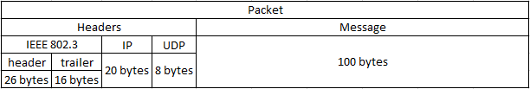

ii. (5 points) **Derive** the fraction f.

$$f= \frac{26+16+20+8}{26+16+20+8+100}=\frac{70}{170}=\frac{7}{17}$$

Exercise 3 (10 points)

This exercise explores the concepts of *bandwidth* (bit rate) and *propagation delay*.

1) (3 points) Define in your own words the *bandwidth* (bit rate). What bandwidth do you get on the modem at home, your cellphone, and your laptop?

Bandwidth is the amount of information allowed to flow over a certain amount of time, ie bit rate.

I pay for 100MBits of bandwidth at my house, depending on the time that is in theory evenly distributed to the devices I have on the wired and wireless network

2) (3 points) Define in your own words *propagation delay*.

The amount of time it takes for my information to reach its destination

3) (2 points) For each of the following applications, explain **if** and **why** they would not work well on a connection with a low bandwidth (20 Kbits/s): remote gaming, video streaming, texting, email, file transfer.

Remote gaming: It depends on the game, 20Kbits/s can be a lot or not enough depending on the how the information is being distributed. Is the server on sending information the client is requesting? Or is the entire server being sent to the client and then the client has to deal with that. So in a optimized game it would be enough, for others it would not be.

Video streaming: This would not be enough, video is hard to compress and for a enjoyable time you would need much more bandwidth.

Texting: This would be enough, text is compressible and also there is not a necessity for the information to be updated quickly and uniformly. As long as the information is send withing a couple of seconds (computer eternity) then its usable.

Email: Sort of the same as texting, larger emails will take a longer time to send but do to the medium its less of an issue.

File transfer: It would be slow for any file that is substantial. But do able since its something that can be broken up over a longer period of time, just as long as the user does not need the files immediately.

3) (2 points) For each of the following applications, explain **if** and why they would not work well on a connection with a high propagation time (about 1 second round trip): remote gaming, video streaming, texting, email, file transfer.

Remote gaming: Would not work well, clients want to have the most up-to date information as soon as possible and a long propagation time is not good for that.

Video streaming: Depending on the bandwidth it would be fine, if enough information can be buffered then it can be usable.

Texting: It would be usable; texting is a medium that does not necessitate being sent quickly

Email: Same as texting. If the entire message is sent it doesn’t matter how long it took, just as long as its not hours, then an issue is happening.

File transfer: Like Video streaming, if the bandwidth is enough then the latency of receiving each packet could be irrelevant to a certain extent.

What you need to turn in:

* Electronic copy of this file (including your answers) (standalone). Submit the file as a Microsoft Word or PDF file.
* Recall that answers must be well written, documented, justified, and presented to get full credit.
* How this assignment will be graded:
* A right answer will get full credit when:
* It is right (worth 25%)
* It is right AND neatly presented making it easy and pleasant to read. (worth 15%)
* There is an obvious and clear link between 1) the information provided in the exercise and in class and 2) the final answer. A clear link is built by properly writing, justifying, and documenting an answer (worth 60%).
* Calculation mistakes will be minimally penalized (2 to 5% of full credit) while errors on units will be more heavily penalized.
* You are welcome/encouraged to discuss exercises with other students or the instructor. But, ultimately, personal writing is expected.

**Appendix**: Grading: What is an OBVIOUS and CLEAR LINK?

Here is an example to explain what an **obvious and clear link** is and how we grade your work.

Consider the following problem:

"(100 points) John travels from Auburn to Atlanta in his car at a speed of 50 mph. Leaving at 8am, at what time will John reach Atlanta".

Here are the answers of three students and their scores:

**Student 1** answers: "10am". Student 1 will get 25 points.

**Student 2**answers : "John will reach Atlanta at 10am". Student 2 will get 25+15 = 40 points

**Student 3** answers: "The time t to travel a distance d at speed v is equal to d/v = d/50mph. The problem does not provide the distance d from Auburn to Atlanta. Based on Google, the distance from Auburn to Atlanta is approximately 100 miles (**document is here**). Therefore, the time t = 100 miles/50mph = 2 hours. Since John left at 8am, he will then reach Atlanta at 8am + 2 hours = 10 am".

**Student 3** will get 25 + 15 + 60 = 100 points

Do you see the **direct** **link** going from the data provided in the question to the final answer, using general knowledge/formula and documents?.... Can you now solve the following problem and get 100 points?

"(100 points) Alice travels from Auburn to Atlanta in her car at a speed of 50 mph. Leaving at 8am, at what time will Alice reach Atlanta assuming that she had a flat tire that delayed her 30 minutes".

1. See on the appendix what an obvious and clear link is.