**Questions and Exercises to work out and turn in:**

**Grading Guidelines:**

A right answer will get full credit when:

1. It is right (worth 25%)
2. It is right **AND** neatly presented making it easy and pleasant to read. (worth an **extra** 15%)
3. There is an **obvious and clear link[1]** between 1) the information provided in the exercise and in class and 2) the final answer. A clear link is built by properly writing, justifying, and documenting an answer (worth an **extra** 60%).
4. Calculation mistakes will be minimally penalized (2 to 5% of full credit) while errors on units will be more heavily penalized.

**Late Submission** : as specified in the syllabus. Days counting starts one minute after the deadline.

**Check Your Submission:**  after submitting, download your submission to check whether it is the right version and it is complete.

You are welcome/encouraged to discuss exercises with other students or the instructor. But, ultimately, **personal** writing is expected.

* USE THIS FILE AS THE STARTING DOCUMENT YOU WILL TURN IN. **KEEP IN THE QUESTIONS** AND INSERT YOUR ANSWERS.
* IF USING HAND WRITING (STRONGLY DISCOURAGED), REWRITE THE QUESTIONS.
* FAILING TO FOLLOW TURN IN DIRECTIONS /GUIDELINES WILL COST A 30% PENALTY.

**Objectives of this assignment:**

* to explore the concepts of propagation time, bit rate, and throughput
* to explore the relationship between switches processing time and propagation time
* to compute best case round trip time for satellite communications.
* to compute maximal channel bit rate/capacity.

**What you need to do:**

Answer the questions and/or solve the exercises described below.

**Exercise 1 (30 points)**

Imagine that you have trained your homing pigeon, *Tucco* to bring you two USB flash drives (instead of a flask of brandy). Each USB flash drive contains 32 GB. The pigeon can travel to your side at 90 km/hour.

1. **Express** the *throughput* *br* (amount of data transmitted per unit time) that *Tucco* achieves as a function of the distance *d* that it must travel. (8 points) **First** find the expression of the throughput as a function of the distance d, the pigeon speed, the capacity of USB flash drive, and the number of drives. (4 points) **Second**, Provide the **simplest** expression. Recall that 1K of storage is equal to 210.

This formulation for the throughput br was chosen because we need to calculate the amount of data sent per unit time, thus, we need to combine the given information in a manner that results in exactly those units. The storage of the flash drives (in total) is simply in gigabytes, a unit of data, thus we need time in the denominator of the units now. The only value we have that has time is the speed of Tucco, which is 90 km/hour. This must be multiplied onto the flashdrive size to result in GB*km/hour, however this leaves us with an additional unit that isn’t part of throughput, distance. Thus, we need to divide by the distance traveled to cancel out that unit, and be left with just GB/hour.

1. (6 points)For what range of distances does *Tucco* have a higher throughput than a transmission line whose bit rate (excluding overhead) is 150 Mbps? Recall that 1K of bitrate is equal to 103. (An inequality is expected).

first we need to convert units from GB/hour to MB/s, to do so, we multiply by 1000 (GB to MB) and divide by 3600 (hours to seconds), giving us 1600/d MB/s. Next, we compare with 150 MB/s, so 1600/d > 150 => 32/3 > d.  
Therefore, when distance is lower than 32/3 kilometers, Tucco has a higher throughput than a transmission line with bit rate 150 Mbps.

1. (4 points)How does your answer (in b.) change if *Tuco*’s speed halves?

Since Tucco’s speed is in the upper portion of the calculation and is linear, halving his speed would halve the throughput, thus the throughput would instead be higher only if the distance is less than 16/3 kilometers

1. (4 points)How does your answer (in b.) change if each USB Flash drive capacity doubles?

Similar to c), the USB capacity is in the upper portion of the calculation and is linear, therefore doubling its capacity in turn doubles the throughput, thus the throughput would be higher only if the distance is less than 64/3 kilometers.

1. (4 points)Since we could reach high throughputs with *Tucco*, why don’t we use homing pigeons to implement the physical layer? (consider only network performance issues. Avoid issues just as animal rights, messy/dirty animals...)

With the high throughput of Tucco we need to take into account that Tucco is only a transportation medium that is not fully autonomous. Tucco is also only efficient with large packets over relatively short distances. If we were to use Tucco we would need every device that we want to communicate with to be able to read and write to flash drives. As well as some kind of mounting system. Using Tucco would require some physical interaction once an endpoint is reached, increasing the delay for the information to and from the receiver.

**Exercise 2 (25 points)**

*A factor in the delay of a store-and-forward packet-switching system is how long it takes to store and forward a packet through a switch (router (L3 switch) or L2 switch). The objective of this exercise is to investigate the impact of the switch time on the overall delivery delay of a packet. The switch time is about 5 μsec. Consider a packet P sent from Auburn University (AU) to Boston University (www.bu.edu) (about 2,000 kms) over a copper line. Assume the propagation speed in copper to be 2/3 the speed of light.*

1. (8 points) What is the propagation time for Packet P?

Propagation time = distance/propagation speed

distance = 2000000 meters, propagation speed = 200000000 meters/second

propagation time = 2000000/200000000 = .01 seconds

1. (4 points) Provide the number of switches (routers) between a computer at Auburn University and a computer at the destination. Provide the answer and do not forget to write how you found the answer. (You can use the command traceroute on Unix machines or tracert on Windows: let us know if you encounter difficulties.)

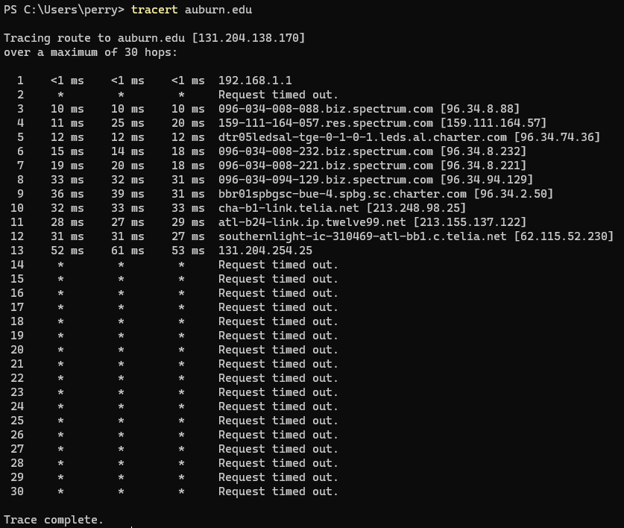

11, By running Tracert in PowerShell we can see that there are 11 intermediary nodes between the host machine and the final destination subnet. I believe that the reason we never actually see the IP 131.204.138.170 is because of load balancing, so we dont actually end there in the trace.

1. (4 points) Assuming that there are about 12 switches between AU and the destination, what is the ratio of the switch time to the propagation time? Is the switching time a major component in the total delivery time?

Propagation speed = $2x10^{8}m/s$

distance = $2000x10^{3}m$

Propagation time = $2x10^{6}/2x10^{8} = 1x10^{-2}sec = .01sec$

for 12 switches:

switch time = $12x10x10^{-6}=1.2x10^{-4}$

ratio = switch time / propagation time

ratio = $.00012/.01 =12/1000$

1. (8 points) How many switches should there be between AU and the destination such that the switch time is equal to the propagation time? Discuss the impact of propagation time and the processing/switching times on the intermediary nodes. Which parameter impacts more delay on networks.

switch time * number of switches = propagation time

switch time * number of switches = distance / propagation speed

$$1.2x10^{-4}sec * n = 2x10^{3}m/2x10^{8}m/sec$$

$$n = .01 / .00012$$

$n≃⌈83.3⌉$ switches

**Exercise 3 (15 points)**

*A client-server system uses a satellite network, with the satellite located about 40,000 km far from the client and the server. What is the best-case delay in response to a request? Note that you must provide the time duration between when a request is sent by the client and when a response is received by the client. The client and the server are on earth.*

distance = $40000km x 4$ (this is due to the fact that the request must travel from client to satellite, satellite to server, server to satellite, then satellite back to server, for a total of four trips each 40000 km in distance, or a total of 160000 km)

propagation speed (vacuum) = $3x10^{5}km/s$ (this is a slightly rounded speed of light in kilometers per second)

delay = $distance / propagation speed$ (this is the formula for the time delay due to propagation through a medium)

$delay =160000/3x10^{5} =.5\underline{3} sec or 533 milliseconds$ (plugging in our values for the total distance and the speed of light through a vacuum in km/s and simplifying)

**Exercise 4 (15 points)**

The highest resolution for a video supported by Youtube is 2160p (i.e 3840 x 2160). Assuming 3 bytes/pixel and 30 frames per second, what should be the bandwidth *bw* (bit rate) to watch such a high quality video if no compression encoding is used?Is *bw* the bandwidth available to most Internet users? If not, how come Youtube offers such a high resolution?

3840*2160 = 8294400 pixels

30 frames/second * 8294400 pixels/frame * 3 bytes/pixel = 746496000 bytes/second.

most users have somewhere between 5 Mbps and 50 Mbps. Therefore, this is nowhere near enough bandwidth to play these videos at a reasonable rate, as the required Mbps for a 2160p video is approximately 746 Mbps, close to 17 times the high end for most households. Youtube offers such a high resolution because some people do have enough bandwidth to watch videos at that quality, and there are usually resolution choices lower than 2160p available for those who do not have enough bandwidth. Additionally, Youtube does use compression so the actual requirement would be lower.

**Exercise 5 (15 points)**

1. What is the maximum data rate supported by a **noiseless** 8-kHz? Assume four level digital signals are used.

max data date = $4x8000kHz$

= $16000$

$$=16kHz$$

(max data rate = bandwidth * number of levels)

1. What is the maximum data rate supported by a **noisy** 8-kHz with a signal-to-noise ratio of 30dB if four level signals are used?

max data rate = $8kHz x log_{2}(1004)$

$$≃8 x 9.971$$

$$≃79.772 kHz$$

(max data rate = bandwidth * log base 2 of (the SNR + number of levels))

1. Television channels are 6MHz wide. Assuming a **noiseless** channel, how many bits/sec can be sent if eight-level digital signals are used?

max data rate = $2 x 6MHz x log_{2}8$

= $36000000$

= $36Mbps$

(max data rate = bandwidth * log base 2 of the number of levels)

**What you need to turn in**:

* Electronic copy of this file (including your answers) (standalone). Submit the file as a Microsoft Word or PDF file.
* Recall that answers must be well written, documented, justified, and presented to get full credit.
* How this assignment will be graded:
* A right answer will get full credit when:
* It is right (worth 25%)
* It is right AND neatly presented making it easy and pleasant to read. (worth 15%)
* There is an obvious and clear link between 1) the information provided in the exercise and in class and 2) the final answer. A clear link is built by properly writing, justifying, and documenting an answer (worth 60%).
* Calculation mistakes will be minimally penalized (2 to 5% of full credit) while errors on units will be more heavily penalized.
* You are welcome/encouraged to discuss exercises with other students or the instructor. But, ultimately, personal writing is expected.

**Appendix**: Grading: What is an OBVIOUS and CLEAR LINK?

Here is an example to explain what an **obvious and clear link** is and how we grade your work.

Consider the following problem:

*"(100 points) John travels from Auburn to Atlanta in his car at a speed of 50 mph. Leaving at 8am, at what time will John reach Atlanta".*

Here are the answers of three students and their scores:

**Student 1** answers: "10am". Student 1 will get 25 points.

**Student 2**answers : "John will reach Atlanta at 10am". Student 2 will get 25+15 = 40 points

**Student 3** answers: "The time t to travel a distance d at speed v is equal to d/v = d/50mph. The problem does not provide the distance d from Auburn to Atlanta. Based on Google, the distance from Auburn to Atlanta is approximately 100 miles (**document is here**). Therefore, the time t = 100 miles/50mph = 2 hours. Since John left at 8am, he will then reach Atlanta at 8am + 2 hours = 10 am".

**Student 3** will get 25 + 15 + 60 = 100 points

Do you see the **direct** **link** going from the data provided in the question to the final answer, using general knowledge/formula and documents?.... Can you now solve the following problem and get 100 points?

*"(100 points) Alice travels from Auburn to Atlanta in her car at a speed of 50 mph. Leaving at 8am, at what time will Alice reach Atlanta assuming that she had a flat tire that delayed her 30 minutes*".

1. See **Appendix** about what an obvious and clear link is.