Eli & Perry

Report:

When gathering data for each of the clients the packets were sent at least 1000 times to get robust averages. Calculating the time it took to complete the trip by getting the time in nanoseconds before sending the packet and after receiving the packet. Min and Max times were also collected outside of the timings, so they do not affect the results. In Fig1 we can see the one of the results that are printed below of the server responses in Fig1.2. Fig2 is the UDP results of like that of the TCP results of Fig1. In Fig3 we can see the server notification messages.

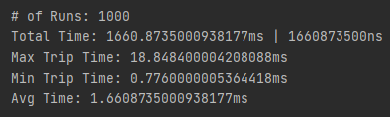 

Fig1 Fig1.2

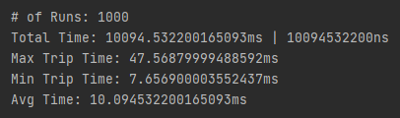

Fig2

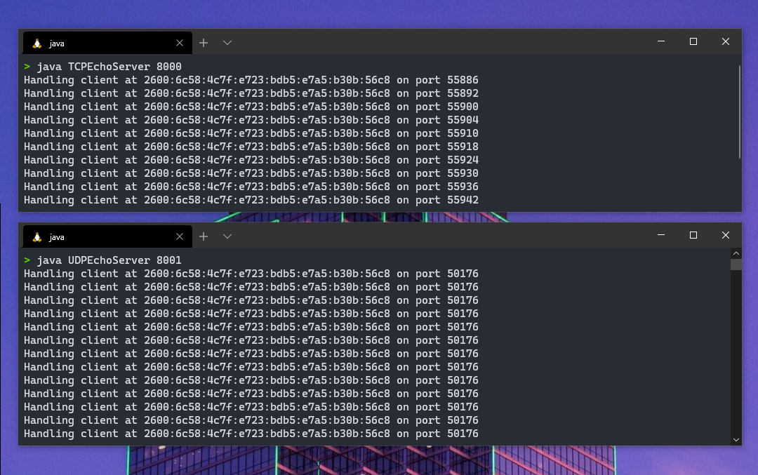

Fig3