Contents
Data Collection 2
Analysis Methods 3
Results 4
Statistical Significance 4
Practical Significance 4
Overall Success 5
Conclusions 5
Data Analysis 5
Prediction Application 5

Data Collection

The data used to train these models was collected from two different sources, Baseball Savant and Fangraphs. The Baseball Savant metrics were downloaded programmatically using the Python `requests` library, and the Fangraphs data was collected using the `pybaseball` library. Both datasets needed to be trimmed to include only the necessary information, then combined into one complete dataset. For future use, I migrated this data to a SQL database. Below is the schema design:
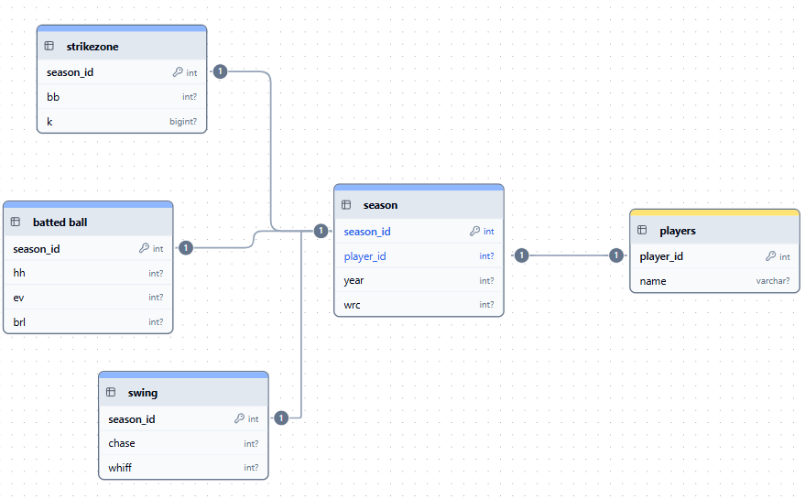
Players - Since a player could have multiple entries, a table was created to separate player names in case one needs to be edited.

Season - This table represents each season for each batter, includes the batter's wRC+ for that season, and generates a season ID to serve as the primary key in the tables for the metrics.

Strikezone - This table contains strikeout and walk percentages (k_percent, bb_percent), which give a general idea of how a player understands the strike zone.

Batted Balls - This table contains hard hit and barrel percentages, and average exit velocity (hard_hit_percent, brl_percent, exit_velocity). Average exit velocity is the average speed of the ball off the bat. A hard hit ball is a ball hit with an exit velocity of at least 95 MPH. A barrel is a ball hit with the perfect combination of launch angle and exit velocity. These metrics measure how well a batter hits the ball when they do put it in play.

Swing - The metrics included in this table are chase and whiff percentages (chase_percent, whiff_percent). A chase is when a batter swings at a pitch outside the strike zone, and a whiff is anytime a player swings and misses. These metrics give an idea of the quality of swings a batter is taking.

With the data now in a SQL database, I connected to it and queried the data using JOINS to recreate the original table.

Analysis Methods

The first step of the analysis was training random forest regression models. A model was trained for each different combination of Baseball Savant metrics. The models were trained on the data from the 2015 to 2022 seasons, excluding 2020, and tested individually on each season from 2023 to 2025. For each test year, 50 bootstraps were performed with replacement to create 50 different test datasets. For each bootstrap, a weighted accuracy score was calculated. Following the completion of the bootstrap for each year, the following metrics were calculated: the mean accuracy score, standard deviation, and confidence interval. These metrics were saved as a dictionary within a dictionary, under the key corresponding to the combination of Baseball Savant metrics for which they are intended.

The next step was to determine the group with the best accuracy score for each year and identify which groups are not statistically significantly different from the best, as determined using a paired bootstrap test. The difference was calculated between the individual bootstrap scores of the top group and each of the other groups, respectively. For each group, the mean difference and confidence interval were calculated. If the confidence interval contained 0, then the two groups were not significantly different from each other. Groups that were either the top group or tied with the top in at least two of the three years were selected.

The final step before analysis was to calculate a stability score for each group. This score was calculated using the standard deviation, confidence interval, and the mean accuracy score. The score for each group was compared to the median, and if the group's score was better than the median, it was selected.

Results

Statistical Significance
The models were first evaluated using three metrics: mean absolute error, r^2, and root mean square error. These three were combined into a single weighted score using the formula (0.6 * MAE) - (0.3 * (R^2* 10)) + (0.1 * RMSE). MAE is given the highest weight since it represents the actual average error of the model. R^2 is next, as it represents the proportion of change in wRC+ that each metric group is responsible for. Finally, RMSE is used as essentially a tiebreaker. This score is calculated for each bootstrap for each year. A paired test is then used to determine which groups are not significantly different from the group with the best score in each year. Groups that appear as the top or tied for the top at least two times over the three years will be considered for the top groups, and five groups met this requirement.

Next, a stability score was calculated using the total standard deviation and confidence interval for each group across all three test years, with the formula (0.7 * (STD/Max STD)) + (0.3 * (CI/Max CI)). To be one of the top groups, the group must have a stability score above the median. When this was used to filter the top groups, only four remained.

Practical Significance
This project aimed to find which groupings of Baseball Savant metrics are the most stable and accurate when predicting a player's wRC+. Prioritizing the use of the metrics identified by this project could give teams an edge when performing player transactions. They could use it to identify players due for positive or negative regression in ways that other teams won't.

Overall Success
Based on the criteria in the project proposal, this project was a success. The criteria for success were defined as the output of a dataframe with all groups that met both requirements, which was produced. There was also the hypothesis stating that there would be at least two subsets of the total group of metrics, and the final results produced seventeen different subsets.

Conclusions

Data Analysis
In the end, seventeen groups satisfied both of the defined criteria for success. These groups of metrics should provide the greatest year-over-year stability while also demonstrating strong predictive ability. The grouping will depend on factors such as which batter is being analyzed or which metric shows greater predictive power this year.

Among those seventeen, five groupings appeared in the group of top groups for all three years. These are the groupings that were used to create my prediction application.

Prediction Application
To utilize these findings, I created an application that lets you enter a player's Baseball Savant metrics and calculate a wRC+ prediction using my models. Rather than use all seventeen groups, I used only the groups that appeared among the top-performing groups in all three years, along with the grouping of all metrics. To calculate the prediction, the application takes the input data, generates a prediction for each model, and averages the predictions.

