CSC 450/550 Database Management Systems
Assignment 1 (50 points)
Due Date: As posted in Blackboard

- (8 points) List four applications you have used that most likely employed a database system to store persistent data.

Microsoft Forefront Identity Manager (MS SQL Server)
IPSwtich WhatsUp Gold (MS SQL Server)
ManageEngine Password Manager Pro (MS SQL Server)
SAP NetWeaver (IBM DB2)

- (20 points) List 4 responsibilities of a general purpose database-management system. For each responsibility, explain the problems that would arise if the responsibility were discharged.
Note: you must refer to sections 1.7 through 1.9 in your textbook to answer this question

Transaction management
The database would not be able to ensure consistency and atomicity of the data
Query processing
Queries could not be executed against the data contained in the database.
Failure recovery
The system would not be able to restore the database to a consistent state in the case of a failure.
Storage management
The system would not be able to store, retrieve or update any data on the disk.

- (12 points) Name and explain what are the 3 problems caused by the design of the table shown in the figure below.
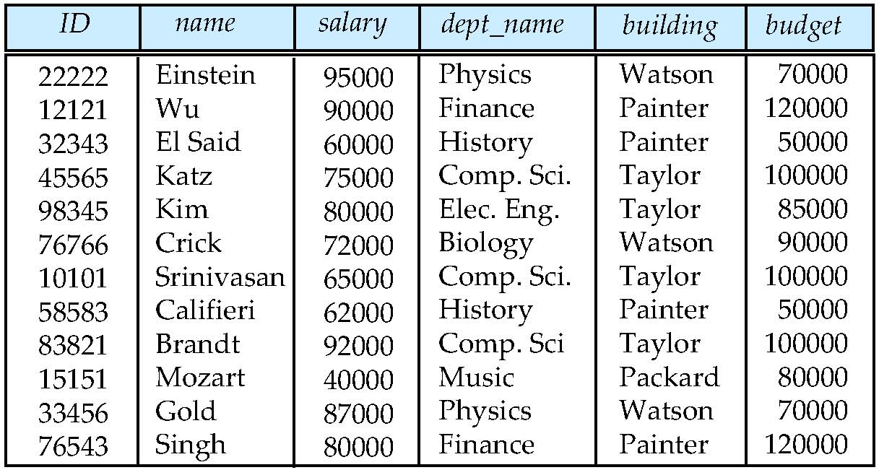
Two disparate sets of information should not be represented in the same table
Instructors and departments should be separated
There is repetition of information
Each department requires multiple rows to represent everything about it, and in the process duplicates a large amount of data.
There is an inability to represent certain types of information
We could not represent a new department without having at least one instructor for that department, since nulls are not allowed

- (10 points) Consider the database in the figure below and answer the following questions:

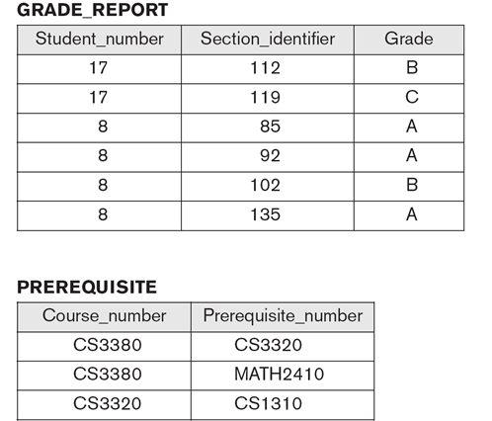
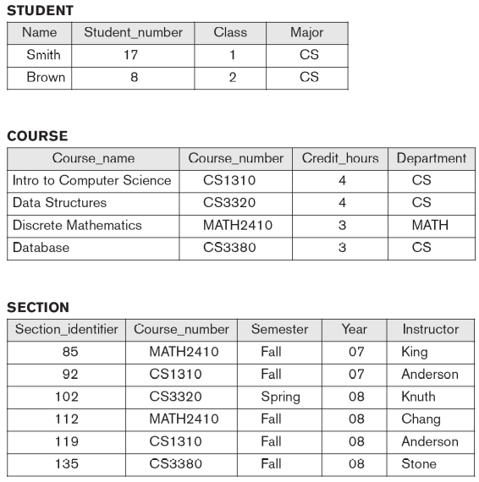

                - (5 points) If the name of the ‘CS’ (Computer Science) Department changes to ‘CSSE’ (Computer Science and Software Engineering) Department and the corresponding prefix for the course number also changes (for example, CS1310 changes to CSSE1310), identify the columns in the database that would need to be updated – indicate the table name and the column name for each column affected by the change.

STUDENT: Major
COURSE: Course_Number
COURSE: Department
SECTION: Course_Number
PREREQUISITE: Course_number
PREREQUISTE: Prerequisite_number

                - (5 points) Can you restructure the columns in this database - without adding or deleting tables, so that to minimize the number of changes that cascade throughout the tables when such a renaming of a department occurs?

COURSE should have a field added called “Course_identifier”

SECTION: Course_number should be replaced by a reference to Course_identifier

PREREQUISITE: Course_number and Prerequisite_number should both be replaced by references to Course_identifier

What to submit: The solutions to these problems should be typed in a Word document and submitted via Blackboard (use the link Assignment 1 in the Assignments folder) + in class (hard-copy please).

