Tamara Buch

Perry Huang

CS 498-DAF

December 14, 2012

**Final Project**

**Using K-means Clustering for Image Classification**

In our project we attempt to classify images depicting a season of the year into an appropriate category (Winter, Spring, Summer and Autumn). The metric we used was color, as images depicting each season tend to be very distinct in the primary colors used. Similar to in Homework 5, we took images from each season and created 8x8x8 histograms by extracting the RGB data per pixel, however, this time we split each image up into a 20x20 and created the histograms from each of these. So we had each image chopped into 400 blocks. We had 25 pictures from each season and created a total of 10,000 “picture pieces” per season (40,000 total picture pieces).

**Our work was separated into steps:**

1. Ruby script: Downloaded images for all seasons into separate folders (final_loader.rb)
2. Ruby script: Create vectors from images into text files (final_vectors.rb)
3. Import text files into MATLAB, cluster via kmeans(), and generate 200x100 matrix (kmeans2.mat)
4. Ruby script: Import matrix into a Ruby script, aggregate counts for each cluster for each image using a Hash map, and then format data into proper format for SVMLight (final_data2svmlight.rb for training data, final_classifydata2svmlight.rb for testing data)
5. Learn SVM using training data (training.svmdata) to create model (model)
6. Classify testing data using testing (testing.svmdata) to create predictions (predictions)
7. Repeat for other seasons. We attached data comparing other seasons to winter as a case study.

**We have all our Ruby code, MATLAB workspaces, intermediate data/vectors, training models, testing images, and classifying results below:**

<https://github.com/perryh/cs498-daf>.

When training our SVM, we set the images that were winter to -1. Here are two winter images that were formatted to learn by SVMLight:

-1 48:0.385 57:0.055 91:1.545 141:0.015

-1 33:0.01 48:0.115 57:0.16 74:1.175 91:0.16 104:0.01 125:0.005 141:0.005 144:0.04 149:0.015 171:0.295 173:0.01

Here are two vectors from Spring, note that we use +1 here and in other seasons:

+1 31:1.365 57:0.15 91:0.3 104:0.07 141:0.115

+1 31:1.015 48:0.21 57:0.31 91:0.34 94:0.005 104:0.01 141:0.11

Here are two vectors from the training data, note that we use 0 here to have SVMLight classify:

0 19:0.005 31:1.205 48:0.025 57:0.14 91:0.32 94:0.13 104:0.07 124:0.05 141:0.05 194:0.005

0 31:0.56 57:0.095 91:1.0 104:0.045 124:0.045 133:0.25 141:0.005

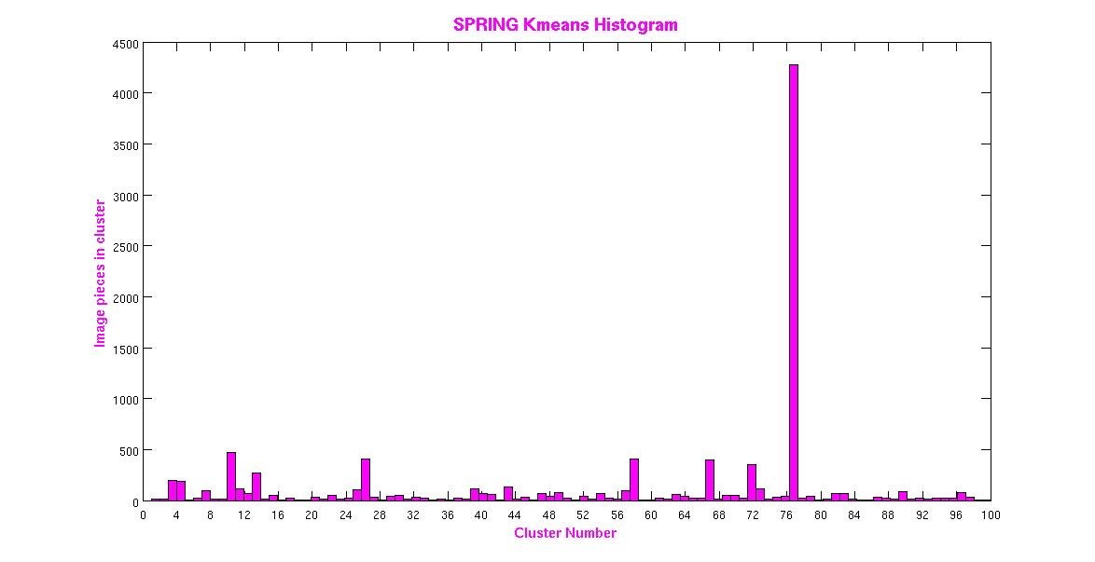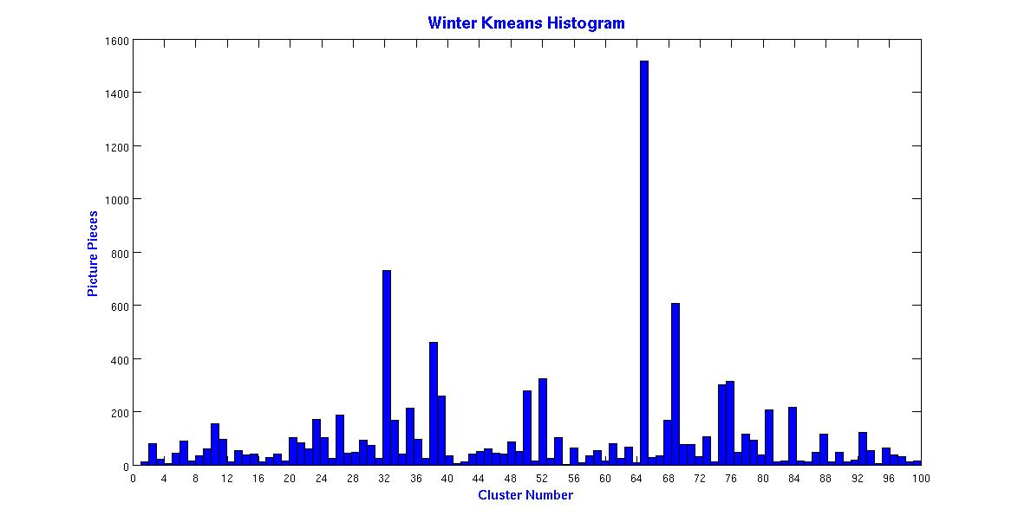

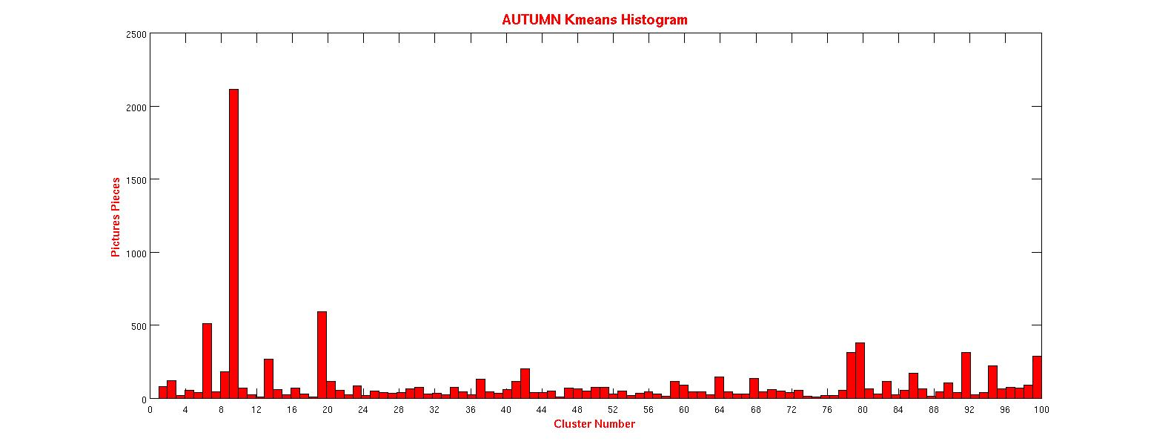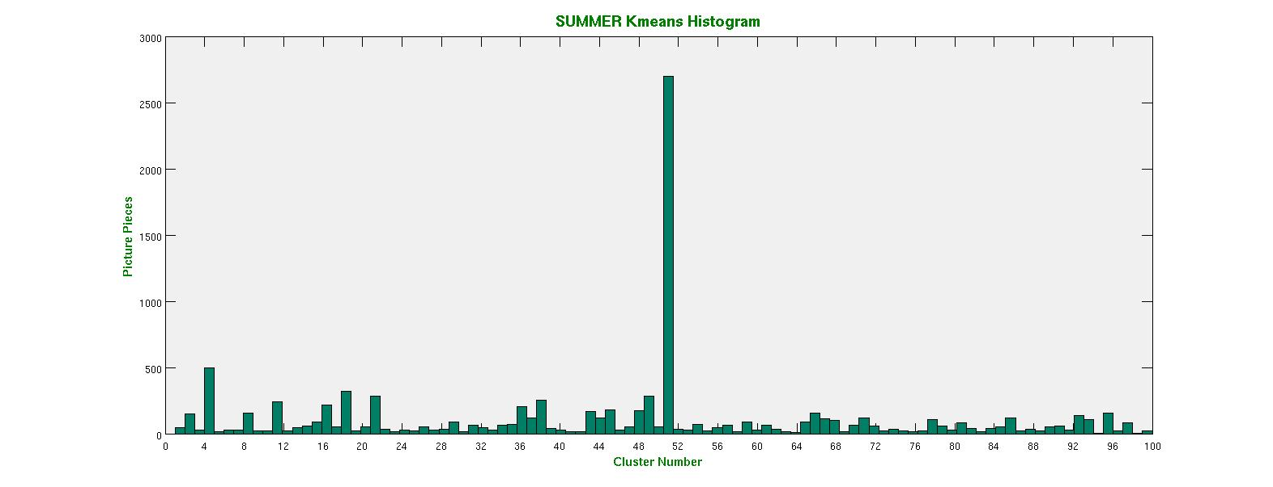

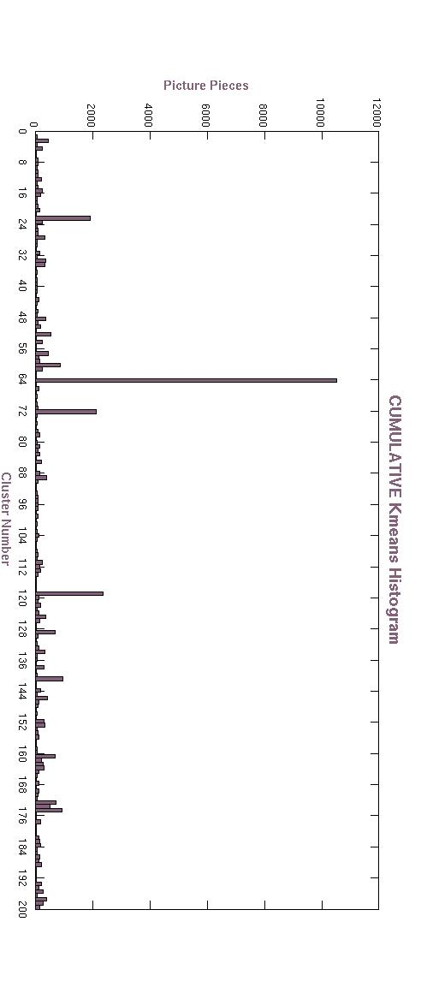

**Case study: Winter**For winter vs. all other seasons, we had 3 out of 5 winter pictures show strong prediction results. We also had 1 picture from spring, fall, and summer predicted to be 0.67. So almost all pictures from other seasons were predicted to be from other seasons. Obviously, winter pictures shares some colors with other seasons, so none of the winter pictures were super close to -1.

Prediction results, note that there were 5 from each season, but our scripts mixed them so they are in no particular order. Towards -1 is winter and towards +1 is all other seasons:

perryh$ cat predictions

1.398203

1.320973

0.90668797

0.86012345 (WINTER)

0.9375513 (WINTER)

0.85031217

0.99476986

0.36011001 (WINTER)

-0.041219067 (WINTER)

0.08511944 (WINTER)

1.7284931

0.81751208

0.90336027

0.99072509

0.67927793

0.71476512

0.8204639

1.1570333

1.0021378

0.76841876

**0.86012345 (WINTER)**

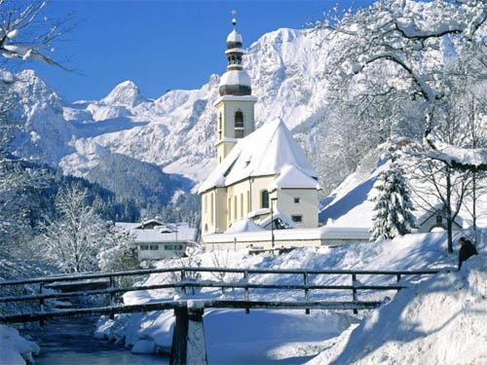

**0.9375513 (WINTER)**

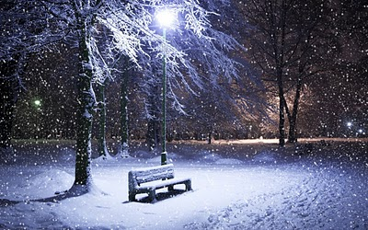

**0.36011001 (WINTER)**

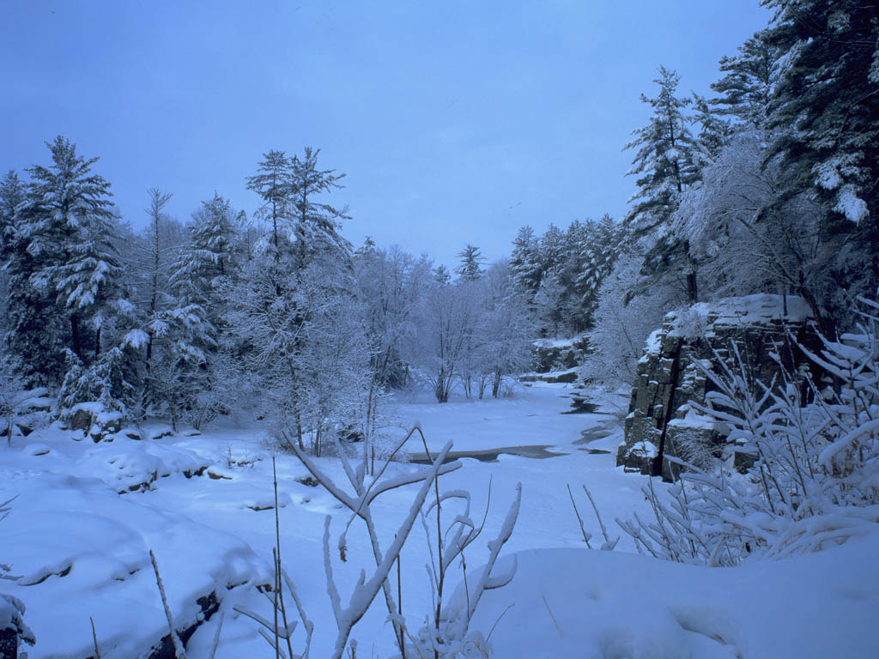

**-0.041219067 (WINTER) : This was strongly predicted to be winter. Look at the amount of whiteness!**

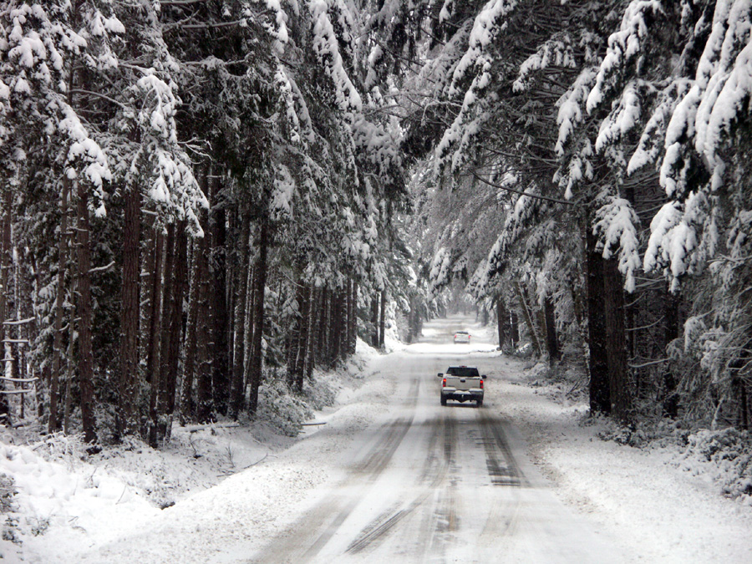

**0.08511944 (WINTER)**

