Team Smack'em Up

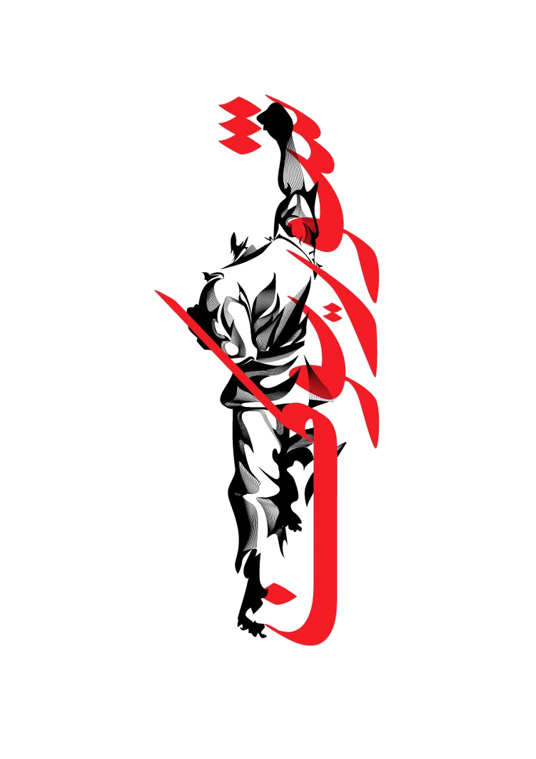

Kenneth Perry and Joey Anderson

Project Name:Revenge

Table of Contents

Concept Statement.....................................................................Pg. 3

Platform......................................................................................Pg. 3

Genre.........................................................................................Pg. 3

Story/Background......................................................................Pg. 3

World Detail..............................................................................Pg. 4

Level 1.......................................................................................Pg. 4

Level 2.......................................................................................Pg. 5

Gameplay...................................................................................Pg. 5

Target........................................................................................Pg. 6

Concept Statement

The world is filled with killers. In this word, the weak die and the strong live. How long can you survive?

Platform

Our game will be built using Adobe Flash and will be built for the PC and Arcade Machine.

Genre

This game will be a Side-Scroller, hack-and-slash, platformer. The goal of our game is to make a stand out game with mixing these genres together in a nice blend. This will further immerse the players.

Story/Backstory

There are two main characters in the game. Tenryu, the main protagonist of the game. Aku, the main antagonist. Aku is an evil warlord with goals of taking over the world, but after killing Tenryu's family, Aku makes the one enemy he shouldn't have.

Tenryu is the main hero of the game. Born into a samurai family, he was trained at a young age to fight. In a world filled with fighting, Tenryu and his family make a living being mercenaries. They are some of the strongest people in the land and are known by all.



One day a samurai warrior from another land arrives in Japan. This warrior is named Aku. Aku's history is a mystery. Aku has dreams on taking over the world. Aku see the people of Japan weak and plans to start here with his world domination. Aku slowly builds up an army. His name is spread across the land. One day, Aku sends his men to a fisherman village to take control of it. The villagers hired a group of mercenaries to defend the village. The mercenaries were from Tenryu's family and the killed all of Aku's men. Aku received word and went to Tenryu's village to kill them off.

Tenryu just finished a job and on his way home saw smoke coming from his village. Tenryu rushed home to see what was going on. When Tenryu arrived he saw his fellow villagers on the ground dead. Tenryu ran towards the center of the village and saw Aku standing there with his swords through Tenryu's father. Tenryu was enraged and attacked Aku. Aku quickly cut down Tenryu and left him to die. Tenryu layed on the ground bleeding, watching Aku leaving the village, and passed out. A merchant walked by after Aku left the village and saw Tenryu. The merchant saw that Tenryu was still alive and took him with him and treated his wounds. When Tenryu awoke he swore to kill Aku and get revenge.

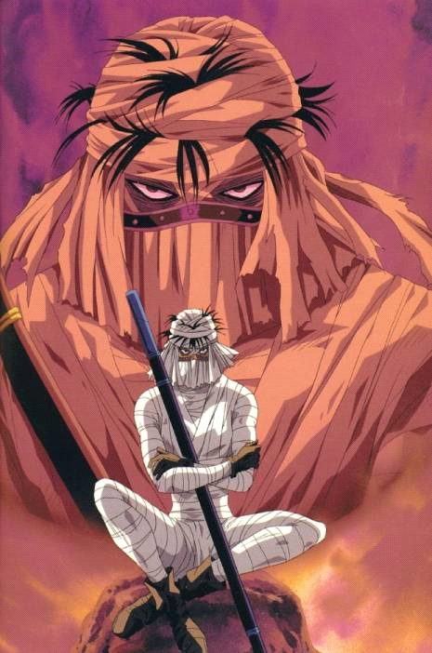

World details

The world is set in Feudal Japan. The land is covered with green forest and small villages. The villages are filled with poor, but hard working men and women. The houses are made of tree branches and straw. The world will be broken up into two levels. These levels will show case what the world looks like.

Level 1

The first level is a mountain trail base level. This level will feature hills and drops to simulate a real mountain. This will give the players a reason to test out what the movement controls. It will be important for the player to jump up little hills that are not walkable. The first level will also serve as a tutorial level for the players to learn what each button does and comfortable with the game.

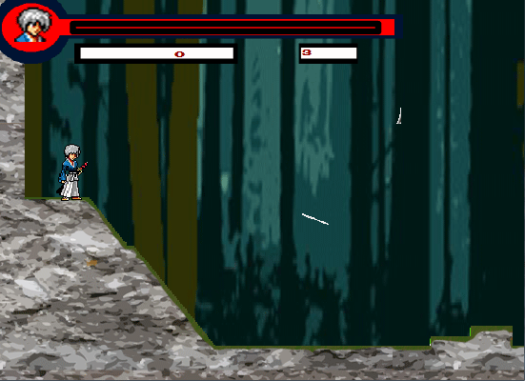

GamePlay

The basic gameplay will consist of moving to left, right, and jumping. It will also consist of one basic attack button and special attack button. With these basic controls and gameplay elements, the player will be able to quickly pick up the game and have fun.

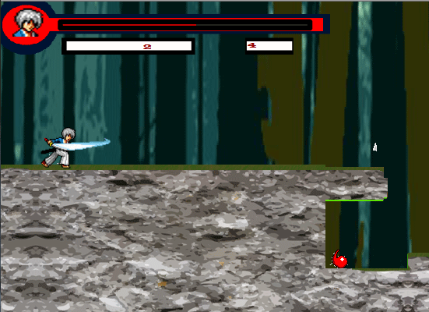

Movement

Movement will be the primary way the player explores the game. The player will be able to move to right at all time but they are limited on moving left because the screen will lock and prevent players from back tracking. Players will also be able to jump to reach higher ledges in the game to mix up the gameplay a little.

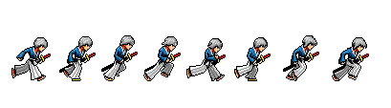 

Attacking

Players will have two main attack buttons in the game. 1) Basic Attack, and 2) Special Attack. Basic Attack will allows the players to perform a basic attacks to beat enemies when up close. These attacks can link into more basic attacks to make a combo. Special attacks are long range attacks the player will be able to do to hit enemies from a far. This attack will not be able to link into a combo.

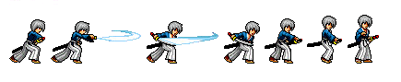

Two-Players

This is a single player game.

Target Audience

Our target audience will be males between the ages of 18-30.

Target rating

Our target rating for the game will be T for Teens. Our game does have violence and you do kill the enemies but we will not showcase any blood. Also so the game is not filled with dead bodies everywhere, when the enemies die they fade off from the screen to keep the game nice and clean.

Target Play Time

Gameplay is expected to be at least 5 minutes but it is subject to change. We are aiming for players to comeback after playing the first time to try and beat their high-score. We believe a fast paced short game will have players coming back.