Titanic Data Workflow and Interpretation

Perry Mertens
AI Programming Foundations
October 30, 2026
Titanic Data Workflow and Interpretation

Overview
I built a Python notebook to load, clean, explore, and plot the Titanic passenger data from the Seaborn example repository. The CSV file is at https://github.com/mwaskom/seaborn-data/blob/master/titanic.csv. I keep all 891 passenger records and compare ages and survival rates by sex and passenger class.

Dataset Description
The CSV file has 891 rows and 15 columns. Each row describes a passenger and whether they survived. The main columns are Survived, Pclass, Sex, Age, and Fare. A Survived value of 1 means the passenger lived, while 0 means they did not.
The other columns include family details, boarding location, and deck. Age data is available for 714 passengers, leaving 177 missing values (about 20%). Deck information is missing for 688 passengers, which is more than 75%. Only two passengers are missing embarked and embark_town data. There are no missing values for survival or passenger class.

Description
I use pandas.read_csv("titanic.csv") to load the data. I then view the first five rows and check that the dataset has enough entries. Next, I check data types, count missing values, calculate missing percentages, and look for duplicate rows. Two cleaning functions create a working copy of the data, remove six unnecessary or overlapping columns, and replace missing embarkation ports with Unknown.

The EDA function provides basic summaries and counts for passengers and survivors. It also calculates survival percentages for different groups. I use Matplotlib to create and save three labeled plots. Finally, I will explain the results in a Markdown section.
Danchev (2022) explains how Jupyter notebooks can combine Python code, explanations, a reproducible process, and thoughtful interpretation. I followed this approach by loading, cleaning, summarizing, plotting, and interpreting the data in one notebook, rather than making untracked changes in a spreadsheet.

The function remove_redundant_columns drops the columns class, who, adult_male, embark_town, alive, and alone. These columns either overlap with the ones I keep or are grouped versions I don't need for my comparisons. For example, pclass has class information, embarked shows where people boarded, and survived shows the outcome. I remove these columns to keep things clear, not because they are incorrect. The original dataset dataframe (df) stays the same, and the working copy has 891 rows and nine columns.

The function label_missing_embarkation changes two missing 'embarked' values to Unknown. This makes it clear when information is missing, instead of guessing the port. This label only shows missing data and is not a full statistical fix. I kept missing ages and deck values and did not delete any passengers with missing data. Sterne et al. (2009) point out that handling missing data can introduce bias, so it is important to report what is absent and any guesses made. That is why I mention the 177 missing ages in Figure 1.
I retain identical rows because the dataset lacks unique passenger IDs; matching details do not necessarily identify the same person. I also retain zero and unusually high fares because there is no evidence they are errors. The EDA focuses on clear group summaries rather than prediction. Figure 1 shows the age distribution using 20 bins. Figures 2 and 3 compare group survival rates as percentages (0 to 100), allowing comparisons between groups of different sizes.

Results and Interpretation
Figure 1 shows that most recorded ages are in young adulthood, with fewer older people and some young children. The average age is 29.7, the median is 28, and ages range from 0.42 to 80. These numbers include only the recorded ages.
Figure 2 shows that 233 of 314 women survived (74.2%), while 109 of 577 men survived (18.9%). That’s a big difference, but I didn’t adjust for age, class, or other factors.
Figure 3 shows that 136 of 216 first-class passengers (63.0%), 87 of 184 second-class passengers (47.3%), and 119 of 491 third-class passengers (24.2%) survived. Survival rates decrease as classes decreases. These comparisons are not adjusted, so they do not show cause and effect. The average fare is 32.20, the median is 14.45, and the highest fare is 512.33, which means fares are right-skewed. I include the fare statistics but not a separate plot.

Responsible Practice
The age histogram could be misleading if missing ages are more common in some groups. Keeping all rows means I do not drop people by age, which keeps the sex and class summaries fair, but it does not fix possible bias in the age plot. Sterne et al. (2009) urge checking for differences between complete and partial records and being clear about what is left out. My next step would be to check if missing ages are more common in certain sexes, classes, or survival groups before deciding how to handle missing ages or do more analysis.
The deck has too much missing data, so I do not include it in the plots. Unknown embarkation is just a label for missing information, not a real port. The data only has two sex categories, so I use them as they are and do not make claims about other groups. The survival patterns are specific to this dataset and do not apply to people today. If I automate cleaning in the future, I will keep the first file and record all changes.

Reproducibility
The repository is at https://github.com/perrym/ai-programming-foundations-project. I use main and development branches in Git and track changes with task-based commits before merging into main. The notebook reads the CSV from a local path. Once the files and packages are set up, you do not need an internet connection or random sampling. Keeping code, explanations, and results together matches Danchev’s (2022) focus on reproducible workflows.

To reproduce the work, clone the repo, set up a Python environment, and install the dependencies with pip install -r requirements.txt. Create requirements.txt by running pip freeze > requirements.txt to list all package versions. Open data_workflow.ipynb with python -m notebook, restart the kernel, and run all cells in order. Keep titanic.csv in the same folder as the notebook; the three figure files will be saved there too. The notebook uses Python 3.11.6, but you will need the requirements file for a full environment match.

Future Integration Reflections
For a machine learning extension, I would use survived as the target, split the data before any preprocessing, and compare a simple baseline with an easy-to-understand classifier. I would exclude alive since it is just a copy of the target, review the other grouped columns, and apply imputation or encoding only to the training data. Before trying a neural network, I would prepare numeric inputs, encode categories, check scaling and missing values, and see if 891 records are enough for that kind of model. An automated agent could run checks, create new plots, and flag changes in missing data counts. But it would be risky to let an agent delete rows, fill in ages, or change interpretations without a clear reason and human review.

Summary and Interpretation
The workflow clearly shows differences in survival by sex and passenger class while preserving every passenger row. Most ages fall within young adulthood, but about 20% are missing. Missing data, overlapping columns, possible fare issues, and unadjusted group comparisons limit the conclusions. The main result is a clear, reusable analysis that lets you review the cleaning steps and findings alongside the code.

Figures
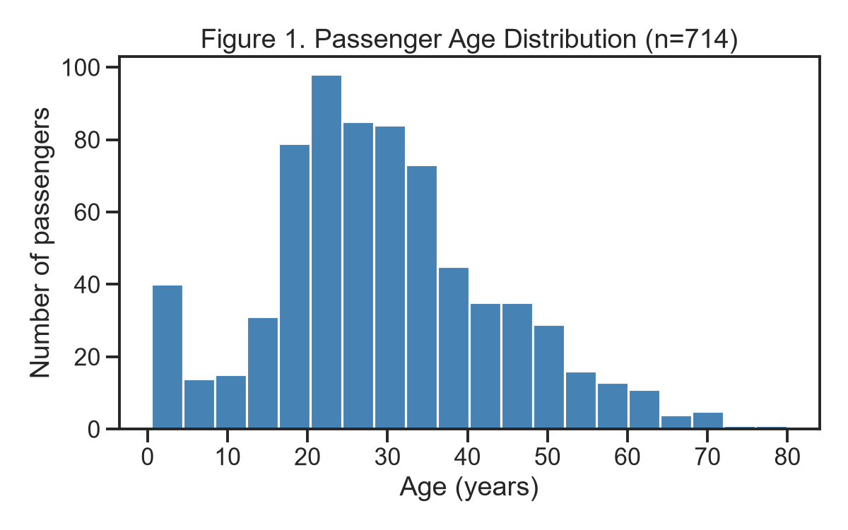
Figure 1. Recorded ages for 714 passengers. The 177 missing ages are excluded only from this histogram.
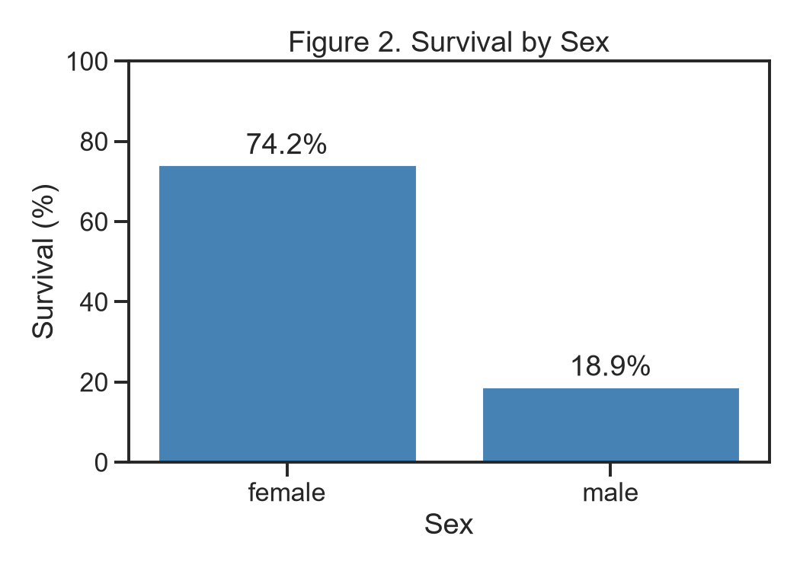
Figure 2. Observed survival percentages within each recorded sex category. Group sizes are 314 female and 577 male passengers.

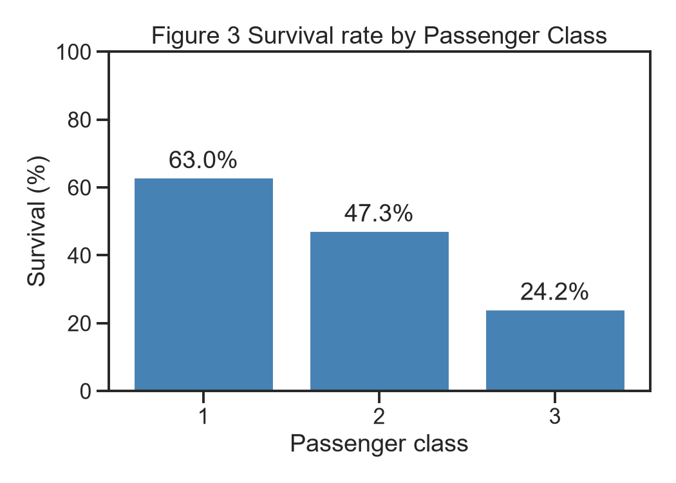
Figure 3. Observed survival percentages by passenger class. Group sizes are 216, 184, and 491 for classes 1, 2, and 3.

References
- Danchev, V. (2022). Reproducible data science with Python: An open learning resource. Journal of Open Source Education, 5(56), Article 156. https://doi.org/10.21105/jose.00156
- Sterne, J. A. C., White, I. R., Carlin, J. B., Spratt, M., Royston, P., Kenward, M. G., Wood, A. M., & Carpenter, J. R. (2009). Multiple imputation for missing data in epidemiological and clinical research: Potential and pitfalls. BMJ, 338, Article b2393. https://doi.org/10.1136/bmj.b2393
- Waskom, M. (n.d.). titanic.csv [Data set]. GitHub. https://github.com/mwaskom/seaborn-data/blob/master/titanic.csv

