DATA WRANGLER · COMPONENT BRIEF
The File Catalog
Turn file sprawl into governed, well-linked data assets.

The problem nobody else solves
Every oil & gas data team sits on terabytes of files — well logs, scout reports, directional surveys, seismic, shapefiles, spreadsheets — scattered across drives and shares. The hard questions go unanswered:
- What do we actually have, and where is it?
- Which well does this file belong to — and is this the final version?
- What happens when files get moved, renamed, or deleted, or when the person who knew the folder structure leaves?
Interpretation suites and data subscriptions assume your data is already clean and loaded. They were never built for the messy file layer that comes before that. The File Catalog is.

What the File Catalog does
The File Catalog is the data-governance layer for your unstructured files. It inventories every file, opens it to learn what is inside, matches it to the right well, and copies it into a protected vault — so your documents become managed, searchable, well-linked assets you can trust. It runs as a six-stage pipeline:
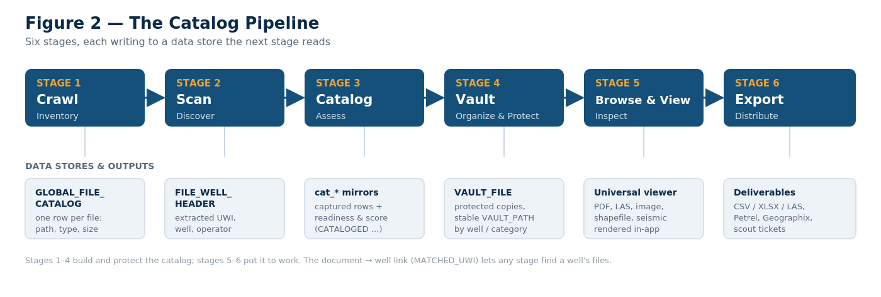
The File Catalog pipeline — each stage writes a store the next stage reads.

Capabilities
Automated inventory & fingerprinting  Crawls drives and shares, fingerprinting every file so junk is skipped, duplicates are caught, and moved or renamed files are recognized — not re-counted. | Content extraction & classification  Opens LAS, PDF, SEG-Y, shapefiles, Office and WITSML to pull UWI, well name, operator, depth and coordinates, and to classify each file precisely.
Well matching & readiness scoring  Matches each file to the right well, scores its quality from 0–100, and flags exactly what needs review — so nothing important slips through. | The Vault — protect & organize  Copies catalogued files into a structured, protected store organized by well and category, so your data survives even when the originals are moved or deleted.
Universal in-app viewer  Open any file in place — PDF, log plot, image, shapefile — without hunting across folders or launching other applications. | Wells ↔ documents, everywhere  See a well’s documents on the map and pull them straight into exports. Every document is tied to its well across the whole platform.

Why it’s unique
No mainstream petroleum platform ships an integrated file-and-document catalog with built-in governance for well data. Interpretation tools manage interpretations; data subscriptions rent you public data. The File Catalog governs the layer everyone else ignores — the files themselves — and turns them into a trustworthy, well-linked asset base that feeds the rest of your workflow.
See it on your own data.
The File Catalog is part of Data Wrangler, the data-management platform from Data Wrangler Solutions. Contact us to arrange a walkthrough against a sample of your own files.

