DATA WRANGLER PLATFORM
Data Wrangler
A self-contained data management platform for petroleum well data — with built-in governance.

The challenge
Well data lives in too many places and too many tools. Public data is rented from cloud subscriptions you never own. Your own files sit ungoverned on shared drives. Loading and reconciling data is a constant battle, and the foreign-key relationships that make the data usable break the moment something is loaded out of order. Most teams stitch together several expensive products and a data team to cope.
Data Wrangler replaces that sprawl with one self-contained platform that runs on your own SQL Server — your data, your control — and bundles the loader, the governance, the mapping, and the public data in a single license.

One platform, built around your data
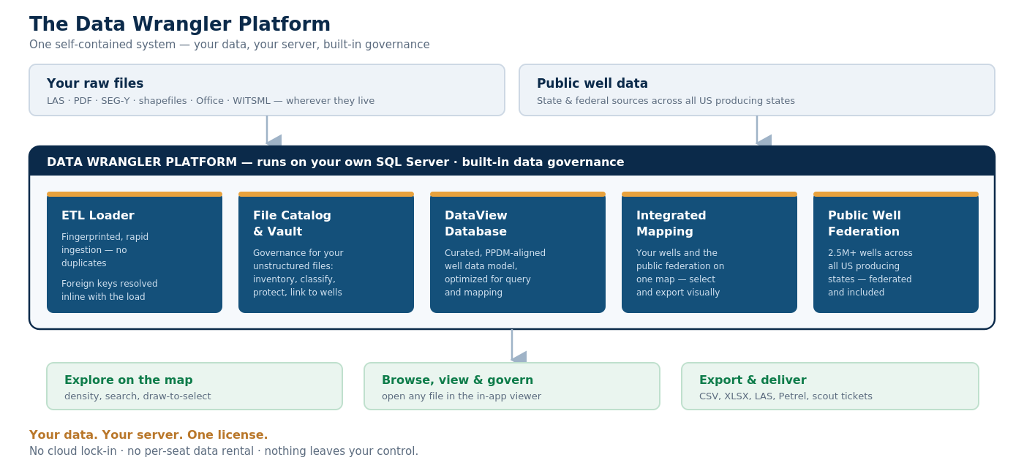
Data Wrangler — inputs flow in, the platform governs and curates, you explore and deliver.

What’s inside
Self-contained, with built-in governance  Runs entirely on your own SQL Server. No cloud lock-in, no per-seat data rental. Fingerprinting, the vault, provenance and readiness give you governance out of the box. | A DataView-optimized database  A curated, industry-standard (PPDM-aligned) well-data model, tuned for fast query and for the integrated mapping system — not a generic schema you have to adapt.
Robust ETL for rapid loading  Fingerprints files for fast, de-duplicated ingestion and resolves foreign keys inline with the load — not as a fragile post-process — so data lands clean and connected the first time. | The File Catalog  Built-in governance for your unstructured files: inventory, classify, match to wells, protect in the vault, and view in place. (See the dedicated File Catalog brief.)
Integrated mapping  A built-in mapping system over your wells and the public federation. Explore by density, search, draw-to-select, and export straight from the map. | Federated public well data  Over 2.5 million wells across all US producing states, federated from state and federal public sources — included, on your server, not rented from a portal.

Built-in data governance
Governance isn’t a bolt-on in Data Wrangler — it is how the platform works. Every file is fingerprinted and de-duplicated on the way in. Foreign keys are resolved during loading, so relationships are never left dangling. Catalogued files are copied into a protected vault and tracked with full provenance, and every file carries a readiness state and quality score. The result is data you can trust and trace, from the original file to the delivered export.

How Data Wrangler compares
The capabilities below normally require several separate products plus a data team. Data Wrangler brings them together in one self-hosted platform.
Capability | Data Wrangler | Interpretation suites | Data subscriptions | In-house / OSDU build
Self-hosted — you own the data | ✓ Included | Varies | — | ✓ Included
One-time license, not a subscription | ✓ Included | Varies | — | Build cost
ETL loader with inline FK resolution | ✓ Included | — | — | Build it
File & document catalog + governance | ✓ Included | — | — | Build it
Integrated mapping | ✓ Included | ✓ Included | Portal | Build it
Public US well data, all producing states | ✓ Included | — | Rented | —
Time to value | Weeks | Weeks | Days* | Months–years
Examples by category: interpretation suites (Petra, GeoGraphix, Petrel); data subscriptions (Enverus, S&P Global); in-house builds on PPDM or OSDU. *Subscription data is fast to access but rented, not owned.
Comparison is by product category; specific vendors’ capabilities and terms vary. Contact us for a comparison tailored to the products you’re evaluating.

Why Data Wrangler
- Ownership. You own your data and your platform — it runs on your server, not someone else’s cloud.
- All-in-one. Loader, governance, mapping and public data in one product, one license.
- Built to load. Fingerprinted loads and inline foreign-key resolution mean data lands clean and connected.
- Governed. The File Catalog governs the unstructured file layer no other platform manages.
- Data included. Over 2.5 million public wells across every US producing state, included.
Bring your data home.
Built by Data Wrangler Solutions LLC. Contact us for a demonstration on your own data and a tailored comparison with the tools you use today.

