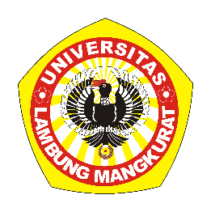**KEMENTERIAN RISET, TEKNOLOGI, DAN PENDIDIKAN TINGGI**

**UNIVERSITAS LAMBUNG MANGKURAT**

**FAKULTAS KEGURUAN DAN ILMU PENDIDIKAN**

**JURUSAN PENDIDIKAN MATEMATIKA DAN IPA**

**PROGRAM STUDI PENDIDIKAN ILMU KOMPUTER**

**KARTU BIMBINGAN SKRIPSI MAHASISWA**

|  |  |  |
| --- | --- | --- |
| **Nama** | **:** | **Yulia Rakhfah** |
| **NIM** | **:** | **1610131120012** |
| **Pemb. 1** | **:** | **Dr. Hj. Noor Fajriah, M.Si** |
| **Pemb. 2** | **:** | **M. Hifdzi Adini, S.Kom, M.T.** |
| **Judul** | **:** | **Pengembangan Media Pembelajaran Interaktif Berbasis Web pada Mata Pelajaran Matematika Materi Persamaan Kuadrat Kelas IX SMP dengan Metode Tutorial** |

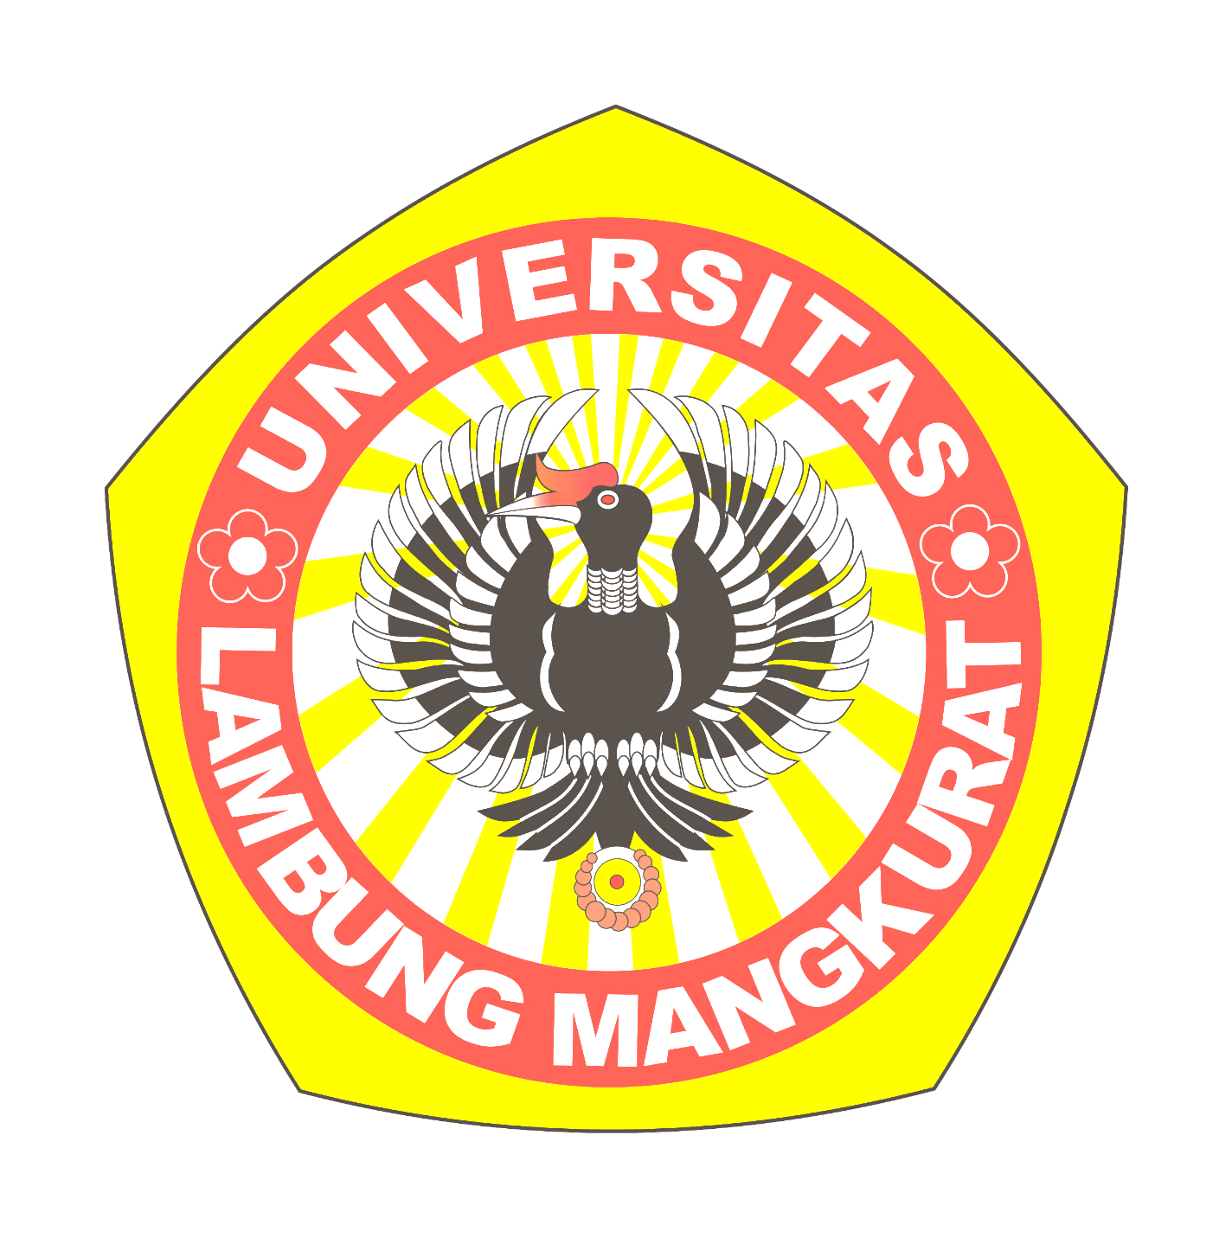

| **No** | **Tanggal** | **Materi Bimbingan** | **Paraf Mahasiswa** | **Paraf Pembimbing** |
| --- | --- | --- | --- | --- |
|  |  |  |  |  |
|  |  |  |  |  |
|  |  |  |  |  |
|  |  |  |  |  |
|  |  |  |  |  |
|  |  |  |  |  |
|  |  |  |  |  |
|  |  |  |  |  |
|  |  |  |  |  |
|  |  |  |  |  |
|  |  |  |  |  |
|  |  |  |  |  |
|  |  |  |  |  |
|  |  |  |  |  |
|  |  |  |  |  |
|  |  |  |  |  |
|  |  |  |  |  |

| **No** | **Tanggal** | **Materi Bimbingan** | **Paraf Mahasiswa** | **Paraf Pembimbing** |
| --- | --- | --- | --- | --- |
|  |  |  |  |  |
|  |  |  |  |  |
|  |  |  |  |  |
|  |  |  |  |  |
|  |  |  |  |  |
|  |  |  |  |  |
|  |  |  |  |  |
|  |  |  |  |  |
|  |  |  |  |  |
|  |  |  |  |  |
|  |  |  |  |  |
|  |  |  |  |  |
|  |  |  |  |  |
|  |  |  |  |  |
|  |  |  |  |  |
|  |  |  |  |  |
|  |  |  |  |  |
|  |  |  |  |  |
|  |  |  |  |  |
|  |  |  |  |  |
|  |  |  |  |  |
|  |  |  |  |  |