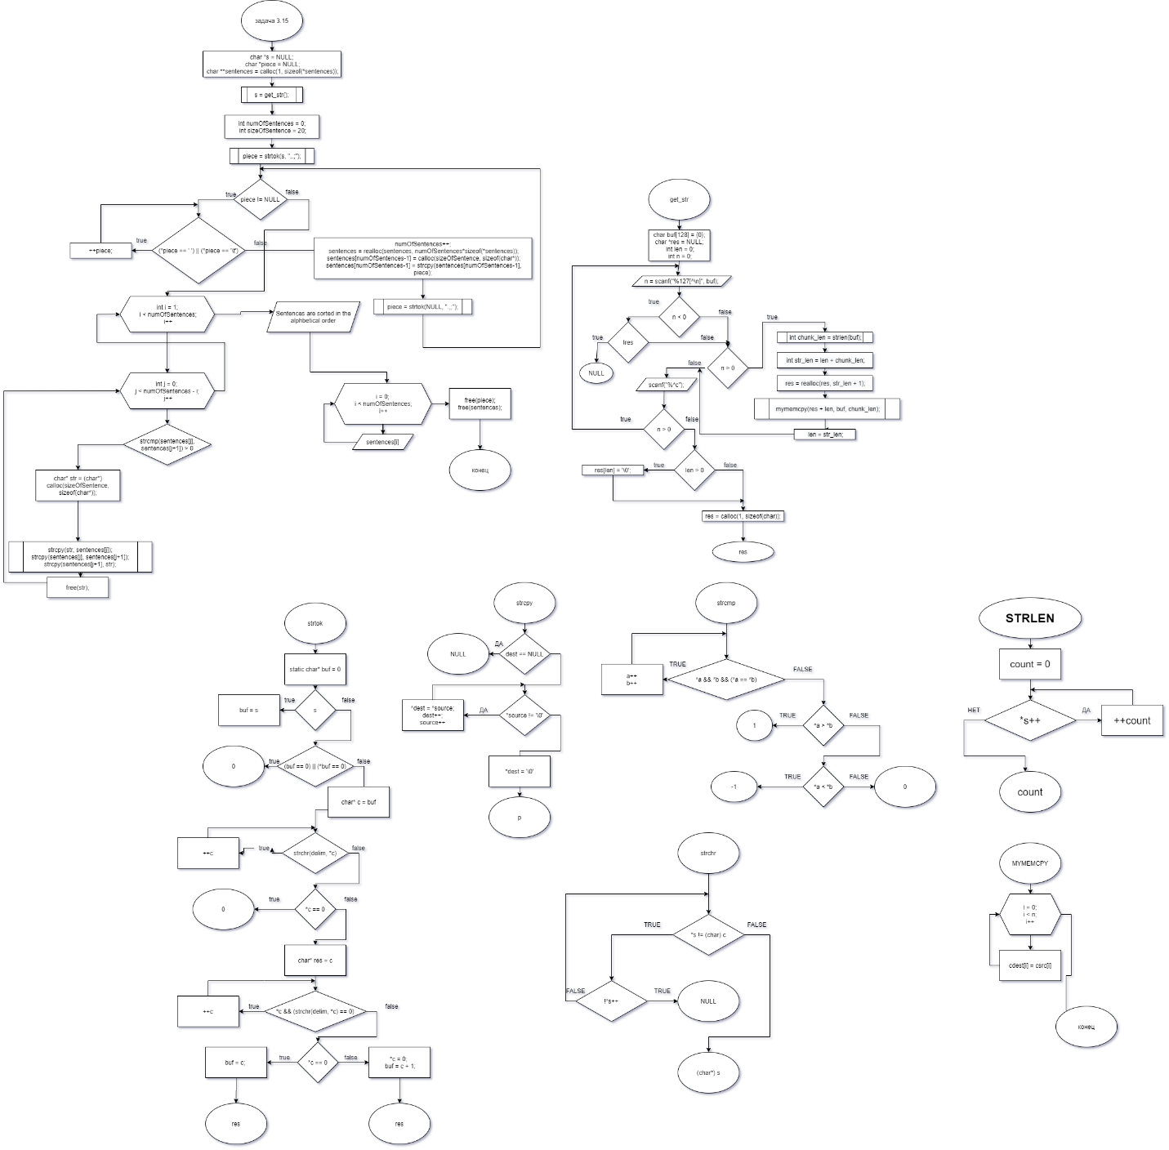

|  |  |
| --- | --- |
| Входные данные | Результат |
| .tj.s. z 64 t; hello, 0, 23. Ze6/g; | 0  23  Ze6/g  hello  s  tj  z 64 t |
| This. Is, a test string; ThAt mean;s 0noThing | Is  ThAt mean  This  a test string  s 0noThing |
| ,w;e,r;t,y;u.i;op;g.h;v,d;s,a;z,x;f,v;c,d;g,hb;,jn,;k,l | a  c  d  d  e  f  g  g  h  hb  i  jn  k  l  op  r  s  t  u  v  v  w  x  y  z |