CSE 212 – Programming with Data Structures
W01 Prove – Response Document

Name: | Perseus Taylor
Date: | 9/19/2026
Teacher: | Bro Alvey

It is a violation of BYU-Idaho Honor Code to post or share this document with others or to post it online. Storage into a personal and private repository (e.g. private GitHub repository, unshared Google Drive folder) is acceptable.

Question 1: For the rotate right problem, provide a description of how you solved the problem.
- I started by finding how many numbers will need to be moved to the front and which ones would stay. I did this by taking the count of the list and subtracting the amount to be rotated.
- I then used the GetRange method to split the list into two lists. One for the numbers that are staying, and one for the numbers that are being rotated.
- I then created a new list and appended the list that is staying first. This is rightPart in my code. Then I appended leftPart which keeps them in the order that makes the logic for this assignment work.
- I then returned the new list

Question 2: For the rotate right problem, draw a picture of how you solved the problem.
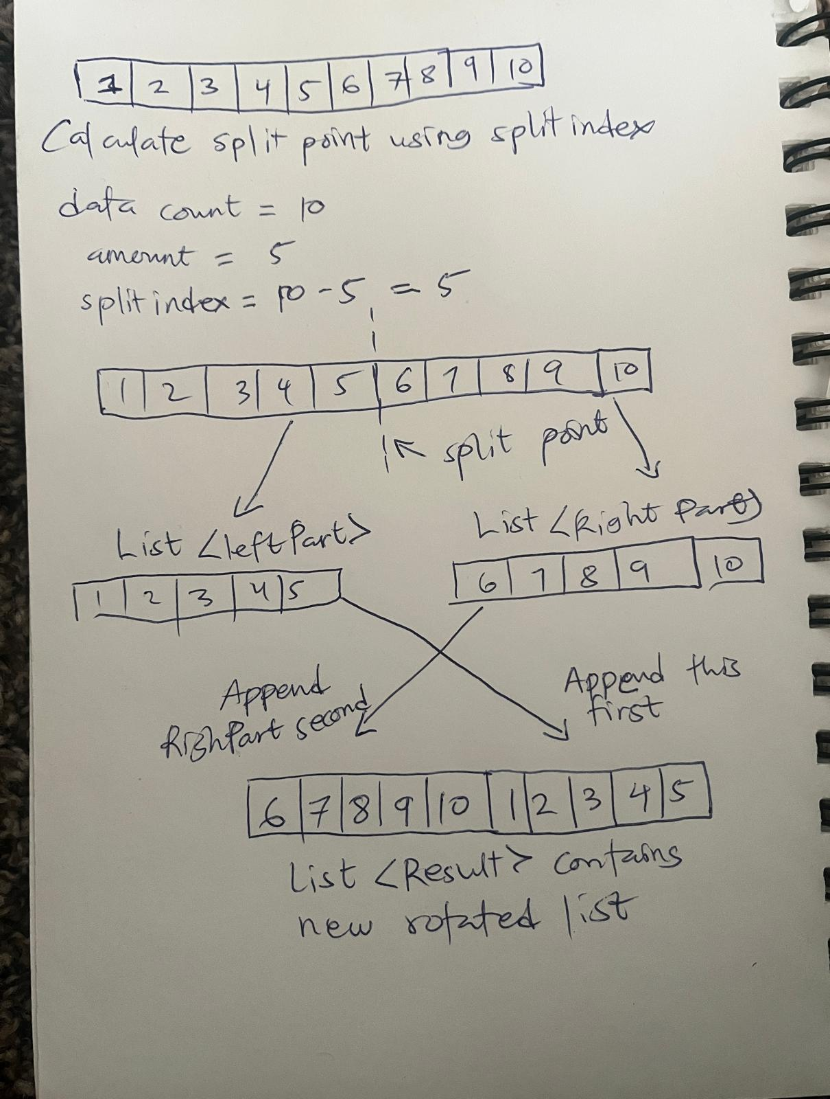

Remember: You need to commit all the changes to the prove-01-<username> repository along with this document. Then submit a link to the repository in I-Learn.

